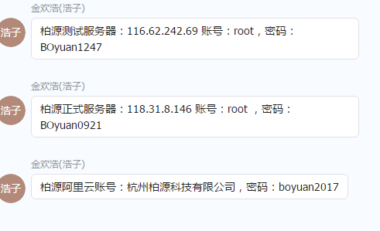

120.27.197.123

账号：Administrator

密码：YUEfaY&&m1121