**Analysis of Practical 1 data set:**

Raw data contained 5255 rows, which was grouped per author into 422 commits. Code was used to read the raw data and these commits were recorded into changes.csv file. Then data was saved into Excel for completing the analysis using the pivot tables. Upon analysis of the data set, the following interesting facts were uncovered:

1. Approximately 81% of commits were completed by 2 authors (Thomas – 45.26% and Jimmy -36.02%)

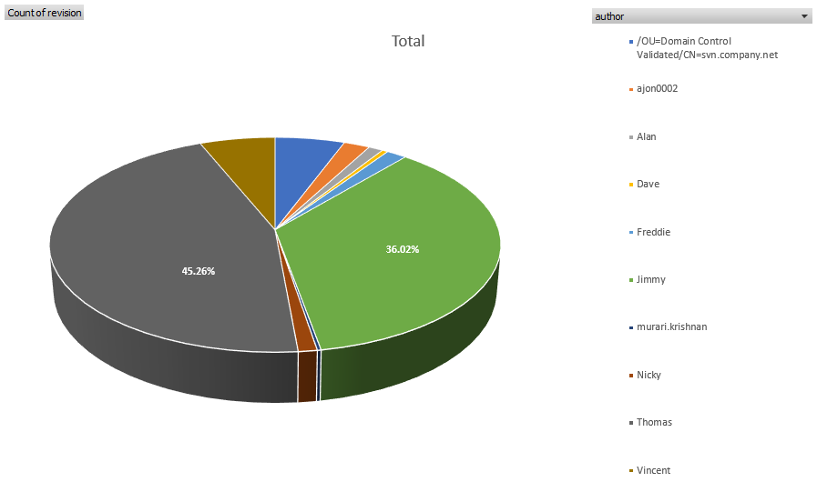

1. All the commits were completed during 5 months period (July-November 2015). Thomas in most of the months (4 out of 5) completed more commits than Jimmy with exception in August. The least commits completed in September by both of them, the most of commits were completed in July and October by Thomas.

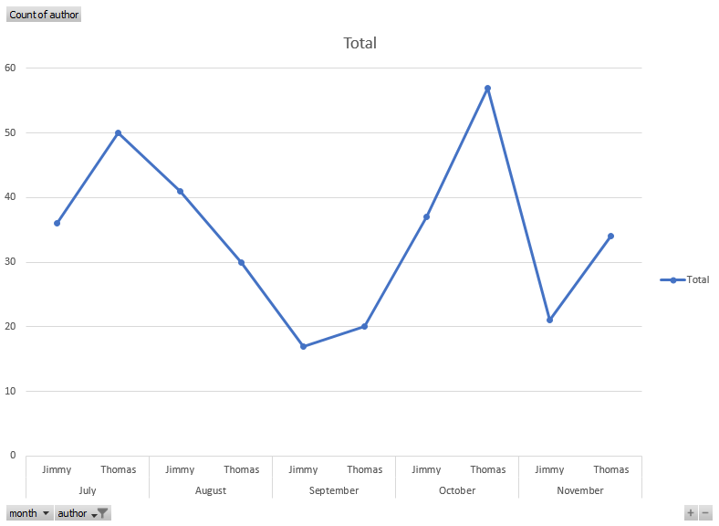

1. There were 100 commits out 422, which contained keyword ‘Phone’ (the graph below displays results per author), but only 62 commits out of 422 contained keyword ‘Android’ (the second graph below). Due to the list of the authors in the two graphs below not being exactly the same, we can draw a conclusion that the commits which contained keyword ‘Phone’ not necessarily contained a keyword ‘Android’. Results for Vincent’s commits proves this theory, as he completed 15 commits with keyword ‘Android’ recorded in the comments section, but his name is not on the list of authors with comment containing keyword ‘Phone’.

