Name *Stefano Ubbiali*

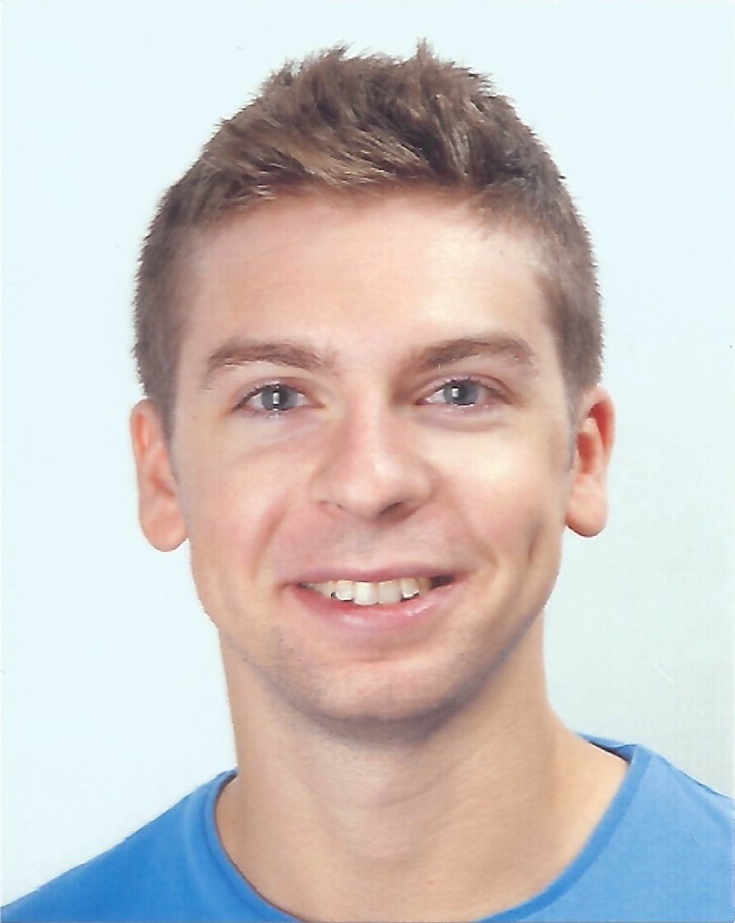

Office address

Phone number

Email *stefano.ubbiali@epfl.ch*

Personal webpage (if available)

**Biography**

I pursued my Bachelor degree in Mathematical Engineering at Politecnico of Milan, Italy in 2014. Then I joined the double degree Master program in Computational Science and Engineering between Politecnico and École Polytechnique Fédérale de Lausanne.

After a three-months internship at the Swiss National Supercomputing Centre in Lugano, Switzerland, I am currently carrying out my Master project under the supervision of Professor Hesthaven. The project deals with reduced order modeling of nonlinear systems using artificial neural networks.

**Research interests**

Mathematical modeling, numerical analysis, high-performance computing

**Publications**