银行用户存钱系统

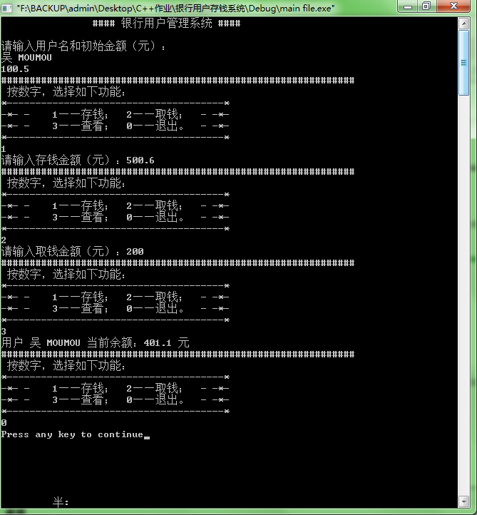

#include<iostream>
#include<string>
using namespace std;
int choice; //为什么不能在public里？
class bank_account{
public:
void password();
void open(string name1,double initial_balance1);
void deposit (double amount);
void withdraw(double amount);
int show_menuANDchoose();
void display_balance(){
cout<<"用户 "<<name<<" 当前余额："<<balance<<" 元 "<<endl;
}
private:
string name,input_password,PASS;//password can't be initialized in here
double balance; //=0
};
void bank_account::password(){
do{
PASS="CHINA";//password
cout<<"请输入银行用户密码：";
cin>>input_password;
}while(!(input_password==PASS));
}
void bank_account::open(string name1,double initial_balance1){
name=name1;
balance=initial_balance1;
}
void bank_account::deposit(double amount){
balance+=amount;
}
void bank_account::withdraw(double amount){
balance-=amount;
}
int bank_account::show_menuANDchoose(){
cout<<"##############################################################";
cout<<endl<<" 按数字，选择如下功能："<<endl;
cout<<"*--------------------------------------*"<<endl;
cout<<"-*- - 1——存钱； 2——取钱； - -*-"<<endl;
cout<<"-*- - 3——查看； 0——退出。 - -*-"<<endl;
cout<<"*--------------------------------------*"<<endl;
cin>>choice;
return choice;
}

int main(){
class bank_account personal;//为什么不能省bank_account，书160页省了？？
double balance_main;//
string name_main;//

// personal.password();
// system("cls"); //为什么一用这两行就会爆掉？？

cout<<" #### 银行用户管理系统 #### "<<endl<<endl;
cout<<"请输入用户名和初始金额（元）："<<endl;
getline(cin,name_main);
cin>>balance_main;//Enter
personal.open(name_main,balance_main);

do{
switch(personal.show_menuANDchoose()){
case 1:
cout<<"请输入存钱金额（元）：";
cin>>balance_main;
personal.deposit(balance_main);break;
case 2:
cout<<"请输入取钱金额（元）：";
cin>>balance_main;
personal.withdraw(balance_main);break;
case 3:
personal.display_balance();break;
}
}while(choice);

return 0;
}

P7D
#include <iostream>
#include<string>
using namespace std;
int main() {
void print_start(int num=4,char c=1);
string a="I am wu.";
print_start(33,'8');
print_start(33,'+');
print_start(33,'_');
print_start();
print_start(33);
cout<<a<<endl;
return 0;
}
void print_start(int num=8,char c=2){
for(int i=0;i<num;i++)
cout<<c;
cout<<endl;
}
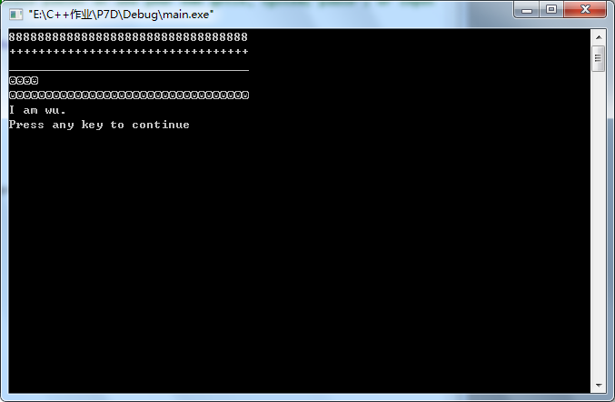

P7H
#include<iostream>
#include<iomanip>
using namespace std;
inline void swap(float &a,float &b);
int main()
{
float aa,bb;
cout<<"Please input two number:"<<endl<<endl;
while(cin>>aa>>bb)
{
if(aa>bb)
swap(aa,bb);
cout<<"The numbers in order are:"<<endl;
cout<<aa<<setw(5)<<bb<<endl;
}
return 0;
}
void swap(float &a,float &b)
{
int t;
t=a;a=b;b=t;
}
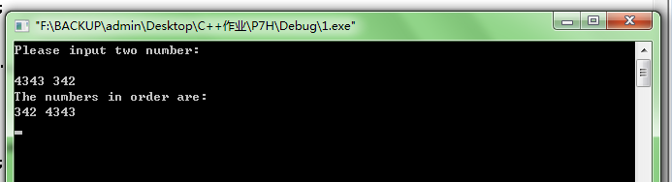

P7O 代码有问题

