 | UNIVERSITI MALAYSIA SARAWAK  Faculty of Computer Science and Information Technology

Assignment/Project/Report Cover Sheet
Student Name | Student ID | Group | Signature
FABIAN ANAK SUDIN | 104106 | G02(SE) | 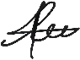

This cover sheet must be completed, signed and firmly attached to the front of the submission. All work must be submitted by the due date. If an extension of work is granted, an extension acknowledgement slip must be signed by the lecturer/tutor and attached to the assignment/project/report. Please note that it is your responsibility to
Course Code: TMA3084 | Course Name: Software Engineering Laboratory
Assignment/Project/Report Title: | Lab 1 | Lecturer: | Madam Nurfauza Jali & Raynold Kabai
Due Date: Saturday, 10 October 2026, 12:00 AM |  | Date Submitted: 08/10/2026
retain copies of your assignment.

Plagiarism and Collusion are methods of cheating that are addressed in the Peraturan Akademik Universiti Malaysia Sarawak para 11: Etika Akademik

Plagiarism
Plagiarism is the presentation of work which has been copied in whole or in part from another person’s work, or from any other source such as the Internet, published books or periodicals without due acknowledgement given in the text.

Collusion
Collusion is the presentation of work that is the result in whole or in part of unauthorized collaboration with another person or persons.

Where there are reasonable grounds for believing that cheating has occurred, the only action that may be taken when plagiarism or collusion is detected is for the staff member not to mark the item of work and to report or refer the matter to the Dean. This may result in work being disallowed and given a fail grade or if the circumstances warrant, the matter may be referred to a Committee of inquiry for investigation. Such investigation may result in the matter being referred to the University Discipline Committee, which has the power to exclude a student.
Upon placing signature above, I certify that I have not plagiarized the work of others or participated in unauthorized collusion when preparing this assignment.
I also certify that I have taken proper case in safeguarding my work and have made all reasonable efforts to ensure that my work is not able to be copied.
MARK :

GitHub Repository Information
Public Repository URL:
https://github.com/104106/TMA3084_104106G02.git

Source Code (pizza_order.dart)
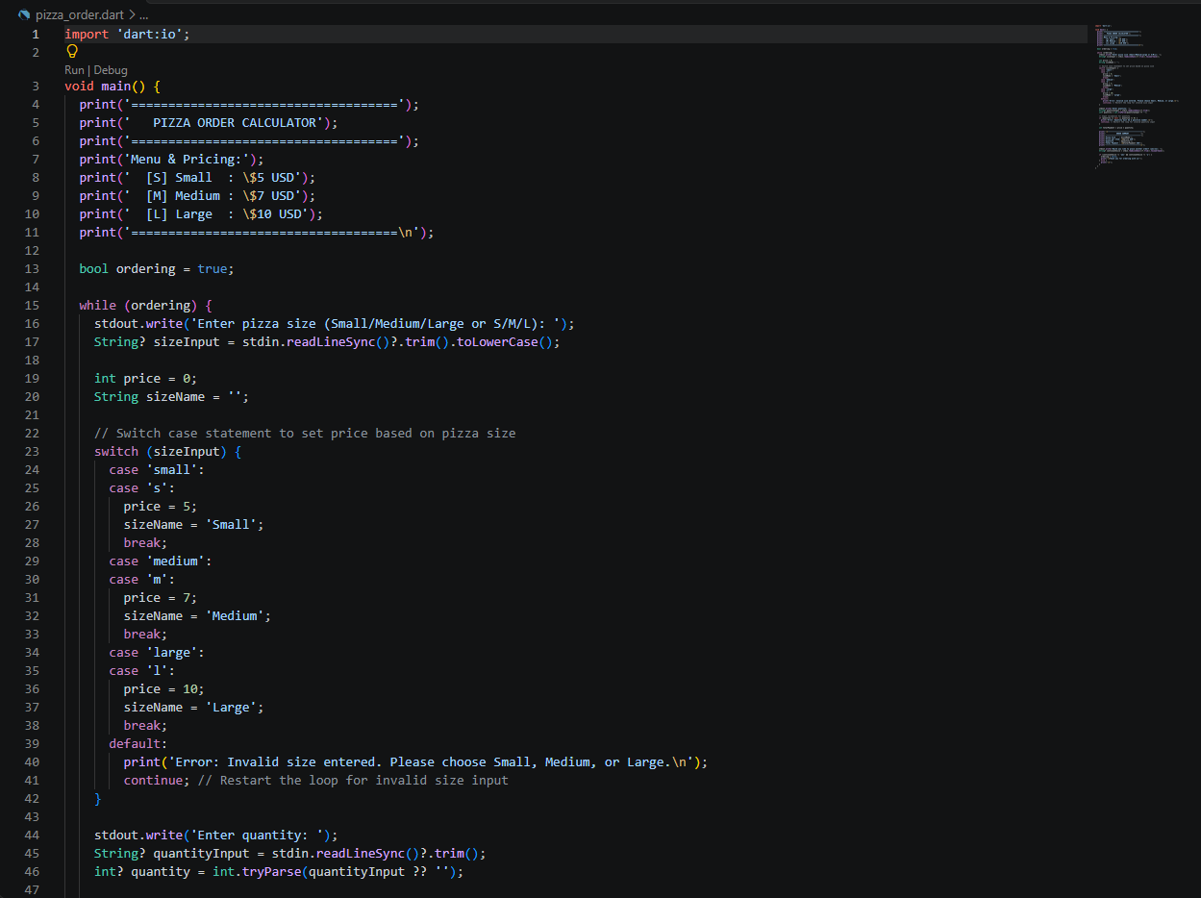
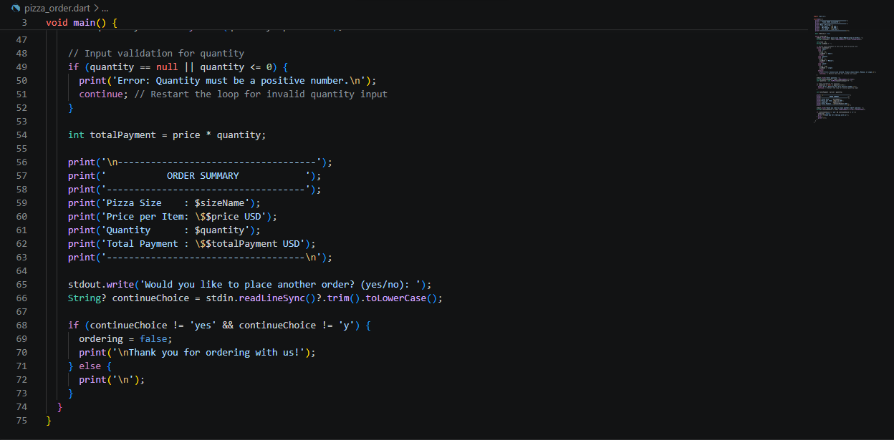
- Example Output
