SWINBURNE VIETNAM

HANOI CAMPUS



COURSE: COS30045

Topic

The differences in the cost of living between United Kingdom and United States

INSTRUCTOR: Hoang Xuan Tung

STUDENT NAME:

Tran Hoang Hai Anh

Hanoi - February, 2024

WORD COUNT: 2908 EXCLUDING REFERENCES

# *Executive summary*

The majority of the data used in this research came from Numbeo. The pie charts highlight housing, food, and eating out as the three main spending categories. The lack of exact data in the charts limits their usefulness, even if they offer insightful information. The heat maps provide a geographical viewpoint, highlighting differences in the cost of living in various cities. The results emphasise similarities and variations in spending habits, with a focus on housing and food costs.

Suggestions for improving accuracy include adding exact figures next to percentages in pie charts and resolving issues with heat map colour interpretation. The goal of these enhancements is to provide the facts in a more accurate and approachable manner. Policymakers, corporations, and people negotiating the complexity of the cost of living in the US and the UK can benefit from the comparative study's strong resourcefulness in understanding economic dynamics and lifestyle choices.

# *Table of contents*

**Executive summary 2**

**Table of contents 3**

**Introduction 4**

**The Visualisations 5**

The distribution of the cost of living index 5

Pie charts represent the distribution of the cost of living 5

Pie charts the pros and cons and makes suggestions for representing the distribution of the cost of living 6

Analysing the distribution of the cost of living in the UK and the US using those 2 pie charts 6

The costs of living by area index: 8

Heat maps represent the cost of living by area 9

Heat maps the pros and cons and makes suggestions for representing the cost of living by area 10

Analysing the cost of living in the UK and the US by area using those 2 heat maps 10

**Final verdict 12**

**References 13**

# *Introduction*

A nation's cost of living is determined by a multitude of factors. A significant amount of living expenditures go toward housing costs, which include utilities, rent, and mortgage payments. The cost of food and groceries is mostly determined by factors such as transportation, import duties, and local production. The expenditures associated with driving, gasoline, and public transportation all have a significant impact on the economy.

The financial picture is further complicated by the availability and cost of healthcare services, educational costs, and the cost of basic utilities. When evaluating the whole cost of living, taxes—including sales, income, and property taxes—come to light.

The pricing of products and services is impacted by variables like inflation and currency rates, which affect the dynamics of the cost of living. Living expenses are influenced by lifestyle choices shaped by cultural and economic considerations. These issues are set against the backdrop of political stability and economic realities.

Furthermore, subtle changes in the cost of living are a result of geographical variances within a nation. This complex interaction of variables emphasises how complex determining and comprehending the cost of living is.

# *The Visualisations*

## *The distribution of the cost of living index*

The United Kingdom:

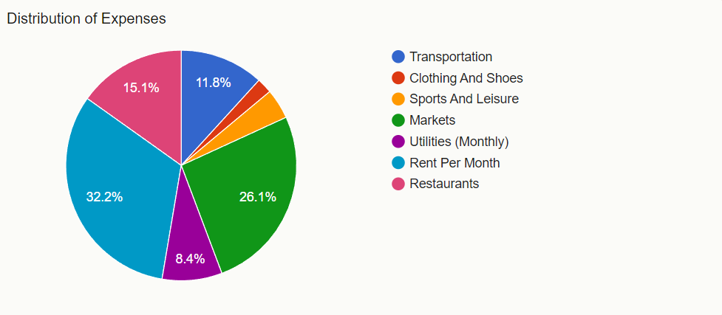

Source: Numbeo, The distribution of expenses in United Kingdom

The United States:

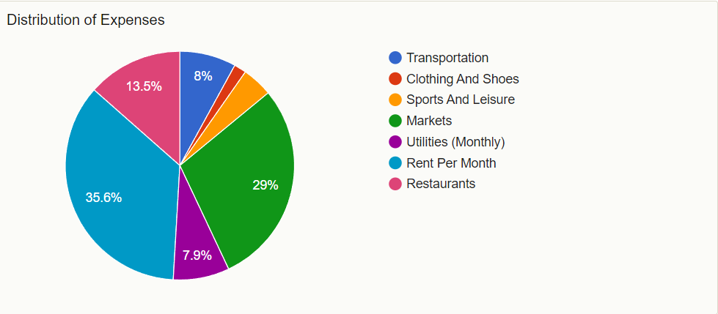

Source: Numbeo, The distribution of expenses in United States

## *Pie charts represent the distribution of the cost of living*

A circular statistical visualisation broken into slices to show numerical proportions is called a pie chart. Every slice is a piece or elements, such as “Transportation” or “Clothing and Shoes,” of the total, and every slice's size corresponds to the quantity it represents. Typically, the separate slices display the distribution or percentage contribution of each category or component, while the full circle indicates 100% or the overall amount of the distribution of expenses. This pie chart covers all the main factors that contribute to the cost of living in each country.

## *Pie charts the pros and cons and makes suggestions for representing the distribution of the cost of living*

The distribution of costs across seven categories—transportation, rent per month, markets, restaurants, utilities (monthly), sports and leisure, and clothing and shoes—is shown visually in the pie chart. The clarity with which the various spending categories and their relative amounts are shown on the chart is one of its strongest points. This clarity is further enhanced by the use of distinct colours for each category, which makes it simple to observe that the two biggest costs are transportation and rent every month.

But the chart is not without its limits. For example, it merely gives percentages rather than precise amounts or values for each category. It is challenging to determine the true monetary value assigned to each category due to this lack of knowledge. Furthermore, it is difficult to compare slices of comparable sizes correctly due to the structure of the chart.

We may think about making the graphic better by including the precise quantities or values for each category next to the corresponding percentages for more clarity. A bar graph, on the other hand, could be something to think about in order to facilitate category comparisons, particularly in cases where the percentages are close to one another.

## *Analysing the distribution of the cost of living in the UK and the US using those 2 pie charts*

The way that living expenditures are distributed in the UK provides important information about what people value most financially. Housing comes up as the top issue, with rent accounting for the greatest portion (32.2%), highlighting the significant influence that lodging costs have on people's finances. The allocation of 26.1% for grocery shopping at markets comes next, highlighting the sizable share of revenue devoted to the purchase of necessities like food. Furthermore, eating out represents a notable 15.1% of total spending, indicating a significant commitment of disposable income to leisure and dining out. With transportation costs amounting to 11.8% of total costs, it is clear how much money is needed for everyday movement. At 8.4% per month, utilities, on the other hand, provide a compromise between affordability and comfort. Conversely, 4.2% of income is set aside for sports and leisure, which represents a lower but no less significant share of money devoted to leisure pursuits. Finally, at 2.2%, clothing and shoes indicate discretionary spending, indicating a preference for basic necessities over fashion-related purchases. This pie chart offers insightful information on the many lifestyle decisions and economic variables influencing how living expenditures are distributed in the UK.

The way that living expenditures are distributed among Americans provides important information on what Americans value most financially. With rent accounting for 35.6% of total living expenditures, rent is the most significant expense. This highlights the significant financial outlay people make for housing, illuminating the effect of real estate expenses on household spending plans. Complying closely behind, the second-highest expenditure is purchasing foods in markets, at 29%. This highlights how important it is to consume food and how much money is spent on maintaining a balanced diet. The significant portion allotted to food shows how crucial this sector is to determining Americans' overall financial situation. The research highlights Americans' discretionary spending choices beyond housing and food. A noteworthy 13.5% of respondents report dining out, suggesting that a sizable amount of discretionary cash is devoted to recreational and culinary pursuits. This illustrates how important dining out is in our culture as a social and leisure activity. On the other hand, transportation costs, at 8%, underscore the financial commitment necessary for everyday movement. The percentages allotted to utilities (7.9%), sports and leisure activities (4.3%), and apparel and shoes (1.7%) offer further perspectives on the varied financial preferences and way of life decisions made by Americans. This thorough study is a useful resource for comprehending the nation's economic dynamics and consumer behaviour.

Both parallels and differences in financial objectives and lifestyle choices may be seen in the distribution of living expenses between the US and the UK. Rent accounts for 32.2% of total expenses in the UK, but in the US, it accounts for an even greater share—35.6%—which suggests that Americans are more financially committed to their homes. Grocery expenditures account for a sizable part of income in both countries—the US allotting 29% and the UK 26.1%. Eating out is a major cost in both countries—the US spends slightly more, at 13.5%, while the UK spends 15.1%—highlighting the significance of food experiences in both cultures. The UK has greater transportation costs than the US, at 11.8% against 8%, suggesting that mobility expenses may be higher in the UK.

However, utility prices in the UK (8.4%) are a little higher than in the US (7.9%), indicating that both countries have struck a balance between comfort and affordability. Sports and leisure time are allocated similarly in the US and the UK, with 4.3% and 4.2% of GDP going toward these activities, respectively, indicating a similar focus on leisure time activities. Interestingly, the UK pays 2.2% less on apparel and shoes than the US does (1.7%), indicating that US consumers place a little greater value on fashion-related expenses.

In conclusion, housing, food, and eating out account for a sizable amount of income in both the US and the UK. Spending disparities on fashion and transportation are indicative of different lifestyle preferences and economic conditions in the two countries. The comparative study offers insightful information on consumer behaviours and financial preferences that influence these nations' standard of living expenses.

## *The costs of living by area index:*

The United Kingdom:

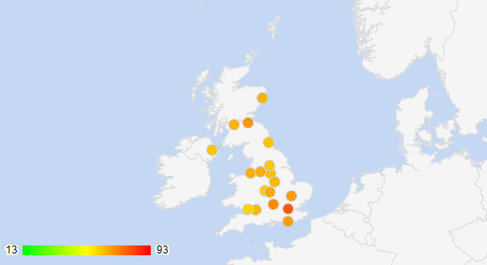

Source: Numbeo, The cost of living index by city in United Kingdom

Detailed list of the top 10 UK cities:

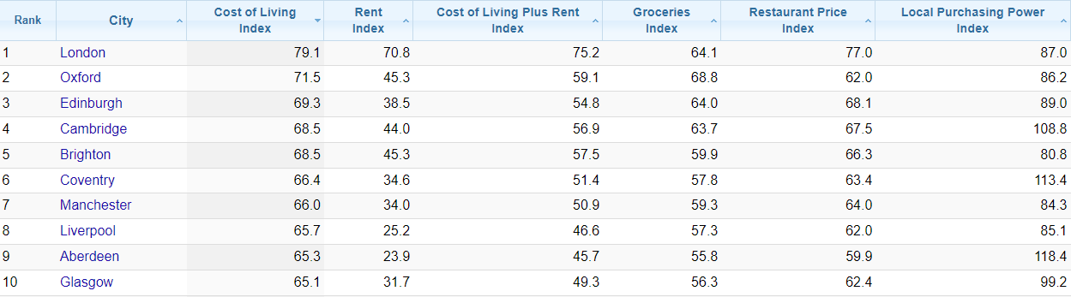

Source: Numbeo, A detailed cost of living table by city in United Kingdom

The United States:

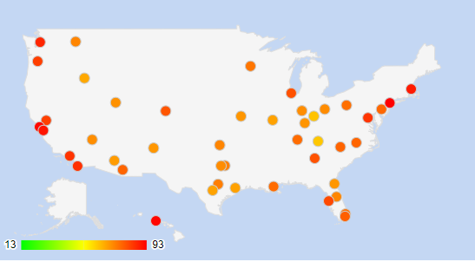

Source: Numbeo, The cost of living index by city in United States

A detailed list of the top 10 US cities:

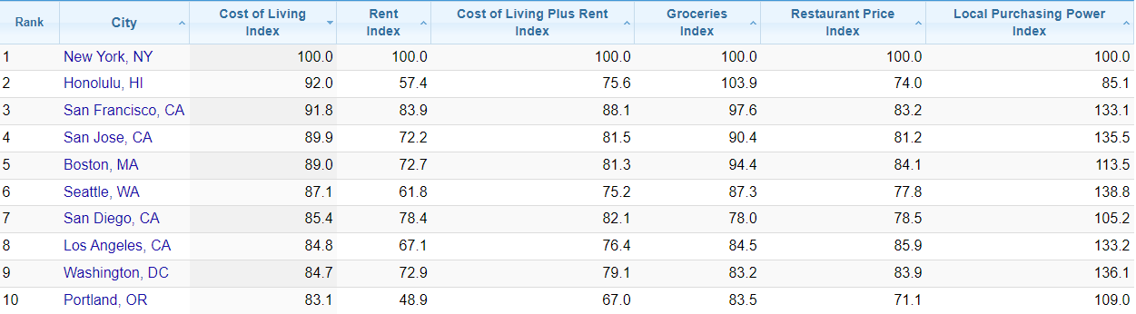

Source: Numbeo, A detailed cost of living table by city in United States

## *Heat maps represent the cost of living by area*

Heat maps, which use colours to represent numbers in a matrix, are a type of data visualisation approach. It is especially helpful for showing the extent of a phenomenon or variable in two dimensions, like categories and time, or geographical areas. Each matrix cell in a heat map is given a colour that symbolises the value of the variable it represents. Usually, the colours vary from cold to warm, with warmer colours denoting greater values and cooler colours signifying lower values.

Heat maps are frequently used to help find patterns, trends, or regions of concentration within the data in a variety of sectors, including statistics, economics, biology, and geography. They provide complicated datasets and easy-to-understand visual representations, which facilitate the identification of outliers and regions of interest. In this case, it helps show the pattern in cost of living by area and city. By using the colour scale from green, which represents the cheapest, to red, which represents the most expensive city to live in, we get a very simple infographic that shows many numbers in a more location-based and colour-based graphic.

## *Heat maps the pros and cons and makes suggestions for representing the cost of living by area*

Heat maps are aesthetically appealing tools that convey complicated data in a way that is simple to comprehend. They do a great job of displaying the density or intensity of variables, which facilitates the process of finding patterns, correlations, and anomalies in the data. They also make it simple to compare various categories or areas within the data.

They do, however, have certain restrictions. It might be challenging to determine precise values for certain data points in heat maps as they lack the numerical data's accuracy. Individuals' perceptions of colour can differ, which could have an impact on how the facts are interpreted. Oversaturation can result from too many dense or overlapping data pieces, which makes it challenging to discern between them. Finally, the significance of a heat map may not be evident in the absence of appropriate context or supplementary explanation.

There are some improvements that should be implemented to these heat maps. First of all, giving the data being shown a clear, descriptive title helps give it instant context. Besides, a legend that explains the meanings behind the various circle colours and sizes might improve user comprehension. Furthermore, the map may be made more accessible, especially for users who are colorblind, by enhancing colour contrast and incorporating patterns in addition to colours. Moreover, the problem of precision can be addressed with interactive tooltips that provide accurate data as the user hovers over data points. Employing transparency, jittering, or higher-level data aggregation if there are overlapping data points. On top of that, we may enhance the map's informativeness by adding contextual information about the data's meaning, the methodology used to gather it, and any other pertinent details.

## *Analysing the cost of living in the UK and the US by area using those 2 heat maps*

The heat map shows that there are large differences in the cost of living between cities in the United Kingdom. With a score of 79.5, the capital city of London stands out as having the highest cost of living, indicating a somewhat costly lifestyle. Higher housing costs, total living costs in cities, and other factors are probably to blame for this. Oxford comes in close behind, scoring 71.8, which also indicates a high cost of living. With scores above 69, Edinburgh and Cambridge stand out for having comparatively higher living expenses. Conversely, cities with lower ratings than their equivalents, such as Aberdeen and Glasgow, may have more reasonably priced living costs. These variances show the regional and economic differences that exist within the United Kingdom. These differences have an impact on everyday spending, housing costs, and transportation costs, all of which add to the total cost of living in each location.

The heat map illustrates how the cost of living in the United States varies significantly between cities. With a cost of living index of 100.0, New York, NY, is the most expensive city in the dataset and is used as the benchmark. The next two closest cities, Honolulu, Hawaii, and San Francisco, California, have indices of 92.0 and 91.8, respectively, indicating a high cost of living. Boston, Massachusetts, and San Jose, California, both have index scores above 90, placing them among the more costly cities. With a cost of living index of 83.1, Portland, Oregon, on the other hand, stands out as the most reasonably priced city in our pick. The cost of living in Seattle, Washington, Los Angeles, California, and Washington, DC, is in the middle of the range. These variances, which represent the economic variety and geographical disparities that exist across the United States, are driven by factors such as house prices, transportation costs, and general living expenditures.

When the cost of living is compared between the US and the UK, there are notable differences between the two nations' cities. With a score of 79.5, London tops the list of most expensive cities in the UK, showing greater housing and total living expenditures. Oxford follows suit, highlighting how expensive living is in big cities overall. There are clear regional differences in living expenses; Aberdeen and Glasgow have lower living costs at just 65.9 and 65.4, respectively. New York, NY, on the other hand, sets the standard as the most expensive city in the United States, with an index of 100.0. In terms of cost of living, San Francisco, California, and Honolulu, Hawaii, score well as well. On the other hand, Portland, Oregon, with an index of 83.1, is the most reasonably priced city in the United States. Overall, there are geographical and economic variances in both nations that affect everyday costs for housing, transportation, and other necessities.

# *Final verdict*

To sum up, heat maps and pie charts are useful resources for comprehending and contrasting the distribution and variances in the cost of living between the US and the UK. Pie charts are a useful tool for efficiently categorising spending and providing information about the financial priorities and allocations of individuals in different countries. Pie charts offer a clear visual representation, but they also have drawbacks, such as the inability to compare slices precisely and the absence of precise numbers.

However, the heat maps offer a spatial viewpoint, highlighting the notable variations in the cost of living between locations. Areas with greater or lower living expenditures may be quickly and easily identified thanks to the colour-coded representation. It is important to recognize the constraints of heat maps, including the possibility of colour interpretation errors and the requirement for further information.

There are both parallels and differences in the spending habits and lifestyle selections between the statistics from the US and the UK. Accommodation, food, and eating out rank highly in both nations, but disparities in expenditure on utilities, transportation, and fashion are indicative of distinct economic environments and cultural inclinations.

Even if these visualisations provide insightful information, it's vital to think about ways they may be improved, such as adding exact numbers to pie charts instead of percentages and fixing issues with heat map colour interpretation. The comparative analysis offers a thorough grasp of the geographical variances, financial choices, and consumer behaviours that affect these countries' cost of living.

# *References*

Anon, (2021). Cost of living in the United Kingdom | Living Cost in UK - A complete guide. [online] Available at: <https://www.upgradabroad.com/articles/cost-of-living-in-uk/>.

Numbeo (2019). Cost of Living in United Kingdom. [online] Numbeo.com. Available at: <https://www.numbeo.com/cost-of-living/country_result.jsp?country=United+Kingdom>.

Expatistan, cost of living comparisons. (n.d.). Cost of Living in United Kingdom. [online] Available at: <https://www.expatistan.com/cost-of-living/country/united-kingdom>.

Office for National Statistics (2023). Cost of living latest insights - Office for National Statistics. [online] www.ons.gov.uk. Available at: <https://www.ons.gov.uk/economy/inflationandpriceindices/articles/costofliving/latestinsights>.

Pearsonpte. (n.d.). Cost of Living in the UK | Pearson PTE. [online] Available at: <https://www.pearsonpte.com/articles/cost-of-living-in-the-uk>.

Francis-Devine, B., Harari, D., Keep, M., Bolton, P., Barton, C. and Carthew, H. (2023). Rising Cost of Living in the UK. House of Commons Library, [online] 9428(1). Available at: <https://commonslibrary.parliament.uk/research-briefings/cbp-9428/>.

Investopedia. (2019). Is it Cheaper to Live in the U.K. Than in the U.S.? [online] Available at: <https://www.investopedia.com/ask/answers/100214/what-cost-living-difference-between-us-and-uk.asp>.

Loncar, Z. (2021). Cost of living in the UK: Your guide. [online] Wise. Available at: <https://wise.com/gb/blog/cost-of-living-in-the-uk>.

Edvoy. (n.d.). Cost of living in the US for International Students. [online] Available at: <https://edvoy.com/countries/study-in-us/cost-of-living/>.

Numbeo (n.d.). Cost of Living in United States. [online] www.numbeo.com. Available at: <https://www.numbeo.com/cost-of-living/country_result.jsp?country=United+States>.

Expatistan (2020). Cost of Living in United States. [online] Expatistan, cost of living comparisons. Available at: <https://www.expatistan.com/cost-of-living/country/united-states>.

World Population Review (2023). Cost of living index by state 2023. [online] worldpopulationreview.com. Available at: <https://worldpopulationreview.com/state-rankings/cost-of-living-index-by-state>.

Upwardli. (2022). Upwardli. [online] Available at: <https://www.upwardli.com/resources/new-to-america-what-is-the-average-monthly-cost-of-living-in-usa>.

Livingcost.org (2020). Cost of Living & Prices in the United States: Comparison of Cities & States. [online] Livingcost.org. Available at: <https://livingcost.org/cost/united-states>.

Rothstein, R. (2023). Cost Of Living By State Statistics & Trends In 2023 – Forbes Advisor. [online] www.forbes.com. Available at: <https://www.forbes.com/advisor/mortgages/cost-of-living-by-state/>.

USA TODAY. (n.d.). What does cost of living mean? How we calculate the comparison for states and cities. [online] Available at: <https://www.usatoday.com/story/money/2024/01/03/what-is-cost-of-living/71838710007/>.