**MINI PROJECT**

**ON**

**ATM OPERATION**

**by**

**BEGARI PREETHAM**

**(104314)**

**TABLE OF CONTENTS**

|  |  |  |
| --- | --- | --- |
| **S.NO** | **NAME OF CONTENTS** | **PAGE NO** |
| **1.** | **Problem statement** | **2** |
| **2.** | **description** | **2** |
| **3.** | **Requirements** | **3** |
| **4.** | **Design** | **3** |
| **5.** | **Research** | **4** |
| **6.** | **Test cases** | **4** |
| **7.** | **Conclusion** | **6** |

1. **PROBLEM STATEMENT :**

The project entitled ATM system has a drastic change to that of the older version of the banking system, customers feel in-convenient with the transaction method as it was in the hands of the bank employees. In our ATM system, the above problem is overcome here, the transactions are done in person by the customer thus makes the customers feel safe and secure. Thus the application of our system helps the customer in checking the balance and transaction of the amount by validating the pin number therefore ATM system is more user friendly.

1. **DESCRIPTION :**

This system allows us to create an account for a user in the bank accordingly provides the user an account number and the user can use the account number whenever he wants to withdraw or deposit money.The amount will be automatically deducted or added from the available balance in the account based on the operations performed by the user .The system also allows us to check the current information of the existing accounts as well. These are the basic banking operations that are present in most of the banking applications.This software will be able to help us maintain all the users records clearly and helps us clear the queries of the user within a short time.This software makes use of simple c programming to define all the functions and can run on any compiler.This shows the available balance in the account whenever amount is deducted or added.

1. **REQUIREMENTS :**
2. Write a suitable code.
3. use the suitable compiler to compile the program.
4. sufficient memory is required.
5. a suitable operating system should be used.

**4. DESIGN :**

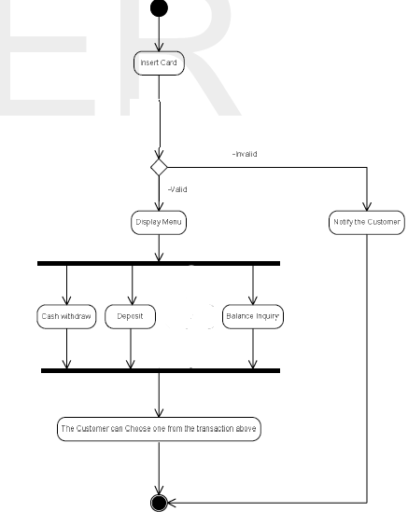

figure 4.1: Activity diagram for simple ATM operation

**5. RESEARCH :**

Did research on various sources

1. Preece, J. Rogers, Y. and Sharp,H., 2007. Interaction

Design: Beyond Human Computer Interaction. 2nd ed.

1. Preece, J. Rogers, Y. and Sharp,H., 2001. Interaction

Design: Beyond HumanComputer Interaction.NewYork:

John Wiley & Sons, Inc.

1. Eric Freeman, Elisabeth Freeman, Kathy Sierra, BertBate,2004, Head First design patterns, O'Reilly, Canada.

**6. TEST CASES :**

**TEST CASE 1:**

**Enter initial amount**

**5000**

**Enter**

**c for credit**

**d for debit**

**b for balance**

**c**

**Enter Credit amount**

**2000**

**New Amount = 7000**

**TEST CASE 2:**

**Enter initial amount**

**5000**

**Enter**

**c for credit**

**d for debit**

**b for balance**

**d**

**Enter Debit amount**

**2000**

**New Amount = 5000**

**TEST CASE 3:**

**Enter initial amount**

**6000**

**Enter**

**c for credit**

**d for debit**

**b for balance**

**d**

**Enter Credit amount**

**8000**

**Insufficient amount in your account.**

**TEST CASE 4:**

**Enter initial amount**

**4500**

**Enter**

**c for credit**

**d for debit**

**b for balance**

**b**

**Amount in your account = 4500.**

**7. CONCLUSION:**

ATMs come in a variety of forms and sizes all to serve the goal; bring the bank closer to the user. ATMs have certain characteristics that need to be fulfilled at all times one of them is security. ATMs now are so advanced they can communicate with each other even if different Banks. When one looks at the different ATM they all share several operations such that withdrawal and View Balance. The requirements of ATM machines came to clarity especially when the use case took place; and the requirements were analyzed and based on the analysis the design took place; and basing on it the implementation done based on object oriented concepts.