**MINI PROJECT**

**ON**

**STATIONARY SHOP MANAGEMENT SYSTEM**

**USING C PROGRAMMING**

**TABLE OF CONTENTS**

|  |  |  |
| --- | --- | --- |
| **CHAPTER No.** | **Content** | **Page No** |
| 1 | Introduction  1.1 Problem Statement  1.2 Problem Description | 3-4 |
| 2 | Requirement Analysis  2.1 Scope of the project  2.2 Objectives  2.3 Software  2.4 Project outcomes | 4-5 |
| 3 | Features | 5 |
| 4 | Project Overview | 6 |
| 5 | Test Plan | 7-9 |
| 6 | Test Cases | 9-10 |

**STATIONARY SHOP MANAGEMENT SYSTEM**

**1. INTRODUCTION**

Stationary Shop Management System is based on the concept of managing stationary items that are present in the store.The user can freely use the system and its features since there is no login system available for this system. This mini project contains limited features, but the essential one.

Pen, pencil, notebooks, books are involved in the differential part of life. Not particularly part of the student’s life but it is part of every person’s life as it is helpful everywhere like in offices, parking, malls, even in temples and where not. So this much important thing of life must be very easily accessible and easily provided to the customer. Here if we talk about getting it online we have a mini project which can maintain the whole objects of stationary in a simple classified manner and make it easy to take out the products fast. Here every user gets the list of stationary things that consist in the store. Then they inquire with the shop for the material with the set of filters like new customer and old customer to avail offer.

**1.1 PROBLEM STATEMENT**

Stationary Shop Management System implementation based on the concept of managing stationary items that present in the store using c programming language.

**1.2 PROBLEM DESCRIPTION**

The user can purchase all the available items in the Stationary shop. By default our program has static information about store information that consists of all the store details like number of books present,number of different stationary goods and their quantity etc., At first the user has to select whether he/she has to buy books or other stationary items. After that, he/she should enter the quantity of selected items then the system displays the total amount.

The system does not create an external file to store the user’s data permanently. The Stationary Shop Management system is developed using C Programming Language and different variables, strings have been used for the development of it.

**2. REQUIREMENT ANALYSIS**

**2.1 SCOPE OF THE PROJECT**

This system provides assurance of proper accuracy and efficiency there by calculating a discount after entering all the wanted list of the user or customer .

So in this mini project mainly the scope of the project is that taking the order from the customer , update the stored information about the stationary products after the order and display the total amount after providing discount for the old customer and for the new customer

**2.2 OBJECTIVES**

The system does not create an external file to store the user’s data permanently.The Stationary Shop Management system is developed using C Programming Language and different variables, strings have been used for the development of it.

This program will enable the shopkeeper to manage the shop by revealing the present status of the shop.

This program will provide the basic idea about:

1.The stationary items present in the shop.

2.The price of the products .

3.The number of items present.

4.Their MRP and discount offer.

5.About various books information that is present in the store.

**2.3 SOFTWARE**

Code::Blocks IDE Version 20.03.

Operating system : Windows operating system.

**2.4 PROJECT OUTCOMES**

1. The data that represents stationary items present in the shop.
2. The price details of different stationary products .
3. The number of items present and purchased .
4. Their MRP and discount offer .
5. About various books and information that are present in the store.

**3. FEATURES**

Talking about the features of the Stationary shop management system, the user can purchase all the available items. At first the user has to select whether he/she has to buy books or other stationary items. After that, he/she should enter the quantity of selected items then the system displays the total amount.

**Features of program :**

1. The program is written for searching in string , so that when the customer will enter the name of the book required,that particular book can be searched in the string present.
2. The program also tells the shopkeeper about the objects which are insufficient in number.
3. And also as the items will be purchased its quantity will be subtracted from the present stock.
4. The program also hasadded membership in this program to know the regular and new customers..eg whether the customer is a regular customer or new.

**4. PROJECT OVERViEW**

MODULES OF STATIONARY SHOP MANAGEMENT SYSTEM :

**MODULE 1 :** Books and Stationary Items to be purchased.

In this module the customer will enter the items to be purchased. The user must specify whether the items to be purchased are books or other stationary items.

The user must also specify the quantity of items he/she wants to purchase.

**MODULE 2 :** Availability of the products.

In this module the program will read the requirements of the customer. The program will check in the stock available whether the required item is present or not.

If present then that item will be provided to the user and the number of items in the stock will be reduced.

**MODULE 3 :** List of items purchased by the customer

Here the total number of items purchased by the user is displayed.The quantity of items purchased is also displayed in this module.

**MODULE 4 :** Bill calculation Notification for shopkeeper

The system is made for calculating the total bill for the purchase made by the customer.And check if the customer is eligible for a discount or not . If the customer is new, no discount else avails upto 25 % of discount.

**MODULE 5 :** Admin features for the shopkeeper

In this module shopkeeper has admin features with verification process by asking for a password . By entering the password only Admin persons can view the availability of products and add the items to the store .

**5. TEST PLAN**

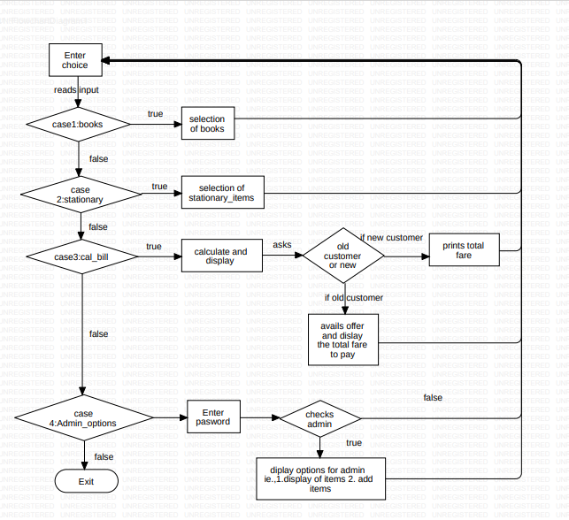

The purpose of testing is to discover errors. Testing is the process of trying to discover every conceivable fault or weakness in a work product. It provides a way to check the functionality of components, sub-assemblies, assemblies and/or a finished product.Software system meets its requirements and user expectations and does not fail in an unacceptable manner.

**TESTING LEVELS**

UNIT TESTING : Unit testing involves the design of test cases that validate that the internal program logic is functioning properly, and that program inputs produce valid outputs. All decision branches and internal code flow should be validated. It is the testing of individual software units of the application .It is done after the completion of an individual unit before integration. This is a structural testing that relies on knowledge of its construction and is invasive. 56 Unit tests perform basic tests at component level and test a specific business process, application, and/or system configuration. Unit tests ensure that each unique path of a business process performs accurately to the documented specifications and contains clearly defined inputs and expected

INTEGRATION TESTING : Integration tests are designed to test integrated software components to determine if they actually run as one program. Testing is event driven and is more concerned with the basic outcome of screens or fields. Integration tests demonstrate that although the components were individually satisfied, as shown by successfully unit testing, the combination of components is correct and consistent. Integration testing is specifically aimed at exposing the problems that arise from the combination of components.

FUNCTIONAL TESTING : Functional tests provide systematic demonstrations that functions tested are available as specified by the business and technical requirements, system documentation, and user manuals.

Functional testing is centered on the following items:

**Valid Input :** identified classes of valid input must be accepted.

**Invalid Input :** identified classes of invalid input must be rejected

**Functions :** identified functions must be exercised.

**Output :** identified classes of application outputs must be exercised.

**Systems / Procedures :** interfacing systems or procedures must be invoked.

SYSTEM TESTING : System testing ensures that the entire integrated software system meets requirements. It tests a configuration to ensure known and predictable results. An example of system testing is the configuration-oriented system integration test. System testing is based on process descriptions and flows, emphasizing pre-driven process links and integration points.

**6. TEST CASES**

|  |  |  |  |
| --- | --- | --- | --- |
| **Sl. No** | **Test Scenario** | **Step** | **Expected Result** |
| 1 | Verify which option is selected from menu | Go to the selected option in menu | If 1 selected display names of books, if 0 is selected display stationary items |
| 2 | If 1 is selected from menu get which number is chosen | Select selected book for purchase | Selected book is displayed asking for required quantity |
| 3. | If 0 is selected from main get which number is chosen next | Select selected item for purchase | Display to ask required quantity of item |
| 4. | Quantity of required item is taken | If quantity is enough the amount is calculated if not calculated | Display the list of item purchased as insufficient quantity of items and if required quantity is more than availability |
| 5. | Checks if the customer is old customer or new customer | For old customer 25% discount is given in total amount | The final amount to be paid after calculation of discount and asks the shopkeeper to enter the code |