3D printer (145) 三维打印机

|  |  |
| --- | --- |
| ] | [dimension](http://www.baidu.com/link?url=LXoAECgzhY9zHYWB59eAKdCaxs6trFz1N6hVRVROEaqz-7uulgv0DGrscJbZ-AGe4kxz4B2OpTd1JgEJdTWBJu8m5tCpSyUNyyEAYwYdkBy" \t "_blank) |

3D scanner (137) 三维扫描仪

active display area (141) 主动显示区域

additive manufacturing (145) **增材制造；添加式制造；添加型制造**

aspect ratio (141) **纵横比, 【摄】长宽比**

bar code (138) 条形码

bar code reader (138) 条形码阅读器

bar code scanner (138) 条形码扫描器

Bluetooth (146) 蓝牙

card reader (138) 读卡器

carpal tunnel syndrome **腕管综合征（手腕长期受力压迫神经引起手和手指疼痛）**

chip card (138) 芯片卡

clarity (141) 清晰度

cloud printer (145) 云打印机

combination key (135) 组合键

connectivity (144) 连通性

contrast ratio (141) 对比率

cordless mouse (136) 无绳鼠标

digital camera (139) 数码相机

digital projector (143) 数字式投影仪

digital whiteboard (143) 数字白板

display screen (141) 显示屏

document scanner (137) 文档扫描仪

dot pitch (141) 点距

dots per inch (dpi) (144) 点每英寸

drones (147) 无人机

duplex printing (144) **双面打印**

e-book reader (142) 电子书阅读器

e-books (142)

e-ink (142) 电子墨水

electronic book (142) 电子书

e-reader (142)

ergonomics (150) 人体工程学

flatbed scanner (137) 平板扫描仪

flat-panel monitor (142) 平板监视器

flexible screens (143) 柔性屏幕

game controller (136) 游戏控制器

gamepads (136) **游戏手柄**

gaming mice (136) 游戏鼠标

Google Cloud Print (145) 谷歌云打印

grayscale (144) 灰度级

handwriting recognition software (136) 手写识别软件

headphone (146) **头戴式耳机**

headset (146) 耳机

immersive experience (146) 沉浸式体验

inkjet printer (145) 喷墨打印机

input (134) 输入

input device (134) 输入设备

interactive whiteboard (143) 交互式白板

joystick (136) 游戏杆

keyboard (134) 键盘

laptop keyboard (135) 笔记本电脑键盘

laser printer (145) 激光打印机

light-emitting diode (LED) (142) 发光二极管

liquid crystal display (LCD) (142) 液晶显示器

magnetic card reader (138) 磁卡阅读器

magnetic-ink character recognition (MICR) (139) 磁性墨水字符识别

MaxiCode (138) 牛眼码 或最大码

*Maxicode is* ***an international 2D (two-dimensional) barcode that is currently used by UPSon shipping labels for world-wide addressing and package sortation***

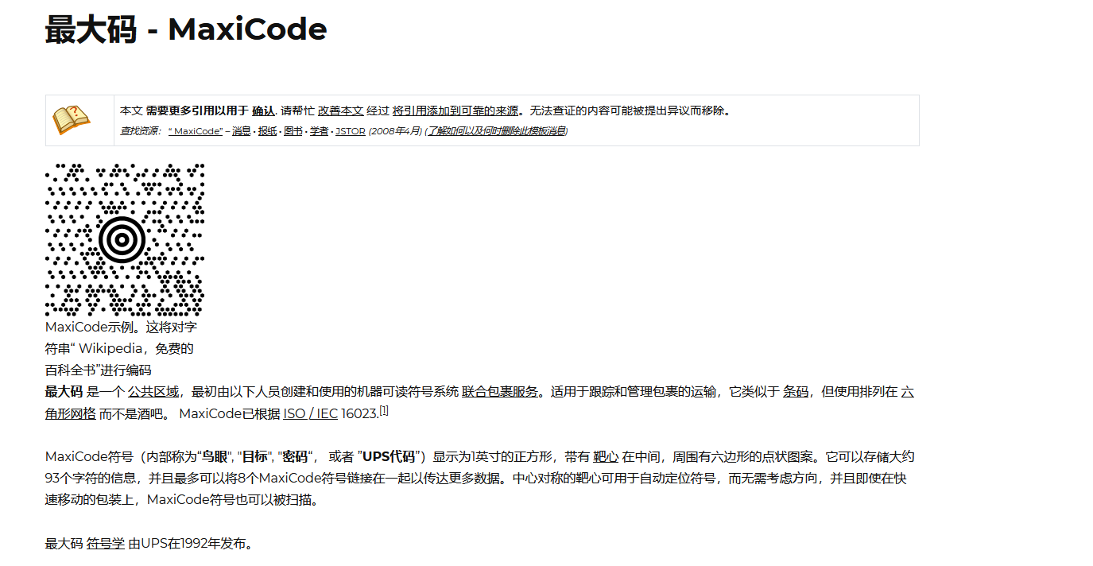

https://wikichi.icu/wiki/MaxiCode

monitor (141) 监视器

motion-sensing device (136) 动作感知设备

mouse (136) 鼠标

mouse pointer (136) 鼠标光标

multifunctional device (MFD) (147) 多功能设备

multitouch screen (136) 多点触摸屏幕

optical scanner (137) 光学扫描器

optical-character recognition (OCR) (139) 光学字符识别

optical-mark recognition (OMR) (139) 光学标记识别

organic light-emitting diode (OLED) (142)

output (141) 输出

output device (141) 输出设备

personal laser printer (145) 个人激光打印机

picture element (141)

pixel (141) 像素

pixel pitch (141) 点间距

platform scanner (138) 平台扫描器

plotter (146) 绘图仪

pointing device (136) 点击设备

portable scanner (137) 便携式扫描器

printer (144) 打印机

repetitive strain injury (RSI) (151) 重复施紧伤害

resolution (monitor) (141) 分辨率

resolution (printer) (144)

RFID reader (139) 无线射频识别读卡器

RFID (radio-frequency identification) tag (138)

robots (150) 机器人

scanner (137) 扫描器

scanning device (137) 扫描设备

shared laser printer (145) 分享式激光打印机

speaker (146) 扬声器

stylus (136) 输入笔

technical writer (152) 技术作家

thermal printer (146) 热敏打印机

toggle key (135) 切换键

touch pad (136) 触摸板

touch screen (136) 触摸屏

traditional keyboard (135) 传统键盘

Universal Product Code (UPC) (138) 统一产品代码

unmanned aerial vehicle (UAV) (147) 无人驾驶飞行器

英[ˈeəriəl]

virtual keyboard (135) 虚拟键盘

virtual reality (VR) (147) 虚拟现实

voice recognition system (140) 语音识别系统

VR controllers (147) 虚拟现实控制器

VR head-mounted display (147) 虚拟现实头戴式显示器

wand reader (138) 条码读入器

webcam (140) 网络摄像头

Web camera

wheel button (136) 滚轮按键

wireless mouse (136)无线鼠标