**附录A 部分芯片引脚图**

1，74LS00 （Y=AB）

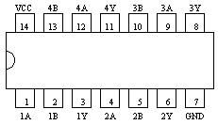

2，74LS02 （Y=A+B）

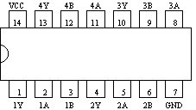

3，74LS04**（同CD4069）**（ Y= A ）

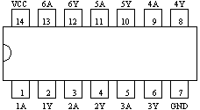

4，74LS08 **（同CD4081）** （Y=AB）



5，74LS10 （Y=ABC）

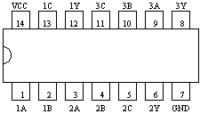

6，74LS20 （Y=ABCD）

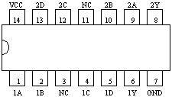

7，74LS21 （Y=ABCD）



8，74LS32 （Y=A+B）



9，74LS73 （双J-K触发器）

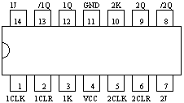

|  |  |  |  |  |  |
| --- | --- | --- | --- | --- | --- |
| CLR | CLK | J | K | Q | /Q |
| 0 | X | X | X | 0 | 1 |
| 1 | ↓ | 0 | 0 | Qo | /Qo |
| 1 | ↓ | 1 | 0 | 1 | 0 |
| 1 | ↓ | 0 | 1 | 0 | 1 |
| 1 | ↓ | 1 | 1 | Toggle | |
| 1 | 1 | X | X | Qo | /Qo |

10，74LS74 （双D触发器）

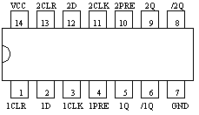

|  |  |  |  |  |  |
| --- | --- | --- | --- | --- | --- |
| PRE | CLR | CLK | D | Q | /Q |
| 0 | 1 | X | X | 1 | 0 |
| 1 | 0 | X | X | 0 | 1 |
| 0 | 0 | X | X | 1* | 1* |
| 1 | 1 | ↑ | 1 | 1 | 0 |
| 1 | 1 | ↑ | 0 | 0 | 1 |
| 1 | 1 | 0 | X | Qo | /Qo |

11，74LS75 （四位D锁存器）

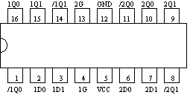

|  |  |  |  |
| --- | --- | --- | --- |
| D | G | Q | /Q |
| 0 | 1 | 0 | 1 |
| 1 | 1 | 1 | 0 |
| X | 0 | Qo | /Qo |

12，74LS54 （Y=AB+CD+EF+GH）

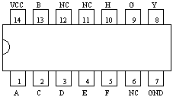

|  |  |  |  |  |  |  |  |  |
| --- | --- | --- | --- | --- | --- | --- | --- | --- |
| A | B | C | D | E | F | G | G | Y |
| 1 | 1 | X | X | X | X | X | X | 0 |
| X | X | 1 | 1 | X | X | X | X | 0 |
| X | X | X | X | 1 | 1 | X | X | 0 |
| X | X | X | X | X | X | 1 | 1 | 0 |
| All other combinations | | | | | | | | 1 |

13，74LS86 （Y=A⊕B）



14，74LS90 （二-五-十进制计数器）

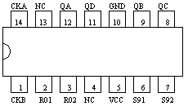

|  |  |  |  |  |  |  |  |
| --- | --- | --- | --- | --- | --- | --- | --- |
| 输入 | | | | 输出 | | | |
| R0（1） | R0（2） | S9（1） | S9（2） | QA | QB | QC | QD |
| 1 | 1 | 0 | X | 0 | 0 | 0 | 0 |
| 1 | 1 | X | 0 | 0 | 0 | 0 | 0 |
| X | X | 1 | 1 | 1 | 0 | 0 | 1 |
| X | 0 | X | 0 | 计数 | | | |
| 0 | X | 0 | X | 计数 | | | |
| 0 | X | X | 0 | 计数 | | | |
| X | 0 | 0 | 0 | 计数 | | | |

15，74LS112 （双J-K触发器）

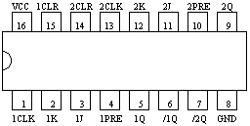

|  |  |  |  |  |  |
| --- | --- | --- | --- | --- | --- |
| PRE（S） | CLR (R) | CLK | J | K | Q |
| 0 | 1 | X | X | X | 1 |
| 1 | 0 | X | X | X | 0 |
| 0 | 0 | X | X | X | * |
| 1 | 1 | ↓ | 0 | 0 | 不变 |
| 1 | 1 | ↓ | 0 | 1 | 0 |
| 1 | 1 | ↓ | 1 | 0 | 1 |
| 1 | 1 | ↓ | 1 | 1 | 翻转 |
| 1 | 1 | ↑ | X | X | 不变 |

16，74LS138 （三-八线译码器）

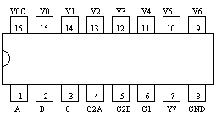

|  |  |  |  |  |  |  |  |  |  |  |  |  |
| --- | --- | --- | --- | --- | --- | --- | --- | --- | --- | --- | --- | --- |
| G1 | G* | C | B | A | Y0 | Y1 | Y2 | Y3 | Y4 | Y5 | Y6 | Y7 |
| X | 1 | X | X | X | 1 | 1 | 1 | 1 | 1 | 1 | 1 | 1 |
| 0 | X | X | X | X | 1 | 1 | 1 | 1 | 1 | 1 | 1 | 1 |
| 1 | 0 | 0 | 0 | 0 | 0 | 1 | 1 | 1 | 1 | 1 | 1 | 1 |
| 1 | 0 | 0 | 0 | 1 | 1 | 0 | 1 | 1 | 1 | 1 | 1 | 1 |
| 1 | 0 | 0 | 1 | 0 | 1 | 1 | 0 | 1 | 1 | 1 | 1 | 1 |
| 1 | 0 | 0 | 1 | 1 | 1 | 1 | 1 | 0 | 1 | 1 | 1 | 1 |
| 1 | 0 | 1 | 0 | 0 | 1 | 1 | 1 | 1 | 0 | 1 | 1 | 1 |
| 1 | 0 | 1 | 0 | 1 | 1 | 1 | 1 | 1 | 1 | 0 | 1 | 1 |
| 1 | 0 | 1 | 1 | 0 | 1 | 1 | 1 | 1 | 1 | 1 | 0 | 1 |
| 1 | 0 | 1 | 1 | 1 | 1 | 1 | 1 | 1 | 1 | 1 | 1 | 0 |

G*=G2A+G2B；

17，74LS139 （二-四线译码器）

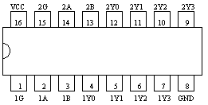

|  |  |  |  |  |  |  |
| --- | --- | --- | --- | --- | --- | --- |
| G | B | A | Y0 | Y1 | Y2 | Y3 |
| 1 | X | X | 1 | 1 | 1 | 1 |
| 0 | 0 | 0 | 0 | 1 | 1 | 1 |
| 0 | 0 | 1 | 1 | 0 | 1 | 1 |
| 0 | 1 | 0 | 1 | 1 | 0 | 1 |
| 0 | 1 | 1 | 1 | 1 | 1 | 0 |

18，74LS153 （双四选一数据选择器）

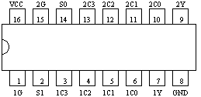

|  |  |  |  |
| --- | --- | --- | --- |
| S1 | S0 | G | Y |
| X | X | 1 | 1 |
| 0 | 0 | 0 | C0 |
| 0 | 1 | 0 | C1 |
| 1 | 0 | 0 | C2 |
| 1 | 1 | 0 | C3 |

19，74LS175 （四D触发器）

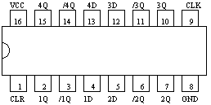

|  |  |  |  |  |
| --- | --- | --- | --- | --- |
| CLR | CLK | D | Q | /Q |
| 0 | X | X | 0 | 1 |
| 1 | ↑ | 1 | 1 | 0 |
| 1 | ↑ | 0 | 0 | 1 |
| 1 | 0 | X | Qo | /Qo |

20,74LS290（二-五-十进制计数器）

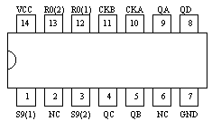

|  |  |  |  |  |  |  |  |
| --- | --- | --- | --- | --- | --- | --- | --- |
| 输入 | | | | 输出 | | | |
| R0（1） | R0（2） | S9（1） | S9（2） | QA | QB | QC | QD |
| 1 | 1 | 0 | X | 0 | 0 | 0 | 0 |
| 1 | 1 | X | 0 | 0 | 0 | 0 | 0 |
| X | X | 1 | 1 | 1 | 0 | 0 | 1 |
| X | 0 | X | 0 | 计数 | | | |
| 0 | X | 0 | X | 计数 | | | |
| 0 | X | X | 0 | 计数 | | | |
| X | 0 | 0 | 0 | 计数 | | | |

21，556时钟芯片

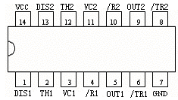

22，CD4043 （三态输出四R-S触发器）

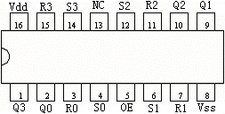

|  |  |  |  |
| --- | --- | --- | --- |
| OE | S | R | Q |
| 0 | X | X | Z |
| 1 | 0 | 0 | 保持不变 |
| 1 | 1 | 0 | 1 |
| 1 | 0 | 1 | 0 |
| 1 | 1 | 1 | 无效 |

23，74LS183 全加器

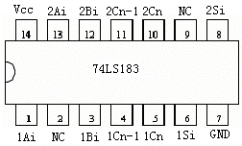

24，74LS161 集成计数器（4位二进制加法）

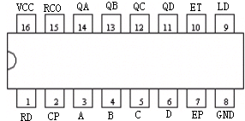

25，74LS194 4位双向移位寄存器

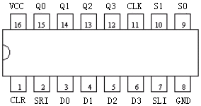

26，CD4511 –BCD码—七段译码器/驱动器

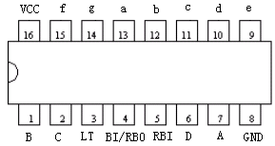

27，10位D/A转换器AD7520

