**《语义网与知识图谱》实验手册**

**实验一 RDF（RDFS）应用**

目的：

1. 回顾了解XML语法；
2. 理解语义网资源描述语言；
3. 掌握RDF(S)的使用。

**1、回顾和学习XML**

https://www.w3school.com.cn/xml/index.asp

**2、练习**

**【习题1】** Consider the following RDF document:

<rdf:RDF

xmlns:rdf="http://www.w3.org/1999/02/22-rdf-syntax-ns#"

xmlns:rdfs="http://www.w3.org/2000/01/rdf-schema#"

xmlns:iswww="http://sw.edu/#"

>

<rdf:Description rdf:about="http://sw.edu/#germany">

<rdf:type rdf:resource="http://sw.edu/#country" />

</rdf:Description>

<rdf:Description rdf:about="http://sw.edu/#capital_of">

<rdf:type rdf:resource="http://www.w3.org/1999/02/22-rdf-syntax-ns#Property"/>

<rdfs:domain rdf:resource="http://sw.edu/#city" />

<rdfs:range rdf:resource="http://sw.edu/#country" />

</rdf:Description>

<rdf:Description rdf:about="http://sw.edu/#country">

<rdf:type rdf:resource="http://www.w3.org/2000/01/rdf-schema#Class" />

<rdfs:label xml:lang="de">Land</rdfs:label>

</rdf:Description>

<rdf:Description rdf:about="http://sw.edu/#berlin">

<rdfs:label xml:lang="en">Berlin</rdfs:label>

<rdf:type rdf:resource="http://sw.edu/#city" />

<iswww:capital_of rdf:resource="http://sw.edu/#germany" />

</rdf:Description>

<rdf:Description rdf:about="http://sw.edu/#city">

<rdf:type rdf:resource="http://www.w3.org/2000/01/rdf-schema#Class" />

<rdfs:label xml:lang="de">Stadt</rdfs:label>

</rdf:Description>

</rdf:RDF>

• Describe in natural language the content of this document.

• Draw the graph representation of the above document.

【习题2】Write down the modeled list authors of this book from following RDF graph in Turtle syntax.

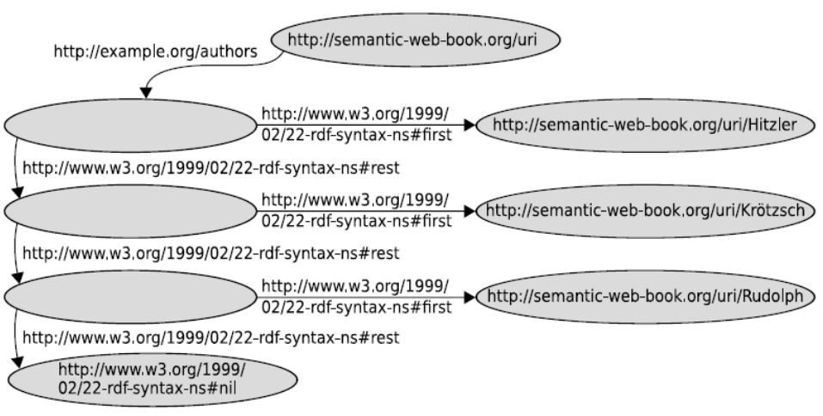

【习题3】 Write the following Turtle triple in RDF/XML syntax:

:Person rdfs:comment "Represents the set of all people."^^xsd:string .

【习题4】 Represent the following sentences graphically by means of reified triples:

* Romeo thought that Juliet was dead.
* John believes that Mary wants to marry him.
* The dwarf noticed that somebody had been eating from his plate.