**《语义网与知识图谱》实验手册**

**实验二 RDF（RDFS）应用二**

目的：

1. 理解语义网资源描述语言；
2. 掌握RDF(S)的使用。

内容：

**【习题1】** Translate the culinary-allergic example ontology presented in follow into RDF/XML syntax.

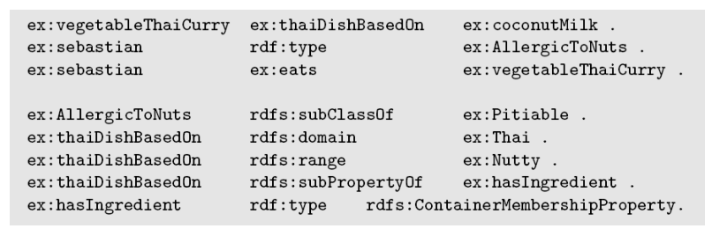

**【习题2】** Decide whether the following propositions can be satisfactorily modeled in RDFS and, if so, give the corresponding RDF(S) specification.

* Every pizza is a meal.
* Pizzas always have at least two toppings.
* Every pizza from the class PizzaMargarita has a Tomato topping.
* Everything having a topping is a pizza.
* No pizza from the class PizzaMargarita has a topping from the class Meat.
* “Having a topping” is a containedness relation.

【**习题3**】 Model the following sentences in XML:

1. Mary is a woman.

2. Every mother is a woman.

3. Mary is John’s wife.

4. Mothers are women who are also parents.

5. At least one child of a grandparent has also a child.

【**习题4**】Model the sentences from Exercise 3 in RDF graph.