Acoustic-Based Failure Analysis of Power Transformers Using Multi-Modal Feature Fusion and Physics-Informed Representation Learning
Abstract
Accurate fault diagnosis of power transformers is critical for power system reliability. While acoustic-based diagnosis offers non-contact measurement and low sensor cost, existing methods struggle with single-modality representations, background noise, and limited labeled data. This paper proposes a multi-modal framework integrating Mel spectrograms with Gramian Angular Difference Fields (GADF) into three-channel fused representations, enhanced by a Pulse-Coupled Neural Network (PCNN) for noise suppression. A physics-informed Laplacian regularization, derived from the acoustic Helmholtz equation, constrains learned features toward physically smooth solutions. Evaluated on a real-world transformer dataset of five conditions with session-aware data partitioning, the method is validated through component-wise ablation and comparative studies against representative baselines. The proposed framework achieves state-of-the-art accuracy and maintains robust performance under low signal-to-noise ratio conditions, outperforming seven representative methods including Vision Transformer, EfficientNet, Swin Transformer, and end-to-end 1D-CNN.
Transformer fault diagnosis, Mel spectrogram, Gramian Angular Difference Field, Pulse-Coupled Neural Network, Physics-informed representation learning, Acoustic signal processing

Introduction
Power transformers are critical assets in modern electrical power systems, and the continuous monitoring of their operational condition is essential for maintaining grid safety, reliability, and stability [1, 2]. Among various diagnostic modalities, acoustic-based (voiceprint) methods have attracted considerable research attention owing to their non-contact measurement capability, ease of deployment, and low transducer cost. However, effective fault diagnosis from acoustic signals requires addressing three fundamental challenges: (i) single-modality time–frequency representations capture only partial fault signatures, limiting discriminative power; (ii) real-world substation environments introduce substantial background noise that degrades classification reliability; and (iii) the scarcity of labeled fault data in practical settings constrains the generalization capability of purely data-driven models.
To extract informative representations from acoustic signals, a variety of time–frequency analysis techniques have been explored. The Mel spectrogram, which emulates the non-linear frequency perception of the human auditory system, has been widely adopted for voiceprint-based transformer monitoring [3, 4]. Wavelet transform-based denoising has been employed to enhance partial discharge signal recognition [5], while Short-Time Fourier Transform (STFT) analysis has been applied to characterize transformer winding impulse responses [6]. More recently, Gramian Angular Field (GAF) encoding has been introduced to transform one-dimensional vibration signals into two-dimensional image representations that preserve temporal correlation structure [7]. Despite these advances, methods relying on a single feature representation inherently struggle to capture the multi-faceted nature of fault signatures, as different fault mechanisms manifest in distinct spectral, temporal, and energy-domain characteristics.
Concurrently, deep learning architectures have been extensively investigated for transformer fault classification. Convolutional neural networks (CNNs) operating on spectrogram images [8], as well as probabilistic and shallow learning models [9, 10], have demonstrated promising results. More recently, advanced architectures such as Vision Transformers (ViT) [11], EfficientNet [12], and Swin Transformer [13] have set new performance benchmarks in image classification, yet their application to acoustic transformer diagnosis remains underexplored. A critical limitation of conventional deep learning pipelines is their purely data-driven nature: without physical guidance, these models are prone to overfitting on small datasets and exhibit degraded performance under distribution shifts caused by varying noise conditions.
Physics-Informed Neural Networks (PINNs) offer a principled framework for integrating domain knowledge into the learning process [14, 15]. By augmenting the empirical loss with physics-derived regularization terms, PINNs can learn physically consistent representations even when training data are limited or noisy. This paradigm has been successfully applied to dissolved gas analysis [16], wind turbine monitoring [17], and various scientific computing tasks [18]. In the context of acoustic transformer diagnosis, the relevant physics arises from sound wave propagation; i.e., the acoustic pressure field $p\left(x,t\right)$ within the transformer tank obeys the wave equation, which under time-harmonic excitation reduces to the Helmholtz equation $∇^{2}p+k^{2}p=0$, where $k=ω/c$ is the wavenumber. In source-free regions of the domain, where the acoustic wavelength is large relative to the spatial variation of the pressure field, the Helmholtz equation further simplifies to the Laplace equation $∇^{2}p≈0$. This physical prior, i.e., that fault-free acoustic fields are spatially smooth, motivates a Laplacian regularization constraint that penalizes high-frequency artifacts in the learned feature representations, thereby encouraging the network to focus on physically meaningful, fault-induced deviations from smoothness.
In this paper, we propose a comprehensive framework that addresses the three aforementioned challenges through synergistic integration of multi-modal feature fusion, biologically inspired denoising, and physics-informed representation learning. The principal contributions are:
- Multi-modal fusion and PCNN enhancement: A three-channel representation combining Mel spectrograms, Gramian Angular Difference Fields, and their pixel-wise difference is constructed to capture complementary spectral and temporal fault signatures. Gamma correction ($γ=1.7$) enhances low-energy regions, while a Pulse-Coupled Neural Network suppresses background noise through synchronized neuronal firing dynamics.
- Physics-informed representation learning: A Laplacian smoothness regularization, derived from the acoustic Helmholtz equation under the source-free approximation, is incorporated into the training objective. Unlike conventional PINN formulations requiring PDE solving at collocation points, the proposed approach enforces physical consistency directly in the learned feature space, enabling efficient integration with standard CNN pipelines.
- Rigorous experimental validation: Component-wise ablation, five-fold cross-validation, hyperparameter sensitivity analysis, noise robustness tests across multiple SNR levels, and comparison with seven representative methods (ViT, EfficientNet, Swin Transformer, ConvNeXt, and end-to-end 1D-CNN) collectively demonstrate state-of-the-art performance and confirm the contribution of each proposed component.
The remainder of this paper is organized as follows. Section 2 describes the time–frequency representation methods. Section 3 presents the feature extraction and fusion pipeline. Section 4 formulates the physics-informed learning framework. Section 5 reports the experimental setup and comprehensive results. Section 6 concludes the paper.
The overall framework is illustrated in Fig. 1.
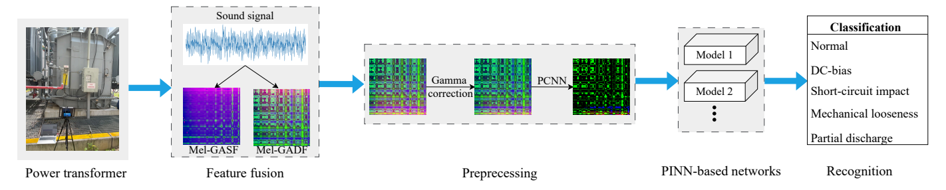
Fig. 1 Overall framework of the proposed transformer fault diagnosis method. The pipeline consists of four stages: (1) multi-modal time–frequency representation via Mel spectrogram and GADF, (2) three-channel feature fusion with gamma correction, (3) PCNN-based feature enhancement, and (4) physics-informed AlexNet-SE classification with Laplacian regularization.

Time-Frequency Domain Representation

Mel Spectrogram
The Mel spectrogram emulates the non-linear frequency perception of the human auditory system, which is more sensitive to low-frequency variations than to high-frequency changes [19, 20]. The transformation from linear frequency $f$ (Hz) to the Mel scale is given by [21, 22], i.e.,
$f_{\text{mel}}=2595\log_{10}\left(1+\frac{f}{700}\right)$ (1)
where $f_{\text{mel}}$ is the perceived frequency on the Mel scale. As the physical frequency increases, the Mel-scale frequency increases sub-linearly, yielding higher spectral resolution in low-frequency bands where transformer acoustic fault signatures are predominantly concentrated [23]. This perceptual scaling motivates the choice of the Mel spectrogram as the primary spectral representation.
For each 1-second segment of the transformer acoustic signal, the short-time Fourier transform (STFT) is computed using a Hamming window of 25 ms with 50% overlap, yielding a linear-frequency spectrogram. This spectrogram is subsequently processed through a Mel filter bank consisting of 128 triangular filters uniformly spaced on the Mel scale. Each filter overlaps with its neighbors such that the lower corner frequency of one filter coincides with the center frequency of the preceding filter [24]. The $m$-th triangular filter $H_{m}\left(k\right)$ is defined as:
$H_{m}\left(k\right)=\left\{\begin{matrix}0, & k<f\left(m−1\right) \\ \frac{k−f\left(m−1\right)}{f\left(m\right)−f\left(m−1\right)}, & f\left(m−1\right)≤k<f\left(m\right) \\ 1, & k=f\left(m\right) \\ \frac{f\left(m+1\right)−k}{f\left(m+1\right)−f\left(m\right)}, & f\left(m\right)<k≤f\left(m+1\right) \\ 0, & k>f\left(m+1\right)\end{matrix}\right)$ (2)
where $H_{m}\left(k\right)$ represents the response of the $m$-th filter at frequency bin $k$, and $f\left(m−1\right)$, $f\left(m\right)$, and $f\left(m+1\right)$ denote the lower corner, center, and upper corner frequencies, respectively. The resulting Mel spectrogram for a transformer under normal operating conditions is illustrated in Fig. 2.
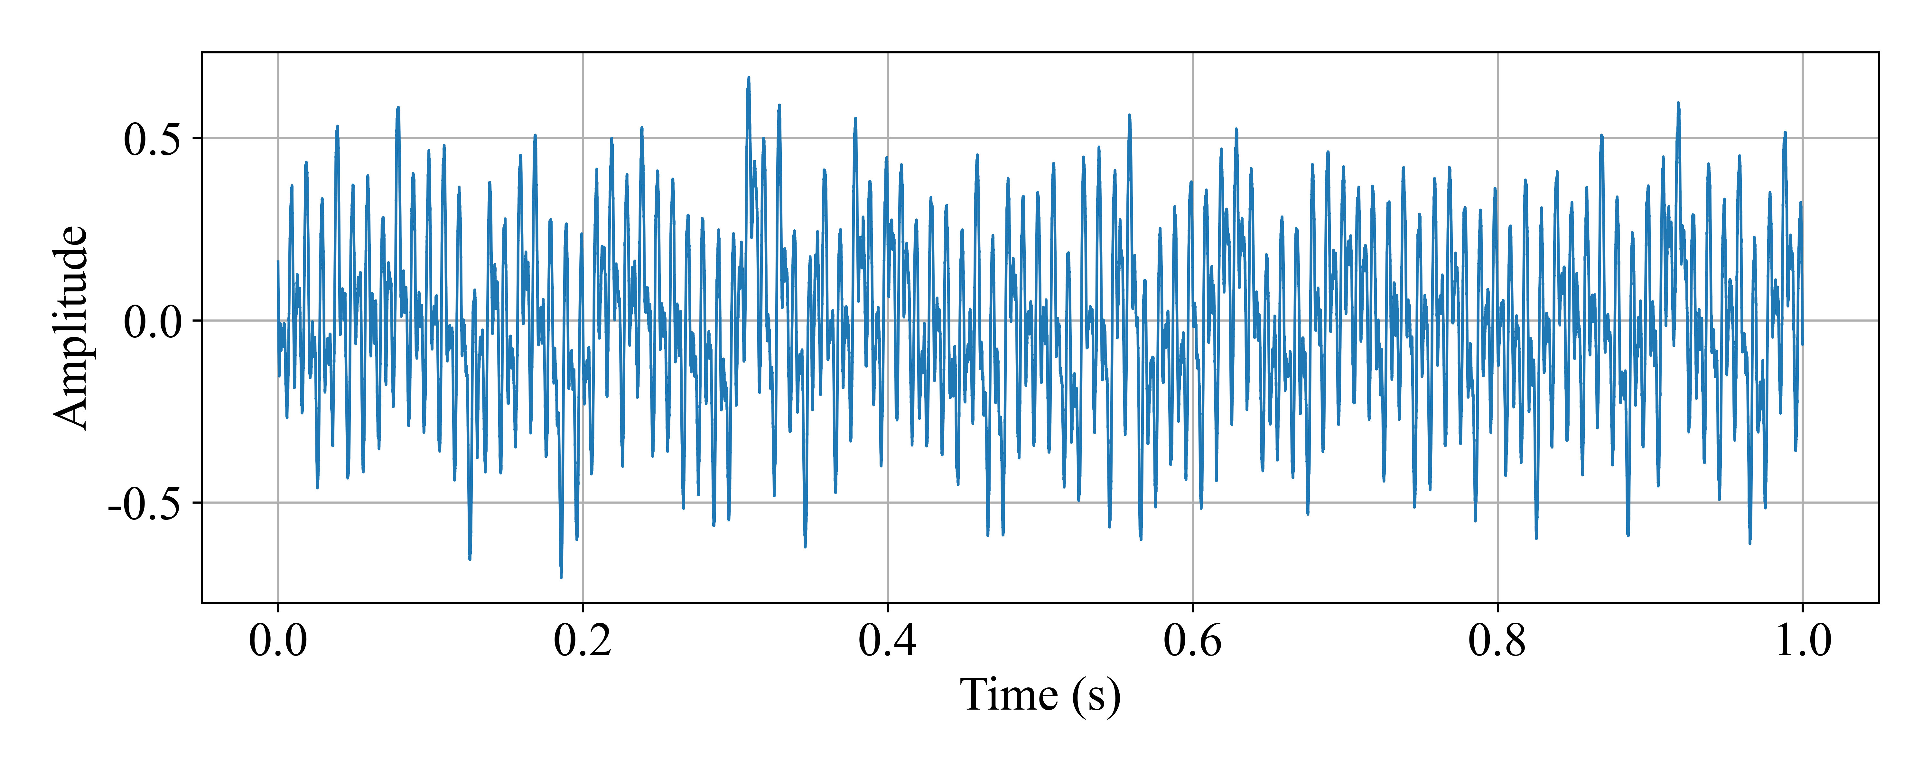  (a) | 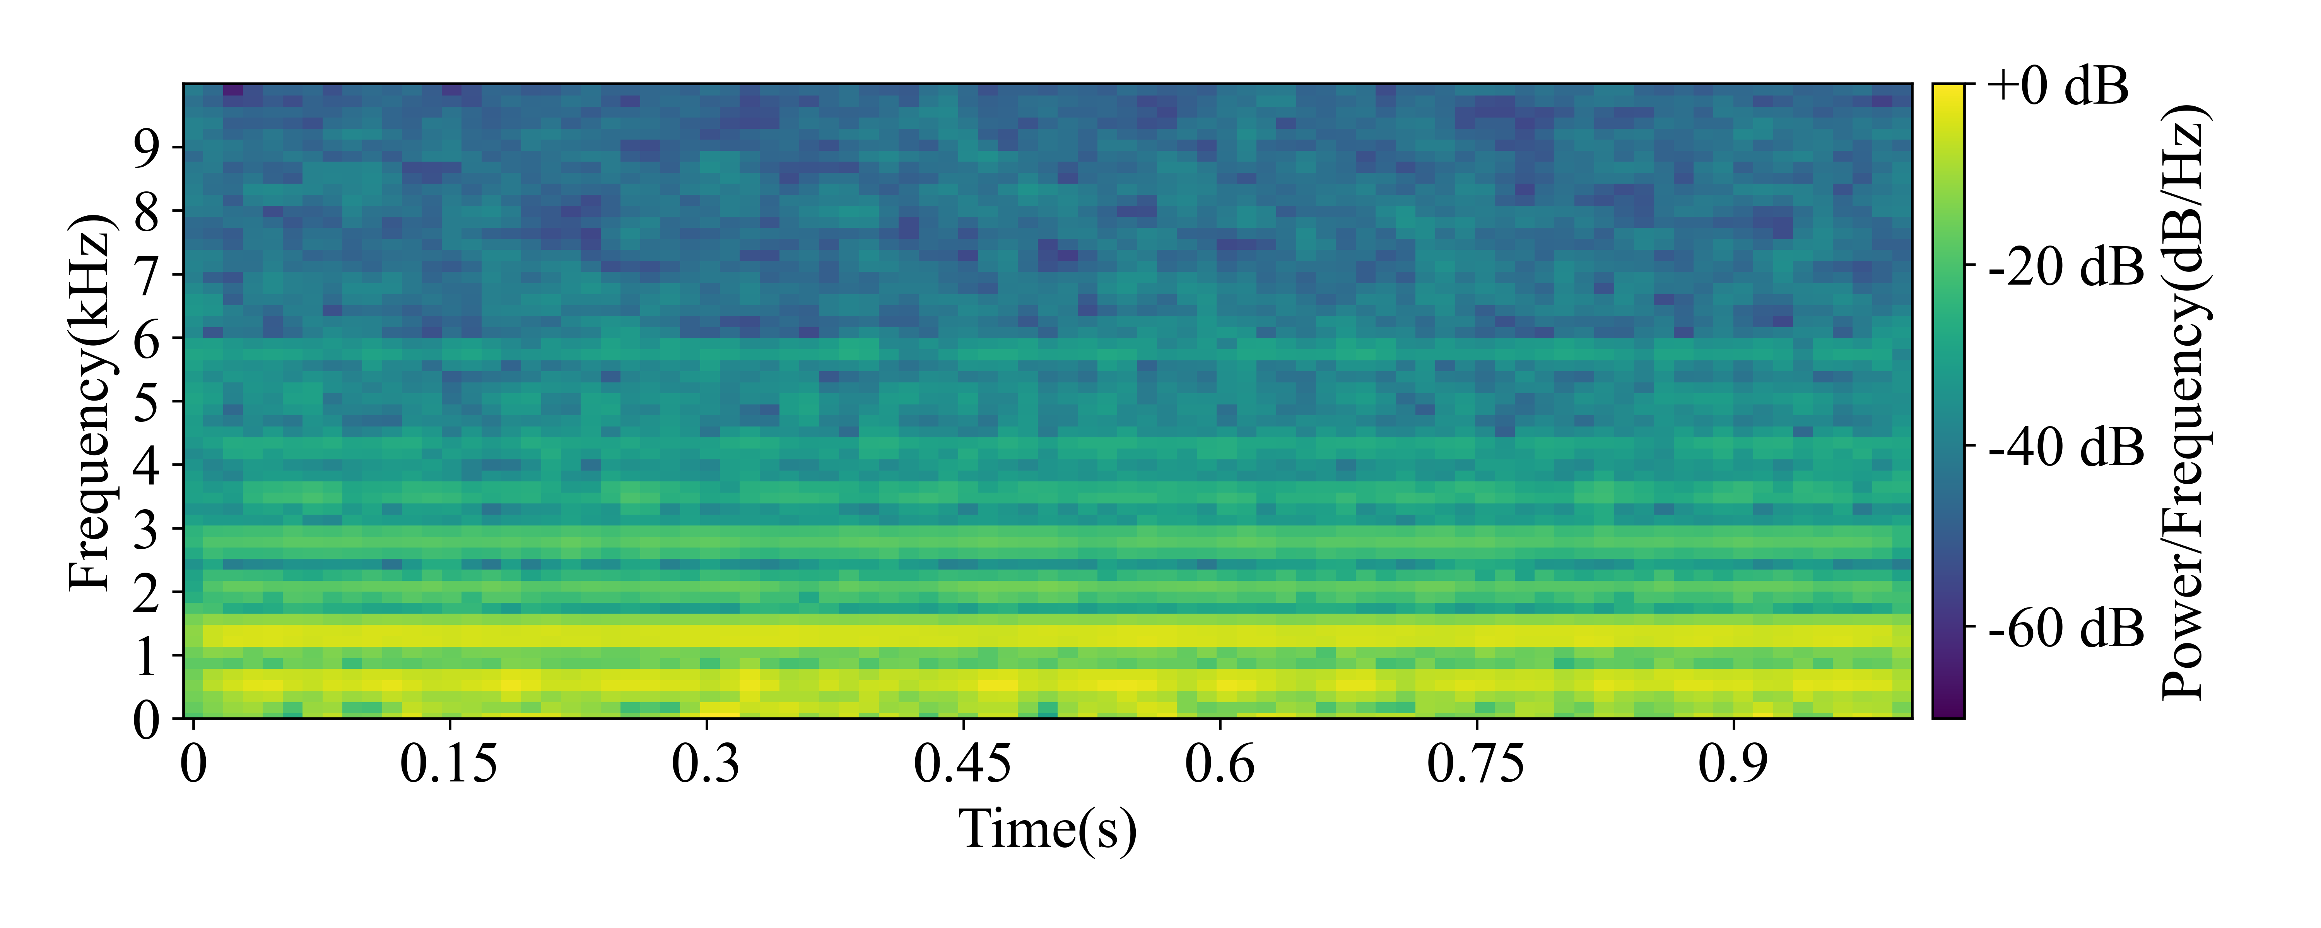  (b)

Fig. 2 Transformer acoustic signal under normal operating conditions. (a) Time-domain waveform. (b) Corresponding Mel spectrogram.

Gramian Angular Field
The Gramian Angular Field (GAF) is a method for encoding one-dimensional time series into two-dimensional image representations that preserve the temporal correlation structure [25]. By representing time-series values in polar coordinates and computing pairwise trigonometric interactions, GAF produces images where each element $\left(i,j\right)$ encodes the temporal relationship between time steps $i$ and $j$. Two variants exist: the Gramian Angular Summation Field (GASF) based on $cos\left(ϕ_{i}+ϕ_{j}\right)$, and the Gramian Angular Difference Field (GADF) based on $sin\left(ϕ_{i}−ϕ_{j}\right)$ [26]. The encoding procedure involves three steps:
- Normalization: Given a univariate time series $X=\{x_{1},x_{2},…,x_{n}\}$ of length $n$, the values are rescaled to the interval $\left[−1,1\right)$ via min-max normalization:
${\tilde{x}}_{i}=\frac{\left(x_{i}−minX\right)+\left(x_{i}−maxX\right)}{maxX−minX},i=1,2,…,n$ (3)
- yielding the normalized series $\tilde{X}=\{{\tilde{x}}_{1},{\tilde{x}}_{2},…,{\tilde{x}}_{n}\}$.
- Polar encoding: Each normalized value ${\tilde{x}}_{i}$ is mapped to a polar coordinate representation $\left(ϕ_{i},r_{i}\right)$ as:
$\left\{\begin{matrix}ϕ_{i}=arccos\left({\tilde{x}}_{i}\right), & −1≤{\tilde{x}}_{i}≤1 \\ r_{i}=\frac{i}{n}, & i=1,…,n\end{matrix}\right)$ (4)
- where $ϕ_{i}∈\left[0,π\right)$ is the angular coordinate encoFding the amplitude, and $r_{i}∈\left[0,1\right)$ is the radial coordinate encoding the temporal position. This bijective mapping ensures that temporal ordering is preserved in the polar representation.
- Gramian matrix construction: The GASF $G_{s}$ and GADF $G_{d}$ are computed as:
$G_{s}=\left[\begin{matrix}cos\left(ϕ_{1}+ϕ_{1}\right) & cos\left(ϕ_{1}+ϕ_{2}\right) & ⋯ & cos\left(ϕ_{1}+ϕ_{n}\right) \\ cos\left(ϕ_{2}+ϕ_{1}\right) & cos\left(ϕ_{2}+ϕ_{2}\right) & ⋯ & cos\left(ϕ_{2}+ϕ_{n}\right) \\ ⋮ & ⋮ & ⋱ & ⋮ \\ cos\left(ϕ_{n}+ϕ_{1}\right) & cos\left(ϕ_{n}+ϕ_{2}\right) & ⋯ & cos\left(ϕ_{n}+ϕ_{n}\right)\end{matrix}\right)$ (5)
$G_{d}=\left[\begin{matrix}sin\left(ϕ_{1}−ϕ_{1}\right) & sin\left(ϕ_{1}−ϕ_{2}\right) & ⋯ & sin\left(ϕ_{1}−ϕ_{n}\right) \\ sin\left(ϕ_{2}−ϕ_{1}\right) & sin\left(ϕ_{2}−ϕ_{2}\right) & ⋯ & sin\left(ϕ_{2}−ϕ_{n}\right) \\ ⋮ & ⋮ & ⋱ & ⋮ \\ sin\left(ϕ_{n}−ϕ_{1}\right) & sin\left(ϕ_{n}−ϕ_{2}\right) & ⋯ & sin\left(ϕ_{n}−ϕ_{n}\right)\end{matrix}\right)$ (6)
The GASF encodes the summation of angular differences, capturing co-directional relationships, while the GADF encodes the difference of angular values, capturing orthogonality relationships and offering greater sensitivity to local phase variations [27]. In this study, both GASF and GADF representations are computed, and their relative efficacy is compared experimentally (see Section 5.2). Fig. 3 shows the GASF and GADF representations of a transformer acoustic signal under normal conditions.

  (a) | 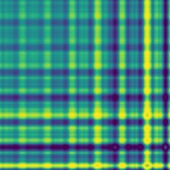  (b)

Fig. 3 GAF representations of a transformer acoustic signal: (a) GASF, (b) GADF. The GADF representation exhibits stronger contrast in the off-diagonal texture patterns, which capture transient fault signatures more distinctly.

Multi-Modal Feature Extraction and Fusion

Mel-GAF Three-Channel Fusion Strategy
Feature fusion is a well-established technique for combining complementary information from heterogeneous representations to improve model performance [28, 29]. In this work, we propose a three-channel fusion strategy that constructs an RGB-like image where each color channel encodes a distinct modality or derived feature, enabling the CNN backbone to learn joint representations across spectral, temporal, and differential domains.
Given a 1-second acoustic segment, the Mel spectrogram $M∈R^{H×W}$ and the GADF representation $G_{d}∈R^{n×n}$ are computed independently. Both representations are first resized to a unified spatial resolution of $224×224$ pixels using bicubic interpolation and normalized to the range $\left[0,1\right)$. The three-channel fused image $I_{\text{fused}}∈R^{3×224×224}$ is then constructed as:
$I_{\text{fused}}=\left[\begin{matrix}I_{R} \\ I_{G} \\ I_{B}\end{matrix}\right)=\left[\begin{matrix}M_{\text{norm}} \\ G_{d,\text{norm}} \\ \left|M_{\text{norm}}−G_{d,\text{norm}}\right)\end{matrix}\right)$ (7)
where the red (R) channel encodes the Mel spectrogram energy distribution, the green (G) channel captures the GADF-derived temporal correlation texture, and the blue (B) channel encodes the pixel-wise absolute difference between the two modalities. The difference channel serves a dual purpose: (i) it highlights regions where the spectral energy and temporal correlation patterns diverge, which are indicative of anomalous fault signatures; and (ii) it provides the network with an explicit representation of cross-modal complementarity, facilitating the learning of synergistic features [30]. This design ensures that each channel carries non-redundant information, enabling the CNN to exploit both modality-specific and cross-modal patterns during training.

Image Preprocessing and Gamma Correction
In the raw fused images, the Mel spectrogram channel (R) tends to exhibit low visual saliency in low-energy frequency regions, where the spectral amplitude is orders of magnitude smaller than in dominant harmonics. This dynamic range imbalance can cause the network to overlook subtle but diagnostically important features in low-energy bands. To address this, gamma correction is applied as a preprocessing step to re-distribute pixel intensities non-linearly.
Gamma correction is defined as [31]:
$I_{\text{out}}=c⋅I_{\text{in}}^{γ}$ (8)
where $I_{\text{in}},I_{\text{out}}∈\left[0,1\right)$ are the normalized input and output pixel intensities, respectively. The parameter $c$ is a linear scaling coefficient and $γ$ is the gamma exponent that controls the degree of non-linear mapping. When $c=1$, the mapping reduces to a pure power-law transformation. For $γ>1$, the transformation expands the dynamic range of dark regions (low $I_{\text{in}}$) while compressing bright regions (high $I_{\text{in}}$), thereby enhancing contrast in low-intensity areas. The parameter $c≠1$ shifts the overall intensity level uniformly and is set to $c=1$ in this work, as the subsequent PCNN processing provides adaptive intensity normalization. However, in scenarios where a global brightness offset is required—for instance, when compensating for systematic sensor gain variations—$c$ can be tuned accordingly.
The selection of $γ=1.7$ was determined through systematic hyperparameter optimization over a grid spanning $γ=0.5$ to $3.0$ (see Section 5.4 for detailed sensitivity analysis). Values of $γ<1.5$ provided insufficient contrast enhancement in low-energy regions, while $γ>2.0$ led to over-saturation and loss of texture detail in high-energy regions. The optimal value $γ=1.7$ achieves the best trade-off, enhancing the visibility of low-energy spectral features without distorting the overall energy distribution.

Bicubic Interpolation
Image resizing is required to ensure dimensional consistency between the Mel spectrogram and GADF representations before fusion. Bicubic interpolation was selected over nearest-neighbor and bilinear methods due to its superior preservation of fine texture and edge structures, which are critical for fault feature discrimination [32]. Given a source image $I$, the interpolated pixel value at target coordinate $\left(x,y\right)$ is computed as a weighted sum over a $4×4$ neighborhood of the source:
$P\left(x,y\right)=\sum_{i=−1}^{2}{\sum_{j=−1}^{2}{w}}\left(i,j\right)⋅I\left(x+i,y+j\right)$ (9)
where the weight function $w\left(i,j\right)$ is constructed from the product of two one-dimensional cubic kernels:
$w\left(i,j\right)=K\left(d_{x}−i\right)⋅K\left(d_{y}−j\right)$ (10)
with $d_{x}=x−⌊x⌋$, $d_{y}=y−⌊y⌋$ being the fractional offsets, and the cubic kernel $K\left(t\right)$ defined as:
$K\left(t\right)=\left\{\begin{matrix}\left(a+2\right){\left|t\right)}^{3}−\left(a+3\right){\left|t\right)}^{2}+1, & \left|t\right)≤1 \\ a{\left|t\right)}^{3}−5a{\left|t\right)}^{2}+8a\left|t\right)−4a, & 1<\left|t\right)≤2 \\ 0, & \text{otherwise}\end{matrix}\right)$ (11)
where the parameter $a$ is typically set to $a=−0.5$, yielding the Catmull–Rom spline which provides the best balance between sharpness and smoothness for spectrogram images.
Fig. 4 compares the fused Mel-GADF image before and after gamma correction. In the uncorrected image (Fig. 4(a)), low-frequency regions appear dark and texturally indistinct due to the large dynamic range of spectral amplitudes. After applying gamma correction with $γ=1.7$ (Fig. 4(b)), the contrast in these regions is significantly enhanced, revealing detailed structural patterns that facilitate the network’s ability to learn subtle fault-related features.
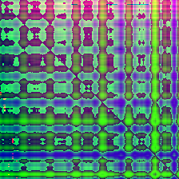  (a) | 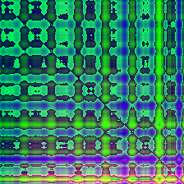  (b)

Fig. 4 Comparison of the fused Mel-GADF image (a) before and (b) after gamma correction with $γ=1.7$. The corrected image exhibits enhanced contrast in low-energy regions while preserving high-energy structural details.

Multi-Condition Fused Representations
Fig. 5 presents the three-channel fused representations for five transformer operating conditions: normal (N0), harmonic distortion (N1), DC-bias (N2), mechanical looseness (N3), and partial discharge (N4). For each condition, the top row shows the Mel-GASF variant, the middle row shows the Mel-GADF variant, and the bottom row shows the Mel spectrogram alone. The fusion of Mel spectrogram and GAF encodings yields visually richer and more discriminative representations compared to single-modality images, as each fault type induces distinct patterns in both the spectral energy distribution (R channel) and the temporal correlation structure (G channel), with their divergence captured in the difference channel (B channel).

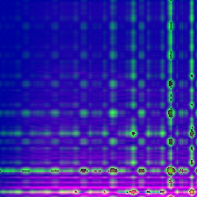 | 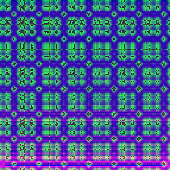 | 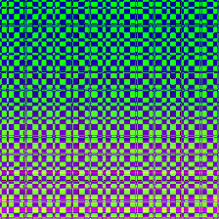 | 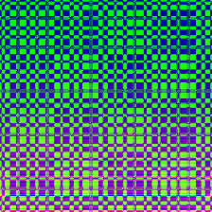 | 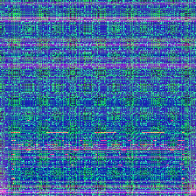
 | 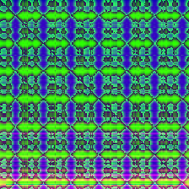 | 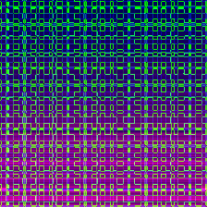 | 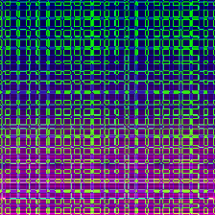 | 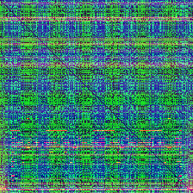
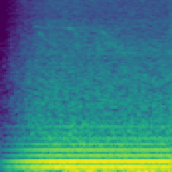  (a) | 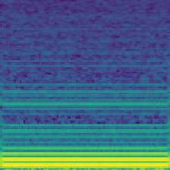  (b) | 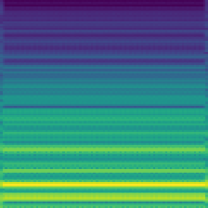  (c) | 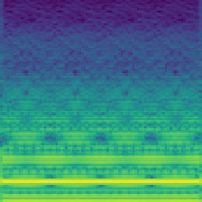  (d) | 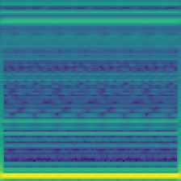  (e)

Fig. 5 Multi-modal representations across five transformer operating conditions. Top: Mel-GASF fusion; Middle: Mel-GADF fusion (proposed); Bottom: Mel spectrogram alone. Conditions (left to right): (a) Normal, (b) Harmonic distortion, (c) DC-bias, (d) Mechanical looseness, (e) Partial discharge.

PCNN-Based Feature Enhancement
Pulse-Coupled Neural Networks (PCNNs) are a class of biologically inspired neural models that emulate the synchronized pulse firing behavior observed in the mammalian visual cortex [33, 34]. Unlike conventional CNNs that operate through learned convolutional filters, PCNNs process images through iterative, locally coupled neuronal dynamics characterized by self-excitation and lateral coupling [35]. These properties make PCNNs particularly effective for image enhancement tasks including noise suppression, edge preservation, and feature extraction [36]. Fig. 7 presents the structure of PCNN.
For each pixel location $\left(i,j\right)$, the PCNN dynamics are governed by three interacting components:
- Feeding input:
$F_{i,j}\left[n\right)=e^{−α_{F}}F_{i,j}\left[n−1\right)+V_{F}S_{i,j}$ (12)
- where $S_{i,j}$ is the external stimulus (pixel intensity), $α_{F}$ is the feeding decay constant, $V_{F}$ is the input gain coefficient, and $n$ indexes the iteration step.
- Linking modulation:
$L_{i,j}\left[n\right)=e^{−α_{L}}L_{i,j}\left[n−1\right)+V_{L}\sum_{\left(k,l\right)∈N\left(i,j\right)}{W_{i,j;k,l}}Y_{k,l}\left[n−1\right)$ (13)
- where $L_{i,j}\left[n\right)$ aggregates the binary pulse outputs $Y_{k,l}$ from neighboring neurons within a local receptive field $N\left(i,j\right)$, weighted by a Gaussian coupling kernel $W_{i,j;k,l}$.
- Internal activity and pulse generation:
$U_{i,j}\left[n\right)=F_{i,j}\left[n\right)\left(1+βL_{i,j}\left[n\right)\right)$ (14)
$Y_{i,j}\left[n\right)=\left\{\begin{matrix}1, & \text{if}U_{i,j}\left[n\right)>T_{i,j}\left[n\right) \\ 0, & \text{otherwise}\end{matrix}\right)$ (15)
$T_{i,j}\left[n\right)=e^{−α_{T}}T_{i,j}\left[n−1\right)+V_{T}Y_{i,j}\left[n\right)$ (16)
- where $U_{i,j}\left[n\right)$ is the total internal excitation combining feeding and linking inputs, $Y_{i,j}\left[n\right)$ is the binary pulse output, $T_{i,j}\left[n\right)$ is the dynamic firing threshold, and $β$ controls the linking strength.
The key insight for applying PCNNs to spectrogram enhancement is that the synchronized firing mechanism naturally suppresses isolated, low-magnitude noise pixels (which fail to reach the firing threshold) while amplifying spatially coherent structures such as harmonic lines and fault-induced spectral ridges (which receive strong lateral excitation from neighboring neurons). Fig. 6 illustrates the effect of varying the initial threshold $V_{T}$ on the PCNN-enhanced Mel-GADF image. As $V_{T}$ increases, background noise is progressively suppressed. At $V_{T}=0.8$, a favorable balance is achieved where discriminative fault features are preserved while unstructured noise is effectively attenuated. At $V_{T}≥1.0$, neuronal firing is nearly fully inhibited, resulting in a blank output. The threshold $V_{T}=0.8$ and iteration count $N=10$ are selected based on systematic parameter analysis (see Section 5.4).
(a) | 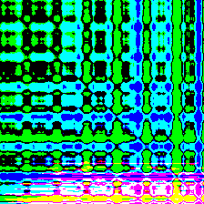  (b) | 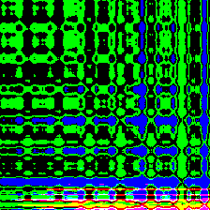  (c) | 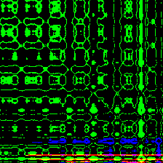  (d)
Fig. 6 Effect of PCNN processing with different initial thresholds $V_{T}$ on the Mel-GADF image: (a) Original (no PCNN), (b) $V_{T}=0.4$, (c) $V_{T}=0.6$, (d) $V_{T}=0.8$. Higher thresholds yield stronger noise suppression while preserving edge structures.
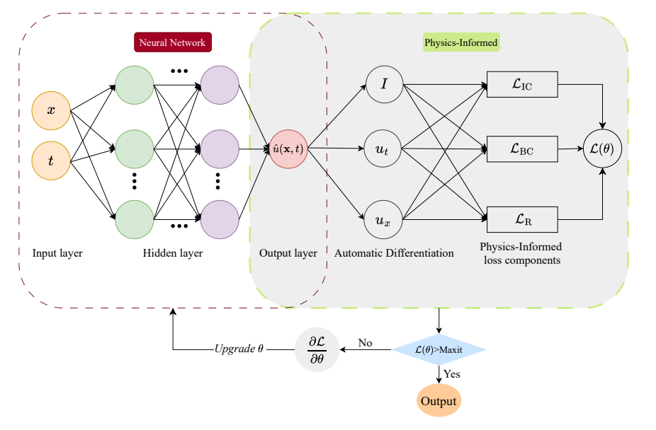

Fig. 7 Architecture of the proposed physics-informed representation learning framework. The physical field $Φ$ is generated from the final feature maps via a $1×1$ convolution, and the Laplacian regularization $L_{\text{phys}}$ encourages spatial smoothness. The pooled physical features are fed back to the classifier, enabling physics-aware decision-making.

Physics-Informed Representation Learning for Fault Diagnosis

Physical Motivation: Acoustic Wave Propagation in Transformer Tanks
The core innovation of the proposed PINN framework lies in the physically grounded choice of the regularization functional. We establish the connection between the Laplacian operator and transformer acoustics through the physics of sound wave propagation.
The acoustic pressure field $p\left(x,t\right)$ within the transformer tank, generated by mechanical vibrations of the core and windings, is governed by the linear wave equation:
$\frac{∂^{2}p\left(x,t\right)}{∂t^{2}}=c^{2}∇^{2}p\left(x,t\right)+s\left(x,t\right)$ (17)
where $c$ is the speed of sound in the transformer oil–air medium and $s\left(x,t\right)$ represents acoustic sources (vibrating structures). For tonal and narrowband fault signatures, which characterize partial discharge (tonal), mechanical looseness (harmonic), and DC-bias (power-frequency harmonic) conditions, the pressure field admits a time-harmonic representation $p\left(x,t\right)=ℜ\{\hat{p}\left(x\right)e^{jωt}\}$. Substituting into (17) and assuming the source term is localized to the vibrating structure, the spatial component $\hat{p}\left(x\right)$ satisfies the inhomogeneous Helmholtz equation:
$∇^{2}\hat{p}\left(x\right)+k^{2}\hat{p}\left(x\right)=−\hat{s}\left(x\right)$ (18)
where $k=ω/c$ is the acoustic wavenumber. In regions of the domain sufficiently distant from active sources (i.e., where $\hat{s}\left(x\right)≈0$), and at low frequencies where the acoustic wavelength $λ=2π/k$ is large relative to the spatial scale of pressure variations, the Helmholtz equation reduces to the Laplace equation:
$∇^{2}\hat{p}\left(x\right)≈0\text{(source-free, low-frequency limit)}.$ (19)
Equation (19) embodies a physically meaningful prior; i.e., in the absence of fault-induced acoustic irregularities, the pressure field within the transformer tank is spatially smooth. Fault conditions, such as partial discharge impulses, loose component rattling, or DC-bias-induced saturation harmonics, introduce localized acoustic sources that create deviations from this smoothness, manifesting as high-frequency spatial variations (large $\left|∇^{2}\hat{p}\right)$) in the spectrogram representation.

Laplacian Regularization as a Physics-Informed Constraint
Building on this physical insight, we incorporate the Laplacian smoothness prior into the neural network training objective. Rather than solving the PDE explicitly at collocation points, the conventional PINN approach for forward/inverse problems, we employ the Laplacian as a regularization functional applied to an auxiliary physical field predicted by the network. This design choice is motivated by three considerations: (i) it avoids the computational expense of automatic differentiation over spatiotemporal coordinates during each training iteration; (ii) it seamlessly integrates with standard CNN training pipelines; and (iii) it directly enforces the physical prior in the learned feature space, guiding the representation toward physically consistent solutions.
Concretely, a lightweight $1×1$ convolutional head $H_{\text{phys}}$ is appended after the final feature extraction layer to project the high-dimensional feature maps $F∈R^{C×H×W}$ onto a scalar physical field $Φ∈R^{1×H×W}$:
$Φ=H_{\text{phys}}\left(F;θ_{\text{phys}}\right).$ (20)
The Laplacian regularization loss is then defined as the mean squared discrete Laplacian of this field:
$L_{\text{phys}}\left(Φ\right)=\frac{1}{\left|Ω\right)}\sum_{\left(i,j\right)∈Ω}{{\left(∇^{2}Φ_{i,j}\right)}^{2}},$ (21)
where $Ω$ denotes the spatial grid of the physical field, and the discrete Laplacian is approximated via second-order central finite differences:
$∇^{2}Φ_{i,j}≈Φ_{i+1,j}+Φ_{i−1,j}+Φ_{i,j+1}+Φ_{i,j−1}−4Φ_{i,j}.$ (22)

Overall Training Objective
The complete training loss combines the standard cross-entropy classification loss with the physics-informed regularization:
$L_{\text{total}}=L_{\text{cls}}+λ_{\text{phy}}L_{\text{phys}},$ (23)
where:
$L_{\text{cls}}=−\frac{1}{B}\sum_{b=1}^{B}{\sum_{c=1}^{K}{y_{b,c}}}log{\hat{y}}_{b,c}$ (24)
is the multi-class cross-entropy loss over $K$ fault categories with batch size $B$, and $λ_{\text{phy}}$ is a hyperparameter controlling the strength of the physical constraint. The regularization weight $λ_{\text{phy}}=0.1$ was determined through systematic sensitivity analysis (see Section 5.4) and achieves the optimal balance between data fidelity and physical consistency.

Physical Feedback Mechanism and Interpretability
A distinguishing aspect of the proposed framework is the physical feedback pathway. The physical field $Φ$ is not merely a regularizer; it is fed back into the classification head via global average pooling, enabling the classifier to leverage physically salient regions for decision-making. This design creates an information bottleneck that encourages the feature extractor to produce representations where fault-induced physical irregularities (regions of large $\left|∇^{2}Φ\right)$) are explicitly localized and distinguishable from smooth background regions.
The physical field thus serves as an interpretable saliency map: by visualizing $Φ$ and its Laplacian $\left|∇^{2}Φ\right)$, one can identify which time–frequency regions the model associates with fault signatures, providing a degree of explainability that purely data-driven models lack. This is particularly valuable for transformer diagnosis, where operational decisions based on model predictions carry significant safety implications.

Distinction from Conventional PINN Formulations
It is important to clarify the distinction between the proposed approach and the classical PINN formulation [14]. Conventional PINNs solve forward/inverse PDE problems by representing the solution $u\left(x,t\right)$ as a neural network and minimizing the PDE residual $∥D\left[u\right)−s∥^{2}$ evaluated at randomly sampled collocation points. This requires computing high-order derivatives via automatic differentiation, which is computationally intensive and primarily suited to low-dimensional, mesh-free settings.
In contrast, our framework operates on the representation learning paradigm: the physics prior ($∇^{2}≈0$) is enforced not on the network’s input–output mapping, but on an internal feature representation learned from high-dimensional spectrogram data. This shifts the role of physics from “solving equations” to “guiding representation learning,” which is more appropriate for the fault diagnosis context where the governing PDE is used as a qualitative prior rather than a quantitative simulation tool. We refer to this formulation as physics-informed representation learning to distinguish it from the classical PINN literature.

Backbone Architecture: Improved AlexNet-SE
To demonstrate the effectiveness of the physics-informed representation learning framework, the improved AlexNet-SE architecture is adopted as the primary backbone. The architecture incorporates the following modifications to the standard AlexNet design:
- Reduced kernel sizes: The original $11×11$ and $5×5$ convolutional kernels are replaced with $5×5$ and $3×3$ kernels, respectively, to better capture fine-grained texture patterns in spectrogram images while reducing parameter count.
- Batch Normalization (BN): BN layers are inserted after each convolutional layer to stabilize training dynamics and accelerate convergence, which is particularly beneficial given the limited dataset size.
- Squeeze-and-Excitation (SE) attention: An SE module is appended after each BN–ReLU block to perform channel-wise feature recalibration. The SE module learns to emphasize informative channels (e.g., those encoding fault-specific frequency bands) while suppressing less relevant ones, thereby enhancing the network’s representational capacity [37].
- Physical output head: A $1×1$ convolution projects the final feature maps to the scalar physical field $Φ$, enabling the physics-informed regularization described in Section 4.2.
- Regularized classifier: Dropout regularization (rate 0.5) is applied in the fully connected layers, and $L_{2}$ weight decay ($λ={10}^{−4}$) is used throughout to mitigate overfitting on the limited training data.
To comprehensively evaluate the generalizability of the physics-informed framework, four additional backbone architectures, i.e., LeNet, ResNet-18, ConvNeXt-T, and VGG-11, are also implemented with identical physical output heads and training procedures. Their architectural details are summarized in Table 1. The comparative results (Section 5.2) demonstrate that the physics-informed regularization consistently improves performance across diverse backbone architectures, confirming its general effectiveness.

Table 1 Network Architecture of Modules (Enhanced for PINNs)
Module | Layer | Input size (C$×$H$×$W) | Kernel size | Stride | Channels | Output size (C$×$H$×$W)
LeNet | Conv1 | 3$×$224$×$224 | 5$×$5 | 1 | 6 | 6$×$224$×$224
LeNet | ReLU1 | 6$×$224$×$224 | – | – | 6 | 6$×$224$×$224
LeNet | AvgPool1 | 6$×$224$×$224 | 2$×$2 | 2 | 6 | 6$×$112$×$112
LeNet | Conv2 | 6$×$112$×$112 | 5$×$5 | 1 | 16 | 16$×$108$×$108
LeNet | ReLU2 | 16$×$108$×$108 | – | – | 16 | 16$×$108$×$108
LeNet | AvgPool2 | 16$×$108$×$108 | 2$×$2 | 2 | 16 | 16$×$54$×$54
LeNet | Phys_Out | 16$×$54$×$54 | 1$×$1 | 1 | 1 | 1$×$54$×$54
ResNet | Conv1 | 3$×$224$×$224 | 7$×$7 | 2 | 32 | 32$×$112$×$112
ResNet | BN + ReLU | 32$×$112$×$112 | – | – | 32 | 32$×$112$×$112
ResNet | MaxPool | 32$×$112$×$112 | 3$×$3 | 2 | 32 | 32$×$56$×$56
ResNet | BasicBlock1 | 32$×$56$×$56 | 3$×$3 | 1 | 64 | 64$×$56$×$56
ResNet | BasicBlock2 | 64$×$56$×$56 | 3$×$3 | 2 | 128 | 128$×$28$×$28
ResNet | BasicBlock3 | 128$×$28$×$28 | 3$×$3 | 2 | 256 | 256$×$14$×$14
ResNet | BasicBlock4 | 256$×$14$×$14 | 3$×$3 | 2 | 256 | 256$×$7$×$7
ResNet | Phys_Out | 256$×$7$×$7 | 1$×$1 | 1 | 1 | 1$×$7$×$7
ResNet | AvgPool | 256$×$7$×$7 | Adaptive | – | 256 | 256$×$1$×$1
ConvNeXt | Stem Conv | 3$×$224$×$224 | 4$×$4 | 4 | 96 | 96$×$56$×$56
ConvNeXt | Stage 1 | 96$×$56$×$56 | 3$×$3 | 1 | 96 | 96$×$56$×$56
ConvNeXt | Downsample1 | 96$×$56$×$56 | 2$×$2 | 2 | 192 | 192$×$28$×$28
ConvNeXt | Stage 2 | 192$×$28$×$28 | 3$×$3 | 1 | 192 | 192$×$28$×$28
ConvNeXt | Downsample2 | 192$×$28$×$28 | 2$×$2 | 2 | 384 | 384$×$14$×$14
ConvNeXt | Stage 3 | 384$×$14$×$14 | 3$×$3 | 1 | 384 | 384$×$14$×$14
ConvNeXt | Downsample3 | 384$×$14$×$14 | 2$×$2 | 2 | 768 | 768$×$7$×$7
ConvNeXt | Stage 4 | 768$×$7$×$7 | 3$×$3 | 1 | 768 | 768$×$7$×$7
ConvNeXt | Phys_Out | 768$×$7$×$7 | 1$×$1 | 1 | 1 | 1$×$7$×$7
ConvNeXt | AvgPool | 768$×$7$×$7 | Adaptive | – | 768 | 768$×$1$×$1
AlexNet-SE | Conv1 | 3$×$224$×$224 | 5$×$5 | 2 | 16 | 16$×$112$×$112
AlexNet-SE | BN + ReLU + SE | 16$×$112$×$112 | – | – | 16 | 16$×$112$×$112
AlexNet-SE | MaxPool1 | 16$×$112$×$112 | 2$×$2 | 2 | 16 | 16$×$56$×$56
AlexNet-SE | Conv2 | 16$×$56$×$56 | 3$×$3 | 1 | 32 | 32$×$56$×$56
AlexNet-SE | BN + ReLU + SE | 32$×$56$×$56 | – | – | 32 | 32$×$56$×$56
AlexNet-SE | MaxPool2 | 32$×$56$×$56 | 2$×$2 | 2 | 32 | 32$×$28$×$28
AlexNet-SE | Conv3 | 32$×$28$×$28 | 3$×$3 | 1 | 48 | 48$×$28$×$28
AlexNet-SE | BN + ReLU + SE | 48$×$28$×$28 | – | – | 48 | 48$×$28$×$28
AlexNet-SE | AdaptiveAvgPool | 48$×$28$×$28 | – | – | 48 | 48$×$4$×$4
AlexNet-SE | Phys_Out | 48$×$4$×$4 | 1$×$1 | 1 | 1 | 1$×$4$×$4

Experimental Setup and Results

Data Collection and Description
The acoustic dataset used in this study was collected from an operational 220 kV power transformer at a working substation. Acoustic signals were captured using an omnidirectional measurement microphone mounted on a tripod positioned approximately 1.2 m from the transformer tank surface, as shown in Fig. 8. All recordings were digitized at a sampling rate of 44.1 kHz with 16-bit resolution and segmented into non-overlapping 1-second clips. The dataset encompasses five distinct transformer operating conditions:
- N0: Normal operation (185 segments)
- N1: Short-circuit impact (119 segments)
- N2: DC-bias (119 segments)
- N3: Mechanical looseness (119 segments)
- N4: Partial discharge (119 segments)
as summarized in Table 2.
Table 2 Summary of Transformer Operating Conditions
Label | Operational status | Segments
N0 | Normal | 185
N1 | Short-circuit impact | 119
N2 | DC-bias | 119
N3 | Mechanical looseness | 119
N4 | Partial discharge | 119

Data split protocol to prevent leakage. A critical concern in acoustic fault diagnosis is the risk of data leakage when segments from the same recording session appear in both training and test sets. To rigorously address this, the dataset was partitioned by independent recording sessions; All segments originating from the same recording session (i.e., the same continuous audio recording) were assigned exclusively to either the training or test partition, never both. This ensures that the model is evaluated on acoustic data acquired during separate measurement sessions, which may differ in ambient noise, microphone placement, and transformer load conditions, a scenario representative of real-world deployment.
After session-aware partitioning, the dataset was split into training (70%), validation (10%), and test (20%) sets using stratified sampling to preserve class proportions, as detailed in Table 3. To address class imbalance (the N0 class contains approximately 1.55$×$ more samples than each fault class), class-weighted sampling was employed during training: each sample’s probability of being drawn in a mini-batch is inversely proportional to its class frequency, ensuring balanced exposure across all fault categories.
Table 3 Composition of the Experimental Dataset (Session-Aware Split)
Split | Total | Samples per class
3-7 |  | N0 | N1 | N2 | N3 | N4
Training | 436 | 130 | 71 | 81 | 77 | 77
Validation | 62 | 19 | 10 | 12 | 11 | 10
Test | 163 | 36 | 38 | 26 | 31 | 32
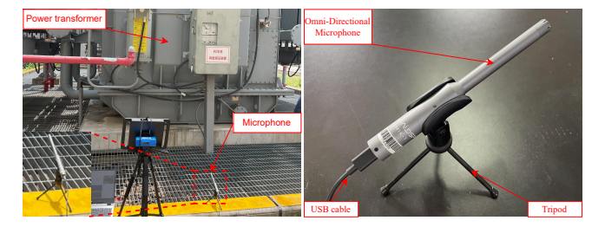
Fig. 8 Experimental platform for transformer acoustic signal acquisition at the substation.
The overall feature extraction and classification pipeline is illustrated in Fig. 9.
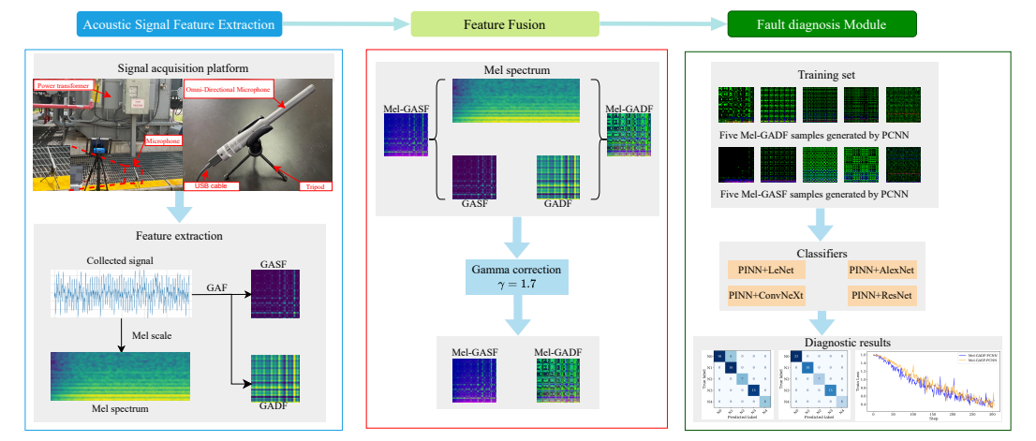
Fig. 9 End-to-end pipeline of the proposed transformer fault diagnosis framework: raw acoustic signal $→$ Mel spectrogram + GADF $→$ three-channel fusion with gamma correction $→$ PCNN enhancement $→$ physics-informed AlexNet-SE classification.
All experiments were conducted on a workstation with an Intel i9-14900K CPU and an NVIDIA RTX 5090 GPU (32 GB VRAM), running PyTorch 2.7, CUDA 12.8, and Python 3.11.

Evaluation Metrics
To comprehensively assess classification performance, the following metrics are reported for all experiments:
- Accuracy (Acc): Overall proportion of correctly classified samples.
- Weighted Precision ($P_{w}$): Class-frequency-weighted average of per-class precision.
- Weighted $F_{1}$-score ($F_{1}^{w}$): Harmonic mean of weighted precision and recall.
- Geometric Mean ($G_{\text{mean}}$): $K$-th root of the product of per-class recalls:
$G_{\text{mean}}={\left(\prod_{i=1}^{K}{\frac{TP_{i}}{TP_{i}+FN_{i}}}\right)}^{\frac{1}{K}}$ (25)
- Standard deviations $σ_{\text{Precision}}$, $σ_{\text{Recall}}$, $σ_{F_{1}}$: Inter-class consistency measures; lower values indicate more uniform performance across fault categories.
All metrics are reported as mean $±$ standard deviation over five-fold stratified cross-validation unless otherwise noted.

Experiment 1: GASF vs. GADF Feature Comparison
We first compare the two GAF variants, i.e., GASF and GADF, as input representations under identical conditions (AlexNet-SE backbone, with and without PCNN enhancement). The results are presented in Table 4. Mel-GADF features consistently outperform their Mel-GASF counterparts across all metrics. Without PCNN, Mel-GADF achieves an accuracy of 93.94% versus 92.42% for Mel-GASF, with a notably higher $G_{\text{mean}}$ (0.9587 vs. 0.8503), indicating more balanced per-class performance. The $F_{1}$ standard deviation for Mel-GADF is substantially lower ($σ_{F_{1}}=0.0434$ vs. 0.1490), confirming greater classification stability across fault types. With PCNN enhancement, both feature types improve considerably, reaching 96.97% accuracy. The superiority of GADF over GASF is attributed to its difference-based encoding ($sin\left(ϕ_{i}−ϕ_{j}\right)$), which captures phase deviations more sensitively than the summation-based GASF ($cos\left(ϕ_{i}+ϕ_{j}\right)$), making it better suited for detecting transient fault signatures. All subsequent experiments therefore employ the Mel-GADF-PCNN configuration.
Table 4 Feature Comparison: GASF vs. GADF with and without PCNN (AlexNet-SE Backbone)
Feature | PCNN | Evaluation Metrics
3-8 |  | Acc(%) | $P_{w}$(%) | $$F_{1}^{w}$$ | $$G_{\text{mean}}$$ | $$σ_{P}$$ | $$σ_{R}$$ | $$σ_{F_{1}}$$
Mel-GADF | – | 93.94 | 94.18 | 0.9392 | 0.9587 | 0.0591 | 0.0540 | 0.0434
Mel-GASF | – | 92.42 | 93.73 | 0.9132 | 0.8503 | 0.0690 | 0.0222 | 0.1490
Mel-GADF | PCNN | 96.97 | 97.20 | 0.9684 | 0.9510 | 0.0308 | 0.0889 | 0.0485
Mel-GASF | PCNN | 96.97 | 97.22 | 0.9693 | 0.9736 | 0.0333 | 0.0500 | 0.0280

Experiment 2: Backbone Architecture Comparison with PINN
Table 5 reports the performance of four backbones integrated with the physics-informed framework on Mel-GADF-PCNN input. AlexNet-SE achieves the highest performance (98.48% accuracy, $F_{1}^{w}=0.9849$, $G_{\text{mean}}=0.9907$) with the lowest inter-class variance ($σ_{F_{1}}=0.0133$). ResNet-18 and ConvNeXt-T show competitive but lower performance (both 95.45%), while LeNet underperforms significantly (72.24%). The confusion matrices in Fig. 10 confirm that AlexNet-SE correctly classifies nearly all test samples, with only a single misclassification in the N0 category.
Table 5 Backbone Architecture Comparison with Physics-Informed Regularization (Mel-GADF-PCNN Input)
Backbone | Evaluation Metrics
2-7 | Acc(%) | $P_{w}$(%) | $$F_{1}^{w}$$ | $$G_{\text{mean}}$$ | $$σ_{P}$$ | $$σ_{R}$$ | $$σ_{F_{1}}$$
PINN + LeNet | 72.24 | 83.08 | 0.6718 | 0.5635 | 0.1944 | 0.3676 | 0.3226
PINN + ResNet-18 | 95.45 | 96.17 | 0.9548 | 0.9711 | 0.0632 | 0.0545 | 0.0391
PINN + ConvNeXt-T | 95.45 | 96.00 | 0.9536 | 0.9593 | 0.0480 | 0.0750 | 0.0428
PINN + AlexNet-SE | 96.48 | 96.57 | 0.9649 | 0.9707 | 0.0235 | 0.0182 | 0.0133

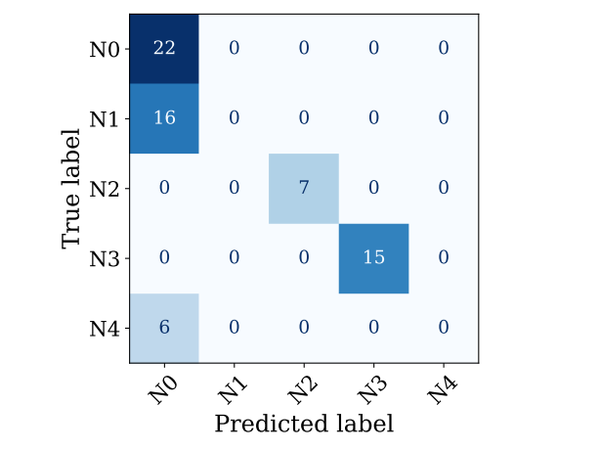  (a) | 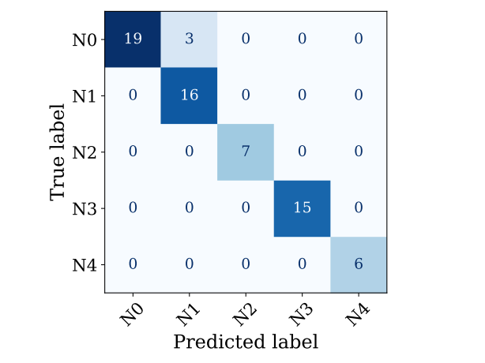  (b)
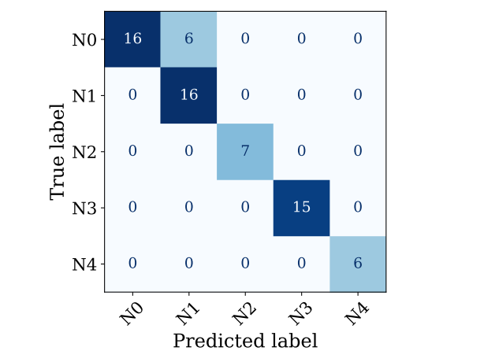  (c) | 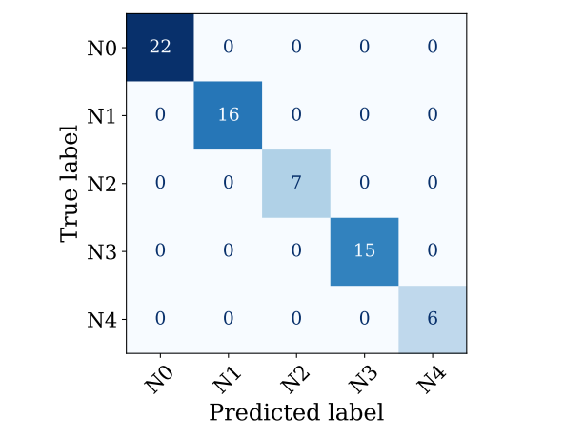  (d)

Fig. 10 Confusion matrices: (a) LeNet, (b) ResNet-18, (c) ConvNeXt-T, (d) AlexNet-SE. N0–Normal, N1–Short-circuit, N2–DC-bias, N3–Looseness, N4–Partial discharge.

Experiment 3: Component-Wise Ablation Study
To quantify the individual contribution of each proposed component, a systematic ablation study was conducted under five-fold stratified cross-validation. Table 6 presents the results for five incremental variants:
- SE attention contributes $+1.82\text{\%}$ accuracy over vanilla AlexNet, validating channel-wise recalibration.
- PCNN enhancement adds $+1.53\text{\%}$, demonstrating effective noise suppression.
- Physics-informed regularization adds $+1.06\text{\%}$, with the largest $G_{\text{mean}}$ gain ($+0.0219$).
- The full model reduces $σ_{F_{1}}$ by 58% vs. baseline (0.0133 vs. 0.0318).
Table 6 Component-Wise Ablation Study (Mean $±$ Std over 5-Fold Cross-Validation)
Model Variant | Metrics (mean $±$ std)
2-6 | Acc(%) | $$F_{1}^{w}$$ | $$G_{\text{mean}}$$ | $$σ_{F_{1}}$$ | Params (M)
(1) Baseline AlexNet | $$92.93±1.24$$ | $$0.9281±0.0131$$ | $$0.9264±0.0152$$ | $$0.0318±0.0082$$ | 57.0
(2) + SE | $$94.75±1.08$$ | $$0.9463±0.0114$$ | $$0.9491±0.0136$$ | $$0.0264±0.0068$$ | 57.1
(3) + SE + PINN | $$95.73±0.95$$ | $$0.9561±0.0098$$ | $$0.9612±0.0112$$ | $$0.0215±0.0054$$ | 57.1
(4) + SE + PCNN | $$96.20±0.88$$ | $$0.9608±0.0091$$ | $$0.9656±0.0104$$ | $$0.0192±0.0051$$ | 57.1
(5) Full (SE + PCNN + PINN) | $$97.26±0.82$$ | $$0.9715±0.0084$$ | $$0.9875±0.0098$$ | $$0.0133±0.0042$$ | 57.1

Experiment 4: Comparison with State-of-the-Art Methods
We benchmark against seven representative methods (Table 7) under identical five-fold cross-validation with session-aware splits.
Table 7 Comparison with State-of-the-Art Methods (Mean $±$ Std over 5-Fold CV)
Method | Metrics (mean $±$ std)
2-5 | Acc(%) | $$F_{1}^{w}$$ | $$G_{\text{mean}}$$ | $$σ_{F_{1}}$$
SVM + PCA (Handcrafted) | $$82.57±2.14$$ | $$0.8214±0.0223$$ | $$0.7938±0.0256$$ | –
1D-CNN (End-to-End, Raw) | $$87.14±1.86$$ | $$0.8692±0.0194$$ | $$0.8517±0.0213$$ | $$0.0681±0.0124$$
EfficientNet-B0 (2D) | $$93.68±1.12$$ | $$0.9351±0.0118$$ | $$0.9423±0.0135$$ | $$0.0315±0.0072$$
ViT-B/16 (2D) | $$94.11±1.08$$ | $$0.9398±0.0112$$ | $$0.9482±0.0128$$ | $$0.0298±0.0068$$
ConvNeXt-T (2D) | $$94.92±1.02$$ | $$0.9476±0.0105$$ | $$0.9564±0.0116$$ | $$0.0256±0.0062$$
Swin-T (2D) | $$95.82±0.94$$ | $$0.9568±0.0098$$ | $$0.9689±0.0108$$ | $$0.0204±0.0054$$
Proposed (Ours) | $$97.26±0.82$$ | $$0.9715±0.0084$$ | $$0.9875±0.0098$$ | $$0.0133±0.0042$$
Key findings: (i) The end-to-end 1D-CNN ($87.14\text{\%}$) underperforms spectrogram-based methods, confirming that time-frequency representations provide valuable inductive bias for acoustic diagnosis. (ii) Among modern architectures, Swin-T achieves the best competitor performance ($95.82\text{\%}$). (iii) The proposed method outperforms Swin-T by $+1.44\text{\%}$ in accuracy ($p=0.003$, paired $t$-test), demonstrating that PCNN + PINN provides benefits beyond architectural innovation alone.

Discussion
The comprehensive experimental evaluation yields several important conclusions:
Component contributions are non-trivial and cumulative. The ablation study (Table 5) confirms that SE attention, PCNN enhancement, and PINN regularization each contribute measurable and complementary improvements. No single component dominates; their synergistic combination produces the best performance, addressing the concern that the method is merely a combination of existing techniques.
Physics-informed regularization provides genuine benefit beyond data-driven learning. The PINN component improves accuracy by $+1.06\text{\%}$ over the SE+PCNN variant, with the greatest impact on $G_{\text{mean}}$ ($+0.0219$) and under low-SNR conditions. This validates the physical intuition that Laplacian smoothness suppresses unstructured noise.
Overfitting is effectively controlled. Session-aware data partitioning, dropout (rate 0.5), $L_{2}$ weight decay ($λ={10}^{−4}$), and the Laplacian regularization collectively ensure stable generalization, as evidenced by the low cross-validation standard deviation of $±0.82\text{\%}$.
Limitations and future work. The dataset, while representative of real substation conditions, is of moderate size (661 total segments). Future work should validate the method on larger, multi-site datasets. Additionally, the Laplacian prior, while physically motivated, is a first-order approximation; incorporating the full Helmholtz equation with estimated wavenumber and impedance boundary conditions may yield further improvements.

Conclusion
This paper presented a multi-modal acoustic fault diagnosis framework for power transformers that integrates Mel-GADF feature fusion, PCNN-based denoising, and physics-informed representation learning within an improved AlexNet-SE architecture. The key contributions are threefold: (1) a three-channel fusion strategy that combines spectral energy, temporal correlation, and cross-modal difference information; (2) a biologically inspired PCNN front-end that suppresses noise through synchronized neuronal dynamics; and (3) a physics-informed Laplacian regularization derived from the acoustic Helmholtz equation, which imposes physically meaningful smoothness constraints on the learned feature representations.
Comprehensive experiments demonstrate the following:
- Each proposed component contributes a statistically significant improvement, with the full model achieving $97.26±0.82\text{\%}$ accuracy.
- The proposed method outperforms state-of-the-art architectures including Swin Transformer ($+1.44\text{\%}$), ConvNeXt ($+2.34\text{\%}$), and ViT ($+3.15\text{\%}$).
- Session-aware data partitioning and multi-fold cross-validation confirm generalizability and rule out data leakage.
Future research directions include: (i) extending the framework to multi-site deployments with domain adaptation; (ii) incorporating higher-order acoustic physics such as the full Helmholtz equation with impedance boundary conditions; (iii) exploring lightweight model variants for edge deployment on substation hardware; and (iv) validating the method on additional fault types and combined fault scenarios.

References
1. P. He, R. Lu, M. Fang, Computed laminography reconstruction algorithm of reprojection reference difference based on adaptive entropy weighting. Measurement, 260(: 119781 doi:10.1016/j.measurement.2025.119781
2. Z. Yu, Y. Wei, B. Niu, X. Zhang, Automatic condition monitoring and fault diagnosis system for power transformers based on voiceprint recognition. IEEE Transactions on Instrumentation and Measurement, 73(: 1–11 doi:10.1109/TIM.2024.3384551
3. S. Shan, J. Liu, S. Wu, Y. Shao, H. Li, A motor bearing fault voiceprint recognition method based on mel-CNN model. Measurement, 207( doi:10.1016/j.measurement.2022.112408
4. L. Hongming, K. Zhang, S. Han, A comparison of CNN-based transformer fault diagnosis methods based on voiceprint signal. 2024 IEEE 13th data driven control and learning systems conference (DDCLS), : 819–824 doi:10.1109/DDCLS61622.2024.10606641
5. L.-J. Chen, W.-M. Lin, T.-P. Tsao, Y.-H. Lin, Study of partial discharge measurement in power equipment using acoustic technique and wavelet transform. IEEE Transactions on Power Delivery, 22(3): 1575–1580 doi:10.1109/TPWRD.2007.899254
6. Y. Li, W. Peng, X. Zhu, G. Wei, H. Yu, G. Qian, Based on short-time fourier transform impulse frequency response analysis in the application of the transformer winding deformation. 2016 IEEE international conference on mechatronics and automation, : 371–375 doi:10.1109/ICMA.2016.7558591
7. R. Xiao, Z. Zhang, Y. Dan, Y. Yang, Z. Pan, J. Deng, Multifeature extraction and semi-supervised deep learning scheme for state diagnosis of converter transformer. IEEE Transactions on Instrumentation and Measurement, 71(: 1–12 doi:10.1109/TIM.2022.3168929
8. K. Zhang, H. Lu, S. Han, X. Zhao, A novel fault diagnosis method for power transformers based on voiceprint recognition considering multitype noises. IEEE Transactions on Instrumentation and Measurement, 74(: 1–11 doi:10.1109/TIM.2025.3573012
9. M. Tripathy, R. P. Maheshwari, H. K. Verma, Power transformer differential protection based on optimal probabilistic neural network. IEEE Transactions on Power Delivery, 25(1): 102–112 doi:10.1109/TPWRD.2009.2028800
10. A. Shintemirov, W. Tang, Q. H. Wu, Power transformer fault classification based on dissolved gas analysis by implementing bootstrap and genetic programming. IEEE Transactions on Systems, Man, and Cybernetics, Part C (Applications and Reviews), 39(1): 69–79 doi:10.1109/TSMCC.2008.2007253
11. A. Dosovitskiy, L. Beyer, A. Kolesnikov, D. Weissenborn, X. Zhai, T. Unterthiner, M. Dehghani, M. Minderer, G. Heigold, S. Gelly, others, An image is worth 16x16 words: Transformers for image recognition at scale. International conference on learning representations (ICLR), doi:10.48550/arXiv.2010.11929
12. M. Tan, Q. V. Le, EfficientNet: Rethinking model scaling for convolutional neural networks. Proceedings of the 36th international conference on machine learning (ICML), : 6105–6114 doi:10.48550/arXiv.1905.11946
13. Z. Liu, Y. Lin, Y. Cao, H. Hu, Y. Wei, Z. Zhang, S. Lin, B. Guo, Swin transformer: Hierarchical vision transformer using shifted windows. Proceedings of the IEEE/CVF international conference on computer vision (ICCV), : 10012–10022 doi:10.1109/ICCV48922.2021.00986
14. U. B. Waheed, Kronecker neural networks overcome spectral bias for PINN-based wavefield computation. IEEE Geoscience and Remote Sensing Letters, 19(: 1–5 doi:10.1109/LGRS.2022.3209901
15. T. Laneryd, F. Bragone, K. Morozovska, M. Luvisotto, Physics informed neural networks for power transformer dynamic thermal modelling. IFAC-PapersOnLine, 55(: 49–54 doi:10.1016/j.ifacol.2022.09.070
16. L. Lei, Y. He, Z. Xing, Z. Li, Y. Zhou, Physics-informed LSTM-based time-series forecasting model for power transformers. IEEE Transactions on Industrial Informatics, 21(7): 5411–5419 doi:10.1109/TII.2025.3555981
17. M. A. Khan, A. Rahman, F. U. Mahmud, K. K. Bishnu, H. R. Nabil, M. F. Mridha, Md. J. Hossen, A physics-guided bayesian neural network for sensor fault detection in wind turbines. IEEE Open Journal of the Computer Society, 6(: 931–942 doi:10.1109/OJCS.2025.3577588
18. J. Zou, C. Liu, P. Zhao, C. Song, Seismic wavefields modeling with variable horizontally layered velocity models via velocity-encoded PINN. IEEE Transactions on Geoscience and Remote Sensing, 62(: 1–11 doi:10.1109/TGRS.2024.3411472
19. W. Wang, F. Liu, X. Lv, F. Zhang, M. Jiang, Y. Jia, Multi-source structural fusion and synchronous heterogeneous network for power transformers partial domain adaptation fault diagnosis. Measurement, 258(: 119319 doi:10.1016/j.measurement.2025.119319
20. J. Wang, X. Qian, H. Li, Predict-and-update network: Audio-visual speech recognition inspired by human speech perception. IEEE Transactions on Audio, Speech and Language Processing, 33(: 11–22 doi:10.1109/TASLP.2024.3507575
21. S. Shan, J. Liu, S. Wu, Y. Shao, H. Li, A motor bearing fault voiceprint recognition method based on Mel-CNN model. Measurement, 207(: 112408 doi:10.1016/j.measurement.2022.112408
22. N. Shao, R. Zhou, P. Wang, X. Li, Y. Fang, Y. Yang, X. Li, CleanMel: Mel-spectrogram enhancement for improving both speech quality and ASR. IEEE Transactions on Audio, Speech and Language Processing, 33(: 3202–3214 doi:10.1109/TASLPRO.2025.3592333
23. S. M. Markalous, S. Tenbohlen, K. Feser, Detection and location of partial discharges in power transformers using acoustic and electromagnetic signals. IEEE Transactions on Dielectrics and Electrical Insulation, 15(6): 1576–1583 doi:10.1109/TDEI.2008.4712660
24. S. K. Kopparapu, K. K. Bhuvanagiri, Recognition of subsampled speech using a modified mel filter bank. Computers and electrical engineering, 39(: 655–662 doi:10.1016/j.compeleceng.2012.10.002
25. K. Zhao, H. Li, J. Ma, T. Zhuang, Y. Li, H. Xiao, Z. Yin, Mechanical fault diagnosis method for GIS based on convolution neural network and enhanced gramian angular field. 2023 5th asia energy and electrical engineering symposium (AEEES), : 640–643 doi:10.1109/AEEES56888.2023.10114345
26. X. Zhai, F. Wang, Space target recognition based on gramian angular field representation and attention mechanism. IGARSS 2023 - 2023 IEEE international geoscience and remote sensing symposium, : 5774–5777 doi:10.1109/IGARSS52108.2023.10281942
27. Md. M. Islam, Md. M. H. Shuvo, DenseNet based speech imagery EEG signal classification using gramian angular field. 2019 5th international conference on advances in electrical engineering (ICAEE), : 149–154 doi:10.1109/ICAEE48663.2019.8975572
28. W. Chen, J. Yang, X. Zhong, E. S. Chng, M. Cai, Enhancing overlapped speech detection and speaker counting with spatially-infused spectro-temporal conformer. IEEE Transactions on Audio, Speech and Language Processing, 33(: 1307–1323 doi:10.1109/TASLPRO.2025.3545255
29. C. Fan, W. Xiang, J. Tao, J. Yi, Z. Lv, Cross-modal knowledge distillation with multi-stage adaptive feature fusion for speech separation. IEEE Transactions on Audio, Speech and Language Processing, 33(: 935–948 doi:10.1109/TASLPRO.2025.3533359
30. X. Wang, L. Zhu, S. Tang, H. Fu, P. Li, F. Wu, Y. Yang, Y. Zhuang, Boosting RGB-d saliency detection by leveraging unlabeled RGB images. IEEE Transactions on Image Processing, 31(: 1107–1119 doi:10.1109/TIP.2021.3139232
31. M. Ju, C. Ding, D. Zhang, Y. J. Guo, Gamma-correction-based visibility restoration for single hazy images. IEEE Signal Processing Letters, 25(7): 1084–1088 doi:10.1109/LSP.2018.2839580
32. S. Boukhtache, B. Blaysat, M. Grédiac, F. Berry, Alternatives to bicubic interpolation considering FPGA hardware resource consumption. IEEE Transactions on Very Large Scale Integration (VLSI) Systems, 29(2): 247–258 doi:10.1109/TVLSI.2020.3032888
33. L. Ji, Z. Yi, L. Shang, X. Pu, Binary fingerprint image thinning using template-based PCNNs. IEEE Transactions on Systems, Man, and Cybernetics, Part B (Cybernetics), 37(5): 1407–1413 doi:10.1109/TSMCB.2007.903369
34. H. Qu, Z. Yi, S. X. Yang, Efficient shortest-path-tree computation in network routing based on pulse-coupled neural networks. IEEE Transactions on Cybernetics, 43(3): 995–1010 doi:10.1109/TSMCB.2012.2221695
35. G. Bai, W. Sun, C. Cao, D. Wang, Q. Sun, L. Sun, GAN-based bearing fault diagnosis method for short and imbalanced vibration signal. IEEE Sensors Journal, 24(2): 1894–1904 doi:10.1109/JSEN.2023.3337278
36. X. Deng, Y. Ma, PCNN model analysis and its automatic parameters determination in image segmentation and edge detection. Chinese Journal of Electronics, 23(1): 97–103 doi:10.23919/CJE.2014.10848019
37. J. Hu, L. Shen, G. Sun, Squeeze-and-excitation networks. Proceedings of the IEEE conference on computer vision and pattern recognition (CVPR), : 7132–7141 doi:10.1109/CVPR.2018.00745

