# docs of Training

（http://wear.techbrood.com/training/basics/firstapp/running-app.html）

## Building Your First App

### Running Your Application

****——****

****Note:**** On Android 4.2 and newer, ****Developer options**** is hidden by default. To make it available, go to****Settings > About phone**** and tap ****Build number**** seven times. Return to the previous screen to find****Developer options****.

### Building a Simple User Interface

——

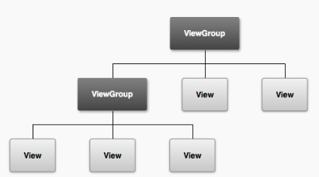

——

The other two attributes, [android:layout\_width](http://wear.techbrood.com/reference/android/view/View.html" \l "attr_android:layout_width) and [android:layout\_height](http://wear.techbrood.com/reference/android/view/View.html" \l "attr_android:layout_height), are required for **all views** in order to specify their size

——

[android:id](http://wear.techbrood.com/reference/android/view/View.html" \l "attr_android:id)

This provides a unique identifier for the view, which you can use to reference the object from your app code, such as to read and manipulate the object (you'll see this in the next lesson).

The at sign (@) is required when you're referring to any resource object from XML. It is followed by the resource type (id in this case), a slash, then the resource name (edit\_message).

The plus sign (+) before the resource type is needed only when you're defining a resource ID for the first time. When you compile the app, the SDK tools use the ID name to create a new resource ID in your project's gen/R.java file that refers to the [EditText](http://wear.techbrood.com/reference/android/widget/EditText.html) element. Once the resource ID is declared once this way, other references to the ID do not need the plus sign. Using the plus sign is necessary only when specifying a new resource ID and not needed for concrete resources such as strings or layouts. See the sidebox for more information about resource objects.

——

The height and width are set to "wrap\_content" so the button is only as big as necessary to fit the button's text. This button doesn't need the [android:id](http://wear.techbrood.com/reference/android/view/View.html" \l "attr_android:id) attribute, because it won't be referenced from the activity code.

——

In order to improve the layout efficiency when you specify the weight, you should change the width of the[EditText](http://wear.techbrood.com/reference/android/widget/EditText.html) to be zero (0dp). Setting the width to zero improves layout performance because using "wrap\_content"as the width requires the system to calculate a width that is ultimately irrelevant because the weight value requires another width calculation to fill the remaining space.

### Starting Another Activity

——

****Tip:**** In Eclipse, press Ctrl + Shift + O to import missing classes (Cmd + Shift + O on Mac).

——

public final static String EXTRA\_MESSAGE = "com.example.myfirstapp.MESSAGE";

intent.putExtra(EXTRA\_MESSAGE, message);

It's generally a good practice to define keys for intent extras using your app's package name as a prefix. This ensures they are unique, in case your app interacts with other apps.

### Adding the Action Bar

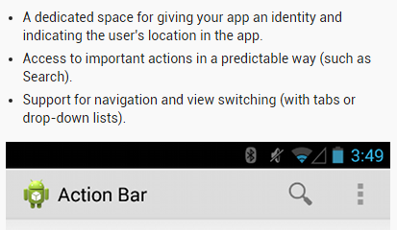

## Supporting Different Devices

### Support Different Screens

****Note:**** Low-density (ldpi) resources aren’t always necessary. When you provide hdpi assets, the system scales them down by one half to properly fit ldpi screens.