**SIVIC GUI Tutorial**

HMTRC Workshop - March 23-24, 2017

Department of Radiology and Biomedical Imaging, UCSF

Supported by NIBIB P41EB013598

**Goal:** The purpose of this tutorial is to introduce you to the SIVIC GUI for visualizing and interactively processing HP 13C data. Additional tutorials from this workshop will cover command line scripting of data analysis from the command line for batch mode data analysis.

**Introduction:** In this example you will load a 2D dynamic HP 13C human prostate MRS data set acquired on a GE 3T scanner. The sample data was acquired with a symmetric EPSI sequence and has already been converted from GE PFile format to DICOM MRS format (using svk\_gepfile\_reader). You will reconstruct the data, generate metabolite maps for pyruvate and lactate at each time point and also manually create an ROI mask of the prostate. These results will be saved as DICOM images and used as input to a kinetic modeling program that will fit the observed dynamic signal changes to a 2-site exchange model within the ROI and generate 3D maps of model parameters (Kpl and T1all) that will be visualized in the SIVIC GUI.

**Setup and Resources:**

* Download [SIVIC](https://sourceforge.net/projects/sivic/)
  + OsX: install dmg

Note: OsX users need to have XQuartz installed (<https://www.xquartz.org/>) if it isn’t in your /Applications directory.

* + Linux: tar –xf \*.gz
  + Windows:
* Download [sample data](https://sourceforge.net/projects/sivic/files/sample_data/HMTRC_2017/hmtrc_gui_tutorial.zip/download)
  + unzip hmtrc\_gui\_tutorial.zip
* An overview of the SIVIC GUI can be found here: [SIVIC GUI Quick Start, anatomy of the SIVIC GUI](https://sourceforge.net/p/sivic/sivicwiki/Tutorials/attachment/SIVIC_GUI_Anatomy.pdf)
* HMTRC tutorials can be found [here](https://sourceforge.net/p/sivic/sivicwiki/Tutorials/).

**Tutorial:**

1. **Load Raw MRS data in DICOM format:**

* Open the SIVIC GUI application.

*OSX*: from the finder click on /Applications/SIVIC.app

*Linux*: from your installation directory run: ./local/bin/sivic

Windows: “sivic.bat”

* From the GUI click and hold on thefolder icon just left of the “spectra” label in the toolbar.

Macintosh HD:Users:bolson:Desktop:2dcsi_workflow:open_spec.tiff

* Select “Load Data” from drop down menu.
* Navigate to sample MRS file (hmtrc\_gui\_tutorial/spectra).
* Select the “dynamic\_raw.dcm” file and click on the “open” button.

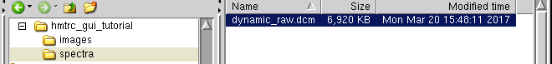

1. **Load DICOM Anatomical Images:**

* From the GUI click and hold on thefolder icon just left of the “images” label in the toolbar.

Macintosh HD:Users:bolson:Desktop:2dcsi_workflow:open_spec.tiff

* Select “Load Data” from drop down menu.
* Navigate to sample MRI file (hmtrc\_gui\_tutorial/images).
* Select the “ax\_pre.dcm” file and click on the “open” button.

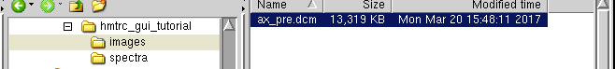

* The first time point from the 2D array of raw spectra will be displayed (k-space, time domain, test slider for Time Point).

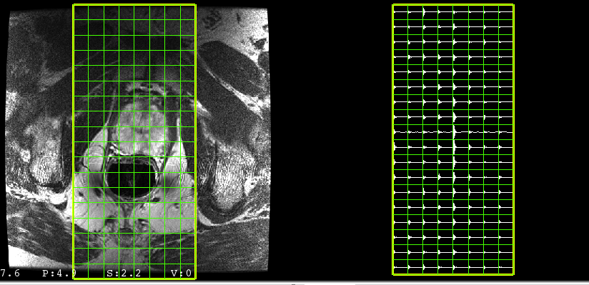

1. **Apodize Spectra:** Click on the“Preproc” tab under the spectra.

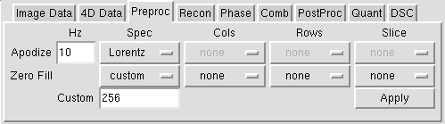

* Select a Lorentzian apodization window in the drop-down menu under the “Spec” column.
* Set the width to 10 in the box under the “Hz” column.
* Click “Apply” to apodize the spectra.

1. **Reconstruct data:** Click on the“Recon” tab under the spectra.

* Click on “Transform” to perform spatial and spectral FFT reconstruction.
* Reconstructed MRS data will be displayed. (WARNING: This can take some time depending on CPU power. If needed reconstructed results are included here: spectra/reconstructed.dcm).

1. **Adjust MRS view:**

* Click on the “Voxel Selection” interactor on the toolbar, then use mouse to select voxels within the prostate.

:::Library:Mail Downloads:var2dcsi_screenshots:select_voxels_after_recon_image.png

* Click on the “Window/Level” interactor on the toolbar and drag the mouse across the image to adjust the reference image contrast.

:::Library:Mail Downloads:var2dcsi_screenshots:select_voxels_after_recon_image.png

* Change MRS view to display magnitude spectra by clicking on the button next to the MRS amplitude slider and select “mag” (see below).
* Change the “Time Point” slider to view dynamic changes in MRS data vs time (24 time points, see below).
* Reset MRS amplitude (eye interactor -> “Reset 4D Amp Range to Current Voxels”)

:::Library:Mail Downloads:var2dcsi_screenshots:select_voxels_after_recon_image.png

**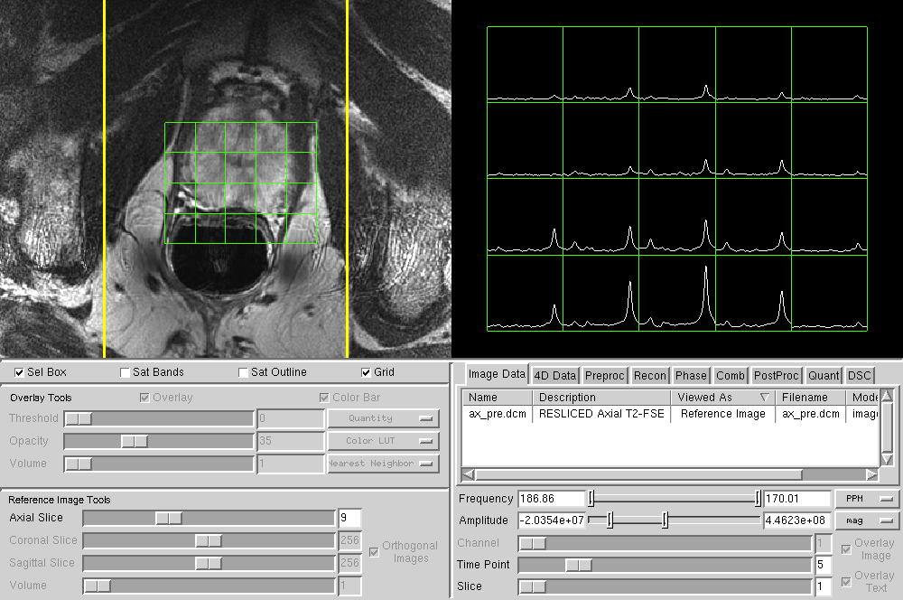**

Time Slider

Magnitude

1. **Quantify metabolites at each time point:**

Here the magnitude peak heights of pyruvate and lactate will be quantified at each time point. The resulting values will be written to dynamic metabolite maps in DICOM Enhanced MRI format and used as inputs to the kinetic modeling application below.

* Click on the“Quant” tab under the spectra. The tab shows the PPM ranges for a set of peaks to be quantified. These ranges are used for finding peak heights or computing integrated areas.

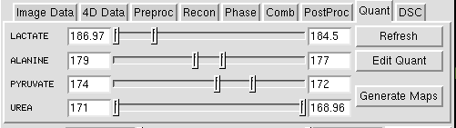

* Click on a single voxel that shows the largest lactate signal (e.g. time point 5).
* When a single voxel is selected a green cursor will appear that can be used to determine PPM ranges (orange oval below) to use for generating metabolite maps. Determine the upper and lower frequency for quantifying lactate and pyruvate. Enter these values in the appropriate boxes. For the screenshots shown below 174-170 ppm was used for pyruvate and 186.5-182.5 ppm was used for lactate.

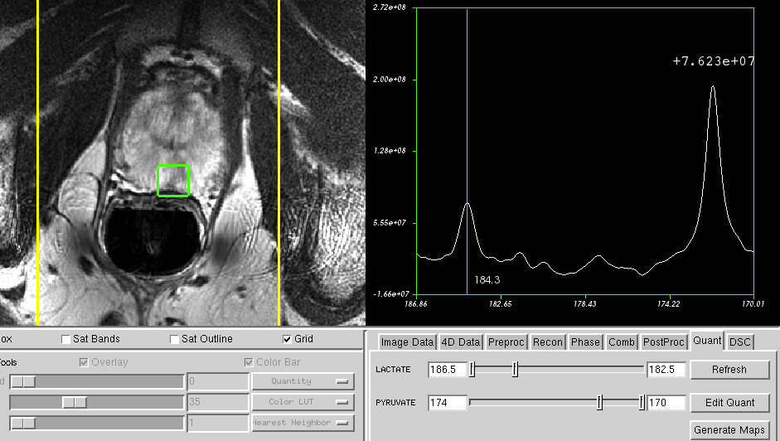

**pyruvate**

**lactate**

* Click on the “Generate Maps” button (above) to create a set of metabolite maps for each defined spectral peak (quantifies all voxels at each time point).

1. **Visualize Metabolite Maps:**

* Click on the “Image Data” tab to see a list of all generated metabolite maps. Scroll down and right click on the “PYRUVATE\_MAG\_PEAK\_HT” map. Select “Set As Overlay”. The map will be displayed as a color overlay on the image.

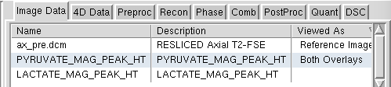

* Under the image in the “Overlay Tools” section drag the “Volume” slider to view how the peak height values change with time during the acquisition. The spectra on the right are synchronized to this slider and will also change.

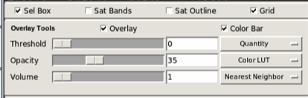

* Overlay the LACTATE\_MAG\_PEAK\_HT map as above and observe how the lactate signal changes.

1. **Display metabolite maps as a function of time to see dynamics:**

* Right click on the PYRUVATE\_MAG\_PEAK\_HT metabolite map in the “Image Data” tab and select “Set As Dynamic Traces”. The spectral view (amplitude vs. frequency) will be replaced with a view showing the temporal change of the metabolite (magnitude peak height vs. time) for each voxel. Repeat for the lactate metabolite map so both dynamic traces are visible.
* Select prostate voxels with high signal as in step 10 and reset the 4D amplitude.

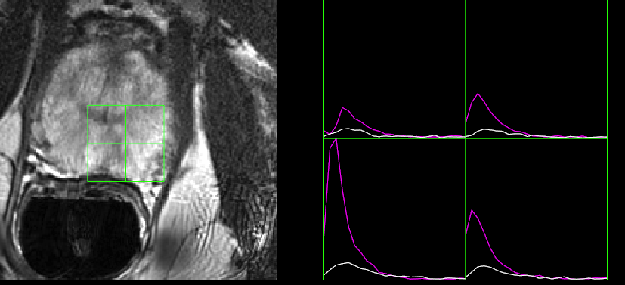

* Save the dynamic metabolite maps as DICOM images. These will be used later for fitting data to a kinetic model.
* select File>> Save Metabolite Maps.
* Select “Files of Type” = DICOM Enhanced MRI
* **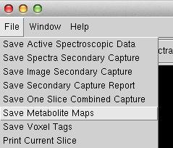**Navigate to the hmtrc\_gui\_tutorial directory and enter the root name, e.g. “pc\_”
* Click “save”

1. **Generate an ROI mask of the prostate:** This will be used to mask the kinetic modeling calculation.

* Select: Windows>>Voxel Tagging
* In the window click “Create Tag Data”.

This will create a new blank image with the same resolution and spatial parameters as the spectroscopic data. It will appear in the “Image Data” tab.

* In the Voxel Tagging window highlight the row with the first voxel label (Tag Value 1).
* Highlight the row with the first voxel label (Tag Value 1). Click on voxels within the prostate (~20voxels).

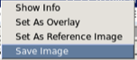 **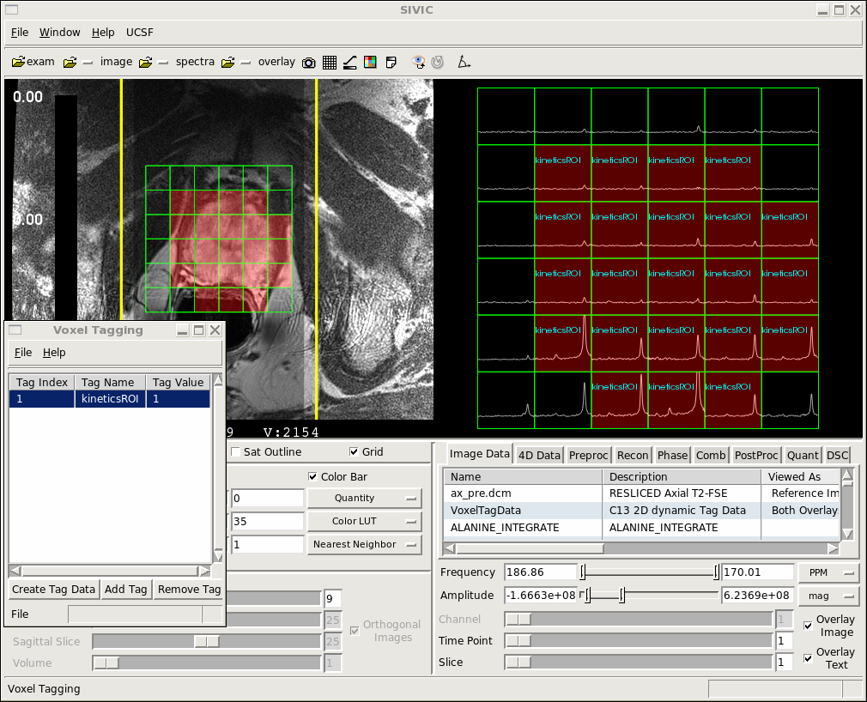**

Select voxels

* In the “Image Data” tab, select the “VoxelTagData” file, right click and save this ROI mask as an Enhanced DICOM object. Name it “mask”
* Close the GUI.

1. **Fit pyruvate and lactate dynamics to a kinetic model to generate 3D kinetic parameter maps:**

* Return to your Terminal or MS-DOS prompt and navigate to the location where your dynamic metabolite maps and mask ROI file are saved.
* Run svk\_met\_kinetics to fit kinetic data at each voxel within the mask ROI:

***LINUX/OSX Terminal***

/YOUR\_INSTALL\_PATH/local/bin/svk\_met\_kinetics --i1 PYRUVATE\_MAG\_PEAK\_HT.dcm --i2 LACTATE\_MAG\_PEAK\_HT.dcm --mask mask.dcm --model 1 -o model1 --tr 5

***Windows MS-DOS prompt***

svk\_met\_kinetics.bat --i1 PYRUVATE\_MAG\_PEAK\_HT.dcm --i2 LACTATE\_MAG\_PEAK\_HT.dcm --mask mask.dcm --model 1 -o model1 --tr 5

* Once the program completes a set of files named model1\*.dcm will have been created (fits, param maps, residuals).

1. **Load Model Results into the SIVIC GUI**

* Restart the SIVIC GUI from the command line

sivic --id PYRUVATE\_MAG\_PEAK\_HT.dcm --id model1\_pyr\_fit.dcm --id model1\_pyr\_residual.dcm -i mask.dcm --id LACTATE\_MAG\_PEAK\_HT.dcm --id model1\_lac\_fit.dcm --id model1\_lac\_residual.dcm -i model1\_T1all.dcm -i model1\_Kpl.dcm -i model1\_dcoffset.dcm -i model1\_rss.dcm

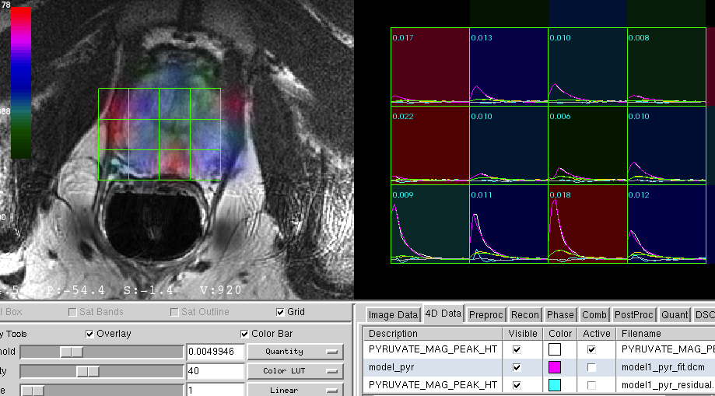

1. **Save Secondary Capture DICOM report**

* Once you have a display set up that shows the fitted results, save the scene as a secondary capture image by clicking on the camera icon on the toolbar. If you are on an OsX machine with OsiriX loaded you can send the DICOM Secondary Capture directly to OsiriX PACS by clicking on (OsiriX SC) in the toolbar.

Macintosh HD:Users:jasonc:Desktop:hmtrc_screens:scene.tiff

