Assignment 03

# Task 01 ● Ask AI to write a function to calculate compound interest, starting with only the function name. Then add a docstring, then input-output example

Expected Output  
● Comparison of AI-generated code styles

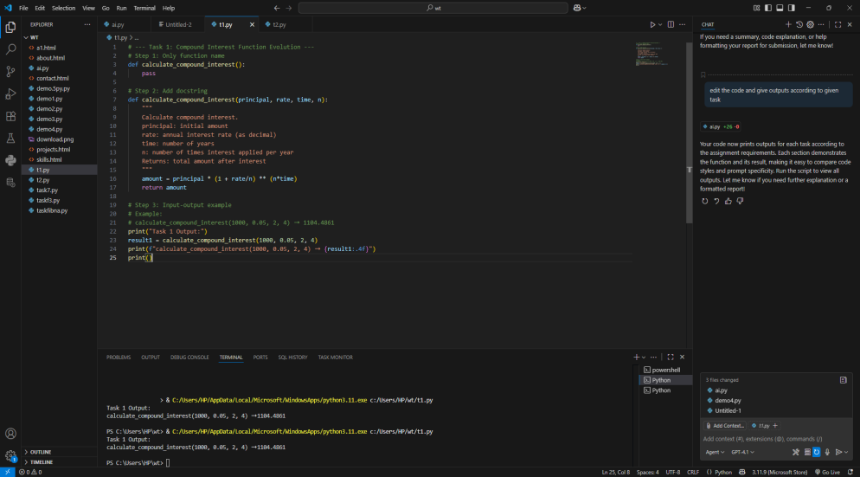

# Task 02

● Do math stuff, then refine it to: # Write a function to calculate average, median, and  
mode of a list of numbers.  
Expected Output  
● AI-generated function evolves from unclear to accurate multi-statistical operation

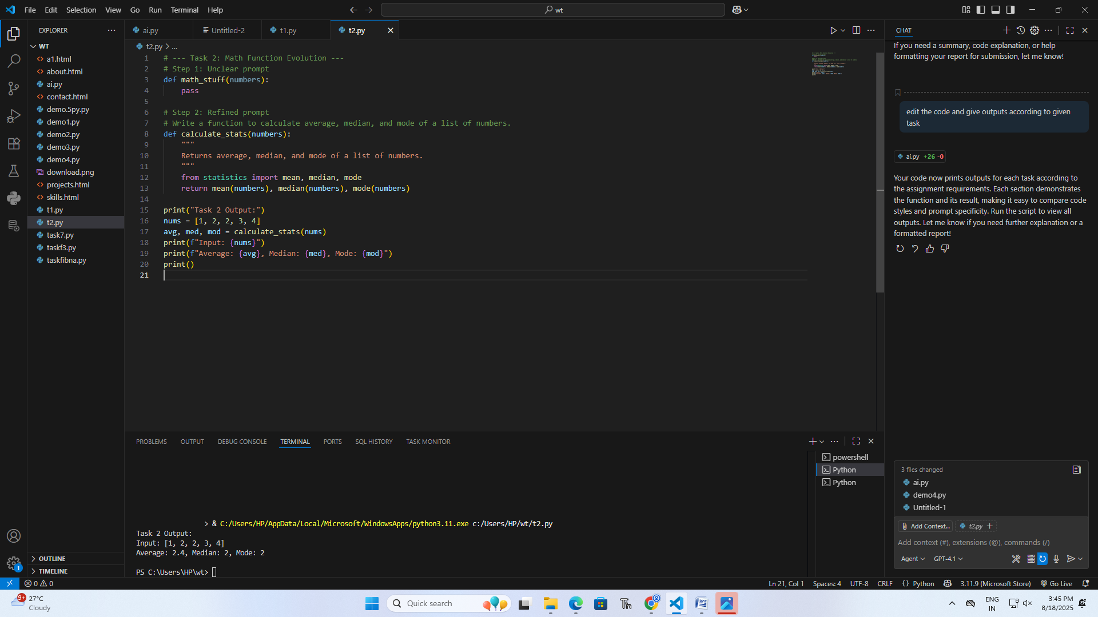

# Task 03

● Provide multiple examples of input-output to the AI for convert_to_binary(num)  
function. Observe how AI uses few-shot prompting to generalize.  
Expected Output  
● Enhanced AI output with clearer prompt

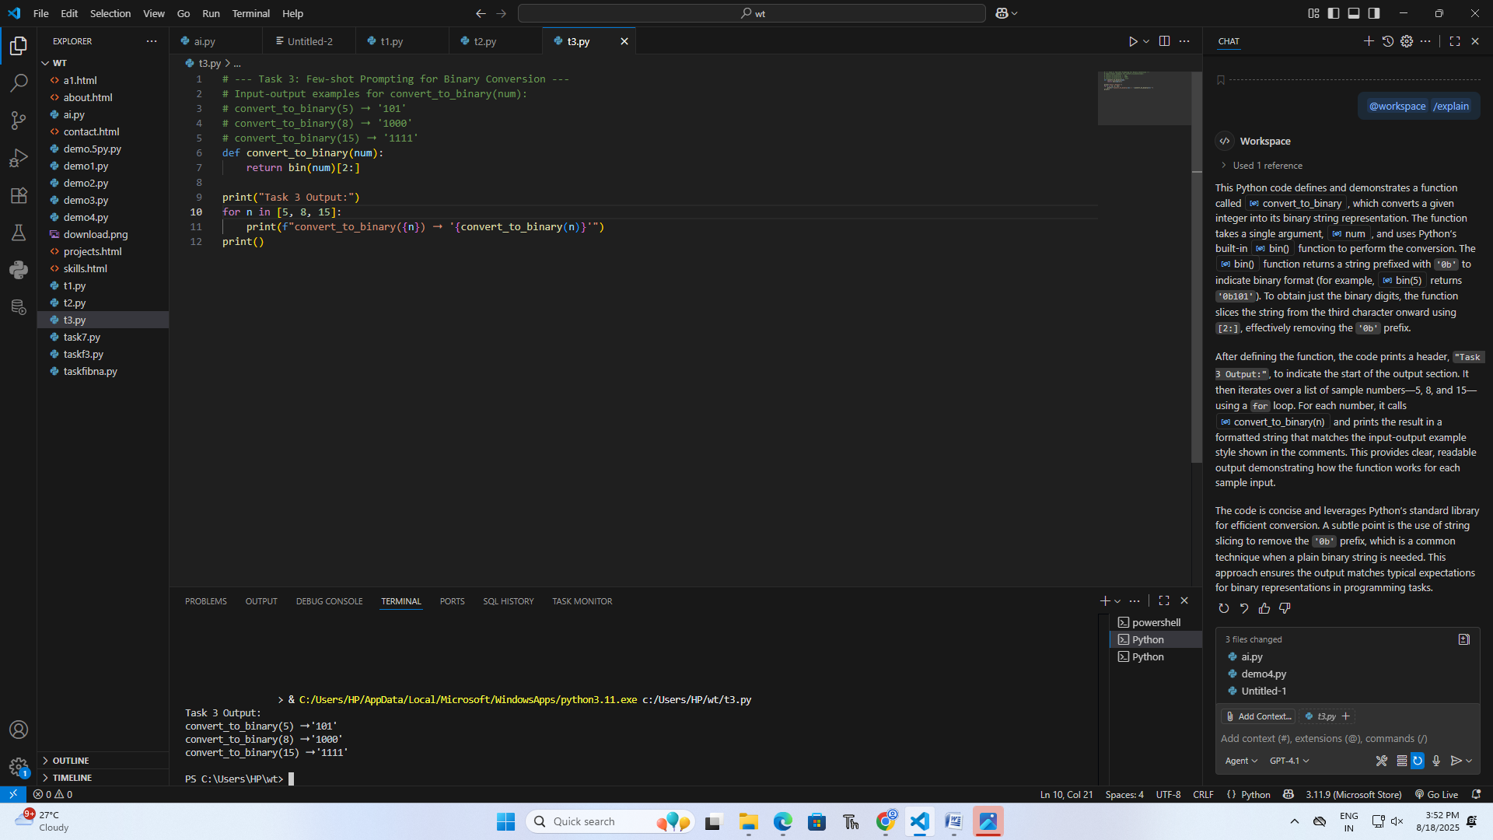

# Task 04

● Create an user interface for an hotel to generate bill based on customer requirements  
Expected Output  
● Consistent functions with shared logic

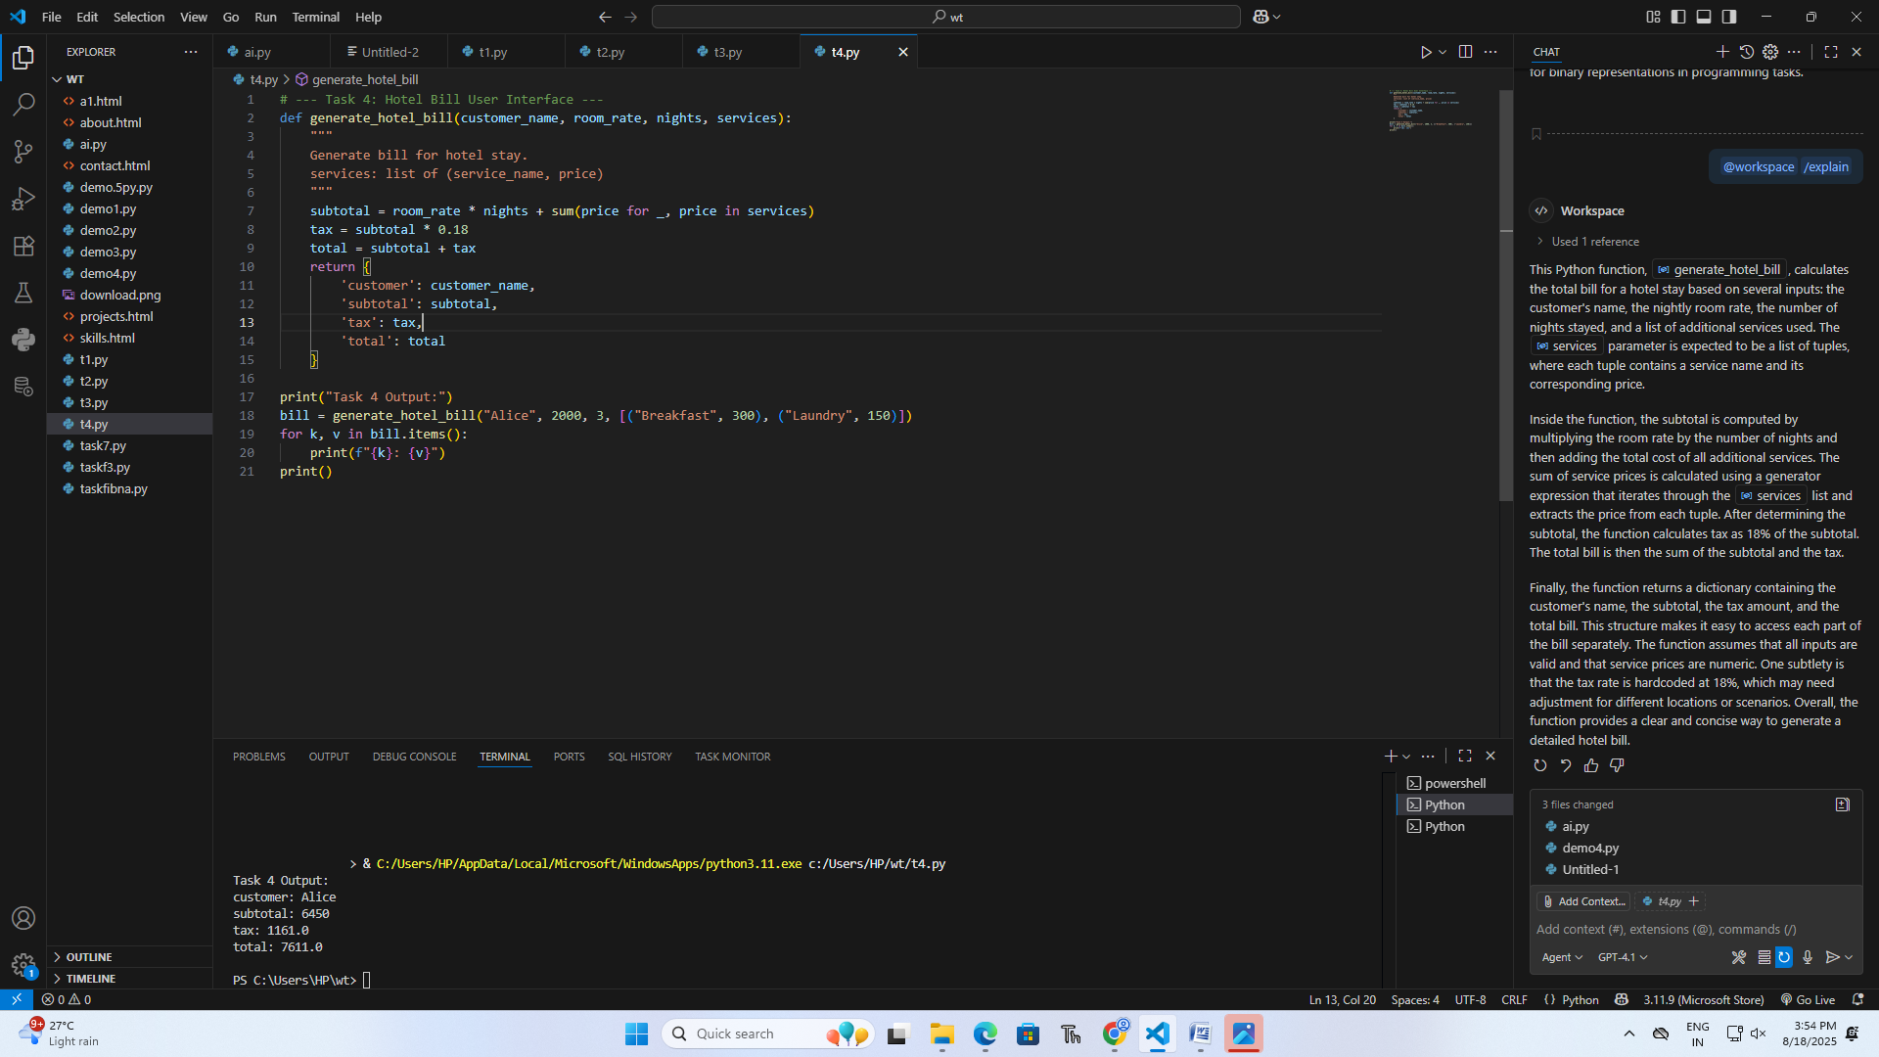

# Task 05

● Analyzing Prompt Specificity: Improving Temperature Conversion Function with  
Clear Instructions  
Expected Output  
● Code quality difference analysis for various prompt

