PWR_BOOST_5P0 | VCC_MPU alone
Power Test Report | Measurement Report
`
System Configurations:
Model Name | Jaws
Stage | EV1B
PCB Version | 21H002-SD

Contents:
 | 1. Testing Configurations | Page | 1
 | 2. Measurement Results  2.1 Regulation at normal temperature  2.2 Output Voltage Ripple/Noise  2.3 Output Load Transient  2.4 Efficiency  2.5 Output Voltage Rising Time  2.6 Inrush Current | Page | 2~3
Appendix:
 | Waveform Charts | Page

Comments: | PASS
Prepared by: | Max YC Chen | Date: | 2021/12/21
Approved by: |  | Date:

1. Testing Configurations

1.1 Testing Date: | 2021/12/21

1.2 Testing Place: | Wistron Labortory

1.3 Testing Environment: | -20 ℃ 25 ℃ 50 ℃

1.4 Testing Equipments
 | Scope: | Tektronix TDS 744A 100MHz (4ch, 2Gs)  Tektronix TDS 784D 1GHz (4ch., 4GS/s)  Tektronix TDS 524A 100MHz (4ch., 100MS/s)  Tektronix DPP 4104B 1GHz (4ch., 5GS/s)
 | Probe: | Signal Integrity Analysis:  Agilent 10073D <15pF 1MΩ 100MHz 10X (Passive Probe)  Tektronix P5050 <11.1pF 10MΩ 100MHz 10X (Passive Probe)  Current Measurement:  Tektronix TCP0030A ~120MHz, 30A Max DC(Current Probe)  Tektronix A6302, AM503, TM502A ~50MHz, 20A Max DC, 50A peak pulse (Current Probe)  Tektronix A6303, ~15MHz, 100A Max DC, 100A peak pulse (High Current Probe)
 | Power Supply | Agilent 66309D Dual output  GOOD WILL GPC-3050D
 | Electronic Load | Chroma 63610 (80V/20A/1500W)  PRODIGIT 3316 (50V/120A)

1.5 Testing Methodology/Procedure
1.Output voltage regulation at normal temperature (static line, load regulation) | Measure the output voltages for any combinations of input voltages and load currents.
2.Output voltage ripple/noise | Measure output voltage ripple /noise for any  combinations of input voltages and load currents.
3.Load Transient | Measure the output voltages and currents at 0.1Imax~Imax 1KHz dynamic, duty = 1/2, skew rate=1.27A/us.
4.Output Voltage Rising Time | 1. Input power at VIN ready.  2. Enable the power converter.  3. Measure signals input, enable and output by scope.
5.Efficiency | Measure the input voltage, input current and output voltage, output load to calculate power efficiency.

- 2. Measurement Results
- Vin = 3.6V~4.4V, Imin = 100 mA, Imax = 1500mA
2.1 Regulation at normal temperature
 |  | Spec.(V) | Vrms[V] | Vmin[V] | Vmax[V] |  | Comment
4.4V | Imax 1500mA@-20℃ | 4.6~5.4 | 5.12 | 5.10 | 5.13 |  | ■Pass Fail
4.4V | Imin 100mA@-20℃ | 4.6~5.4 | 5.20 | 5.18 | 5.23 |  | ■Pass Fail
3.6V | Imax 1500mA@-20℃ | 4.6~5.4 | 5.12 | 5.09 | 5.14 |  | ■Pass Fail
3.6V | Imin 100mA@-20℃ | 4.6~5.4 | 5.20 | 5.18 | 5.22 |  | ■Pass Fail
4.4V | Imax 1500mA@25℃ | 4.6~5.4 | 5.12 | 5.10 |  | 5.14 | ■Pass Fail
4.4V | Imin 100mA@25℃ | 4.6~5.4 | 5.21 | 5.19 |  | 5.23 | ■Pass Fail
3.6V | Imax 1500mA@25℃ | 4.6~5.4 | 5.12 | 5.10 |  | 5.15 | ■Pass Fail
3.6V | Imin 100mA@25℃ | 4.6~5.4 | 5.21 | 5.19 |  | 5.23 | ■Pass Fail
4.4V | Imax 1500mA@50℃ | 4.6~5.4 | 5.12 | 5.10 |  | 5.14 | ■Pass Fail
4.4V | Imin 100mA@50℃ | 4.6~5.4 | 5.21 | 5.19 |  | 5.23 | ■Pass Fail
3.6V | Imax 1500mA@50℃ | 4.6~5.4 | 5.13 | 5.10 |  | 5.15 | ■Pass Fail
3.6V | Imin 100mA@50℃ | 4.6~5.4 | 5.21 | 5.19 |  | 5.23 | ■Pass Fail

2.2 Output Voltage Ripple/Noise
Description |  | Spec. (mV) |  | Measured(mV) |  | Comment
 |  | Ripple | R+N | Ripple | R+N
Fig. 2-1 | Vin 4.4V  load current = Imax1500mA@-20℃ | 250 |  | 32.0 |  | ■Pass Fail
Fig. 2-2 | Vin 4.4V  load current = Imin  100mA @-20℃ | 250 |  | 52.0 |  | ■Pass Fail
Fig. 2-3 | Vin 3.6V  load current = Imax 1500mA@-20℃ | 250 |  | 47.2 |  | ■Pass Fail
Fig. 2-4 | Vin 3.6V  load current = Imin  100mA @-20℃ | 250 |  | 49.6 |  | ■Pass Fail
Fig. 2-5 | Vin 4.4V  load current = Imax  1500mA@25℃ | 250 |  | 40.8 |  | ■Pass Fail
Fig. 2-6 | Vin 4.4V  load current = Imin  100mA @25℃ | 250 |  | 44.0 |  | ■Pass Fail
Fig. 2-7 | Vin 3.6V  load current = Imax 1500mA@25℃ | 250 |  | 45.6 |  | ■Pass Fail
Fig. 2-8 | Vin 3.6V  load current = Imin  100mA @25℃ | 250 |  | 44.0 |  | ■Pass Fail
Fig. 2-9 | Vin 4.4V  load current = Imax 1500mA@50℃ | 250 |  | 36.0 |  | ■Pass Fail
Fig. 2-10 | Vin 4.4V  load current = Imin  100mA @50℃ | 250 |  | 42.4 |  | ■Pass Fail
Fig. 2-11 | Vin 3.6V  load current = Imax 1500mA@50℃ | 250 |  | 43.2 |  | ■Pass Fail
Fig. 2-12 | Vin 3.6V  load current = Imin  100mA @50℃ | 250 |  | 45.6 |  | ■Pass Fail

2.3 Load Transient
Imin = 100 mA, Imax = 1500mA, 1KHz dynamic, duty = 1/2, skew rate=0.25A/us
Description |  | Spec. (V) |  | Measured(V) | Comment | Imax
 |  | Min. | Max. | Measured(V) | Comment
-20℃
Fig. 3-1 | Vin = 4.4V | 4.0 | 6.0 | 4.70~5.57 | ■Pass Fail
Fig. 3-2 | Vin = 3.6V | 4.0 | 6.0 | 4.63~5.64 | ■Pass Fail
25℃
Fig. 3-3 | Vin = 4.4V | 4.0 | 6.0 | 4.62~5.68 | ■Pass Fail
Fig. 3-4 | Vin = 3.6V | 4.0 | 6.0 | 4.57~5.75 | ■Pass Fail
50℃
Fig. 3-5 | Vin = 4.4V | 4.0 | 6.0 | 4.59~5.69 | ■Pass Fail
Fig. 3-6 | Vin = 3.6V | 4.0 | 6.0 | 4.57~5.77 | ■Pass Fail

2.4 Line Transient
Description |  | Spec. (V) |  | Measured(V) | Comment | Remark
 |  | Min. | Max. | Measured(V) | Comment
-20℃
Fig. 4-1 | Vin 3.6V~4.4V  Imax 1500mA  Fall Edge | 4.6 | 5.4 | 5.08~5.13 | ■Pass Fail
Fig. 4-2 | Vin 3.6V~4.4V  Imin 100mA  Fall Edge | 4.6 | 5.4 | 5.18~5.23 | ■Pass Fail
Fig. 4-3 | Vin 3.6V~4.4V  Imax 1500mA  Rise Edge | 4.6 | 5.4 | 5.09~5.17 | ■Pass Fail
Fig. 4-4 | Vin 3.6V~4.4V  Imin 100mA  Rise Edge | 4.6 | 5.4 | 5.18~5.23 | ■Pass Fail
25℃
Fig. 4-5 | Vin 3.6V~4.4V  Imax 1500mA  Fall Edge | 4.6 | 5.4 | 5.08~5.14 | ■Pass Fail
Fig. 4-6 | Vin 3.6V~4.4V  Imin 100mA  Fall Edge | 4.6 | 5.4 | 5.19~5.23 | ■Pass Fail
Fig. 4-7 | Vin 3.6V~4.4V  Imax 1500mA  Rise Edge | 4.6 | 5.4 | 5.10~5.19 | ■Pass Fail
Fig. 4-8 | Vin 3.6V~4.4V  Imin 100mA  Rise Edge | 4.6 | 5.4 | 5.18~5.23 | ■Pass Fail
50℃
Fig. 4-9 | Vin 3.6V~4.4V  Imax 1500mA  Fall Edge | 4.6 | 5.4 | 5.07~5.14 | ■Pass Fail
Fig. 4-10 | Vin 3.6V~4.4V  Imin 100mA  Fall Edge | 4.6 | 5.4 | 5.19~5.23 | ■Pass Fail
Fig. 4-11 | Vin 3.6V~4.4V  Imax 1500mA  Rise Edge | 4.6 | 5.4 | 5.10~5.20 | ■Pass Fail
Fig. 4-12 | Vin 3.6V~4.4V  Imin 100mA  Rise Edge | 4.6 | 5.4 | 5.19~5.23 | ■Pass Fail

2.5 Efficiency
Description | Input |  | Output |  | Power Efficiency
Description | Voltage(V) | Current(A) | Voltage(V) | Current(A) | Power Efficiency
-20℃
Vin 4.4V  load current = Imax 1500mA | 4.39 | 1.9340 | 5.12 | 1.5 | 90.46%
Vin 4.4V  load current=Imin 100mA | 4.40 | 0.1301 | 5.21 | 0.1 | 91.01%
Vin 3.6V  load current = Imax 1500mA | 3.59 | 2.3577 | 5.13 | 1.5 | 90.91%
Vin 3.6V  load current=Imin 100mA | 3.60 | 0.1566 | 5.21 | 0.1 | 92.42%
25℃
Vin 4.4V  load current = Imax1500mA | 4.39 | 1.9351 | 5.12 | 1.5 | 90.41%
Vin 4.4V  load current=Imin 100mA | 4.4 | 0.1306 | 5.21 | 0.1 | 90.67%
Vin 3.6V  load current = Imax 1500mA | 3.59 | 2.3574 | 5.13 | 1.5 | 90.92%
Vin 3.6V  load current=Imin 100mA | 3.6 | 0.1591 | 5.21 | 0.1 | 90.96%
50℃
Vin 4.4V  load current = Imax 1500mA | 4.39 | 1.9681 | 5.12 | 1.5 | 88.89%
Vin 4.4V  load current=Imin 100mA | 4.40 | 0.1355 | 5.21 | 0.1 | 87.39%
Vin 3.6V  load current = Imax 1500mA | 3.59 | 2.3566 | 5.13 | 1.5 | 90.96%
Vin 3.6V  load current=Imin 100mA | 3.60 | 0.1601 | 5.21 | 0.1 | 90.39%

Waveform#  Fig. 2-1 | Output Voltage Ripple  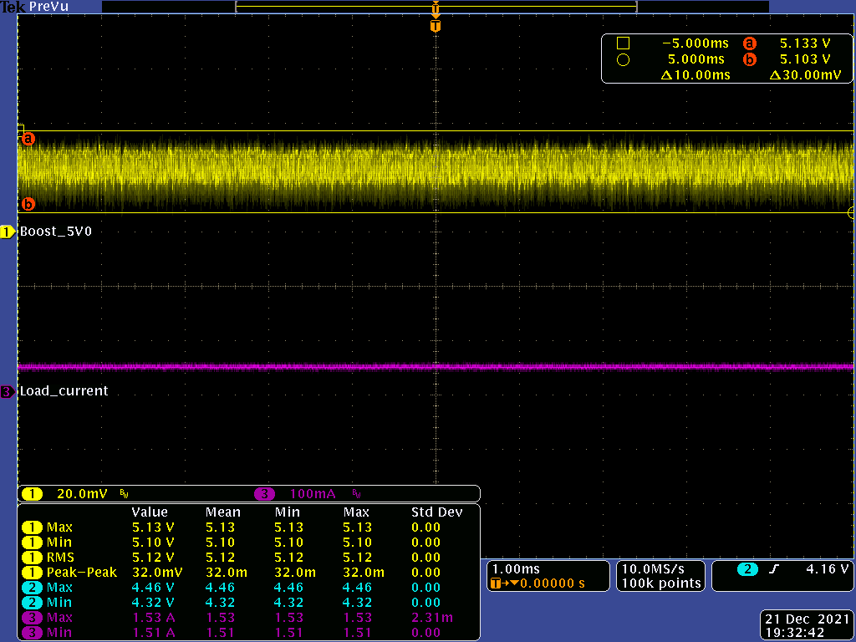 | Measurement:

Waveform#  Fig. 2-2 | Output Voltage Ripple  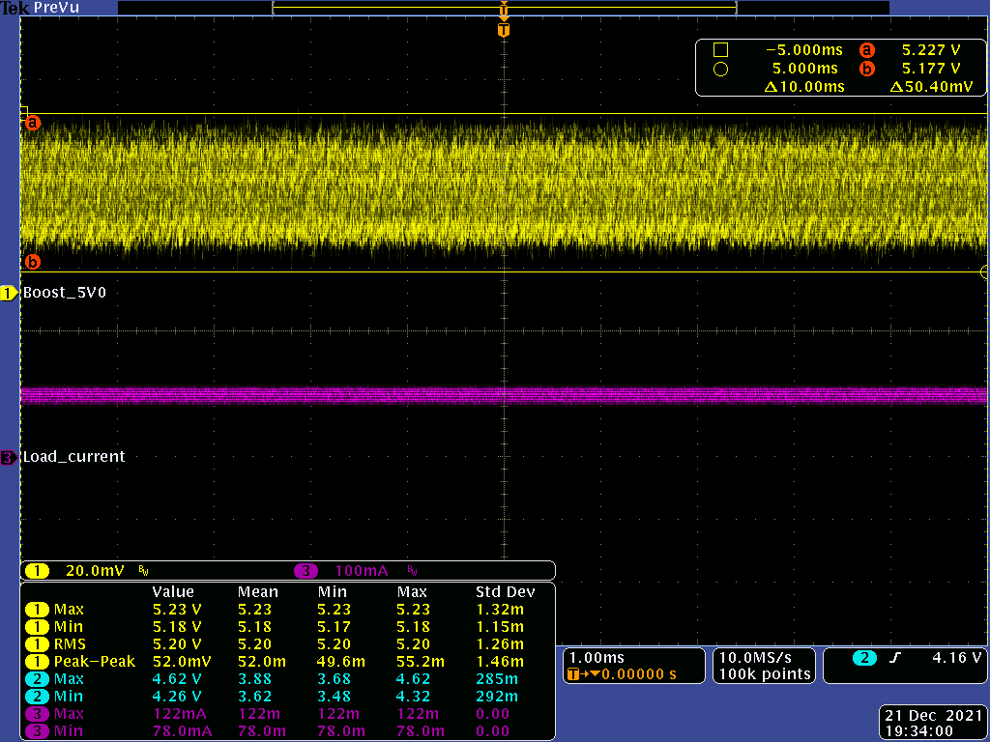 | Measurement:

Waveform#  Fig. 2-3 | Output Voltage Ripple  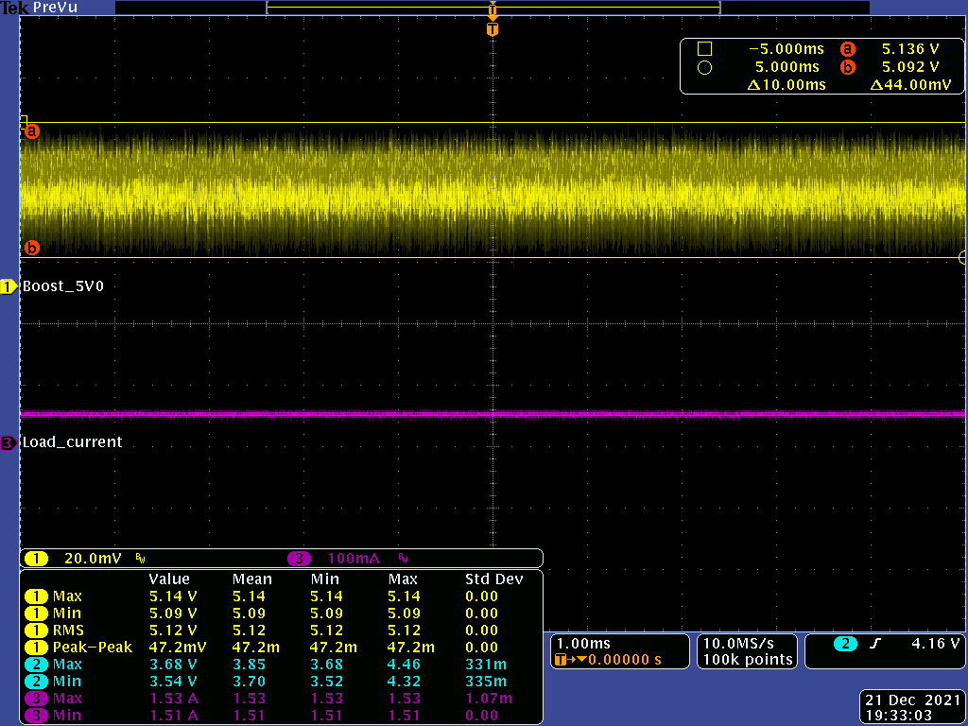 | Measurement:

Waveform#  Fig. 2-4 | Output Voltage Ripple  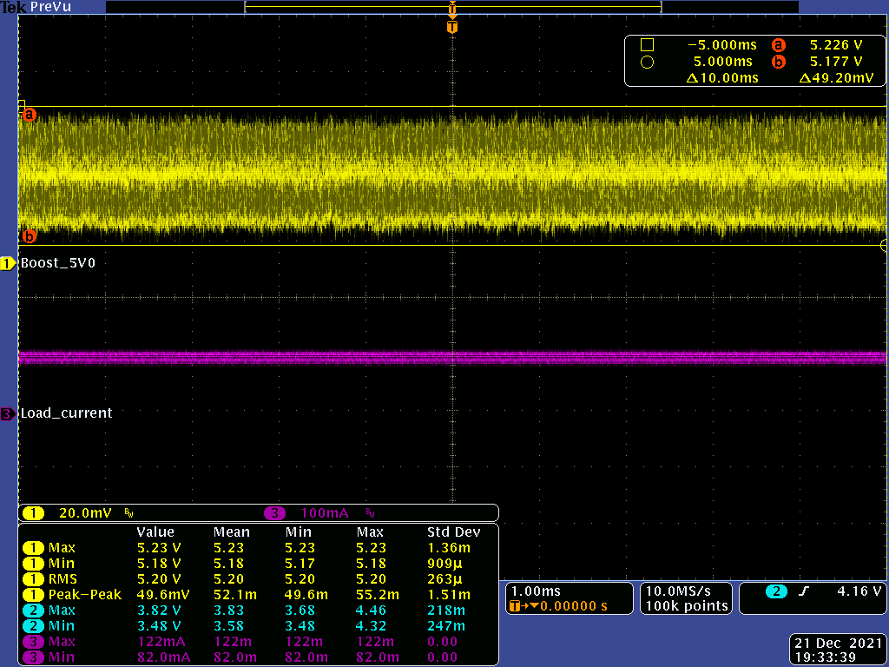 | Measurement:

Waveform#  Fig. 2-5 | Output Voltage Ripple  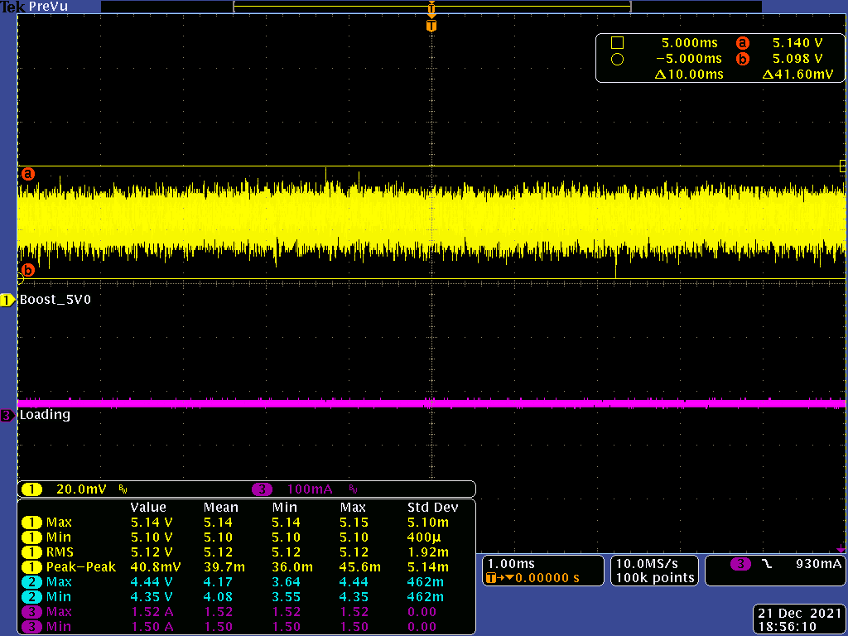 | Measurement:

Waveform#  Fig. 2-6 | Output Voltage Ripple  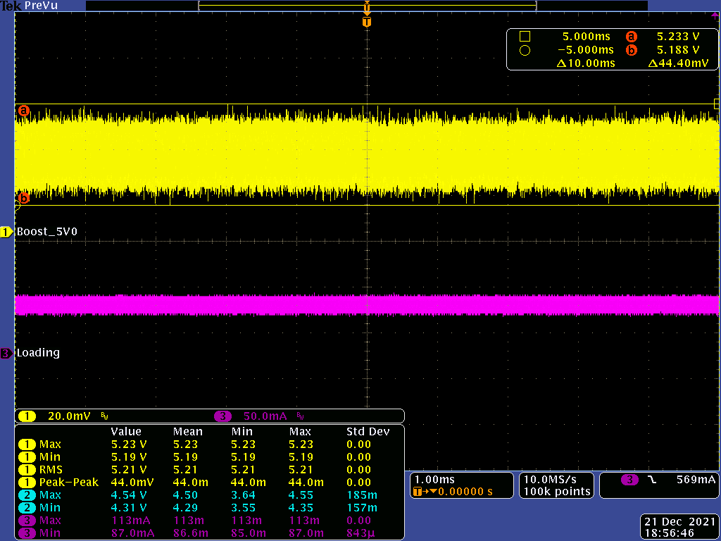 | Measurement:

Waveform#  Fig. 2-7 | Output Voltage Ripple  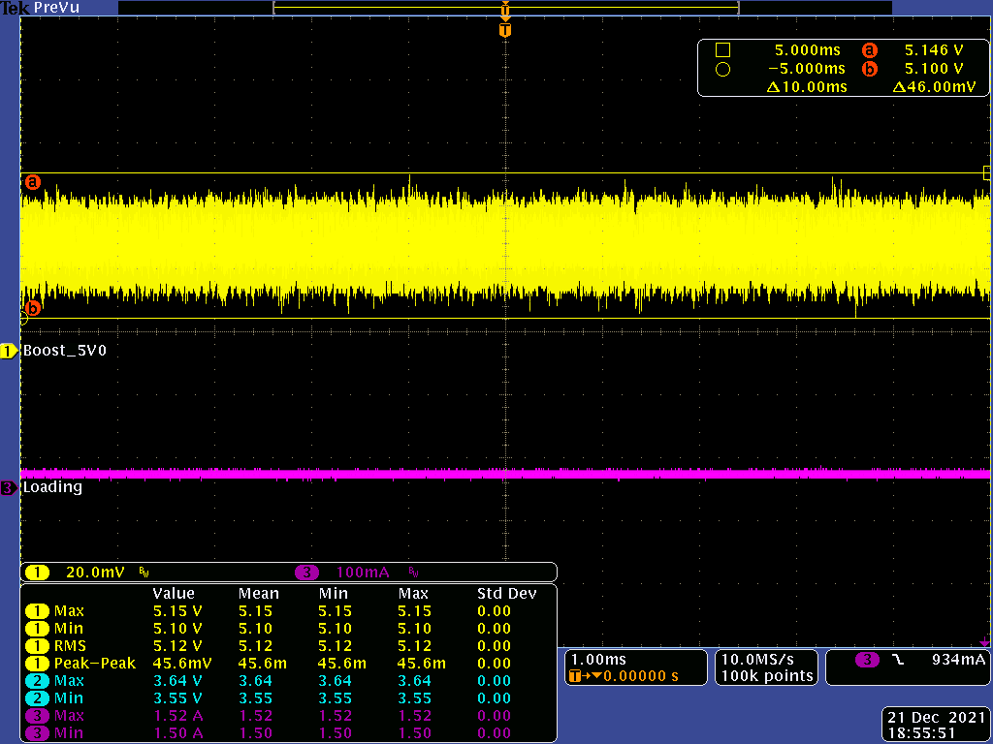 | Measurement:

Waveform#  Fig. 2-8 | Output Voltage Ripple  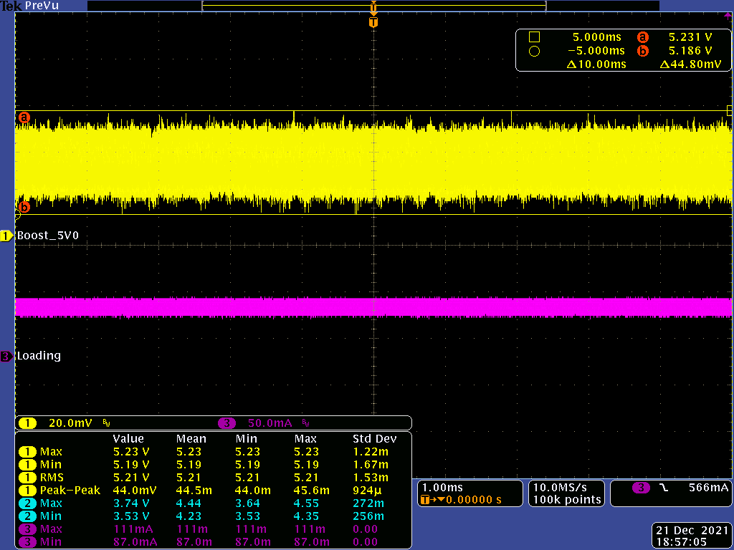 | Measurement:

Waveform#  Fig. 2-9 | Output Voltage Ripple  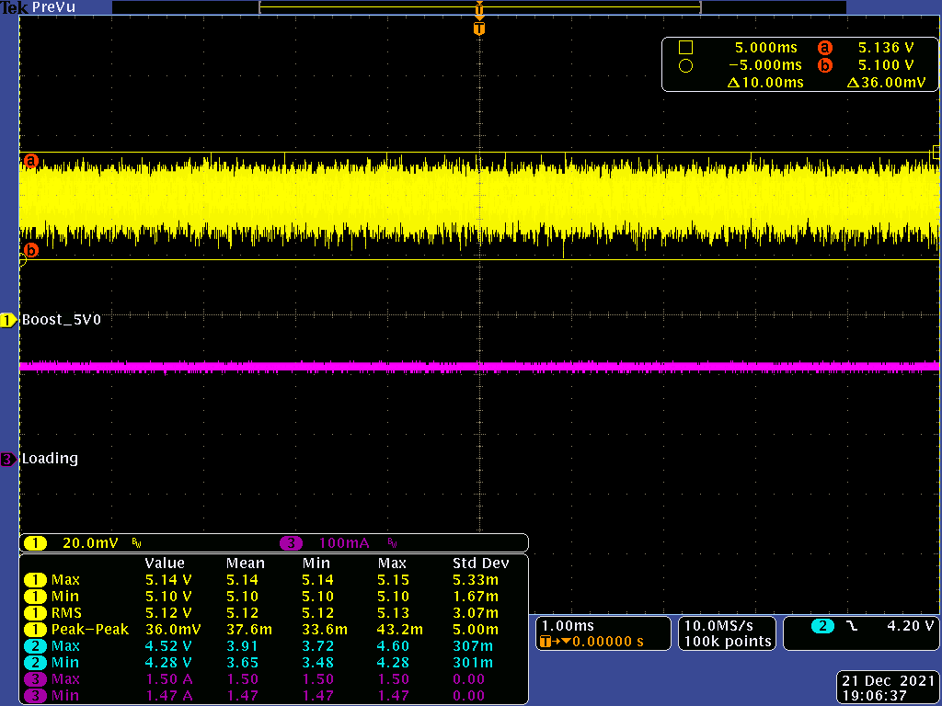 | Measurement:

Waveform#  Fig. 2-10 | Output Voltage Ripple  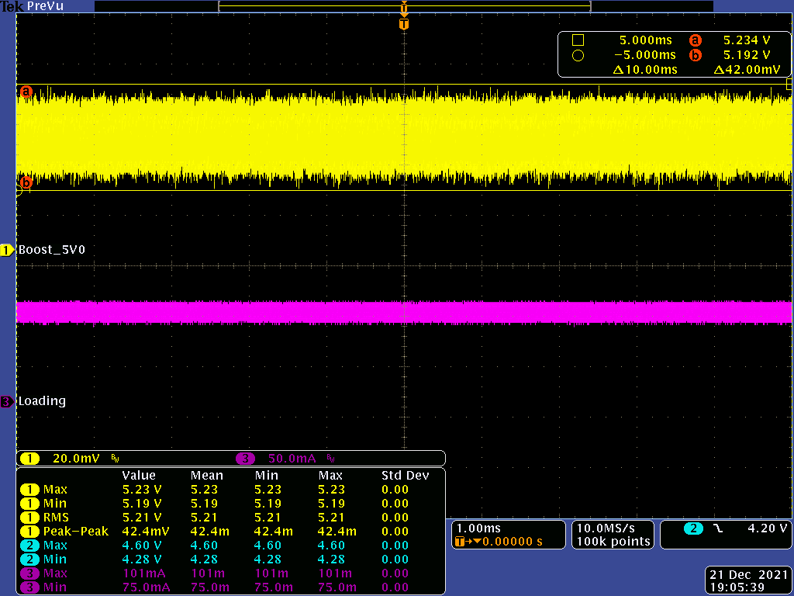 | Measurement:

Waveform#  Fig. 2-11 | Output Voltage Ripple  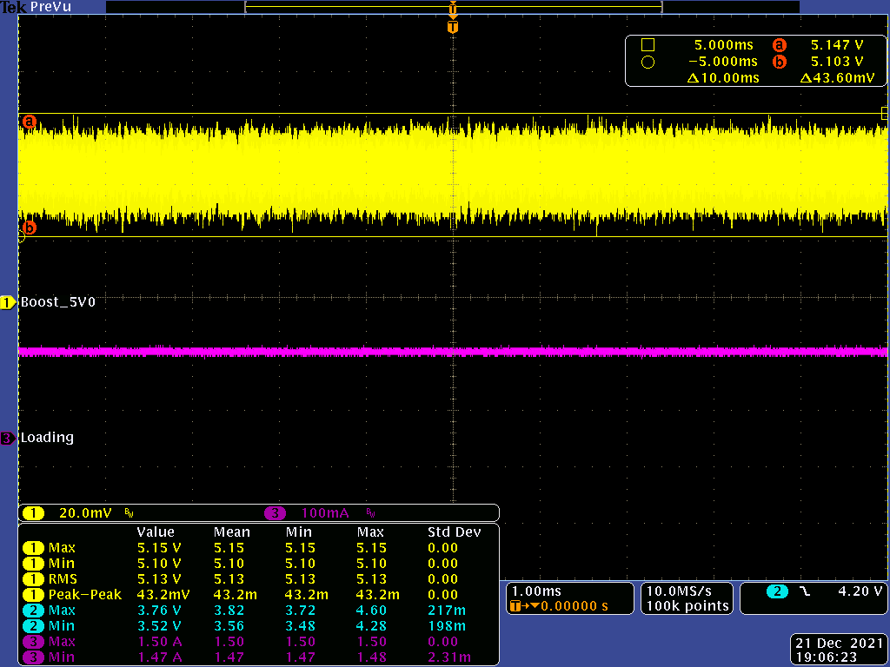 | Measurement:

Waveform#  Fig. 2-12 | Output Voltage Ripple  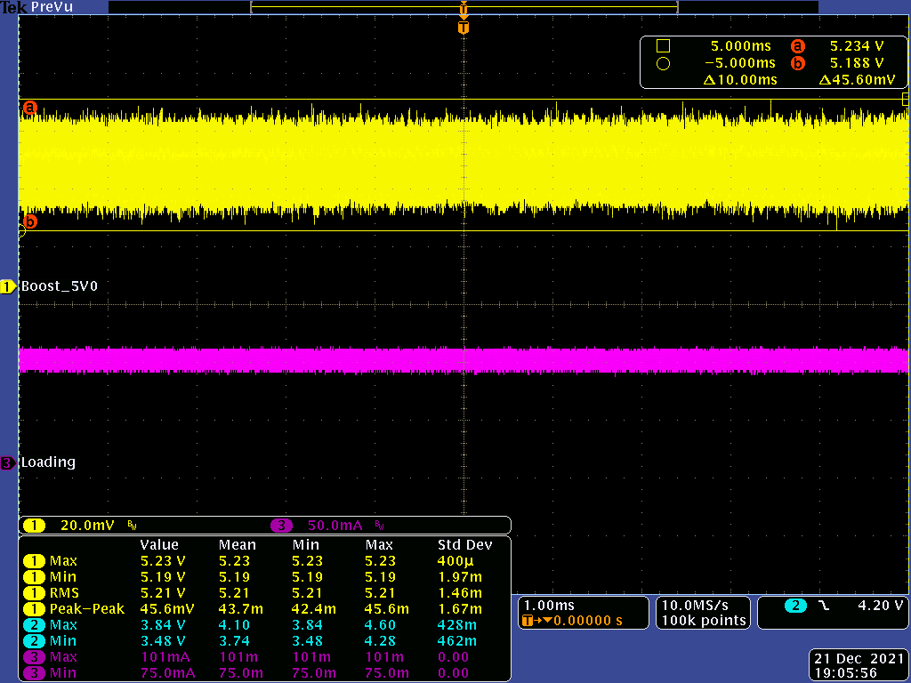 | Measurement:

Waveform#  Fig. 3-1 | Load Transient  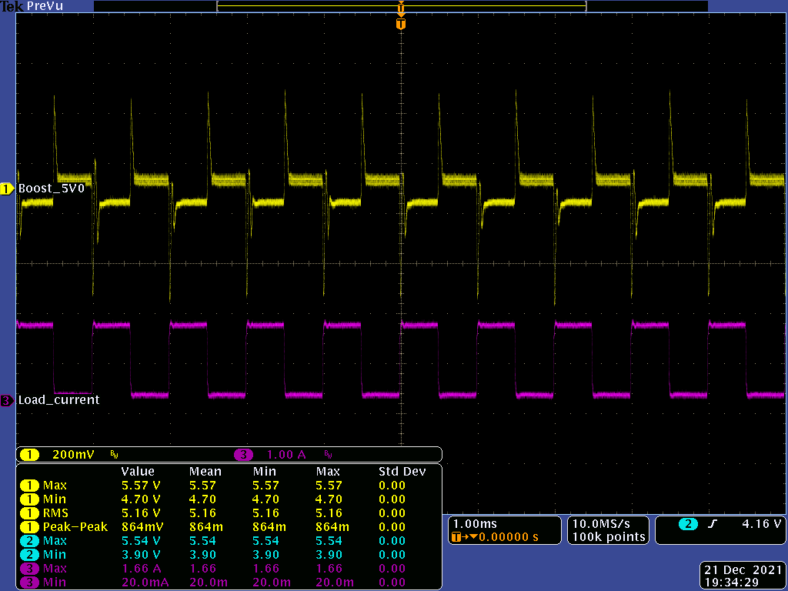 | Measurement:

Waveform#  Fig. 3-2 | Load Transient  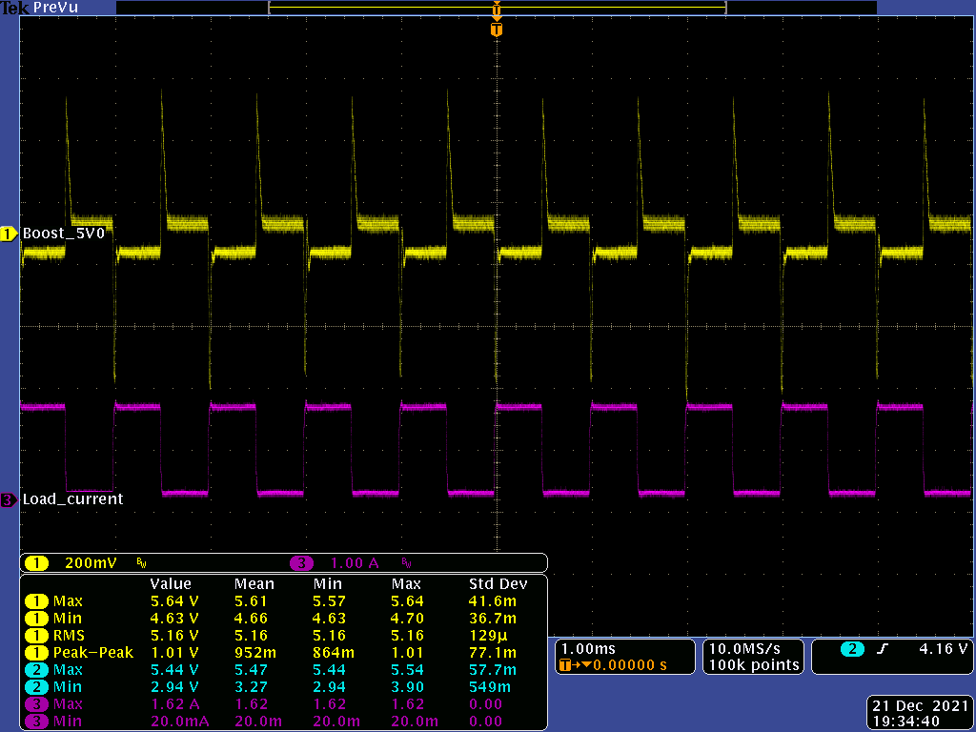 | Measurement:

Waveform#  Fig. 3-3 | Load Transient  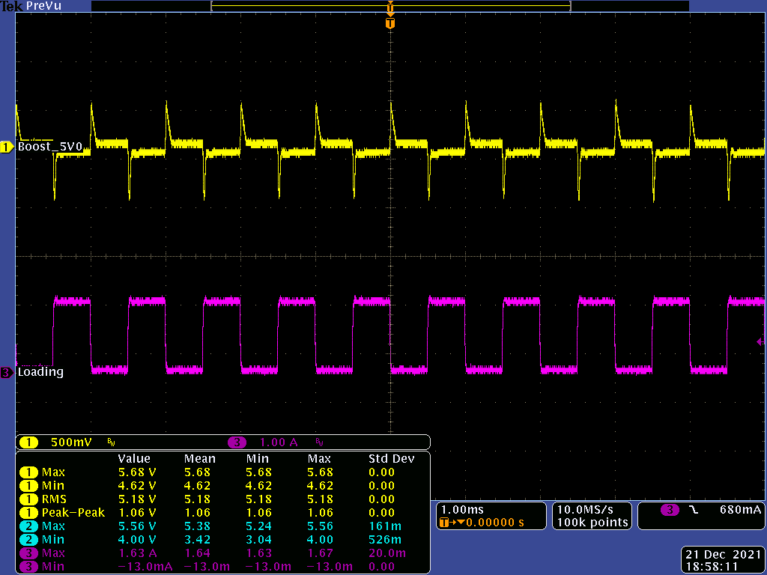 | Measurement:

Waveform#  Fig. 3-4 | Load Transient  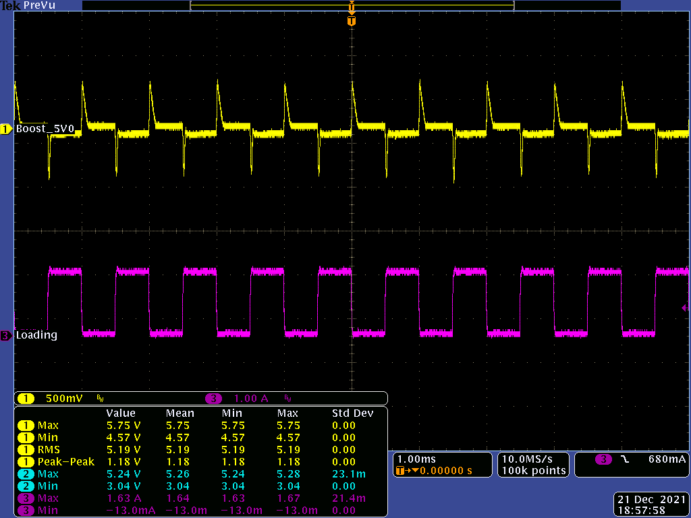 | Measurement:

Waveform#  Fig. 3-5 | Load Transient  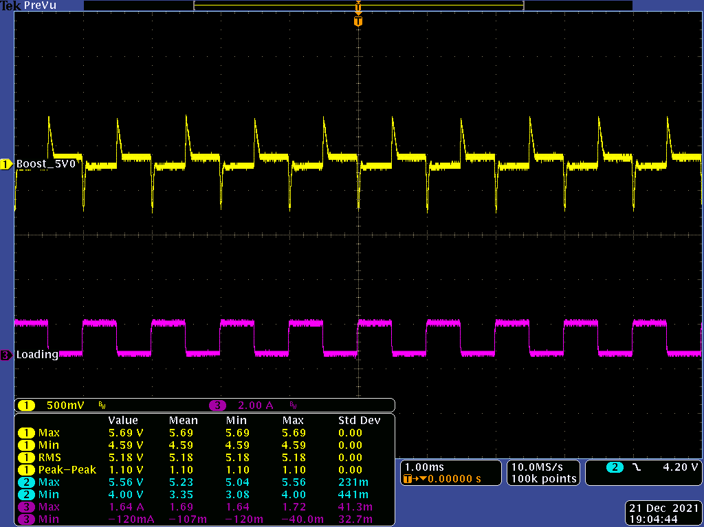 | Measurement:

Waveform#  Fig. 3-6 | Load Transient  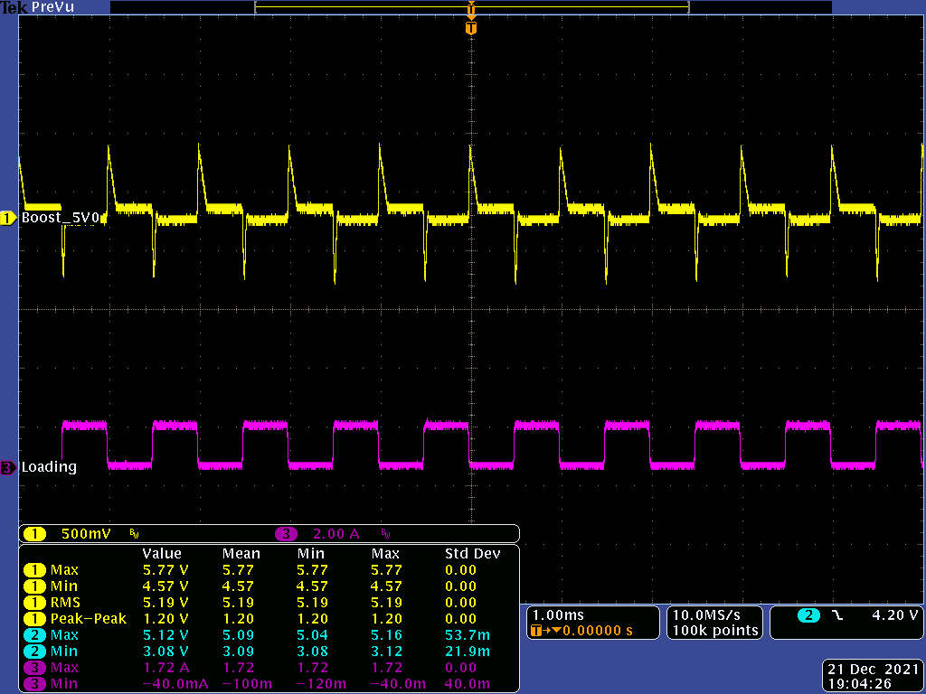 | Measurement:

Waveform#  Fig. 4-1 | Line Transient  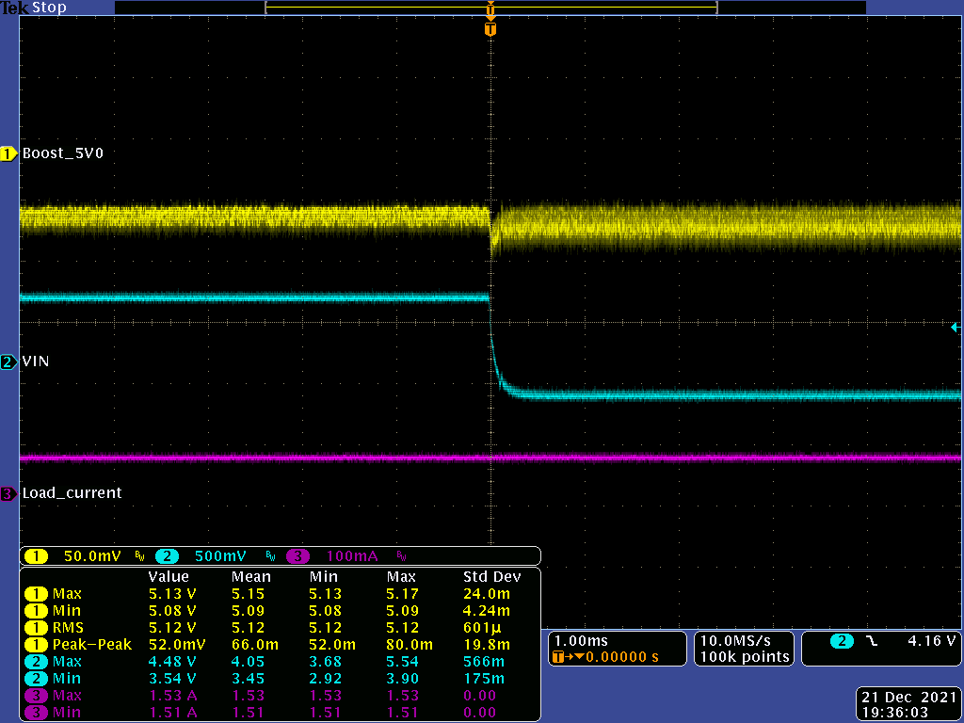 | Measurement:

Waveform#  Fig. 4-2 | Line Transient  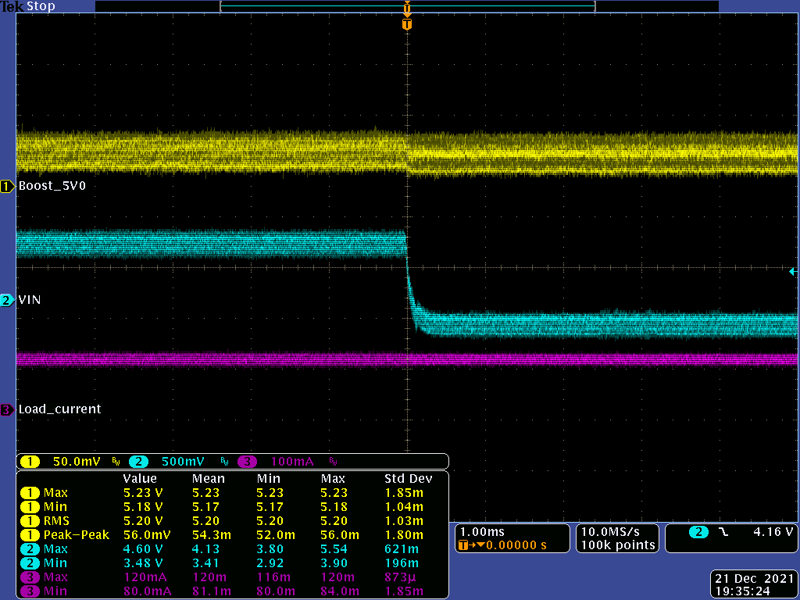 | Measurement:

Waveform#  Fig. 4-3 | Line Transient  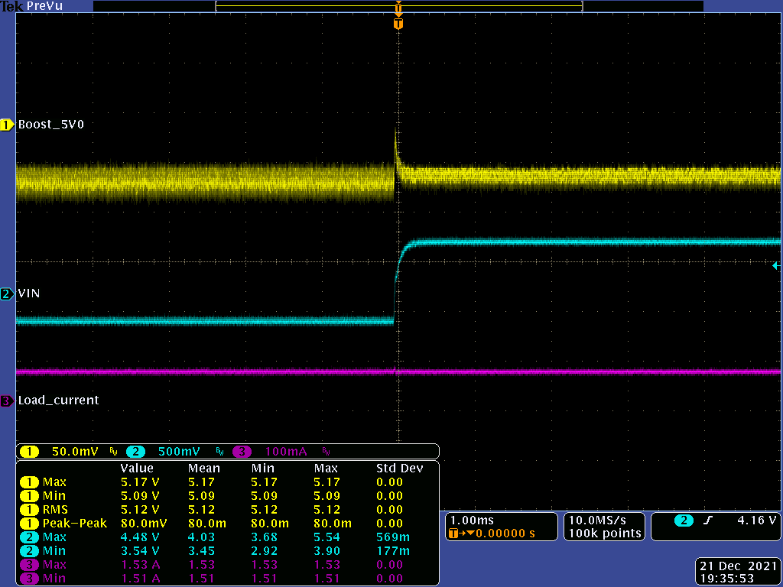 | Measurement:

Waveform#  Fig. 4-4 | Line Transient  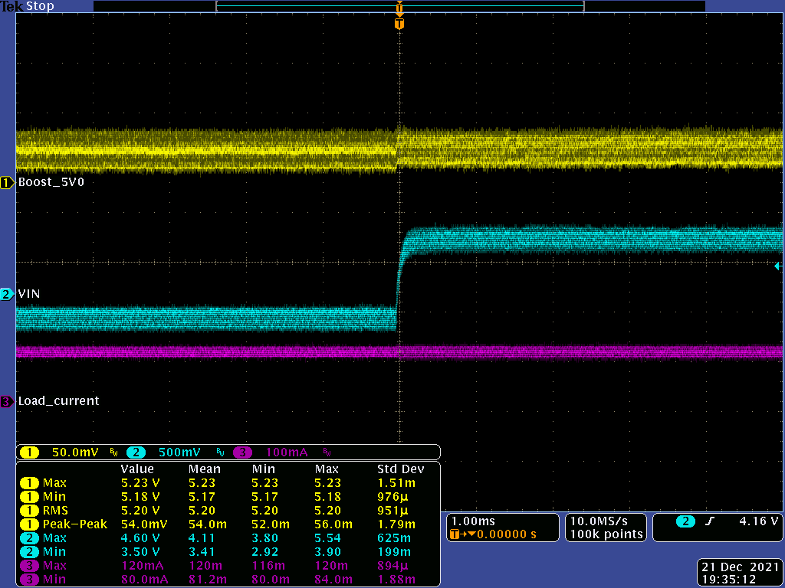 | Measurement:

Waveform#  Fig. 4-5 | Line Transient  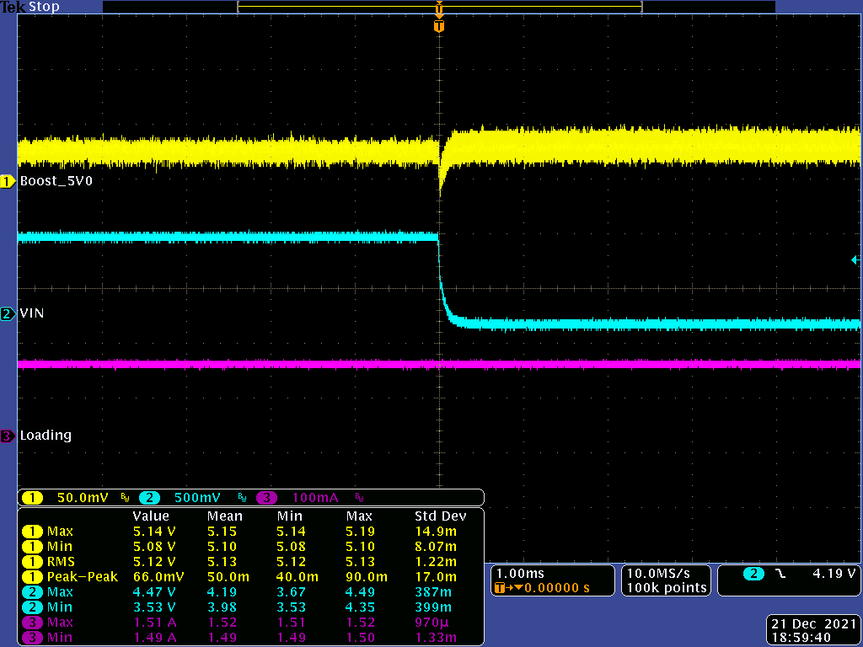 | Measurement:

Waveform#  Fig. 4-6 | Line Transient  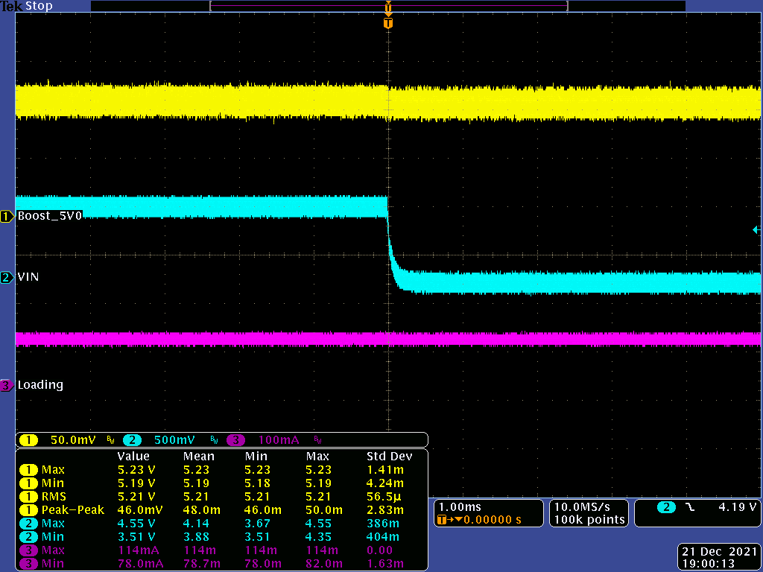 | Measurement:

Waveform#  Fig. 4-7 | Line Transient  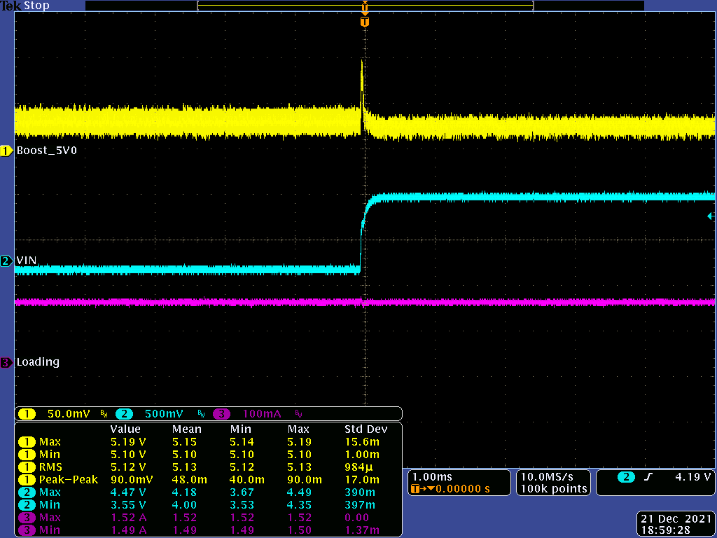 | Measurement:

Waveform#  Fig. 4-8 | Line Transient  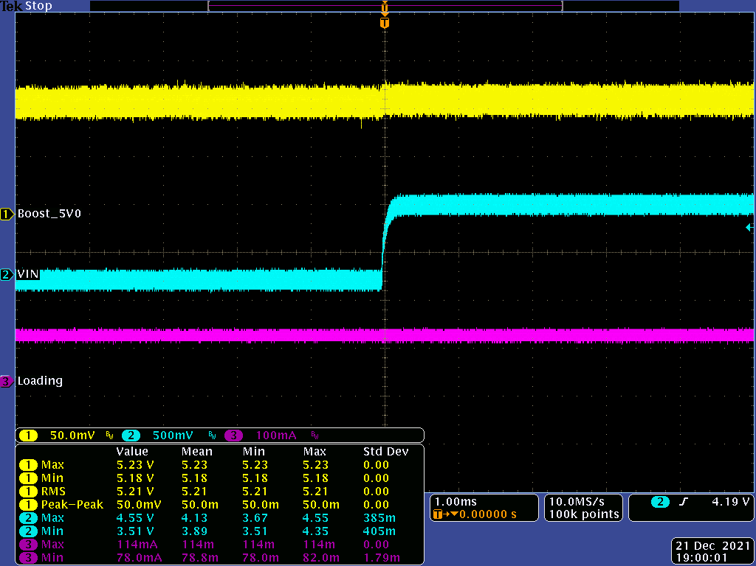 | Measurement:

Waveform#  Fig. 4-9 | Line Transient  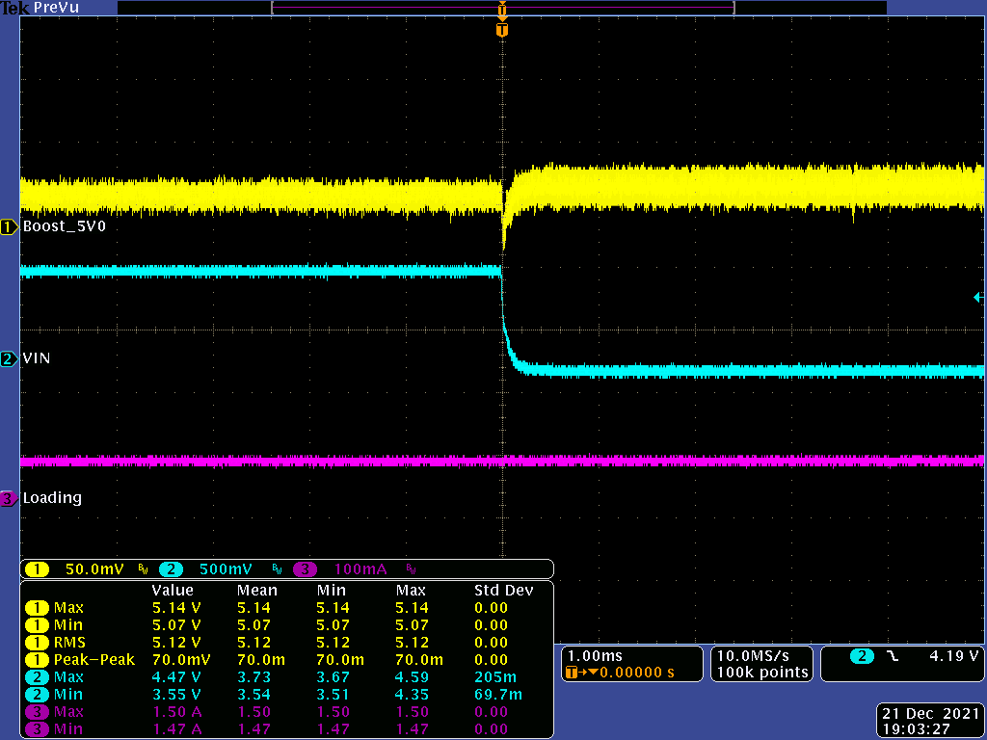 | Measurement:

Waveform#  Fig. 4-10 | Line Transient  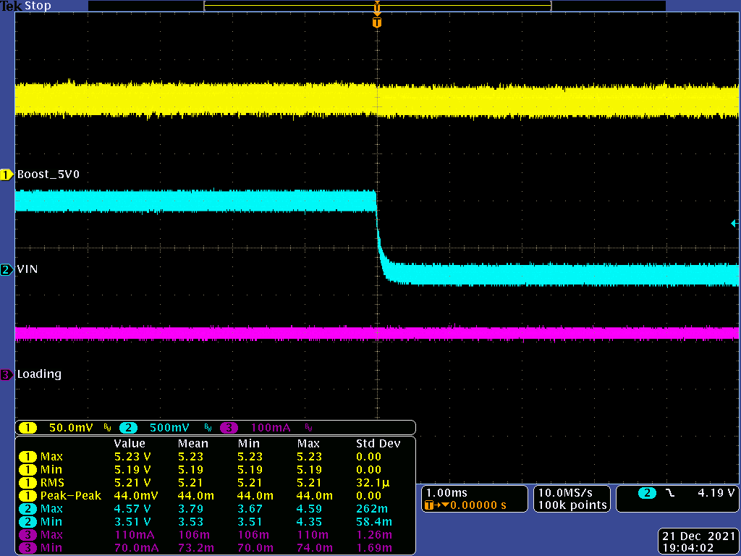 | Measurement:

Waveform#  Fig. 4-11 | Line Transient  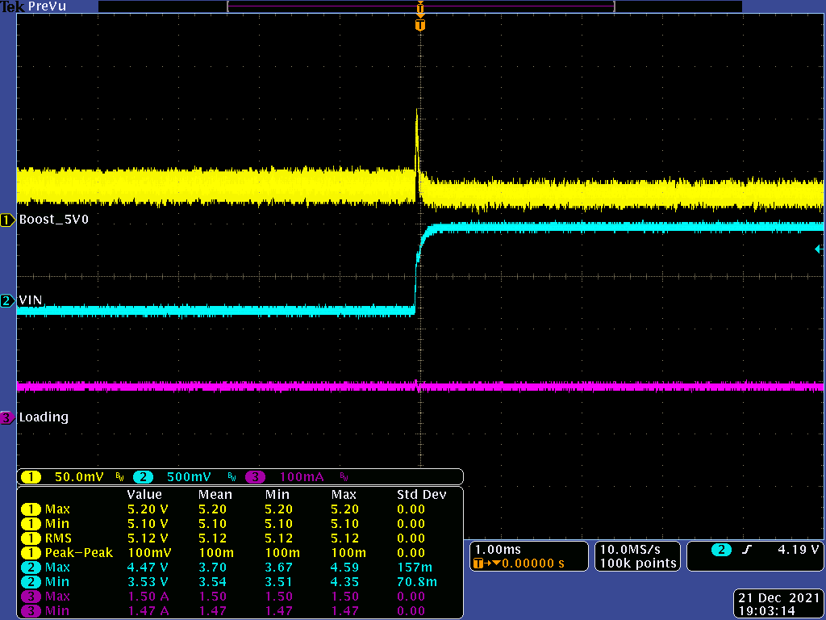 | Measurement:

Waveform#  Fig. 4-12 | Line Transient  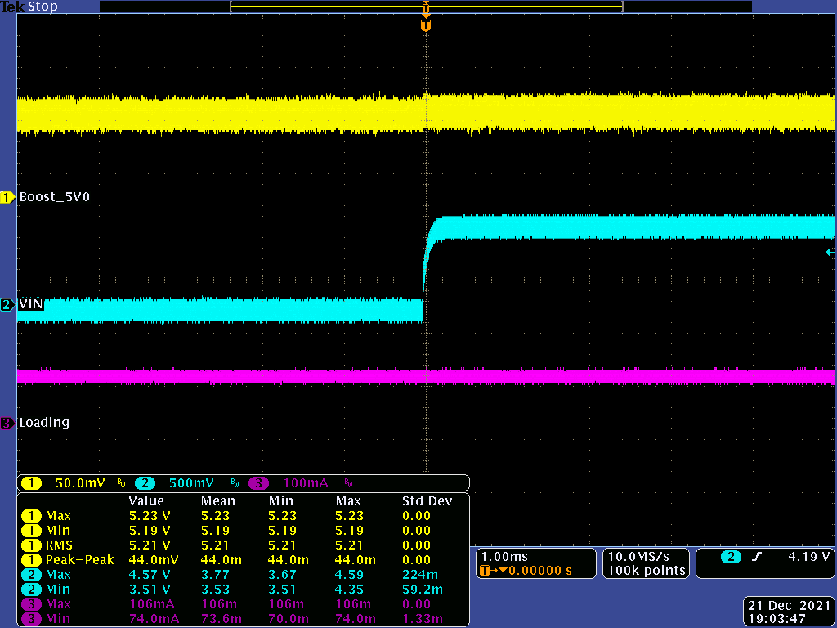 | Measurement:

