

**OEM MODEL: Jaws**

**Project Name: QA618**

**PCB Number:** **21H002-SD**

EE-4058

Power Consumption: BT Active Mode (WLAN Product) Current Consumption

|  |  |  |  |
| --- | --- | --- | --- |
| Judge | Customer  Approval | Reviewer | Tester |
|  |  |  | Chien Huang |

# 1. TEST CONFIGURATION AND TEST EQUIPMENT

* **System Configuration:**

|  |  |  |
| --- | --- | --- |
| PCB Number | Main Board | 21H002-SD |
| Firmware Version | WLAN EV2 | Android version: 11 Build number: 11-11-03.00-RG-U00-PRD-HEL-04 Kernel version: 4.19.157-perf #4 Mon May 3 06:16:49 CDT 2021 |
| CPU | Qualcomm QCS6490 | |
| RAM / ROM | 4G/64G | |
| Test Utility | CFA System_Functionality | |

* **Test Equipment:**

|  |  |  |
| --- | --- | --- |
| Items | Description | Note |
| Digital Scope | DPO 4054B Digital Phosphor Oscilloscope |  |
| Probe | Tek TTP1000 1GHz 3.9pF 10Mohm |  |

* **Serial Number of Units under Test:**

|  |  |  |
| --- | --- | --- |
| PCB Version or Terminal  (EX:19H04-SA or TC55 | Serial Number(S/N) | Note |
| **21H002-SD** | 20259522518074 | 2021/5/1 |
|  |  |  |

# 2. TEST CONTENT TABLE AND MEASUREMENT SPEC. AND JUDGMENT

## 2.1 EE-3562 Accelerometer/GYRO Sensor Control and Data Signals Integrity

|  |  |  |  |  |  |  |
| --- | --- | --- | --- | --- | --- | --- |
| #Test | Test Case | | Test Procedure | Pass/Fail | Note | |
| EE-3562 | Accelerometer/GYRO Sensor Control and Data Signals Integrity | At room temperature, verify signal integrity of the communication interface between accelerometer and processor during active mode while processor and accelerometer are communicating with each other. Follow accelerometer data sheet for spec | |  |  |

Judge: None

Reference: ST_LSM6DSLTR(G-Sensor)_SPEC

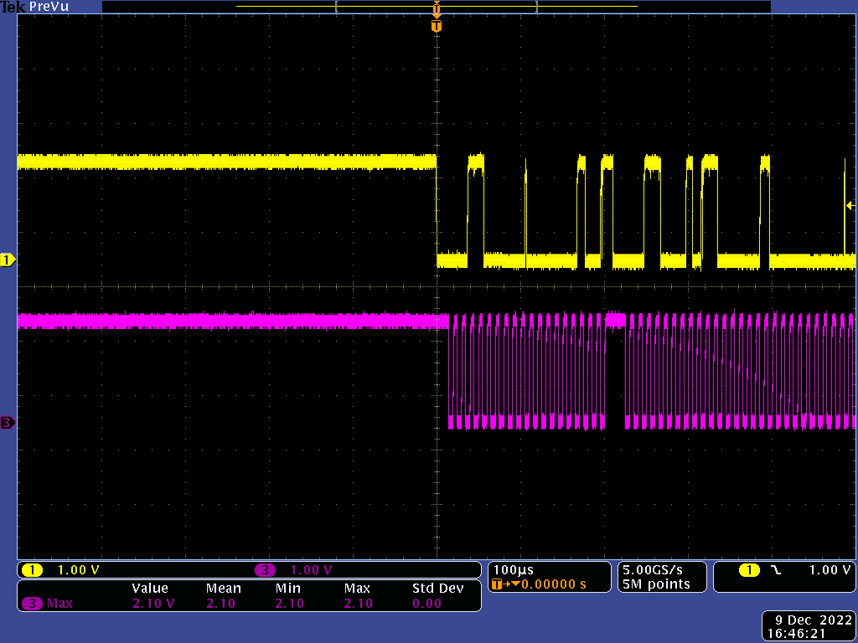

|  |  |  |  |  |  |
| --- | --- | --- | --- | --- | --- |
| **symbol** | **Parameter** | **Specification** | | **Measurement** | **Unit** |
| **I2C fast mode** | |
| **Min** | **Max** |
| Clk VIH | Clk VIH | 1.26 |  | Result | V |
| Clk VIL | Clk VIL |  | 0.54 | 2.1 | V |
| DATA VIH | DATA VIH | 1.26 |  | -0.14 | V |
| DATA VIL | DATA VIL |  | 0.54 | 1.98 | V |
| f(SCL) | SCL clock frequency | 0 | 400 | -0.22 | kHz |
| tw(SCLL) | SCL clock low time | 1.3 |  | 980.0 | us |
| tw(SCLH) | SCL clock high time | 0.6 |  | 0.0 |
| tR(SCL) | SCL clock Rise time |  | 300 | 99.64 | ns |
| tF(SCL) | SCL clock Fall time |  | 300 | 260.0 |
| tR(SDA) | SDA DATA Rise time |  | 300 | 4.0 |
| tF(SDA) | SDA DATA Fall time |  | 300 | 320.0 |
| tsu(SDA) | SDA setup time | 100 |  | 4.0 | ns |
| th(SDA) | SDA data hold time | 0 | 0.9 | 2920.0 | us |
| th(ST) | START condition  hold time | 0.6 |  | 34400.0 | us |
| tsu(SR) | Repeated START condition setup time | 0.6 |  | 960.0 |
| tsu(SP) | STOP condition setup time | 0.6 |  | 14.8 |
| tw(SP:SR) | Bus free time between STOP  and START condition | 1.3 |  | 4.72 |

|  |  |  |
| --- | --- | --- |
| Item Name | Waveform | Measurement |
| CH3:  I2C_ALSP_SCL Test Pad:  R4712.2 Ground Pad: R4713.2 |  | f(SMBCLK) =368.7KHz400KHz |
| CH1:  I2C_ALSP_SDA Test Pad:  R4713.2 Ground Pad: R4713.2  CH3:  I2C_ALSP_SCL Test Pad:  R4712.2 Ground Pad: R4713.2 |  | t(BUF) =137us>1.3us |

|  |  |  |
| --- | --- | --- |
| Item Name | Waveform | Measurement |
| CH1:  I2C_ALSP_SDA Test Pad:  R4713.2 Ground Pad: R4713.2  CH3:  I2C_ALSP_SCL Test Pad:  R4712.2 Ground Pad: R4713.2 |  | t(HDSTA) =1.56us>0.6us |
| CH1:  I2C_ALSP_SDA Test Pad:  R4713.2 Ground Pad: R4713.2  CH3:  I2C_ALSP_SCL Test Pad:  R4712.2 Ground Pad: R4713.2 |  | t(SUSTA) =2.76us>0.6us |

|  |  |  |
| --- | --- | --- |
| Item Name | Waveform | Measurement |
| CH1:  I2C_ALSP_SDA Test Pad:  R4713.2 Ground Pad: R4713.2  CH3:  I2C_ALSP_SCL Test Pad:  R4712.2 Ground Pad: R4713.2 |  | t(SUSTO) =1.65us>0.6us |
| CH1:  I2C_ALSP_SDA Test Pad:  R4713.2 Ground Pad: R4713.2  CH3:  I2C_ALSP_SCL Test Pad:  R4712.2 Ground Pad: R4713.2 |  | t(HDDAT) =290ns900ns |

|  |  |  |
| --- | --- | --- |
| Item Name | Waveform | Measurement |
| CH1:  I2C_ALSP_SDA Test Pad:  R4713.2 Ground Pad: R4713.2  CH3:  I2C_ALSP_SCL Test Pad:  R4712.2 Ground Pad: R4713.2 |  | t(SUDAT) =1.13us>0.1us |
| CH3:  I2C_ALSP_SCL Test Pad:  R4712.2 Ground Pad: R4713.2 |  | t(LOW) =1.58us>1.3us |

|  |  |  |
| --- | --- | --- |
| Item Name | Waveform | Measurement |
| SCLK t(R) =128ns300ns |  | CH3:  I2C_ALSP_SCL Test Pad:  R4712.2 Ground Pad: R4713.2 |

**Measurement Point:**

1. **None**
2. **None**

