

**OEM MODEL: Jaws**

**Project Name: QA618**

**PCB Number: 21H002-SD**

**EE-4058**

**Power Consumption: BT Active Mode (WLAN Product) Current Consumption**

|  |  |  |  |
| --- | --- | --- | --- |
| Judge | Customer  Approval | Reviewer | Tester |
|  |  |  | Chien Huang |

# 1. TEST CONFIGURATION AND TEST EQUIPMENT

* **System Configuration:**

|  |  |  |
| --- | --- | --- |
| PCB Number | Main Board | 21H002-SD |
| Firmware Version |  | Android version: 11 Build number: 11-11-03.00-RG-U00-PRD-HEL-04 Kernel version: 4.19.157-perf #4 Mon May 3 06:16:49 CDT 2021 |
| CPU | Qualcomm QCS6490 | |
| RAM / ROM | 4G/64G | |
| Test Utility | CFA System_Functionality | |

* **Test Equipment:**

|  |  |  |
| --- | --- | --- |
| Items | Picture | Note |
| Oscilloscope    DPO4104B  1GHz  5GS/s |  |  |
| Probe  Tek TTP1000 1GHz 3.9pF 10Mohm |  |  |

* **Serial Number of Units under Test:**

|  |  |  |
| --- | --- | --- |
| PCB Version or Terminal  (EX:19H04-SA or TC55) | Serial Number(S/N) | Note |
| 21H002-SD | 20259522518074 | 2021/5/1 |

## 2. TEST CONTENT TABLE AND MEASUREMENT SPEC. AND JUDGMENT

## 2.1 EE-14699 Back Camera Signal integrity (MIPI, I2C)

|  |  |  |  |  |
| --- | --- | --- | --- | --- |
| #Test | Test Case | Test Procedure | Pass/Fail | Note |
| EE-14699 | Back Camera Signal integrity (MIPI, I2C) | 1. Run the following test at room temperature for camera of different focus technology covered in the design: <<Camera Type>> 2. At room temperature, verify signal integrity of the communication interface between camera and processor during active mode while processor and camera are communicating with each other. Follow camera data sheet for spec   Recorded Data: frequency, voltage, hold time, setup time, rise time, fall time…etc  Test Variation: If it is bidirectional: 1. Next to processor 2. Next to Camera  Note: the testing spots on PCB got to be close to processor and camera |  |  |

**Judge:** None

**Reference:** " None "

**SPEC:** None

**Test Result:**

|  |  |  |  |  |
| --- | --- | --- | --- | --- |
| Signal Name/  Schematics Net Name | Specification | | Measurement  result | Unit |
| Min | Max |
| SCL/CLK | 1.26 | None | 2.1 | V |
| tHD;STA | -0.5 | 0.54 | -0.14 | V |
| tLOW | 1.26 | None | 1.98 | V |
| tHIGH | -0.5 | 0.54 | -0.22 | V |
| tSU;STA | 4.7 | None | 980.0 | us |
| tHD;DAT | 4 | None | 0.0 | us |
| tSU;DAT | 0 | 200 | 99.64 | kHz |
| tr(SCL) | None | 1000 | 260.0 | ns |
| tr(SDA) | None | 300 | 4.0 | ns |
| tf(SCL) | None | 1000 | 320.0 | ns |
| tf(SDA) | 20 | 300 | 4.0 | ns |
| tSU;STO | 250 | None | 2920.0 | ns |
| tBUF | 0 | None | 34400.0 | ns |

|  |  |  |
| --- | --- | --- |
| Item Name | Waveform | Measurement |
| CH3:  I2C_ALSP_SCL Test Pad:  R4712.2 Ground Pad: R4713.2 |  | None =  None None |
| CH1:  I2C_ALSP_SDA Test Pad:  R4713.2 Ground Pad: R4713.2  CH3:  I2C_ALSP_SCL Test Pad:  R4712.2 Ground Pad: R4713.2 |  | None =  None None |
| CH1:  I2C_ALSP_SDA Test Pad:  R4713.2 Ground Pad: R4713.2  CH3:  I2C_ALSP_SCL Test Pad:  R4712.2 Ground Pad: R4713.2 |  | None =  None None |

|  |  |  |
| --- | --- | --- |
| Item Name | Waveform | Measurement |
| CH1:  I2C_ALSP_SDA Test Pad:  R4713.2 Ground Pad: R4713.2  CH3:  I2C_ALSP_SCL Test Pad:  R4712.2 Ground Pad: R4713.2 |  | None =  None None |
| CH1:  I2C_ALSP_SDA Test Pad:  R4713.2 Ground Pad: R4713.2  CH3:  I2C_ALSP_SCL Test Pad:  R4712.2 Ground Pad: R4713.2 |  | None =  None None |
| CH1:  I2C_ALSP_SDA Test Pad:  R4713.2 Ground Pad: R4713.2  CH3:  I2C_ALSP_SCL Test Pad:  R4712.2 Ground Pad: R4713.2 |  | None =  None None |

|  |  |  |
| --- | --- | --- |
| Item Name | Waveform | Measurement |
| CH1:  I2C_ALSP_SDA Test Pad:  R4713.2 Ground Pad: R4713.2  CH3:  I2C_ALSP_SCL Test Pad:  R4712.2 Ground Pad: R4713.2 |  | None =  None None  None =  None None  None =  None None  None =  None None |
| CH3:  I2C_ALSP_SCL Test Pad:  R4712.2 Ground Pad: R4713.2 |  | None =  None None |
| CH3:  I2C_ALSP_SCL Test Pad:  R4712.2 Ground Pad: R4713.2 |  | None =  None None |

|  |  |  |
| --- | --- | --- |
| Item Name | Waveform | Measurement |
| CH3:  I2C_ALSP_SCL Test Pad:  R4712.2 Ground Pad: R4713.2 |  | None =  None None |

**Measurement Point:**

**1.** **None**

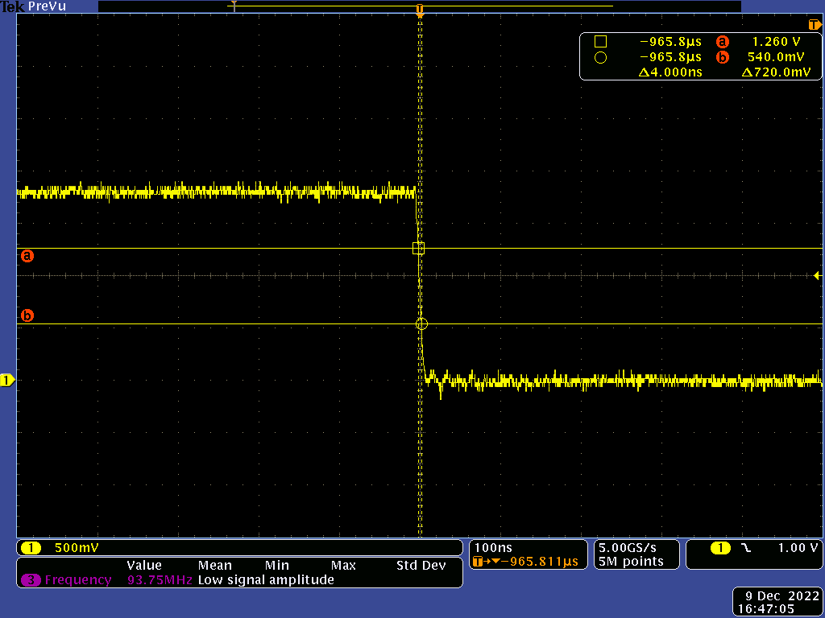 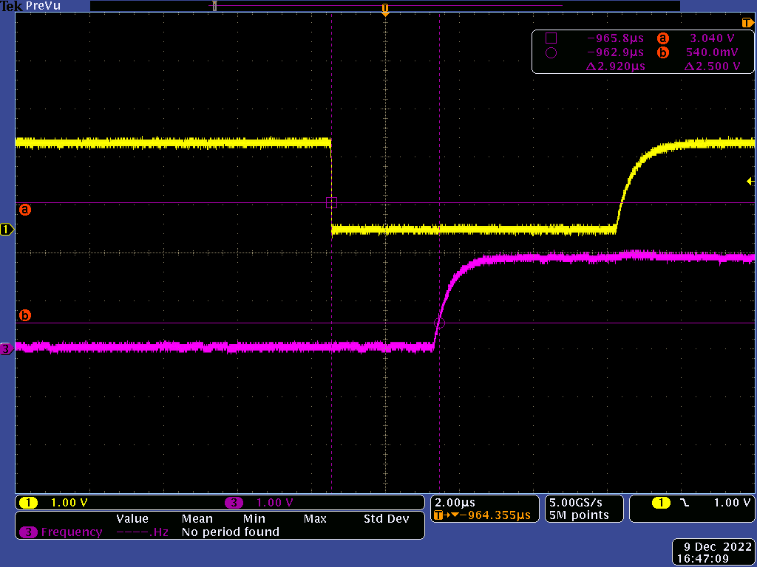

**2.** **None**

