**Homework assignment#1 (Chap3)**

106971001 林上人

1. **Pseudo codes documentation**

Pages: 3

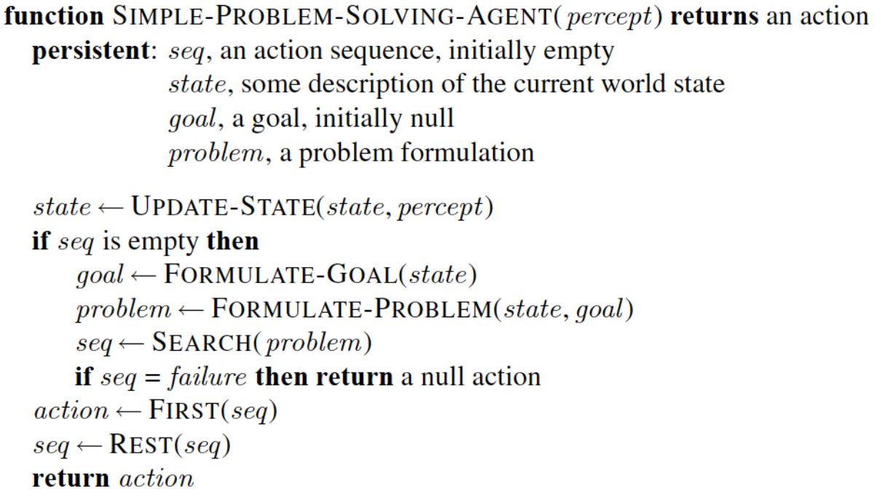

After formulating a goal and a problem to solve,  
the agent calls a search procedure to solve it. It then uses the solution to guide its actions,  
doing whatever the solution recommends as the next thing to do—typically, the first action of  
the sequence—and then removing that step from the sequence. Once the solution has been  
executed, the agent will formulate a new goal.

Pages: 47

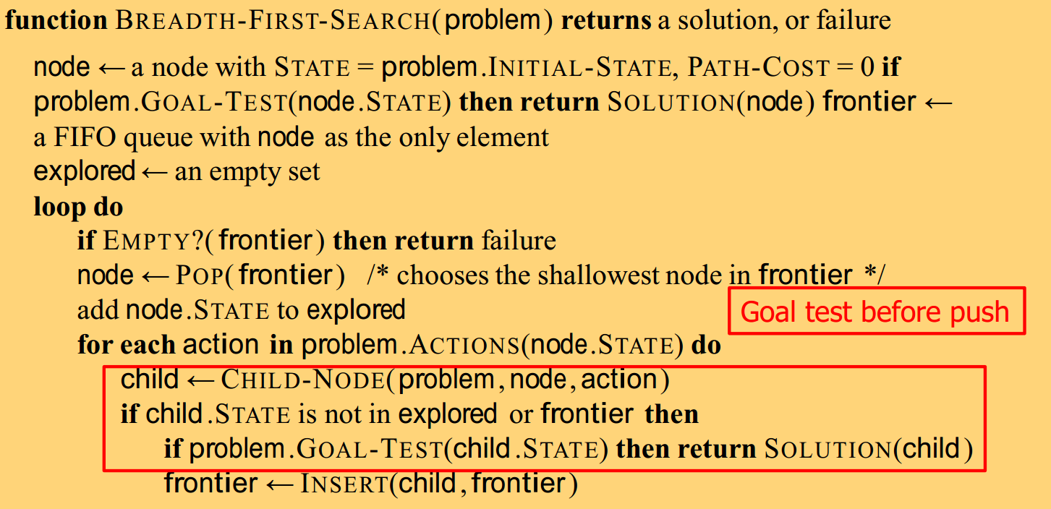

Pages: 48

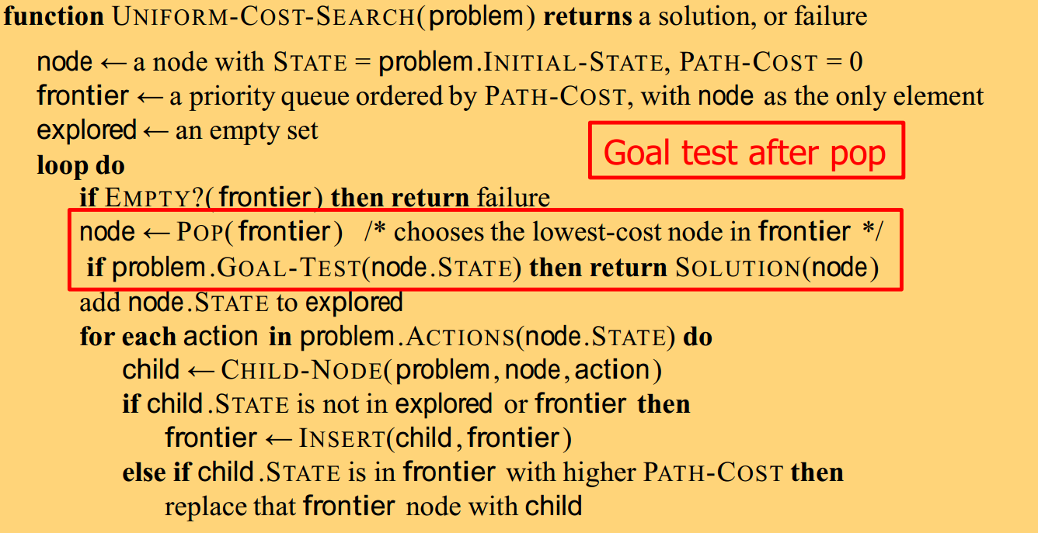

Pages: 49

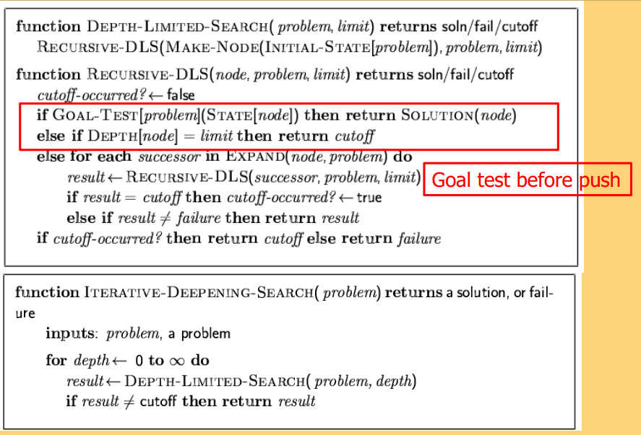

Pages: 61

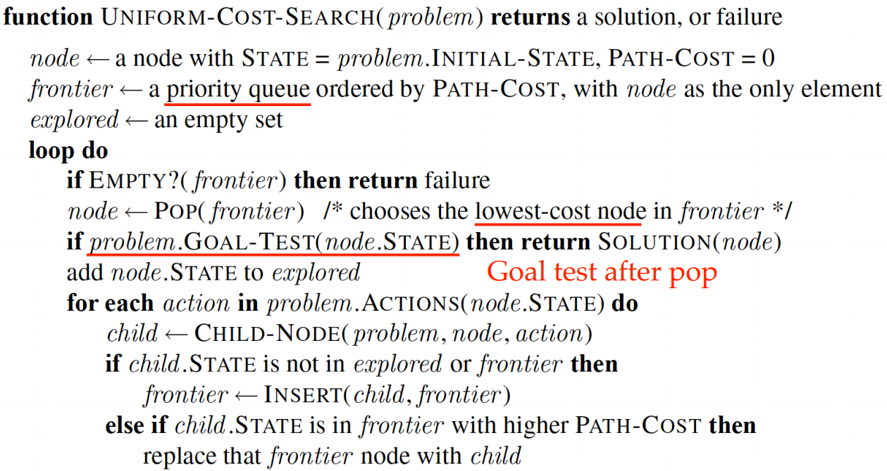

Pages: 85

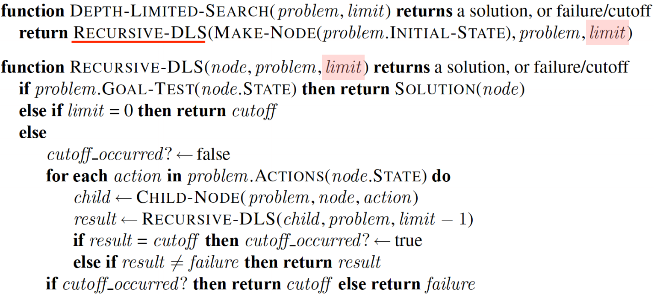

Pages: 137

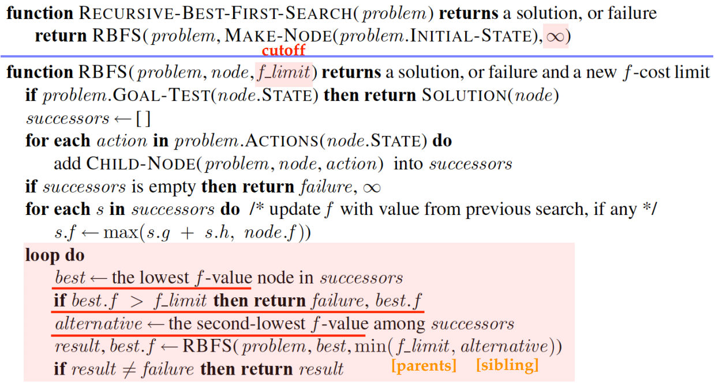

Pages: 146

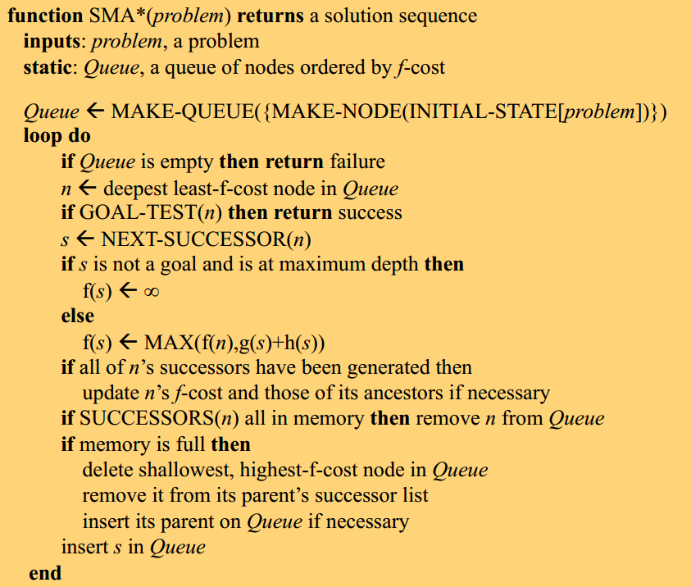

Pages: 154

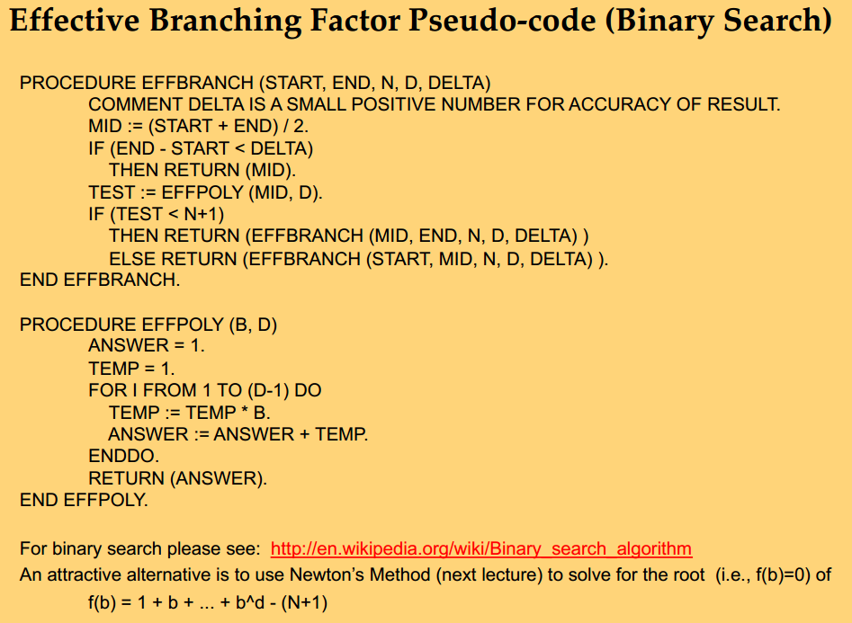

1. **Exercises**

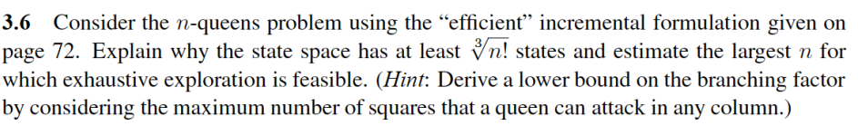

Ans

