**Course Work II**

**Question-and-Answer Sheet**

**30 Marks**

Write your answers in the boxes provided below. A copy of your NetLogo simulation code, your Thymio code and the completed Question-and-Answer sheet should submitted to the slot setup on Canvas at Friday 11th January 2019 at the latest. An additional copy of your NetLogo/Thymio code should also be pasted into in a .docx or .txt file and be complete; we (the markers) should be able to just paste the code in NetLogo/ASEBA Studio to see if it runs (at all).

# Part 1: NETLOGO

To answer the questions below, use your NetLogo simulation. For this part of the course work we will only be concerned with the sliders *population* (number of turtles), *max-view* (*mv*), vision-angle (*v*), near-view (*nv*), and personal-space (*ps*). Set the population at 10 turtles of size 8 and the max-pxy-coordinates of a fully wrapped-around “world” at 100. All other sliders should initially be set at zero.

1. Set max-view (*mv*) at **100** (why is this very large range of vision?). How does this affect the simulation?

Set the vision-angle (*v*) at a very small value (<20) [You get something very different if you mistakenly set 0 < maxview <= 20 and vision-angle to 100! It is worthwhile to try]. Run the model for a short time, than increase *v* to “reasonably large” (40 < *v* < 100) and see what happens.

Let the program run for ***v* = 100** until the pattern does not change any more. In the box below, describe the PATTERN [in terms of 1. ***shape***, 2. ***colour*** of turtles and 3. ***direction*** of movement (**1/3** **mark** for each)] and EXPLAIN how it comes about because of the maxview value (**1/2 mark**) and the vision-angle (**1/2 marks**).

PATTERN (1 mark):

1.

For pattern 1 the value of max-view is 100 and other sliders value set to zero then we get the random movements of wanderers and the colour is white because the value of vision angle is zero

2. if the value of vision angle is less than 20 and max view value is also less than 20 the colour of wanderer change to yellow when it comes to max view zone and they try to follow each other since the value of vision angle is less so that’s why it took more time to follow each other in a line shape but if the value of vision angle changed from 20 to between 40 and hundred the patterns setts quickly because the vision angle is large

3. if the value of vision angle set to 100 and value of max view set to 20 then first they make small groups which follow each other in line and there colour turned to yellow from white when they appear in the max view space but at the end they all settle down to follow each other in a line pattern and due to value of max

EXPLANATION (1 mark): The value of max view change the colour of the wanderer ,The more value of max –view the colour change through more distance whereas the vision angle set the pattern of the wanderers the more value of vision angle the pattern sets more quickly

2. Run the model for the settings *mv* = 100, *v* = 100 and all other sliders (apart from population size) zero. Let the pattern settle, and then increase *nv* from zero to 25.

You should observe that some turtles turn white and some others orange. What is the REASON for the colour change (**1 mark**)? With what PATTERN is it associated (**1 mark**) and what is the EXPLANATION for the pattern change (**1 mark**)?

REASON FOR COLOUR CHANGE (1 mark):

When wanderer come in to the near view space then its colour change to orange otherwise it colour remain to yellow because the value of max view is maximum so when they close to near view there colour change from yellow to orange

ASSOCIATED PATTERN (1 mark):

They try to make flock and the colour change with respect of zone and some time they all settled to gather so it seems like only one wanderer

EXPLANATION PATTERN CHANGE (1 mark):

When the value of max view and vision angle is 100 the pattern remain same in the line when value of near view is changed to 25 the try to from flock and try to look like only one altogether but this pattern stay for a while and then try to set together after they form and the colour change to orange with respect to zone and speed increase because they more forward to one this is set in code

3. What is the EFFECT of introducing a search-angle (*s*) of 45 with regard to the pattern that emerges? In what respect does the pattern differ from that of Exercise 1? EXPLAIN how the search-angle brings this about in terms of the changed parameter values (**2 marks**).

EFFECT (1 mark):

There is no such effect if the value of search angle is 45 the pattern remain same

EXPLANATION (1 mark):

If run for a considerable time, the pattern may change shape. This change is made more pronounced by the next adaptation (4) of the model:

4. Now reduce the max-view to a value of *mv* = 75. Describe the PATTERN in terms of ***change*** ***of*** ***shape*** (**1/3 mark**) as well as ***colour*** (**1/3 mark**) and ***behaviour*** (**1/3 mark**) of the turtles. EXPLAIN how it comes about in terms of the parameter values (**1 mark**). You might have to run the simulation a bit longer before the effect takes shape.

PATTERN (1 mark):

1.if the value of max view is 75 and vision angle the pattern is like to follow each other smoothly and try to decrease the distance between them and if the value of near view is 25 then they try to form only one block or flock

2. if mv is 75 so there colour changes from white to yellow is the nv is 25 there colour change from yellow to orange and vice versa

3.

EXPLANATION (1 mark): The colour change with respect of the zones and there behaviour changes because of the value of mv and nv In mv they have to follow nearest neagibour and in nv they have to move left and right

A more spectacular version is realised when you change the search behaviour from “turn over a search-angle **either** to the left **or** to the right” to “turn over a search-angle **just** to the left (or right”)*.

5. Finally, introduce a personal space with a value of *ps* = 10 and *ps* = 15. Observe the pattern that emerges due to the effect of increased personal space (**1 mark**).

PATTERN (1 mark):if the value of mv = 100 and vison angle is 100 and per space is 10 the colour of wanderer change to red when it comes to wanderer zone but the pattern is scattered they try to follow each other but when they faces they turn from each other

**Extra** (**5 marks**)

* To allow adaptation of this feature on the interface, install a slider called “escape-angle” (to be called at the appropriate command in the code) which has a range of 0 – 5 with increments of 1. The default value should be set at 2.

Check what happens if at **step 4** the search angle is set at various values.

Set the “escape-angle” at 5 and proceed to **step 5** (increase personal space from 0 to 15). You should find that the pattern of the default setting (escape-angle = 2) does not arise. Reduce the slider back to 2 and let the simulation run for a while. Then increase it again. Describe and explain what happens in terms of the effects of initial conditions

At step four the colour is changed and the pattern remain the following but with more speed and if the value of escape angle set to at 5 then the face each other and color changed with the respect of zone but it’s a jerk pattern they form of small groups and when the face another group the jerk before facing each other

## Overview of NetLogo Simulation Marking Scheme

Exercise 1: 2 marks

Exercise 2: 3

Exercise 3: 2

Exercise 4: 2

Exercise 5: 1

Extra: 5 marks

TOTAL: 15 marks

# Part 2: Robotics

1.

Draw a suitable diagram which illustrates how you might structure a Thymio Robot program as described in the Assignment Brief, which uses an Augmented Finite State Machine (AFSM). Show clearly the states (behaviours), robot actions for each state, and state transition triggers in the diagram.

**3 marks.**

Augmented Finite State Machine Diagram:

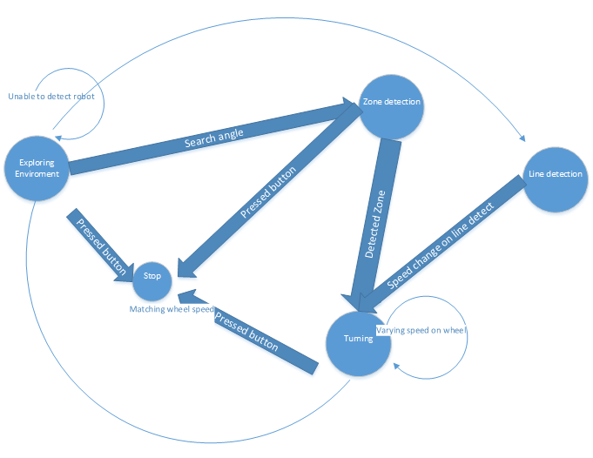

2. Add a Markov State Diagram on the basis of behaviour sequences observed for a group of interacting Thymio robots. Remark on any similarities and differences with the AFSM.

4 marks.

Markov State Diagram:

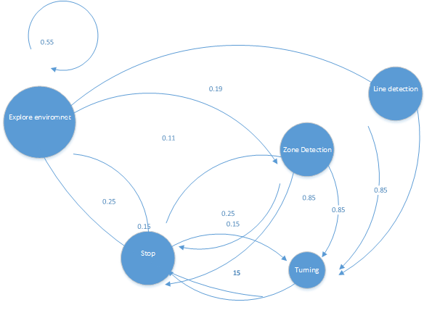

Comments:  
  
the difference between markov and Augmented state machine diagram is that the markov is probabilistic and augmented state machine is deterministic ,we can say with the markov that this going to definitely happen

2. Draw a suitable diagram which illustrates how a Subsumption-based Control Architecture may be used to implement the robot program. Show clearly how the robot behaviours are prioritised; which actions the individual behaviours are composed of; and also how individual behaviours are inhibited and/or released by sensor inputs, other behaviours and/or actions.

**3 Marks**

# 

3. Write down the following values for MAX_VIEW, NEAR_VIEW, PERSPACE, SEARCH_ANGLE and SEARCH_DISTANCE to optimise for the following observed robot behaviour in actual Thymio robots (i.e not simulated):

a) When the values are optimised for multiple robots to follow each other (**2.5 Marks**):

Constant (Parameter) Values

MAX_VIEW = 920

NEAR_VIEW = 5000

PERSPACE = 4600

SEARCH_ANGLE =220

SEARCH_DISTANCE = 22

b) When optimised for multiple Thymio robots to “flock” (i.e group closely) together (**2.5 Marks**):

Constant (Parameter) Values

MAX_VIEW = 180

NEAR_VIEW = 4400

PERSPACE = 4900

SEARCH_ANGLE =150

SEARCH_DISTANCE = 30

## Overview of Thymio Robot Program Marking Scheme

AFSM Diagram 3

Markov Diagram + Comments 4

Subsumption Diagram 3

Parameters for Following 2.5

Parameters for Flocking 2.5

TOTAL 15