**VALIDATED CREDITCARD NUMBER**

**OUTPUT:**

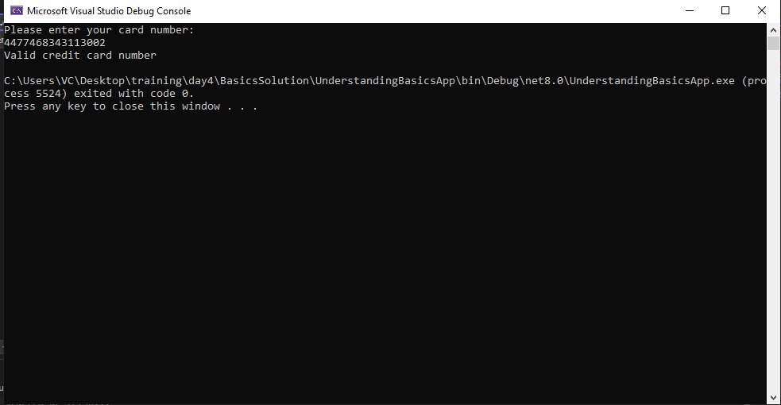

**DOCTOR APPLICATION:**

**OUTPUT:**

