11210CS 543200 Advanced UNIX Programming

FreeBSD Installation Tutorial

1. Write FreeBSD 13.2 RPi image into an SD card

**Mac Version**

**Step 1:**

Download the FreeBSD 13.2 RPi image.

Link: <https://download.freebsd.org/releases/arm64/aarch64/ISO-IMAGES/13.2/FreeBSD-13.2-RELEASE-arm64-aarch64-RPI.img.xz>

**Step 2:**

Insert the SD card into your computer.

Find the right device, which is /dev/disk5 in the below sample:

Command:

/usr/sbin/diskutil list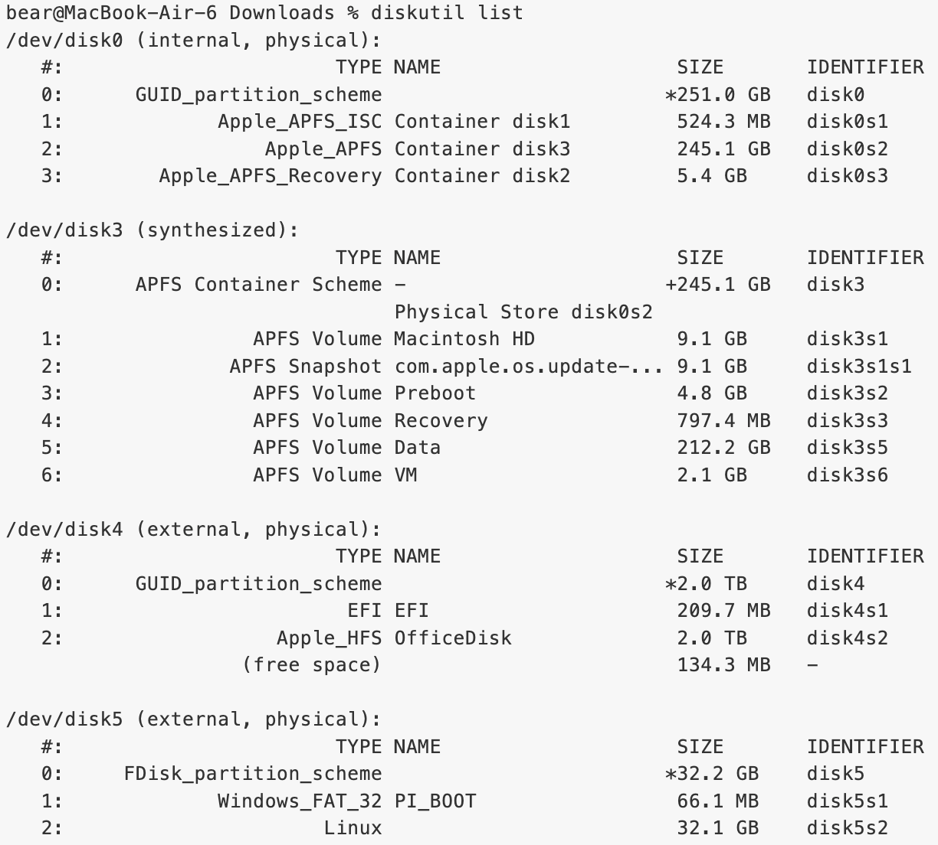

**Step 3:**

Uncompress the RPi image.

Command:

unxz FreeBSD-13.2-RELEASE-arm64-aarch64-RPI.img.xz

**Step 4:**

Unmount any partitions of your current SD card

Command:

mount |grep disk5

🡪 Search for information containing “disk5” in the mounted file systems and display the results. In this example, the path of disk5 is “/dev/disk5s1”

sudo umount /dev/disk5s1

🡪 Unmount the SD card

**Step 5:**

Write the image to the SD card.

Command:

sudo dd if=FreeBSD-13.2-RELEASE-arm64-aarch64-RPI.img of=/dev/disk5 bs=4m

**Resource**

- The main project page: [https://www.freebsd.org](https://www.freebsd.org/)

- Installation youtube videos: <https://www.youtube.com/watch?v=WuoMPP_178U> and <https://www.youtube.com/watch?v=l_rPjsauSsc>

**Windows Version**

**Step 1:**

Download the FreeBSD 13.2 RPi image.

Link: <https://download.freebsd.org/releases/arm64/aarch64/ISO-IMAGES/13.2/FreeBSD-13.2-RELEASE-arm64-aarch64-RPI.img.xz>

**Step 2:**

Download the image writer software “Win32 Disk Imager”.

Link: <https://sourceforge.net/projects/win32diskimager/>

**Step 3:**

Insert the SD card into the computer, and remember the drive letter assigned to the SD card (e.g., D: or E:).

**Step 4:**

Run "Win32 Disk Imager" as administrator.

In the “Image File” field, select the downloaded FreeBSD image file (.img).

In the “Device” field, choose the drive letter corresponding to your SD card.

**Step 5:**

Click the “Write” button to start writing the image file to the SD card.

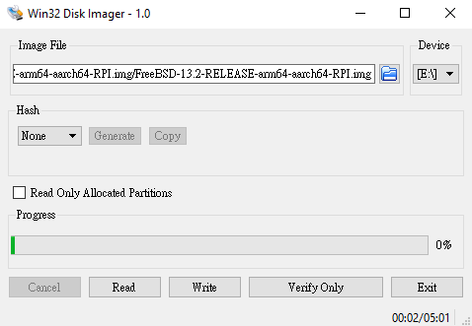

**5**

**4**

Notes: Make sure that you have already formatted your SD card before writing the FreeBSD image.

You can use the “SD Memory Card Formatter” to format your SD card.

Link: <https://www.sdcard.org/downloads/formatter/>

1. Setup FreeBSD on RPi 400

Now, you have already written the FreeBSD 13.2 RPi image on the SD card.

Insert your SD card, plug in the Ethernet cable to RPi 400, connect to a monitor (please use the right HDMI interface on RPi 400), and power it up.

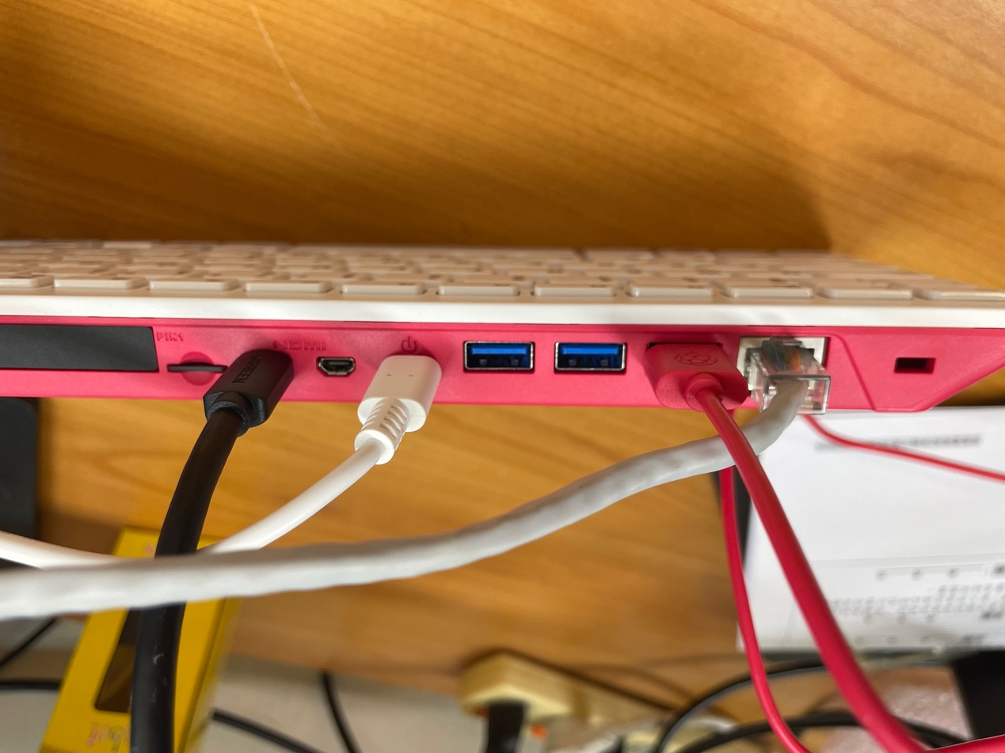

**SD Card**

**Monitor**

**Power**

**Mouse**

**Ethernet**

**Step 1:**

The default username and password are both “root”, please log in first.

**Step 2 ~ Step 3** should do under root permission.

**Step 2:**

Configure your RPi 400.

Command:

bsdconfig

Then, a UI window will pop up.

Please change:

1. time zone
2. network management

(network interfaces 🡪 enable DHCP)

**Step 3:**

Install the text editor “vim”, “git”, and“lynx”.

You will use these tools to finish your assignment throughout this semester.

Command: (vim for example)

pkg install vim

**Step 4:**

Create a new user and share the username and password with your teammate.

Command:

adduser [username]

1. Get the assignments on GitHub

**Step 1: (This step is compulsory, you cannot skip it)**

Fork a new project from our announced assignment github repository to your own github account.

(The below picture is just an example.)

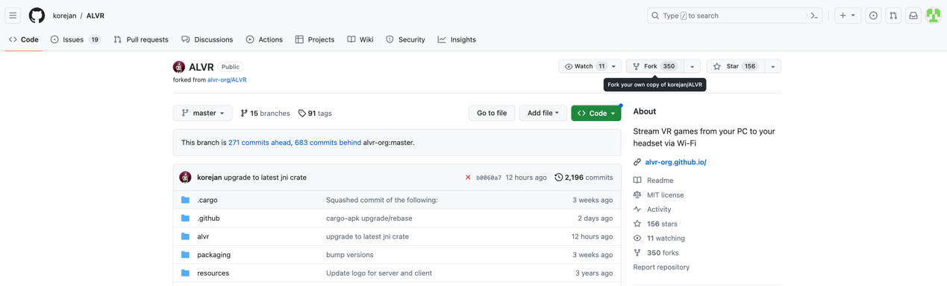

**Step 2:**

Go to your own forked repository and copy the url.

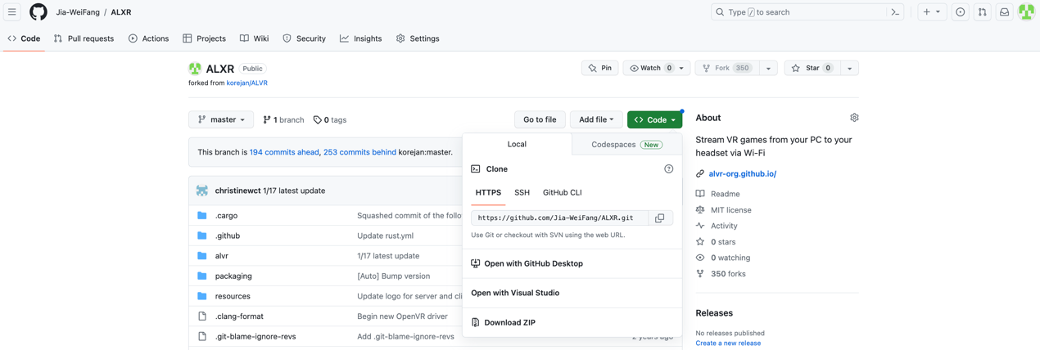

**Step 3:**

Download the assignment on your RPi 400.

Command:

git clone [url]

**Step 4:**

You can use the following commands to commit and push your code to your github repository.

Command:

git add * 🡪 add all files

git commit -m “[your commit msg]” 🡪 commit your change

git push 🡪 push the files on your github repository

1. Use Vim to edit your code

**Step 1:**

Get into the vim editor.

Command:

vim assignment1.c

**Step 2:**

Press the key “i” to start editing the file.

**Step 3:**

If you finish editing the file, press “esc” and key in:

1. :wq 🡪 write (save) the file and quit
2. :q 🡪 just quit the file (If you didn’t edit anything, you can use this)