
PT. MSG PETRO ENERGY

AUTHORIZED DISTRIBUTOR OIL AND GAS FOR INDUSTRY & BUNKER SHIPPING
OFFICE : Perum Gedong Kaloran Blok. A3 No. 5 Lontar Baru, Kota Serang – Banten – Indonesia

E-mail :

pt.msg2004@yahoo.co.id

I N V O I C E
No : 330/MSG-LSA/MFO/IV/2018

BILL TO. | SHIP TO.
CV. LAJU SURYA ABADI  Jl. Pelangi No. 9 – 11 RT. 01/04  Kel. Sukamukti Kec. Majalaya  Kab. Bandung –Jawa Barat | CV. LAJU SURYA ABADI  Jl. Pelangi No. 9 – 11 RT. 01/04  Kel. Sukamukti Kec. Majalaya  Kab. Bandung –Jawa Barat

TERM | FOB |  | SHIP VIA |  |  |  | SHIP DATE |  | NO. PO.
- | TANKI |  | PT. MSG PETRO ENERGY |  |  |  | 19/04/2018 |  | -
ITEM | QTY |  |  | UNIT | TAX | PRICE |  | OAT |  | AMOUNT
MFO | 14,930 |  |  | KG | TAX | Rp 4,250 |  | - |  | Rp 6 3,452,500
 |  |  |  |  |  | DPP |  |  |  | Rp 5 7,683,995
 |  |  |  |  |  | PPN 10% |  |  |  | Rp 5,768,399
 |  |  |  |  |  | TOTAL INVOICE |  |  |  | Rp 6 3,452,500
Say |  | # ENAM PULUH TIGA JUTA EMPAT RATUS LIMA PULUH DUA RIBU LIMA RATUS RUPIAH #

PEMBAYARAN KE : A/N. PT. MAULANA SAMUDERA GEMILANG
BANK MANDIRI NO. REK. 163 - 00 - 00764871
KK SERANG CICERI SERANG BANTEN
A/N. PT. MAULANA SAMUDERA GEMILANG

BANK BRI NO. REK. 1164-01-000-541302

CABANG CILEGON BANTEN

Banten, 19 – 04 – 2018
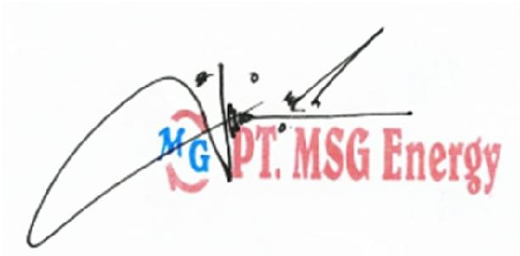
Hormat kami,

Mr. H A F I D Z FINANCE DIV.

