**Problem Identification**

As of late, there is a decline on the number of electorates who decide to vote and this is largly as a result of the traditional voting system being slow, complex, and not reliable enough. In light of this, my voting system provides a platform for reliable voting to take place. It can be used anywhere, at any time, with multiple electronic devices, which reduces the stress elactorates go through in order to vote. This will minimize the amount of people who choose not to vote due to the stressful process of the manual voting system.

**REQUIREMENTS**

* Users of this system will need to sign up or log in to get their information into the database.

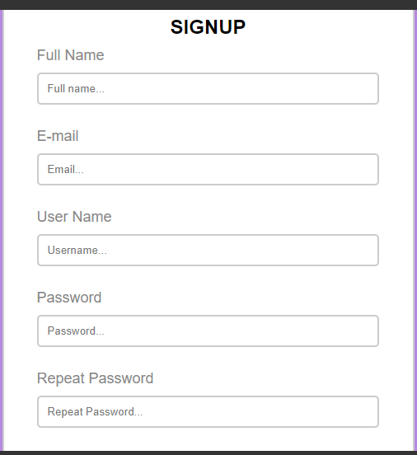

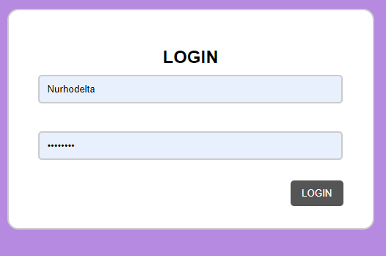

**SignUp Login**

* Users will be able to vote for the person of their choice.

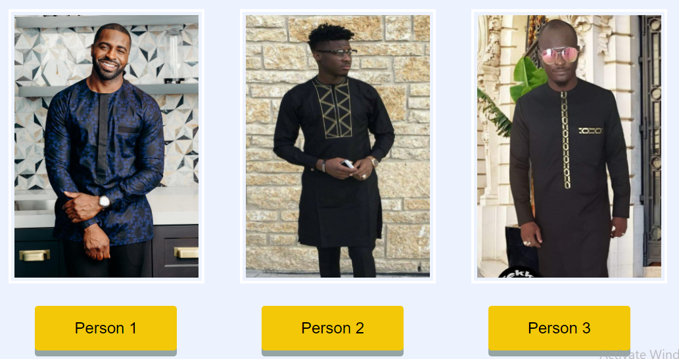

* Users will be able to see the results of the voting system only after they have voted.



* Users will be able to logout in order to allow more than one people to vote on the same device.

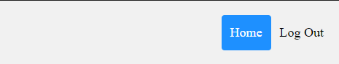

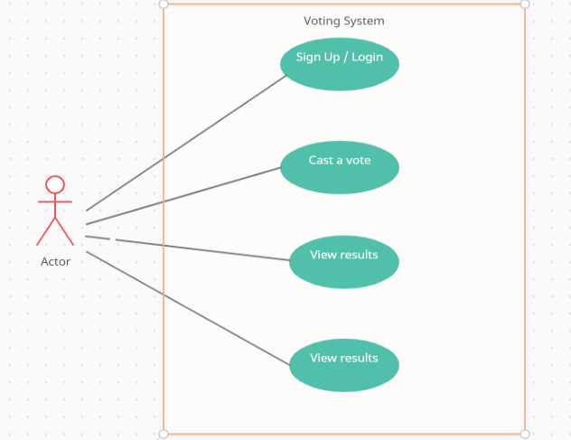

**Ineraction Model**

**SOFTWARE PROCESS**

The agile process was used in the construction of the application. This was to ensure that modifications could be made later on depending of the demand of the client.

**SOFTWARE MODELLING**

Incremental development was used in the making of the voting application. This was done in order to save time and run numerous tests on it.

**SOFTWARE SYSTEM ARCHITECTURE**

**DESIGN AND IMPLEMENTATION**

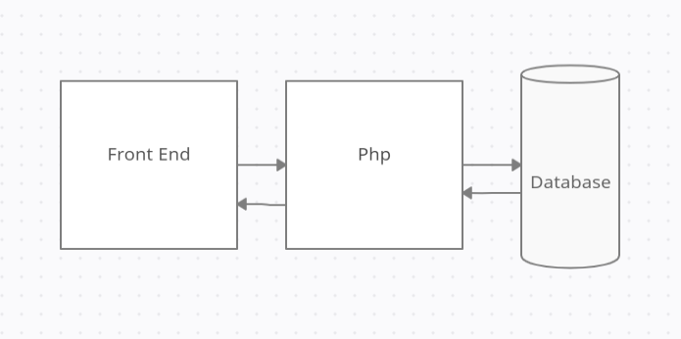

**TESTING**

As a result of the agile process being used, a lot of tests were conducted in order to find and correct issues found.

**SOFTWARE PRODUCT MANAGEMENT**

* Planning: A model was created in order to accurately estimate the scalability and maintainability of the website. From this, the estimation for the time needed in order to complete an website as well as the budget was drawn.
* Costing: