MTT202: Lab 1
Circuit Design: Build and Simulate Digital Logic Circuit Online.
Total marks: 3
Student Name:Mohammed Omar Al-galadi
Student ID:1094044

- Individual Report.
- Select at least 4 circuits out of 9 given below and build them in the software available at https://circuitverse.org/simulator.
- Use the simulator to produce the i/o table.
- Complete the below table.

p | q | r | Circuit2__ | Circuit1__ | Circuit5__ | Circuit6__
1 | 1 | 1 | 0 | 1 | 1 | 1
1 | 1 | 0 | 0 | 1 | 1 | 0
1 | 0 | 1 | 0 | 1 | 0 | 1
1 | 0 | 0 | 0 | 1 | 0 | 1
0 | 1 | 1 | 0 | 0 | 1 | 1
0 | 1 | 0 | 0 | 0 | 0 | 0
0 | 0 | 1 | 1 | 1 | 0 | 0
0 | 0 | 0 | 0 | 0 | 0 | 0

- Put screenshots of your circuits next to the circuit you chose.
- Upload the completed file on Blackboard.

All circuits are given below.

Circuit 1
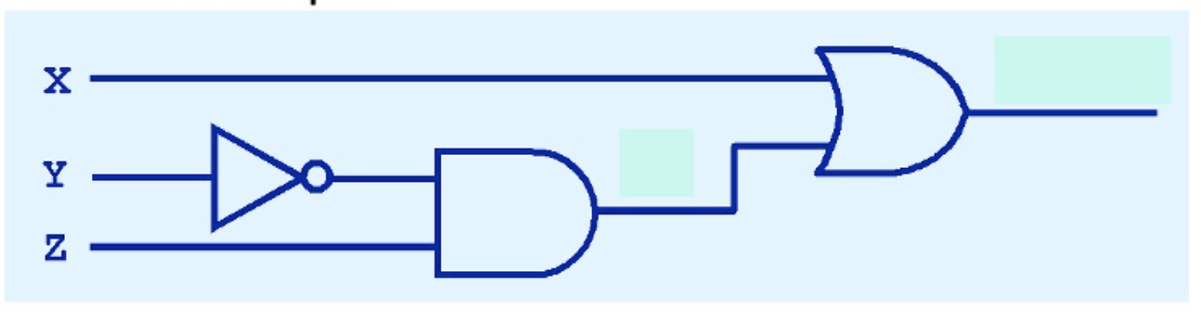

Circuit 2
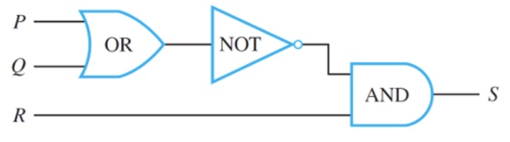

Circuit 3
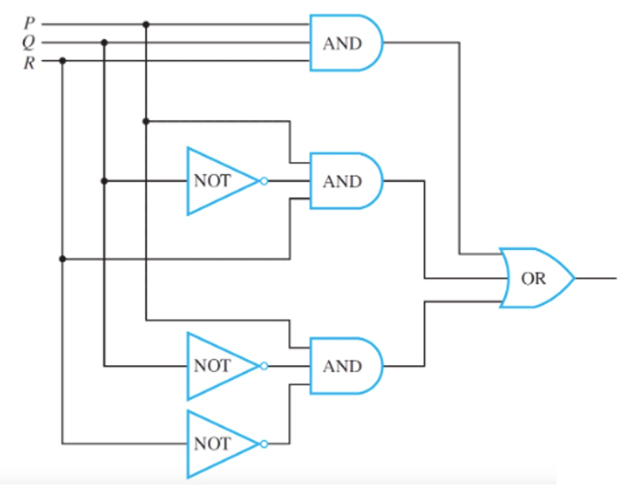

Circuit 4
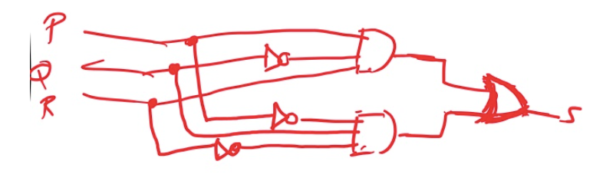

Circuit 5
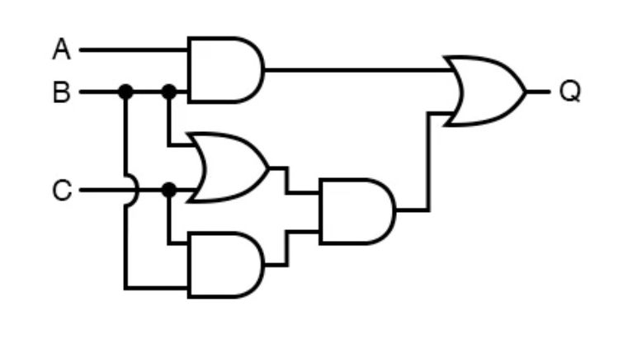

Circuit 6
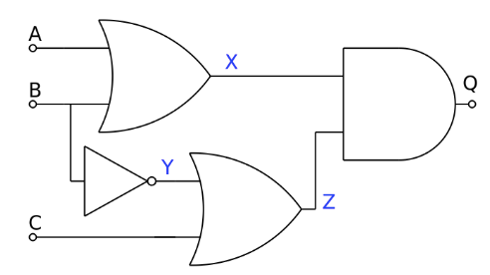

Circuit 7
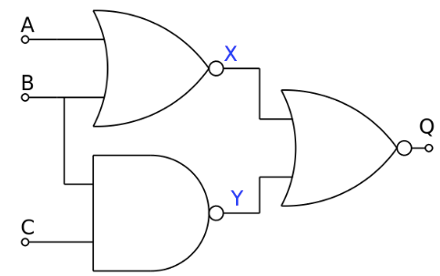

Circuit 8
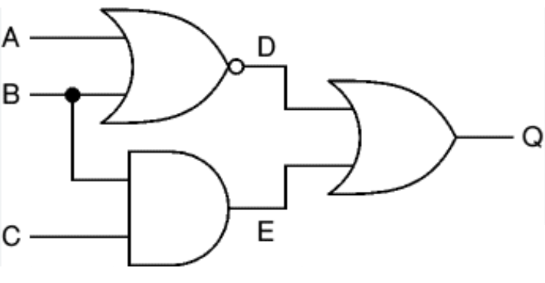

Circuit 9
