DESIGN REPORT

CONTENTS

PROBLEM STATEMENT 2

SOLUTION 3

Methodology 3

Step 1 3
Prim’s Algorithm 4
Pseudo code: Prim’s Algorithm 6

Step 2: 6
Degree optimization: 6
Pseudo Code: Degree Optimization 7

Step 3: 7
Diameter optimization: 7
Pseudo Code: Degree Optimization 8
Psuedo Code: Best_paths 8

Implementation 8

ENHANCEMENTS 10

RANDOM EXAMPLES 12

MEASUREMENTS 17

APPENDIX 20
Source Code: 20

REFERENCES 39

PROBLEM STATEMENT

Given, the location of n nodes in the plane by their coordinates, Create a network topology (represented by a graph), such that it has the following properties:

- It contains all the given nodes.
- It forms a connected graph.
- Each node is connected to at least 2 other nodes (that is, the degree of each vertex in the graph is at least 2).
- The diameter of the graph is at most 4. By this we mean that any node can be reached from any other node in at most 4 hops.
- The total cost of the network topology is as low as possible, where the cost is measured by the total geometric length of all links.

The goal is to implement an optimization algorithm for this specific problem, and experiment with it.

SOLUTION

Methodology

Step 1: Consider a full mesh connection of the given nodes. Apply the Prim’s Algorithm to derive a minimum weight spanning tree. This step satisfies constraints 1), 2) and 5), that is, at the end of this step, we will have a minimum weight connected graph of given nodes.

Step 2: Using this reduced graph we perform a degree optimization to meet constraint 3), that is, at the end of this step, each node will have degree of at least 2.

Step 3: Using the degree optimized graph, we now apply another optimization algorithm to meet constraint 4), that is, at the end of this step each node will be able to reach every other node within a maximum of 4 hops.

At the end all the 3 steps, we would then arrive at solution which would satisfy all the given constraints. The complexity of the entire algorithm (steps 1, 2 and 3) is an O(n³).

Step 1

Prim’s Algorithm

Prim’s Algorithm is a generic minimum weight spanning tree (MST) algorithm. It is similar to Dijkstra’s shortest path algorithm in the sense that it uses a greedy approach when selecting edges that are to be a part of the spanning tree. The algorithm works as follows,

Given a graph G = (V, E) and the weight Wi of each link, the algorithm starts with some vertex v in a given graph G =(V, E) to define the initial set of vertices T, which would eventually contain the set of vertices that for the MST. Then, in each iteration, the algorithm chooses a minimum-weight edge (u, v), connecting a vertex v in the set T , to vertex u that is not in T. Then vertex u is added to T. This process is repeated until a spanning tree is formed. The fact Prim’s algorithm chooses a minimum weight edge connecting a vertex in the T to a vertex outside the set implies that it adds only edges that are safe for T; therefore when the algorithm terminates, the edges in set T form a MST.

Like Kruskal's algorithm, Prim’s also chooses the smallest-weight edge in each iteration, but the difference is that Kruskal’s algorithm builds a forest at each stage but produces a spanning tree at the end and Prim’s builds a spanning tree at each iteration, growing it to include all the nodes.

Below is an Example*[1] of how Prim’s algorithm works

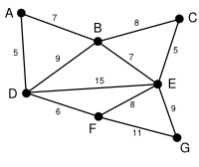 | This is our original weighted graph. This is not a tree because the definition of a tree requires that there are no circuits and this diagram contains circuits. A more correct name for this diagram would be a graph or a network. The numbers near the arcs indicate their weight. None of the arcs are highlighted, and vertex D has been arbitrarily chosen as a starting point.
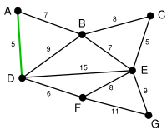 | The second chosen vertex is the vertex nearest to D: A is 5 away, B is 9, E is 15, and F is 6. Of these, 5 is the smallest, so we highlight the vertex A and the arc DA.
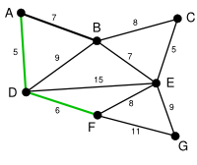 | The next vertex chosen is the vertex nearest to either D or A. B is 9 away from D and 7 away from A, E is 15, and F is 6. 6 is the smallest, so we highlight the vertex F and the arc DF.
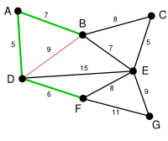 | The algorithm carries on as above. Vertex B, which is 7 away from A, is highlighted. Here, the arc DB is highlighted in red, because both vertex B and vertex D have been highlighted, so it cannot be used.
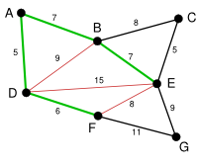 | In this case, we can choose between C, E, and G. C is 8 away from B, E is 7 away from B, and G is 11 away from F. E is nearest, so we highlight the vertex E and the arc EB. Two other arcs have been highlighted in red, as both their joining vertices have been used.
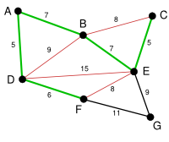 | Here, the only vertices available are C and G. C is 5 away from E, and G is 9 away from E. C is chosen, so it is highlighted along with the arc EC. The arc BC is also highlighted in red.
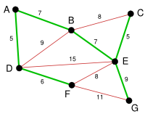 | Vertex G is the only remaining vertex. It is 11 away from F, and 9 away from E. E is nearer, so we highlight it and the arc EG. Now all the vertices have been highlighted, the minimum spanning tree is shown in green. In this case, it has weight 39.
*Adopted from Wikipedia.org

Pseudo code: Prim’s Algorithm [2][3]

Given: Graph G = (V, E) and W[u, v] is weight of edge (u,v).

- T ← V[g]
- For each vertex u in G do
- key [u] € ∞
- key [r] ← 0
- π[r] ← NIL
- while Array T is not empty do
- scan over T find the node u with smallest key, and remove it from array A
- for each vertex v € Adj[u]
- if v € T and W[u, v] < key[v] then
- π[v] ← u
- key[v] ← W[u, v]

Time Complexity: O(n²)

Step 2:

As explained earlier, this step optimizes the graph obtained in step 1 to produce a new graph that satisfies the degree constraint of 2. The method used here was self designed and it works as described below,

Degree optimization:

For each node A with degree < 2,
1) Check all other nodes whose degree is < 2, choose the closest such node and add a
link for A to that node.
2) If no such node exists then, find the next closest node to A, to which there exists no
link. Add a link to it,
3) If no such node exists, just add a redundant link to the closest node of A.

Pseudo Code: Degree Optimization

For (i range from 1 to no:_of_nodes) {
While (degree[i] < 2) {
If(there exists a node j with degree[j] < 2)
Add a link from i to j
Else If (j is closest to i and there is no link from i to j )
Add a link from i to j
Else
Add a link from i to its closest node j
}//end while
}//end for

Time Complexity: O(n²)

Step 3:

This step further optimizes the above graph to satisfy the diameter constraint of 4, without violating any existing constraints. The method used here was self designed and it works as described below,

Diameter optimization:

For each node A in the graph
1) Find a path from every node to every other node, through all your neighboring nodes
2) To choose which neighbor to traverse first, the following heuristic is used.
Preferred Neighbor = the neighbor closest to the destination.
We then sort all the neighbors based on their distances to the destination
3) During the path traversal, the path count is tracked and the third hop node is noted.
4) If the destination is found and path count is less than the diameter requirement of 4.
We start the algorithm with the next node.
5) If the path count is greater than 4 (diameter requirement), we discard that path and
start our traversal through the next preferred neighbor.
6) This process is repeated until we traversed through each of our neighbors.
7) At the end of this step if we still don’t have a path to the destination in under 4 hops,
then, using the pre-noted 3rd hops via each path, we find the 3rd hop that is closest to
the destination.
8) Draw an edge from this 3rd hop to the destination.

Pseudo Code: Degree Optimization

For (i range from 1 to no:_of_nodes) {
For (j range from 1 to no:_of_nodes {

Call function: best_paths(i, i, j, 0);
//this function recursively computes paths from source i to destination j with a list of
//path counts and candidate nodes (3rd hops),

Find the closest candidate node to destination j, and add a link between them.

}//end j
}//end i

Time Complexity: O(n²)

Psuedo Code: Best_paths (parent, source, destination)

For (i range from 1 to no:_of_nodes) {
Find neighbors of i and sort them according to their distances to the destination
While (j < neighbors of node i) {
Call function: best_paths(source, neighbor, destination);
}//end j
}//end i

Time Complexity: O(n)

Overall complexity for diameter optimization is O(n³). Hence the total time complexity of the entire program is O(n³).

Implementation

The entire project was implemented in Java. The graphical user interface was implemented using Java Swings package. The source code is attached at the end of this document. The program provides multiple options, users have the choice of generating random examples (with a random number of nodes and default degree and diameter constraints of 2 and 4 respectively). They can also explicitly specify the number of nodes, the degree constraint and the diameter constraint.

A sample output of the program is show below:

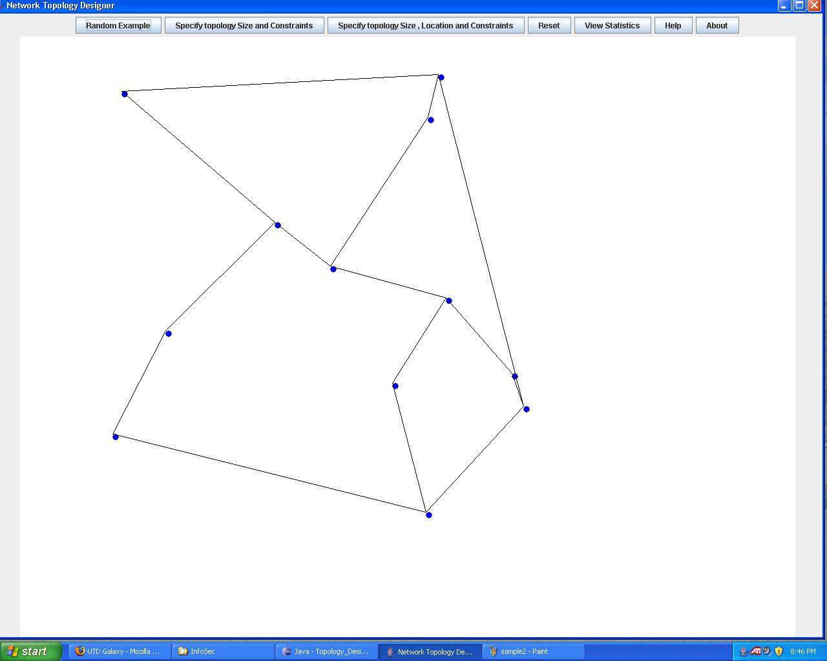

ENHANCEMENTS

The degree optimization and diameter optimization algorithms have been generalized to any user specified value.

A sample output with a user specified degree constraint

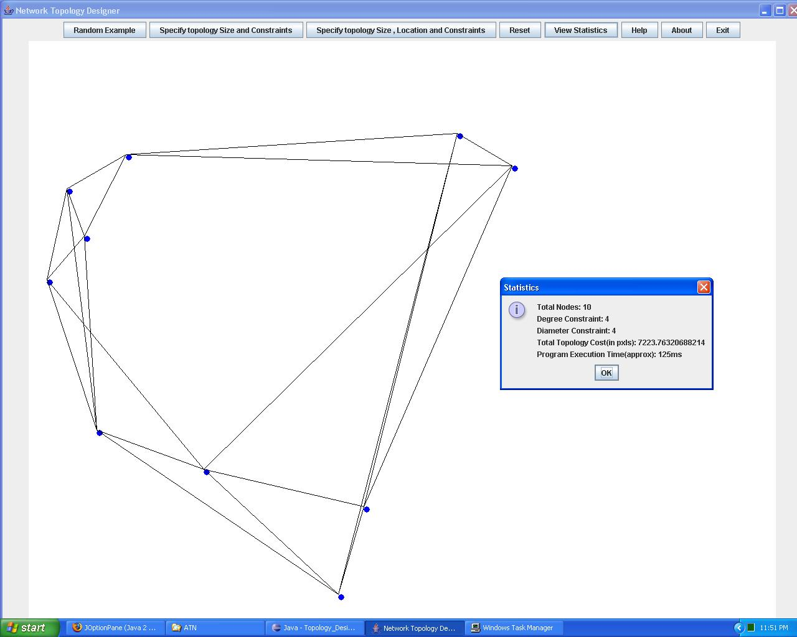

Here the degree constraint is 4, diameter constraint is 4. Also note that the statistics displays the total cost of the topology as well the approximate execution time.

A sample output with diameter constraint of 3

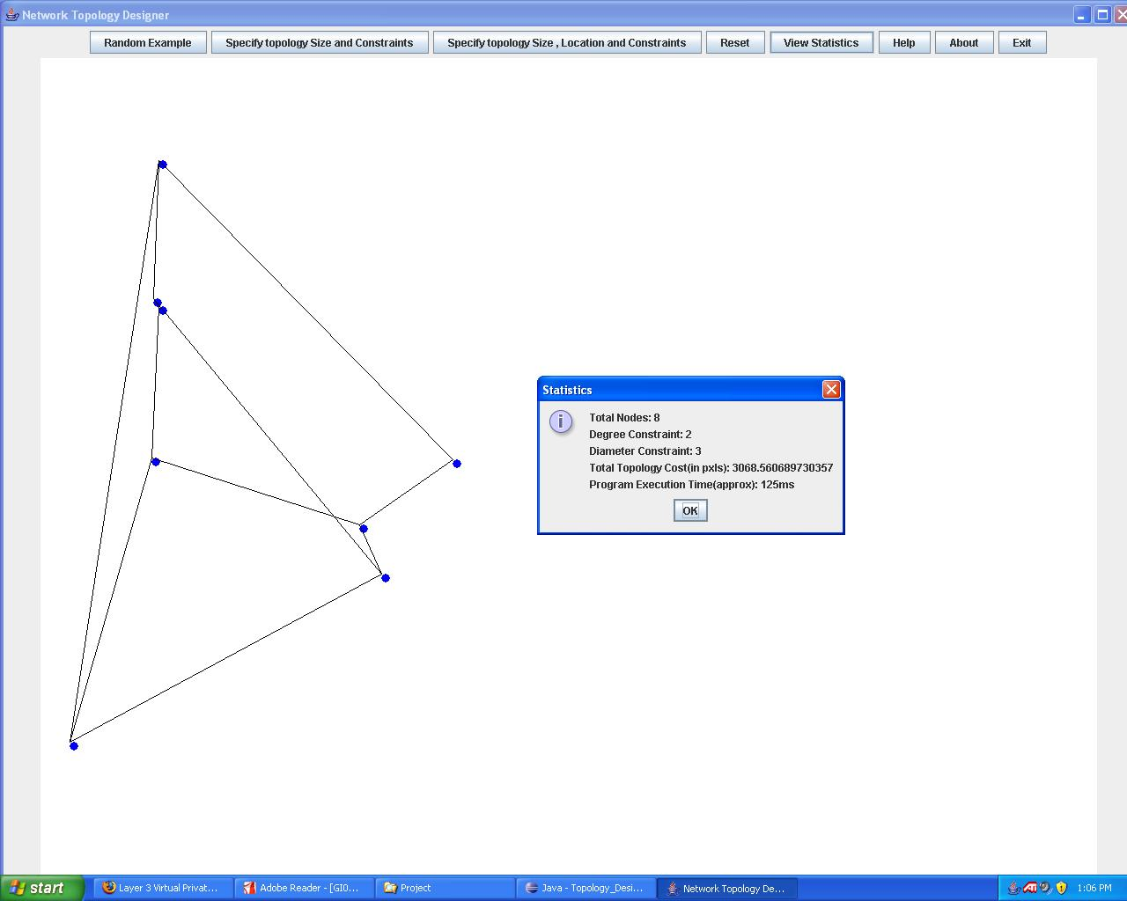

RANDOM EXAMPLES

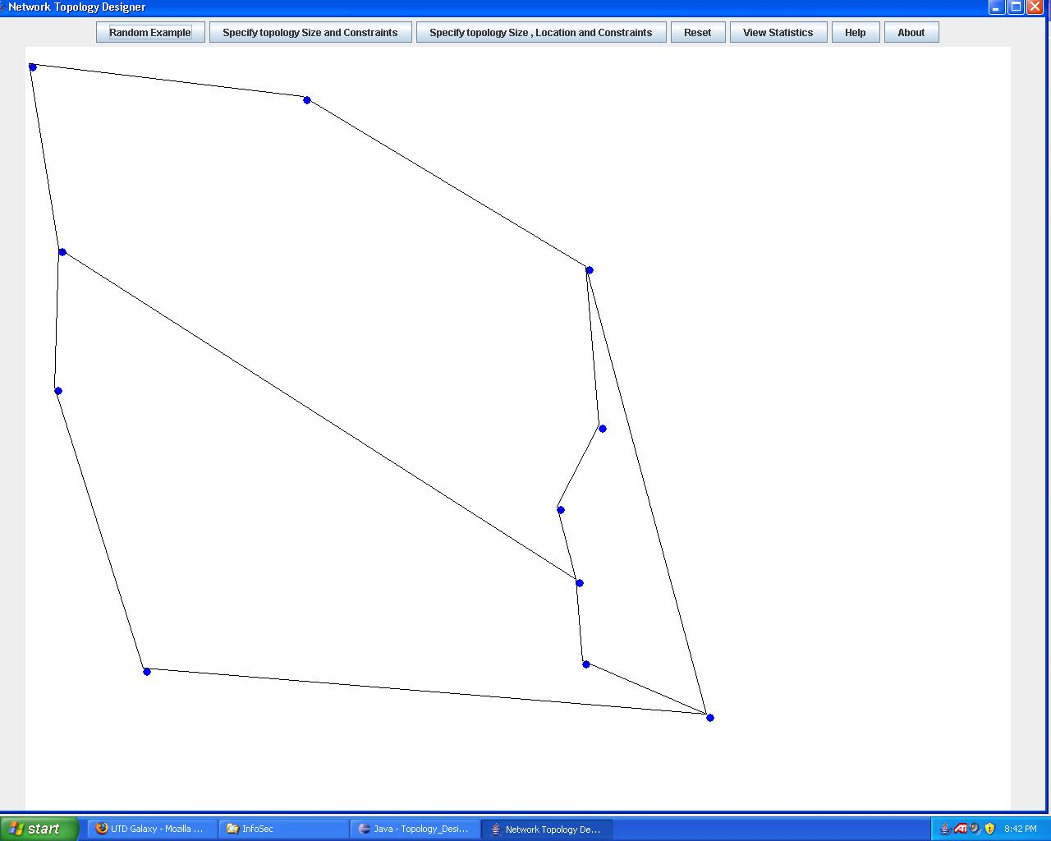

Here, the number of nodes is 11, degree constraint is 2 and diameter constraint is 4.
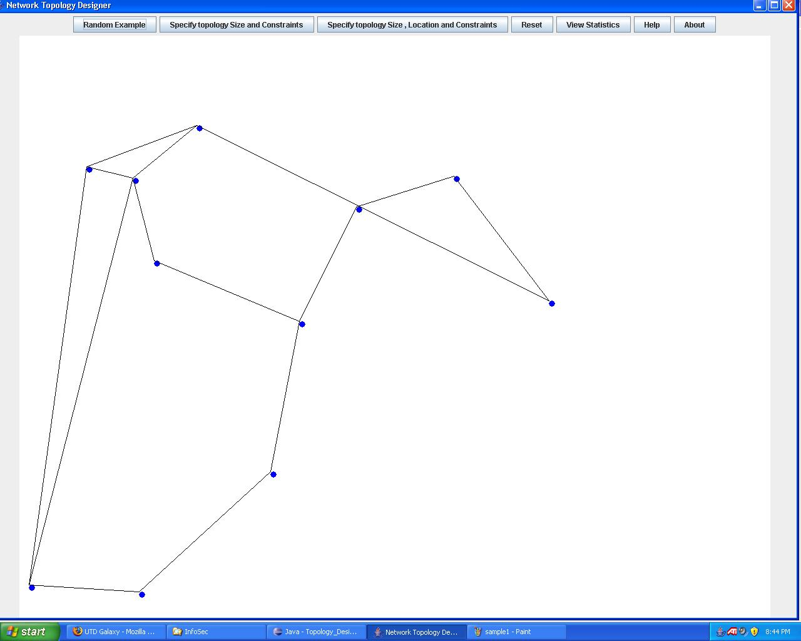

Here, the number of nodes is 11, degree constraint is 2 and diameter constraint is 4.

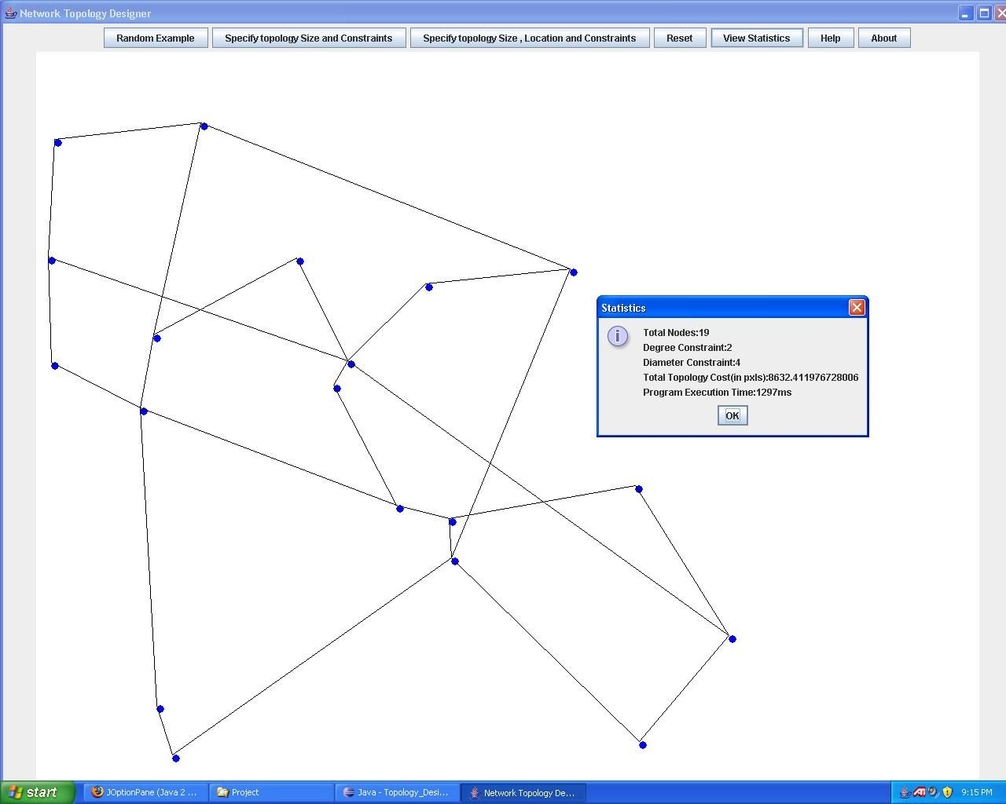

Another example of 19 nodes, degree constraint is 2 and diameter constraint is 4.

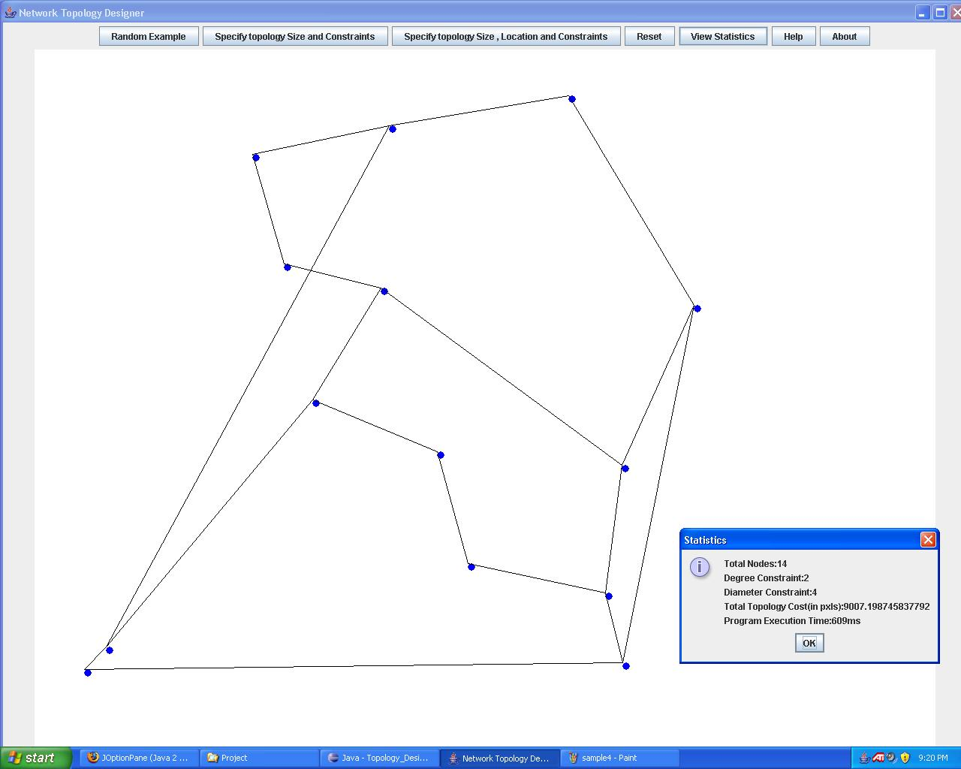

Another example of 14 nodes, degree constraint is 2 and diameter constraint is 4.

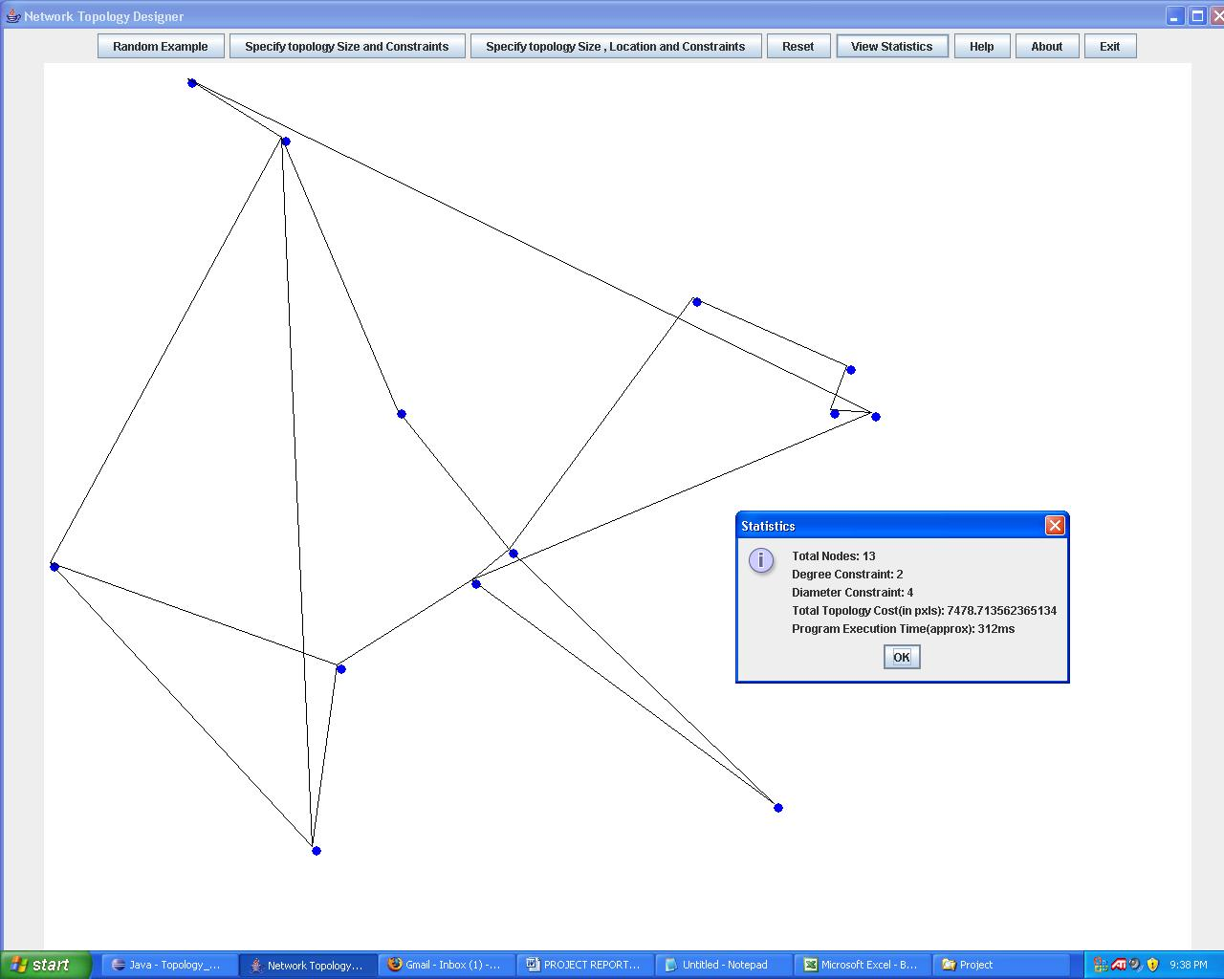

Another example of 13 nodes, degree constraint is 2 and diameter constraint is 4.

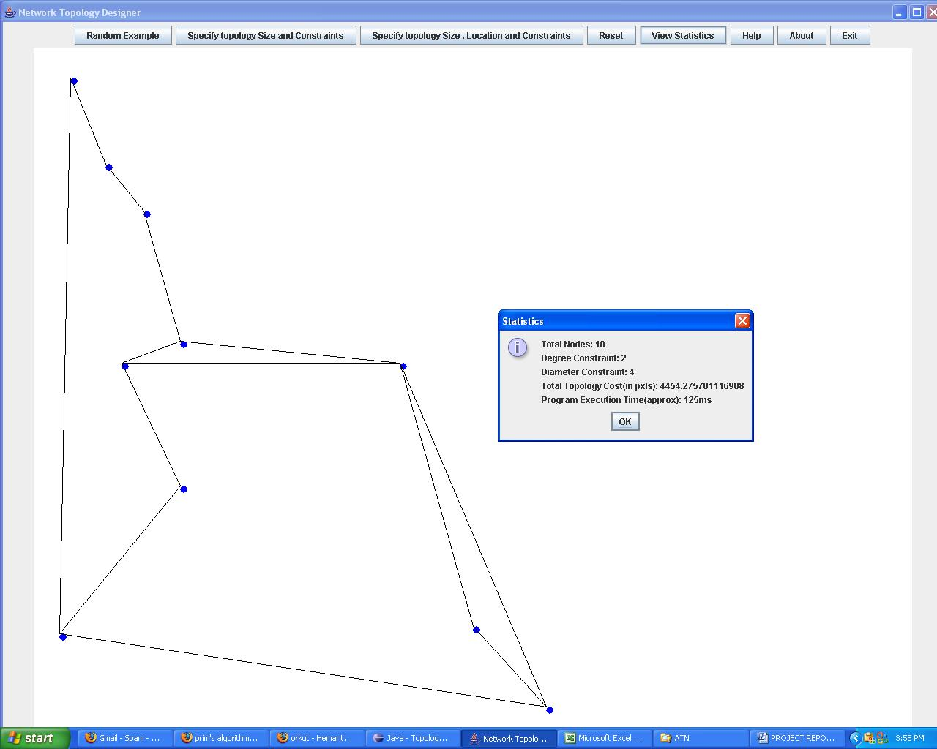
Another example of 10 nodes, degree constraint is 2 and diameter constraint is 4.

MEASUREMENTS

A sample statistics output

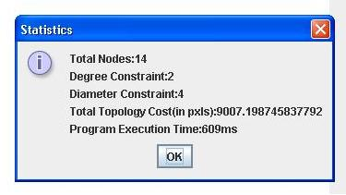

Execution time v/s Cost

The below table and graph shows the variation of execution time with respect to the total topology cost. The measurements were made with the following values fixed, number of nodes = 10, Degree constraint = 2, Diameter constraint = 4.

Total Topology Cost | Execution Time
3592 | 93
3594 | 78
3783 | 93
4148 | 93
4379 | 110
4415 | 94
4418 | 125
4574 | 125
4700 | 110
4896 | 141
5313 | 141
6003 | 610

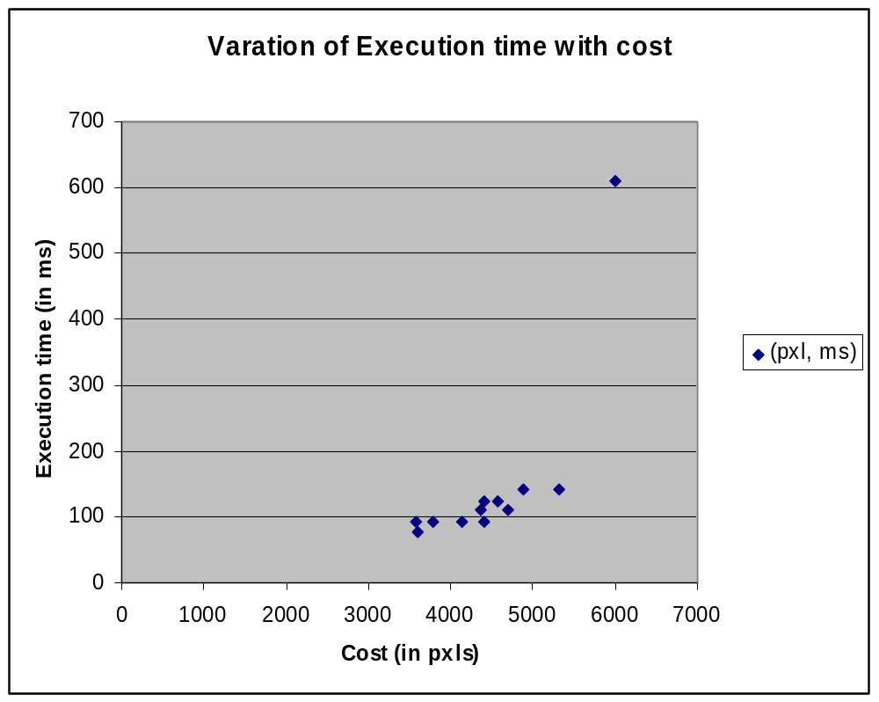

Execution time v/s Number of nodes

The below table and graph shows the variation of execution time with respect to the number of nodes in the topology. The measurements were made with the following values fixed, Degree constraint = 2, Diameter constraint = 4.

Number of Nodes | Execution Time
7 | 31
9 | 78
9 | 94
10 | 94
10 | 125
12 | 172
13 | 203
15 | 250
16 | 297
17 | 515
20 | 781
22 | 1218

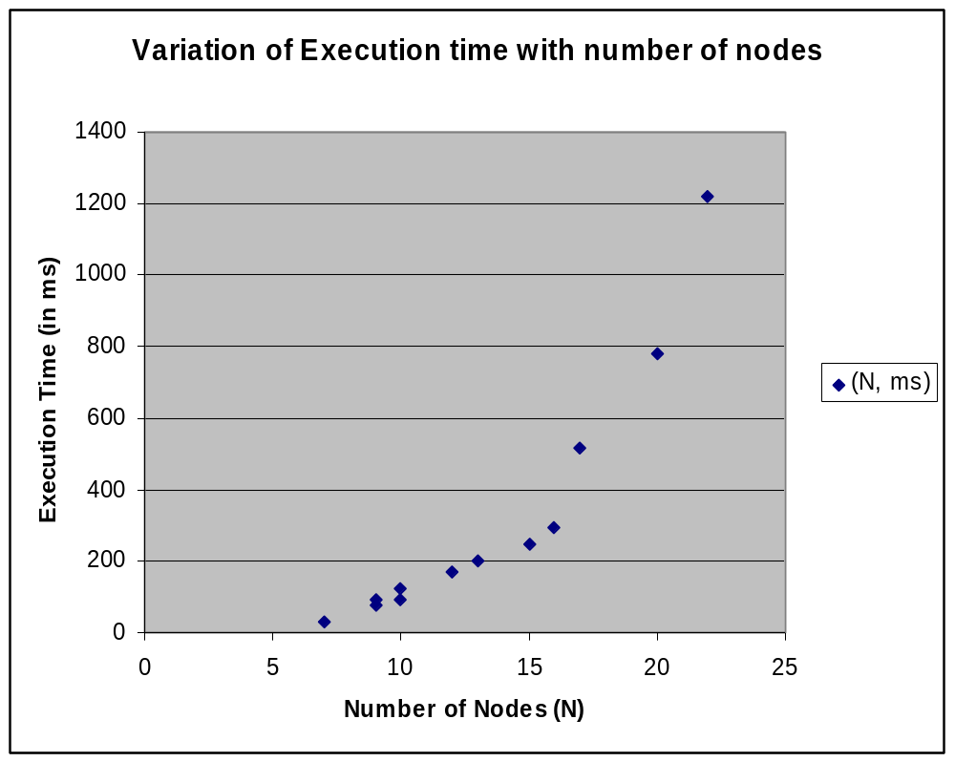

REFERENCES

[1] www.wikipedia.org
[2] Introduction to Algorithms, Second Edition
Thomas H. Cormen, Charles E. Leiserson, Ronald L. Rivest and Clifford Stein
[3] http://www.personal.kent.edu/
[4] http://java.sun.com/docs/
[6] Algorithmic aspects of telecom networks, Second Edition
Thomas G Robertazzi
[7] Core Java 2. Vol. 1, Fundamentals
Cay S. Horstmann, Gary Cornell.

