RNG and INOP Broadcast Protocols
Design Document

Table of Contents

- Introduction

- Relative Neighborhood Graph

  - Algorithm Specification

  - System Design

    - Functional Block Diagram
    - Data structures

  - Implementation Details
  - Assumptions and Details
  - User Manual

- Reliable Relative Neighborhood Graph

  - System Design and brief explanation

- INside-Out Power adaptive (INOP)

  - Algorithm Specification

  - System Design

    - Functional Block Diagram
    - Data structures

  - Implementation Details
  - Assumptions and Details
  - User Manual

5. References

1. Introduction:

This project involves simulation of two wireless based protocols on wired networks. The aim of this project is to understand the behavior of wireless broadcast and compare the power consumption of the two protocols under consideration. The protocols considered for implementation are derived from the following papers.

- J. Cartigny, D. Simplot, and I. Stojmenovic, Localized minimum-energy broadcasting in ad-hoc networks, INFOCOM 2003.
- A. Chiganmi, K. Sarac, and R. Prakash, Variable Power Broadcasting in Ad Hoc Networks, ICC 2006.
The main idea in the first paper is the construction of a Relative Neighborhood Graph (RNG) for broadcast simulation while the latter discusses a 2-hop approach for broadcast using an INside-Out Power adaptive (INOP) method. More theoretical aspects of these can be referred to from the papers mentioned above. This document solely comprises of the design and implementation aspects of the above two protocols RNG and INOP.

2. Relative Neighborhood Graph

2.1 Algorithm Specification
See below sections

2.2 System Design
The design of RNG protocol is described below with the help of a functional block diagram.

2.2.1 Functional Block Diagram

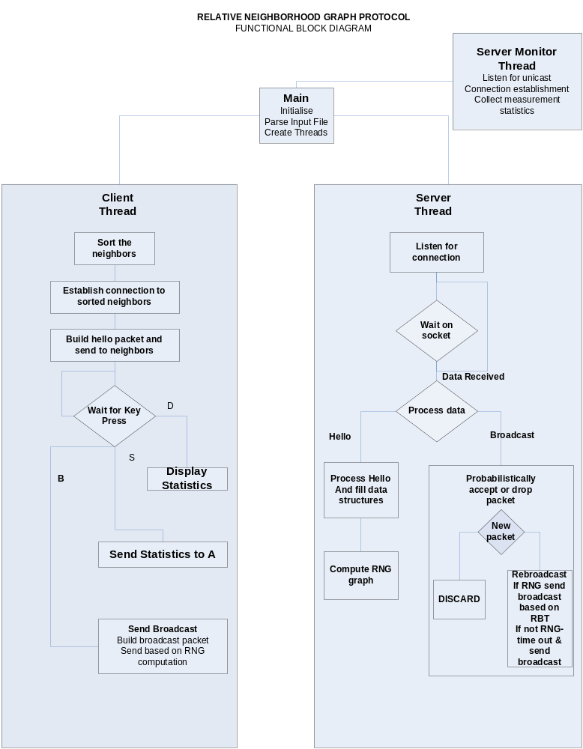

2.2.1 Data structures

The node functionalities are explained below with the help of the data structures used in the code. The algorithm uses its neighborhood information and information from its neighbors to perform its computations.

The structure used below explains the information that is stored at each node and information regarding the neighbor nodes.

struct Node {

char name[3]; //name of this node
char num_Neighbor[4]; //no: of neighbors for this node
struct nodeList *neighbor_List; //neighbor names and their distances
};

struct nodeList {

char node_Name[3]; //neighbor name
char distance[6]; //distance

};

Nodes exchange Hello and Broadcast messages among themselves. The structure of this message is shown below.

struct Message {

char message_Type; //H- Hello ,B - Broadcast, U - unused
char source[3];
char retransmit_source[3];
char seq_Num[10];
char data[256];
};

The message exchange contains message type, source information, retransmit source information, sequence number and data. The data field in the message structure would contain the distance with which the message was transmitted by each node which helps to eliminate the common neighbors when computing the neighbor to be covered for further re-broadcast.

The information about the sequence number is also maintained at each node to check for duplication of packets and elimination of the same in order to maintain the algorithm stable.

struct source_sequence {
char name;
int sequencenum;
int sent;
};

Finally, another structure for maintaining statistics at each node is also used and this comprises of information about the broadcast count, received count and consumed power.

struct StatMessage {
char source[3];
char broadcastCnt[3];
char receivedCnt[10];
char consumedPower[10];
};

2.3 Implementation Details

The implementation of RNG protocol involves total of 3 threads whose functionalities are mentioned below

serverFunctionThread:

The server functionality for this algorithm executes as a thread which is responsible for the receiving different messages such as hello packets and broadcast packets from neighbor nodes and invokes the related functionality and waits for new messages. Initially this accepts connections from all its neighbor nodes.

clientFunctionThread:

The client functionality executes as a thread which is responsible for initially connecting to its neighbor nodes and sending messages such as hello packets and broadcast packets to the other nodes

serverFunctionMonitorThread

This thread is solely used for the purpose of monitoring statistics and helps in displaying detailed information on per broadcast or cumulative broadcast basis.

parse_input

The function parses the configuration file and updates the global data structures which would be used for further computations.

Hello Functionality
sendHello – at client thread
hello_packet_processing - at server thread

The RNG graph construction function would be invoked once hello packets are received from all the neighbors of the current node. This would yield a set of nodes that form a part of the RNG graph for the entire topology.

Broadcast functionality
sendBroadcast
broadcast_packet_processing

This involves constructing and sending a broadcast packet and processing a received broadcast packet wherein we perform the following functionality for proper execution of the protocol.

A simple pseudocode along with respective function is given below which helps us to explain the algorithm clearly.Respective functions are marked in bold within parenthesis.

Once a broadcast packet is received at the current node being considered we first calculate the probability to decide on acceptance of the packet [calculate_probability].If not accepted we drop the packet. In case of accepting a packet we also check for whether it was a new broadcast packet or an old broadcast packet based on the sequence number. We then eliminate the source from the RNG graph. We proceed further to obtain the power with which the source transmitted and compute the common neighbors covered by that power. We proceed to eliminate these neighbors if they are our RNG neighbors. [commonNeighborCheck,find_common_neighbors].We then obtain the physical neighbors within our maximum power and construct a send list from the max RNG neighbor that is present.

Further functionality in the form of pseudocode

if (accept & new broadcast) {
if(source == rng) {
rebroadcast (type, send_lst, max_power); //type = 1, RNG
}
else {
rebroadcast(type, snd_lst, max_power); //type = 0, non-RNG
}
}

else if(accept & recvd broadcast) {
ignore msg if already sent,
ignore msg it RNG list is empty
else
if(source == rng) {
rebroadcast (type, send_lst, max_power); //type = 1, RNG
}
else {
rebroadcast(type, snd_lst, max_power); //type = 0, non-RNG
}
}
}
rebroadcast (type, send_lst, max power) {
if(rng) {
RBT () computation (alarm) broadcast with max_power to computed send list
}
else if (!rng) {
wait for a timeinterval 'x', (alarm) and broadcast with max_power to send list
and do neighbor elimination if necessary
}
}

Functions used for RNG Computation
rngComputation
find_v_w_dist
maxDistIndexFunction
rebroadcast

nonrng_alarm_handler
send_rebroadcast
nonrng_alarm_handler
rng_alarm_handler
calculate_probability
compute_consumed_power

Miscellaneous functions used and descriptions of the same

process_data()
print_message()
itoa()
get_node_address()

2.4 Assumptions and Details

We have implemented a queue structure for accepting more than once broadcast at a time. These queues will hold the data for up to 5 messages. The maximum limit for this queue size is fixed to be 5 which can be modified if need later. This is implemented for behavior of re-transmissions that can be received from many nodes.

Another broadcast message can be sent from the source only after the completion of the first broadcast packet is reached at all nodes. So eventually the system can support a single broadcast at one instance of execution.

2.5 User Manual

Execute the program at all nodes as shown below wait until all the hello messages are exchanged and request for user to continue message appears

- Type B and press enter from any node from which a broadcast is intended to be sent.
- In order to send statistics and display the information sent to the server press S on each node.
- At node A press D to display the cumulative information from all nodes.

Execution command

Usage: RNG <seed> <max_delay> <self ID>

- Reliable Relative Neighborhood Graph

  - System Design and brief explanation

The design of a reliable RNG protocol uses the existing RNG design as the base and includes the following additions.

After originating or retransmitting a broadcast, we start a retransmission timer, whose expiry triggers a retransmission of the packet. The maximum number of transmissions can be controlled, thereby controlling the level of reliability bearing the power consumption factor as well. The retransmission timer is cancelled when the packet sent out is heard (received), from a neighbor’s (furthest) broadcast. By this mechanism we achieve implicit acknowledgements with minimal additional power consumption. (Note: The leaf nodes of RNG don’t start a retransmission timer. This is another optimization that reduces the total power consumed.)

- INside-Out Power adaptive (INOP)

  - Algorithm Specification
  - System Design

The system design for INOP includes initial functionality until hello packet exchange and gets modified for broadcast functionality. The broadcast functionality depends on 2 hop information and computation of INOP algorithm to find maximum distance to broadcast as given in the paper and implementation of neighbor selection algorithm for further rebroadcasts.

    - Functional Block Diagram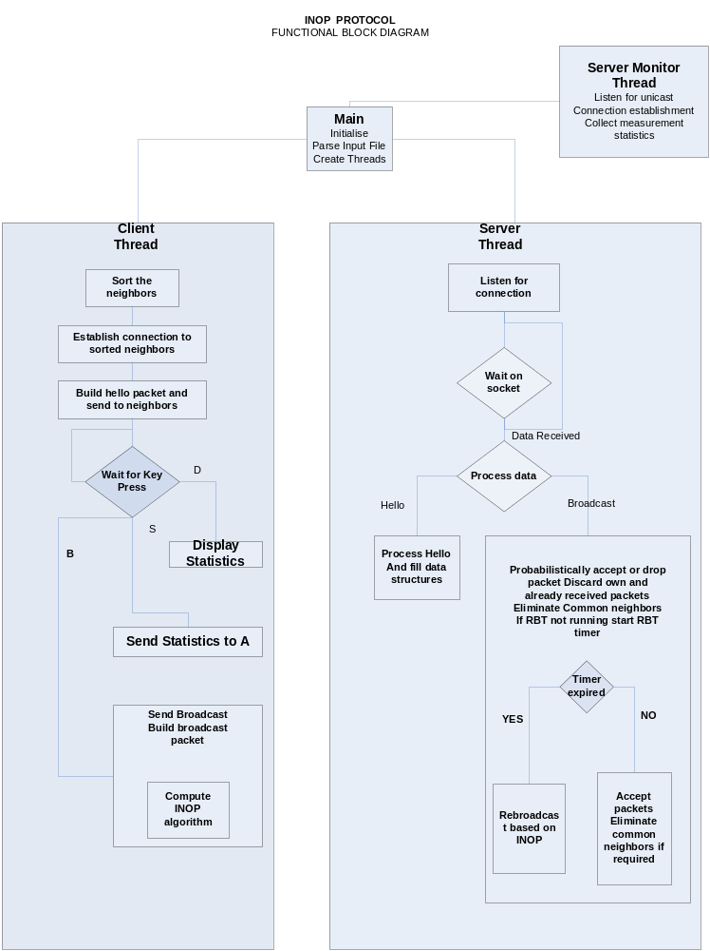

    - Data structures

Similar data structures are used for INOP.

  - Implementation Details
Incorporation of INOP functionality using the following function

Inop_algorithm

This function implements the INOP algorithm as given in the paper. Upon reception of a new broadcast inop_alarm_handler is triggered based RBT calculation. If any other packet is received before the expiry of this timer we calculate the new covered list and re-transmit based on the INOP algorithm.

  - Assumptions and Details
Computation of RBT.

  - User Manual

Usage: INOP <seed> <max_delay> <self ID>

