С++ Software Developer Applicants Qualification Test

Messages queue

Task:

Implement the blocking priority queue for messages asynchronous interchange between several "Reader" and "Writer" streams and the test application to demonstrate the functionality.

The MessageQueue class must support the HWM/LWM mechanism (high water mark/low water mark), message priorities and the “get” blocking call (the call is blocking before message appears in the queue)

Class Structure:

General Diagram:

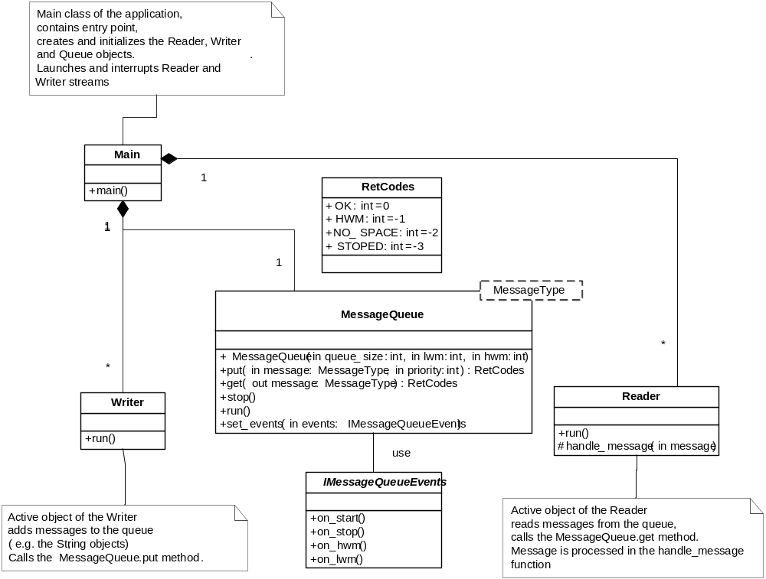

The on_lwm/on_hwm notification procedure enables suspension and recommencement of the Writers if the queue is overflown and accordingly is free again. Usually the hwm and lwm thresholds are assigned 90% and 10% of message queue length relatively.

The Writer class:

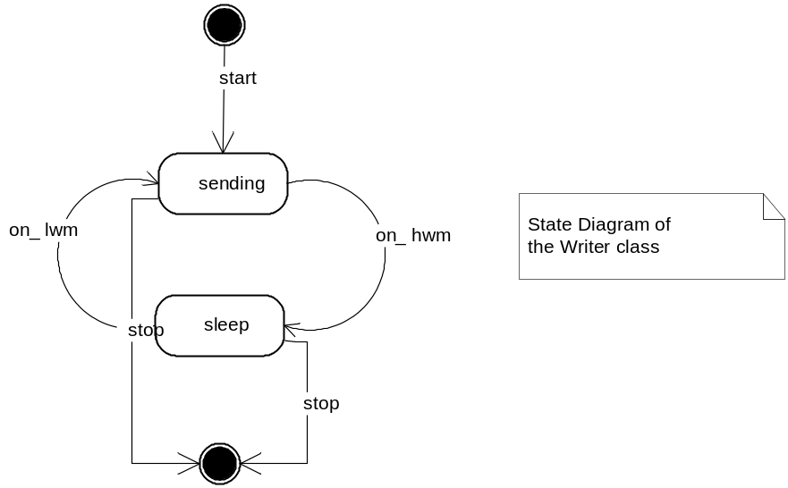

The Reader class:

The Reader class object is permanently in MessageQueue messages waiting state. The Reader stream stops only if the MessageQueue.get method returns STOPPED.
The handle_message procedure is called each time to process a received message e.g. to print message into console or a file.

Main:

Creates, initializes and launches all objects of the application. Then waits some time (until a message from the user is received), interrupts the queue and waits until the Reader and Writer streams correctly terminate and after that stops.

Required Result

As a result, both the compiled file (message_queue[.exe]) which demonstrates MessageQueue class work and the source codes must be provided as well as detailed description of all functional methods of all implemented classes with the behaviour dynamics indications and threads safety requirements.

Notes:
- the application must provide at least two Writer objects;
- the information that is not specified in the task is at the applicant discretion;
- the application must be compiled on either Win32 or Solaris/SPARC or Linux (x86 or x64).

