高等數位影像處理

Advanced Digital Image Process

HW#1

姓名：張耀中

學號：109368008

指導教授：高立人教授

### Development envirment：

OS：unbuntu18.04

Editing tools：VScode

Compilation tools：CMake

Opencv version：3.2.0

1. Raw image I/O(80%)

1.1 Raw image file format understanding.

1. Download raw images from ntut course system.
2. Find a raw image viewer that you prefer to read raw image.

Try to use Xnview to read raw image lena256.raw. Show screenshot of

output. What options do you have to set to read the raw images

correctly?(Figure,5%;Discussion,5%)

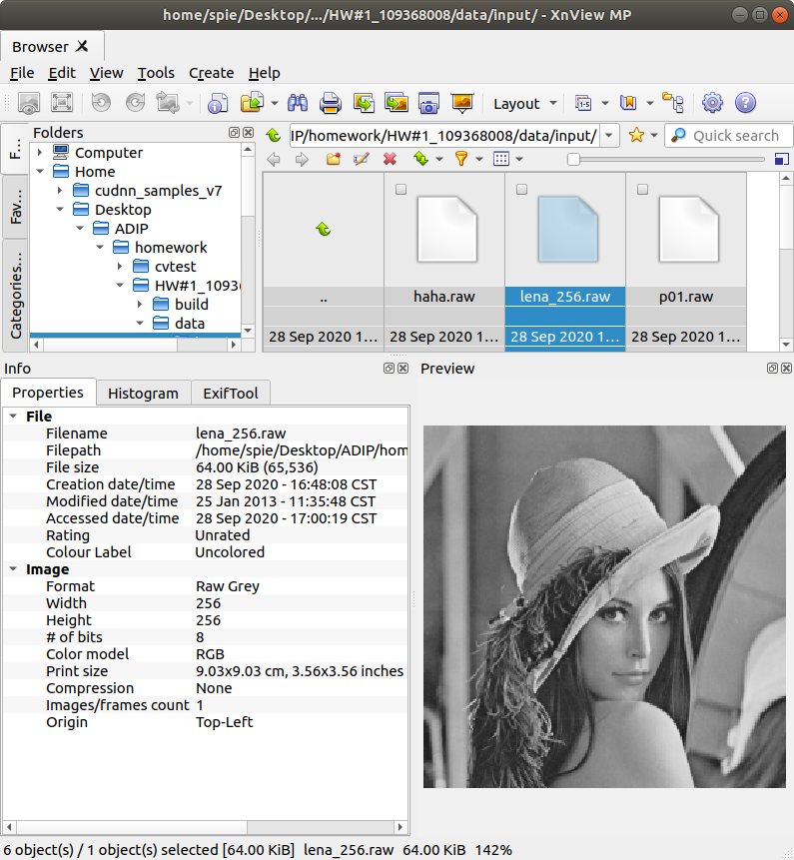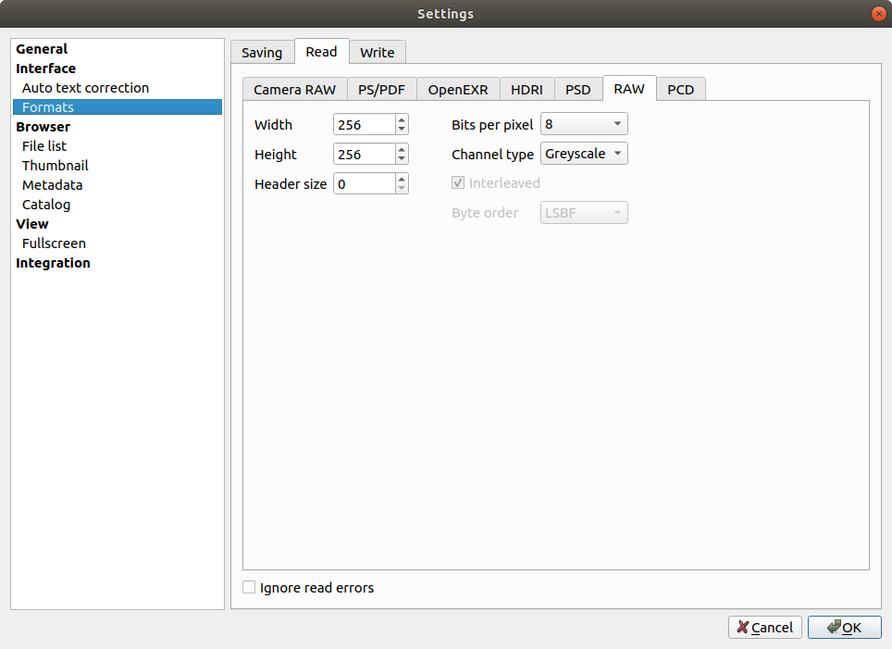

To read RAW image file need to know height, width and depth

a 65536 Byte file is 256*256*8 bits

1.2 Raw image file input/output

a.install opencv

b.Download and modify the example program to read the raw image file lena_256

(1)Intensity value of the pixel at the coordinate of the 123 row & 234 col

is 157

(2)Intensity value of the 5487 pixel stored in lena_256.raw is 119

The pixel coordinate is (21,111)

c.Display lena.raw d.Try to relocate pixels to rotate

lena256

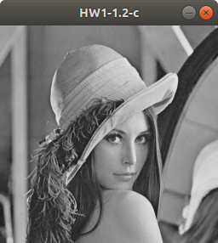 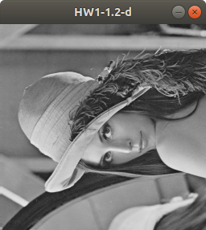

e.Split lena_256 into 16 square patches of the same size, and randomly swap them to output a new raw image(please generate and save two images with different random patterns).

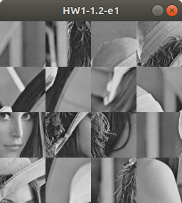 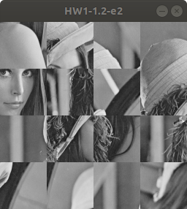

split image into 16 piece, each one is 64*64 size

use rand() function to get two non duplication random arrays in range 0~15.

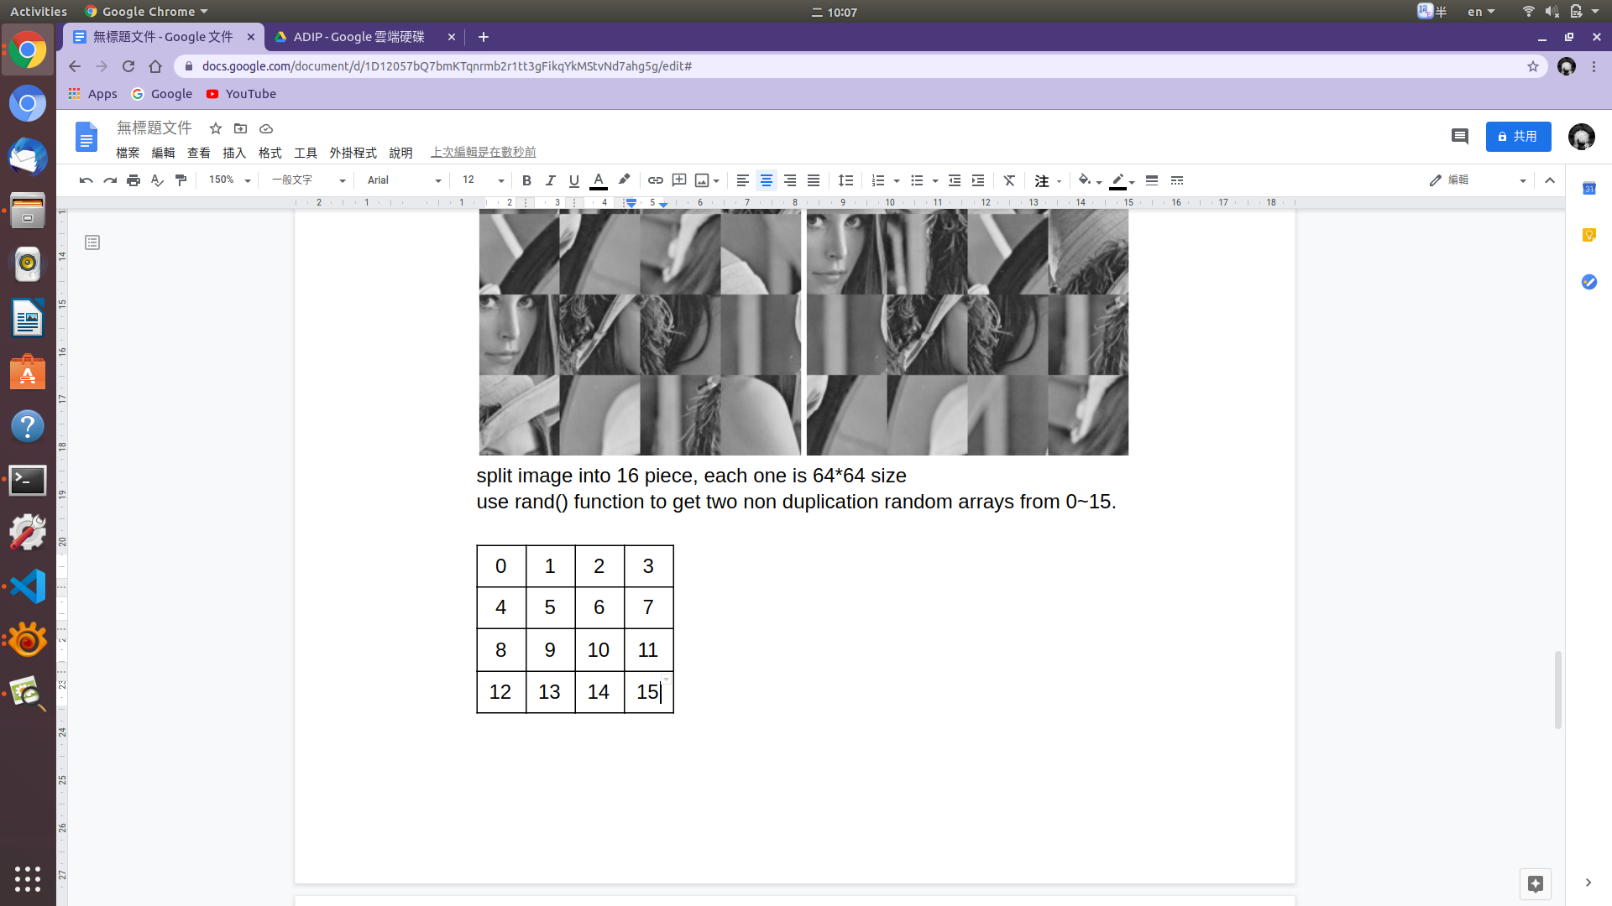

Follow the sequence of array to put the 16 pieces

into the corresponding position.

f.Given four 8-bit images p01.raw, p02.raw, p03.raw and p04.raw. Each image is in square size.

(1)please determine the image size from the file information of raw size.

65536 Bytes is 256*256*8 bits

(2)Use these images to assemble a larger image as below.

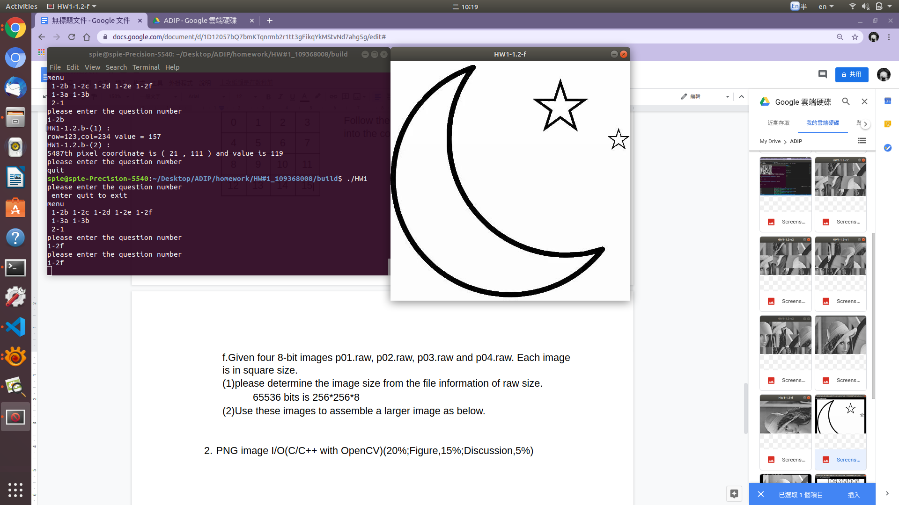

At the beginning, use the Xnview to check

the order of pictures.

Read the raw picture and use 3-layer

for loop to merge the image.

(3)Save the assembled image as raw format and use Xnview to verify results

After merging image, the image size become 512*512*8 = 256KiB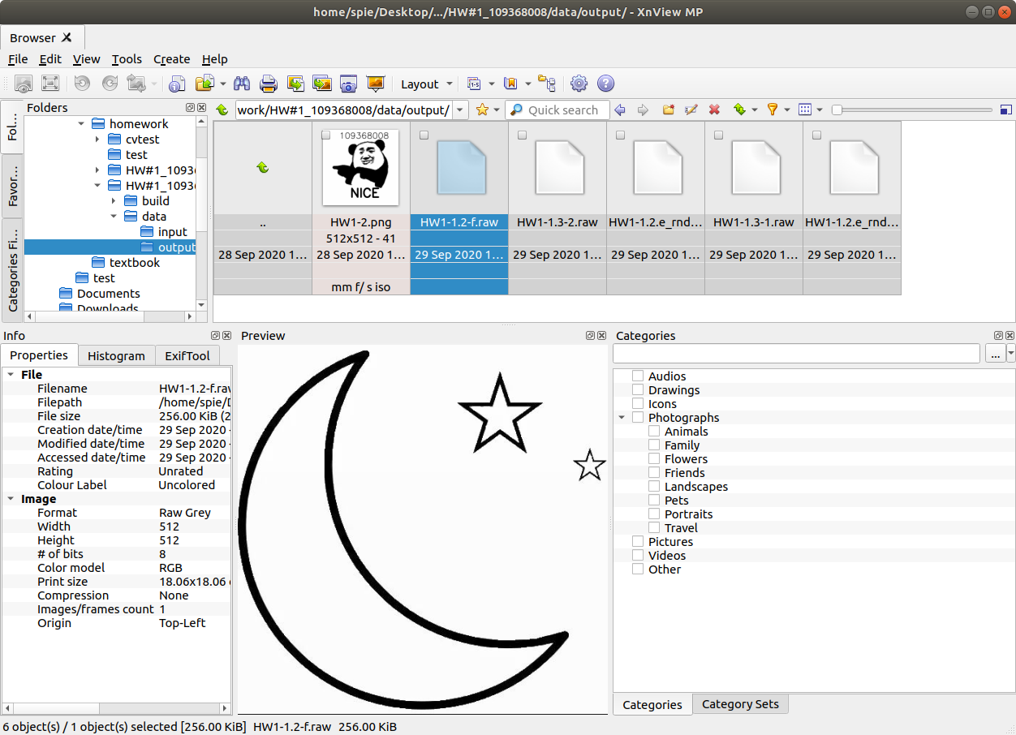

1.3 Brightness

a.Increase the image brightness. Reading lena_256.raw and adding value 50 to each pixel value by C/C++. Write the output to a raw image file. Use Xnview to view the result.



The intensity is obviously brighter.

b.Reading lena_256.raw and increasing the image brightness with random value within -50 to 50. Write the output to a raw image file. Use Xnview to view the result.

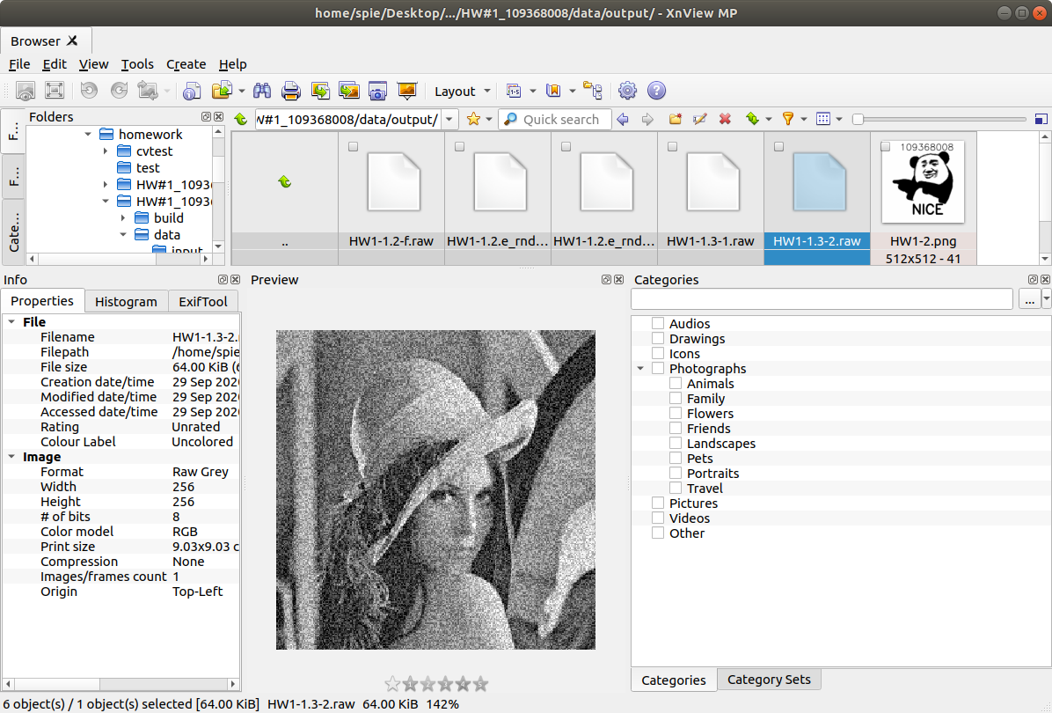

The image is noisy because of the random value we add.

c.Which part you have to be careful?

because we use unsigned character type to store the value so we need to be careful to make sure the data will be within 0~255. You can use an integer variable to save your calculations and determine if it is greater than 255 or less then 0 to make sure that overflow and underflow will not happen.

1. PNG image I/O(C/C++ with OpenCV)(20%;Figure,15%;Discussion,5%)

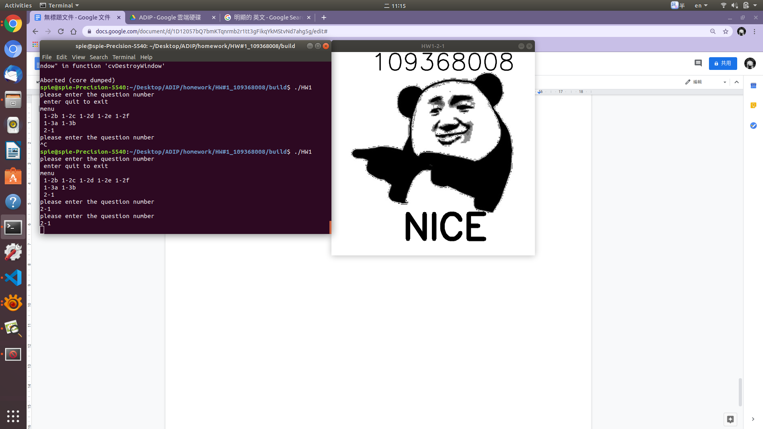

put your raw image into Mat array space and use the putText() function to put the word on the image and use ImWrite to save as a png file.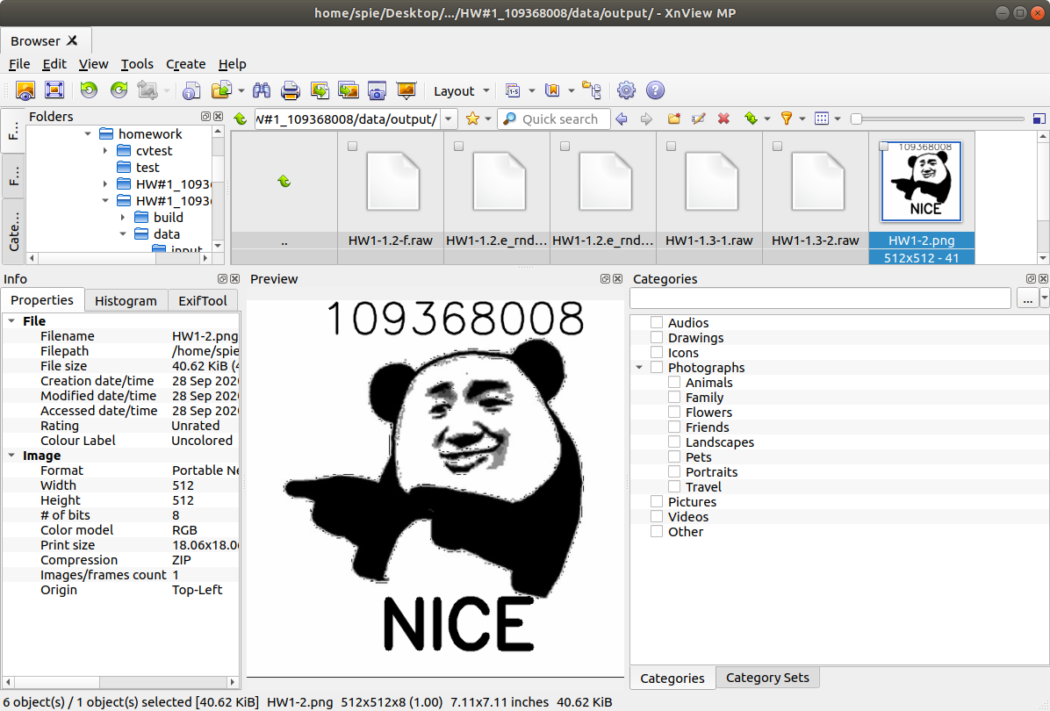

P.S. Main cpp file is under folder “HW#1_109368008”

To execute the application under ubuntu. Please open terminal and cd “HW#1_109368008/build” then execute “./HW1”.