Advanced Digital Image Process

HW#2

作業#2

姓名：張耀中

學號：109368008

指導教授：高立人教授

### Development environment：

OS：unbuntu18.04

Editing tools：VScode

complilation tools：CMake

opencv version：3.2.0

1.Zooming and Shrinking

(1). Zooming the eyes area of lena_256.raw with zooming ratio 2:1

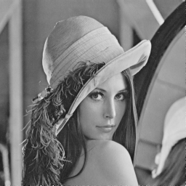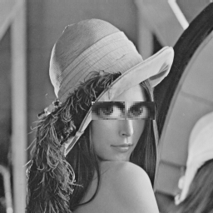

origin big_eyes

(2).Shrinking the image with ratio 1:2 raw-column deletion.

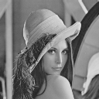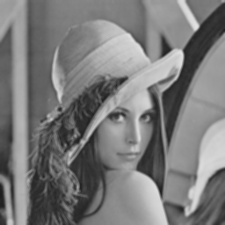

blur lena128*128

(3).Use Xnview to blur the lena_256.raw.

Compare ↑2.5↓2 and ↓2↑2.5 and ↑1.25 with nearest neighbor, bilinear and bicubic. Please discuss the difference in execution time, image quality and any other issues. Explain the difference with reason.

|  |  |  |  |
| --- | --- | --- | --- |
|  | near neighbor | bilinear | bicubic |
| ↑2.5  ↓2 |  |  |  |
| time | 10.1ms | 35.36ms | 80.8ms |
| ↓2  ↑2.5 |  |  |  |
| time | 1.45ms | 7.17ms | 17.5ms |
| ↑1.25 |  |  |  |
| time | 1.1ms | 6.2ms | 15.4ms |

In image quality

We can see bicubic is best and bilinear is better then near neighbor

Because of shrinking first so we lose a lot of data at doing ↓2↑2.5, we can see all three kinds of zooming in ↓2↑2.5 have the worst quality.

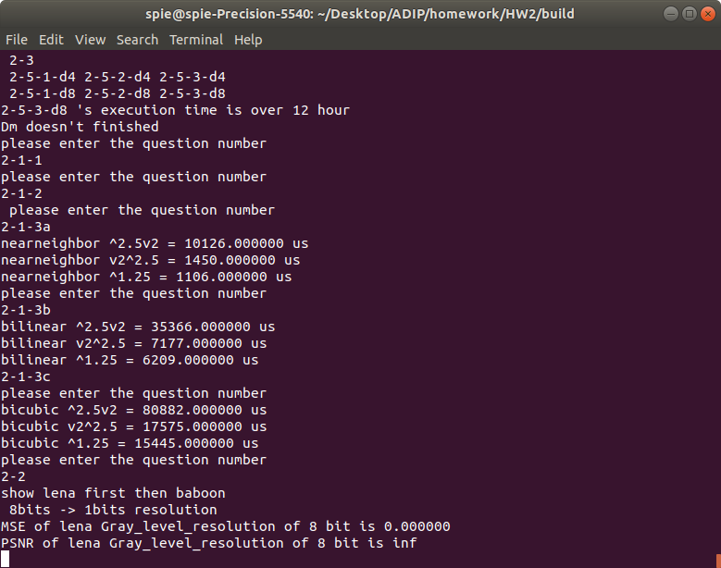

In execution time

We can see near neighbor is shortest and bilinear is then bicubic.

Because of zooming first so we get a lot of unnecessary data at ↑2.5↓2 ,we can see all three kinds zooming in three sequences.↑2.5↓2 have the longest execution time.

Issue

Using bicubic to zoom images will have some boundary effect and sometime the value will overflow or underflow.

Experience

If you're gonna zoom an Image you should use bicubic and zoom in one step.

2.Gray-level resolution

(1).Using C/C++ to quantize the gray-level resolution of lena_256.raw and baboon_256.raw from 8bit to 1 bit. Show the results of these quantized images and the corresponding MSE and PSNR value.

Discuss the bit rate saving.

|  |  |  |
| --- | --- | --- |
|  | lena | baboon |
| 8bits |  |  |
|  | MSE=0 / PSNR=INF | MSE=0 / PSNR=INF |
| 7bits |  |  |
|  | MSE=0.5 / PSNR=51.1 | MSE=0.5 / PSNR=51.1 |
| 6bits |  |  |
|  | MSE=3.5 / PSNR=42.6 | MSE=3.5 / PSNR=42.6 |
| 5bits |  |  |
|  | MSE=17.4 / PSNR=35.7 | MSE=17.4 / PSNR=35.7 |
| 4bits |  |  |
|  | MSE=78.6 / PSNR=29.1 | MSE=77.8 / PSNR=29.2 |
| 3bits |  |  |
|  | MSE=324.8 / PSNR=23 | MSE=338.6 / PSNR=22.8 |
| 2bits |  |  |
|  | MSE=1345 / PSNR=16.8 | MSE=1497 / PSNR=16.3 |
| 1bits |  |  |
|  | MSE=4800 / PSNR=11.3 | MSE=5382 / PSNR=10.8 |

According to the result we can see if gray-level resolution is greater than 5 bits, people can’t even find the difference. When gray-level resolution comes to 4 bits, some smooth place can see some false boundary.

Such as Lena's shoulder and baboon’s bridge of the nose, but you still can’t really find the difference at hair or other complex places.

When gray-level resolution comes to 3 bits Lena’s false boundary gets more serious but baboon is still acceptable.When gray-level resolution is lower than 3 bits we can only identify what is it but not any details.

So we know that if an image is more complex you can use lower gray-level resolution to save the image.

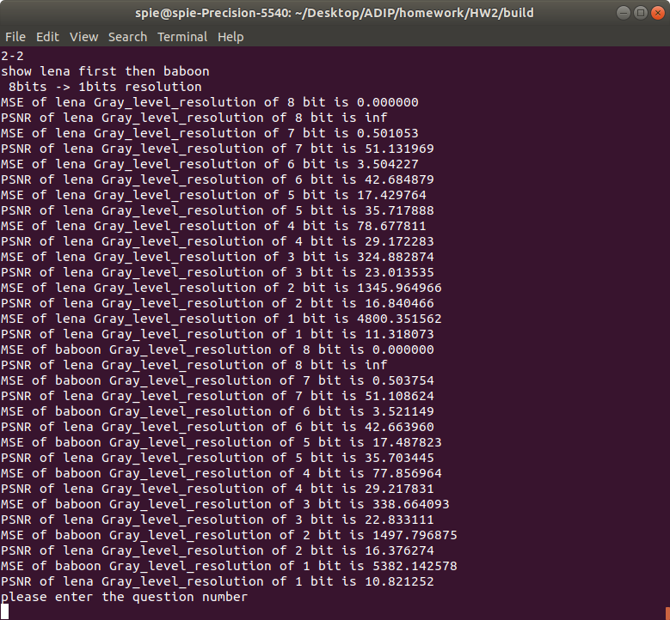

3.Isopreference test on gray-level resolution

(1).Test the isopreference on lena_256.raw and baboon_256.raw images using the programs written in Problems 1and 2.

|  |  |
| --- | --- |
| gray-level resolution=8bits | |
| 256*256 | 128*128 |
|  |  |
| 64*64 | 32*32 |
|  |  |

Even though gray-level resolution is 8bits but the quality is still not good at 64*64 and lower.

Now let’s see the quality at gray-level resolution is 5 bits

|  |  |
| --- | --- |
| gray-level resolution=5bits | |
| 256*256 | 128*128 |
|  |  |
| 64*64 | 32*32 |
|  |  |

According to the result we can see gray-level resolution 8bits and 5 bits have nothing changed.

|  |  |
| --- | --- |
| gray-level resolution=4bits | |
| 256*256 | 128*128 |
|  |  |
| 64*64 | 32*32 |
|  |  |

Even at 64*64 we can see the false boundary, and 32*32 is always too blurry to see all the details even gray-level resolution is 8bits

Now let’s see baboon

|  |  |
| --- | --- |
| gray-level resolution=8bits | |
| 256*256 | 128*128 |
|  |  |
| 64*64 | 32*32 |
|  |  |

I almost can’t tell that 32*32 image was a baboon even though I have seen the origin image before.

|  |  |
| --- | --- |
| gray-level resolution=5bits | |
| 256*256 | 128*128 |
|  |  |
| 64*64 | 32*32 |
|  |  |

The conclusion is just the same as lena in 5bit.

|  |  |
| --- | --- |
| gray-level resolution=4bits | |
| 256*256 | 128*128 |
|  |  |
| 64*64 | 32*32 |
|  |  |

The different between lena and baboon is baboons is still acceptable at 128*128 with gray-level resolution is 4bits.

conclusion:

In a Baboon image, you can use lower spatial resolution and gray-level resolution but you can’t reduce too much resolution.

In a Lena image, you should not reduce resolution.

You can see more image with other resolution at [LINK](https://drive.google.com/drive/folders/1wz4iotP-nSaZy_xawkIc6RkNyLKQcviW?usp=sharing)

5.Distance and and path

Give an image map.raw if size 20x20 pixels as below. Find the distance values from (0,0) to (19,19) using D4,D8 and Dm distance, and show their corresponding shortest paths in the images.

(1). gray-value of the road {80}

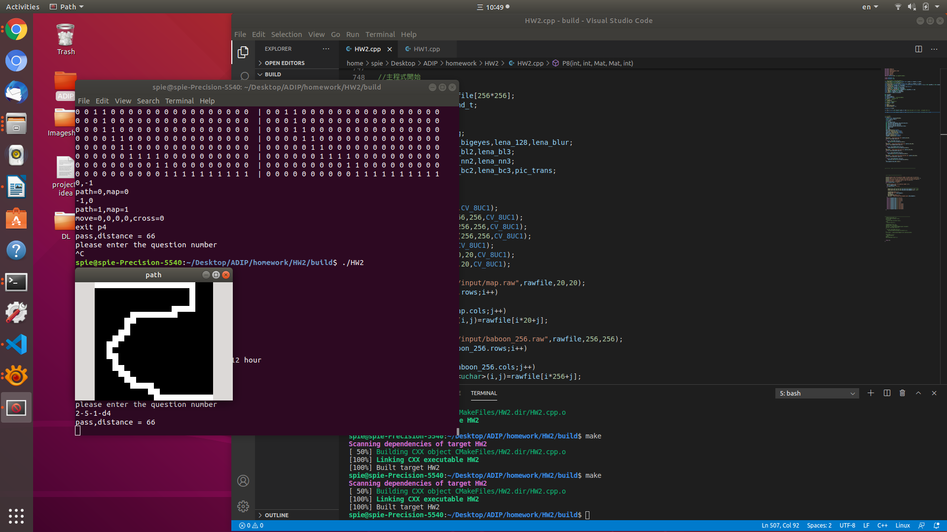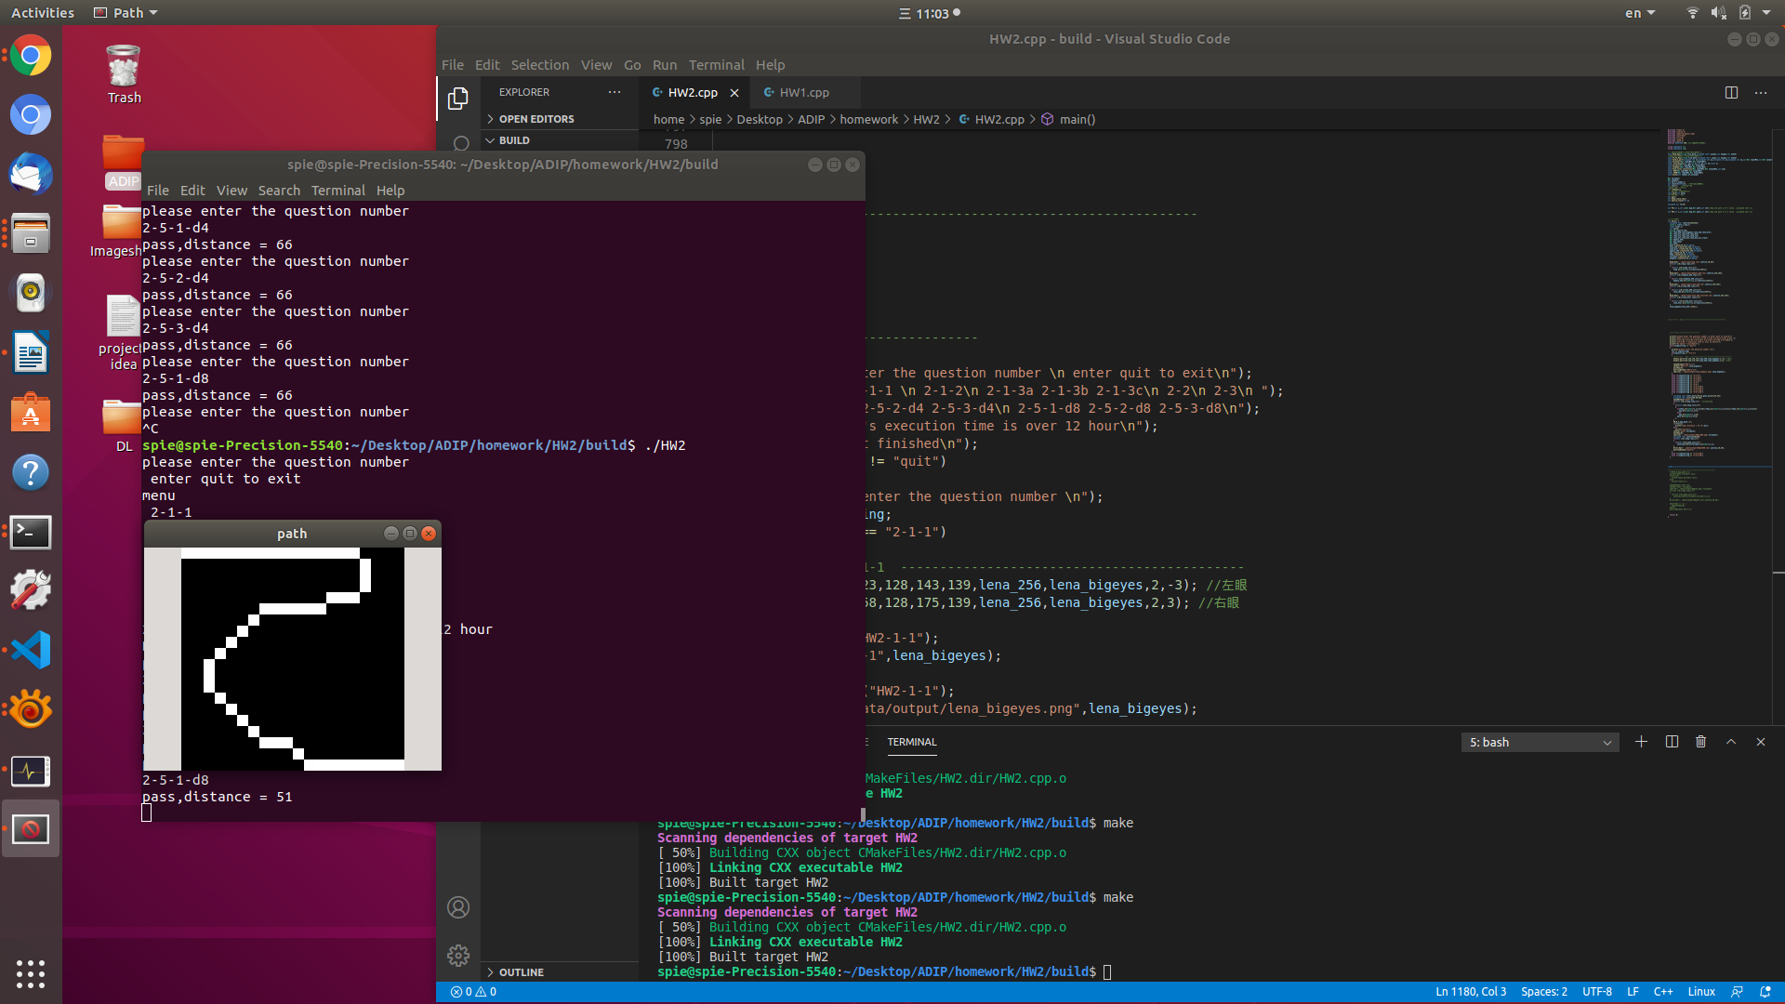

For D4 it is the only way to get to the goal.

For D8 having a lot of corners is not the best way.(10mins)

(2). gray-value of the road {80,160}

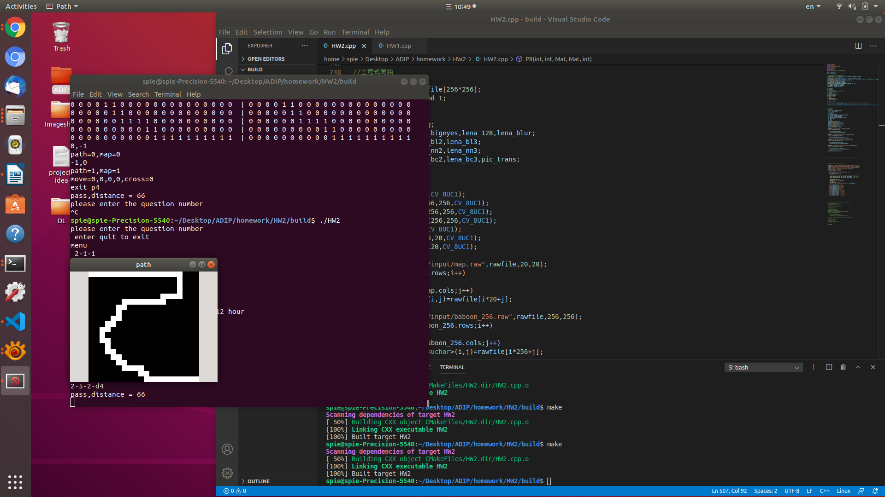

Adding more roads doesn’t affect D4 in this case because other road’s distance is the same.I’ll only record the shortest distance. If the distance is the same, I won’t record.

I can’t finish executing the d8 at road {80,160}, there are too many possibilities.I execute program about (7 hours+)

(3). gray-value of the road {80,160,255}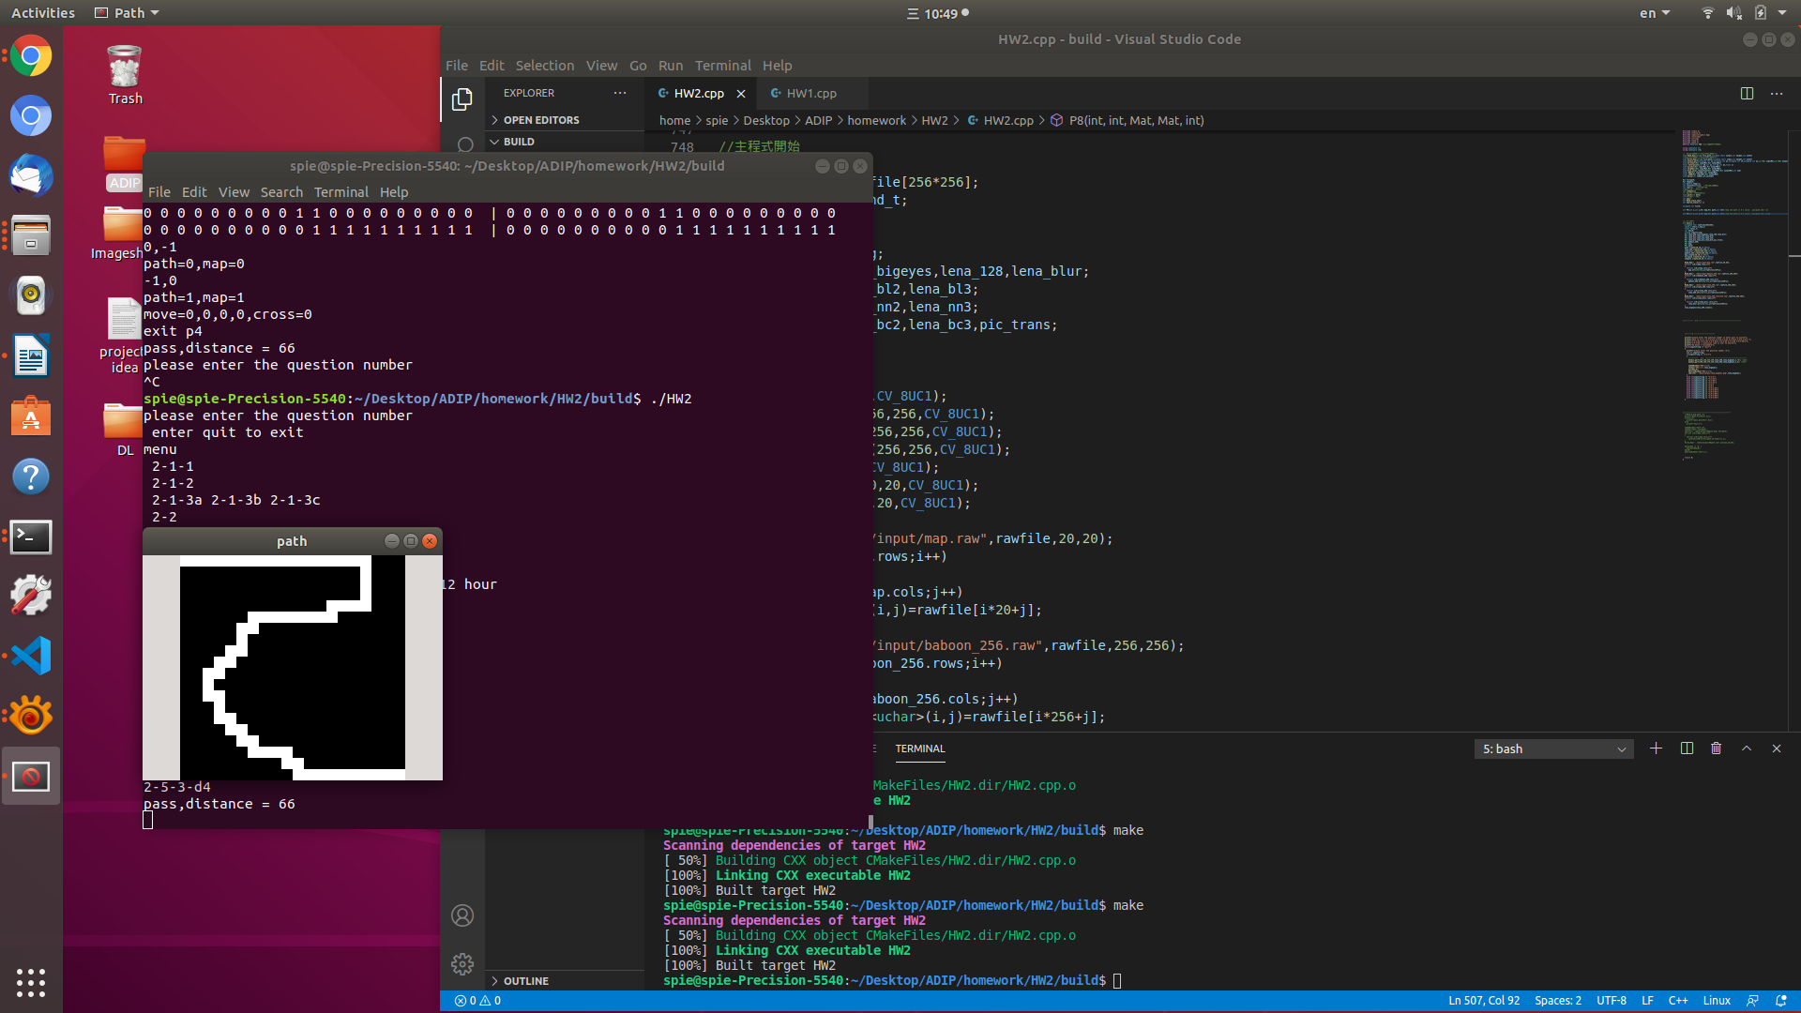

Adding more roads doesn’t affect D4 in this case because other road’s distance is the same.I’ll only record the shortest distance. If the distance is the same, I won’t record.

I can’t finish executing the d8 at road {80,160,255}, there are too many possibilities.(12 hours+)

P.S. Main cpp file is under folder “HW#2_109368008”

To execute the application under ubuntu. Please open terminal and cd

“HW#2_109368008/build” then execute “./HW2”.