Advanced Digital Image Process

HW#3

作業#3

姓名：張耀中

學號：109368008

指導教授：高立人教授

### Development environment：

OS：unbuntu18.04

Editing tools：VScode

complilation tools：CMake

opencv version：3.2.0

1. Bit plane

1. Hide baboon_256.raw in lena_256 and save the file as lena_with_baboon-

.raw. Explain your method. Try not to visually alter baboon_256.raw and lena_256.raw as much as you can. Show your result of lena_with_baboon-

.raw. Calculate MSE and PSNR of your lena_with_baboon.raw with respect to the original lena_256.raw. Your design should have the PSNR value as high as possible in both (1)&(2).

|  |  |
| --- | --- |
| lena_256(original) | lena_with_baboon |
|  |  |
|  | |

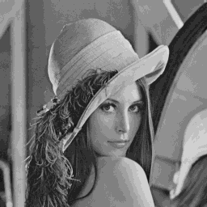

If you observe carefully, you can see there is some noise in the background but you can’t identify that it is a baboon.If we use 4 bits lena and 4 bits baboon the image will have a false boundary and you can see a baboon contour.

1. Extract your modified babon_256.raw from lena_with_baboon.raw. Calculate MSE and PSNR of your extracted baboon_256.raw with respect to the original baboon_256.raw. Your design should have the PSNR value as high as possible in both(1)&(2).

|  |  |
| --- | --- |
| origin | baboon_extract |
|  |  |
|  |  |
|  | |

Baboon_extract is less detailed but it is still acceptable and Lena's PSNR doesn’t drop out 30.

2.Bit-plane and Negative

1. Synthesize eight bit-plane images back to the original image. The bit-plane images are given in random order and some of them have been processed by image negative effect.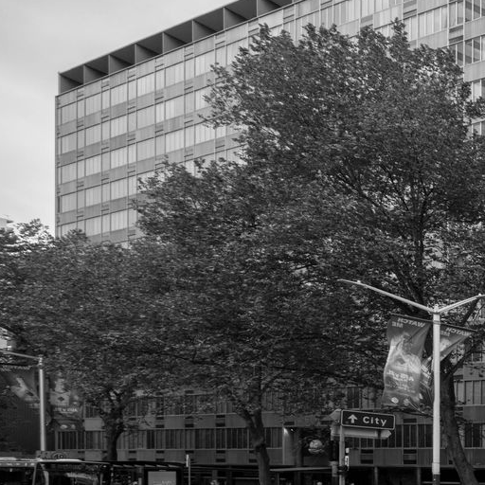

The order from MSB to LSB is (b,g,h,c,a,e,d,f) and among them (h,e,d) need to be negative.

If plane f is negative the image is almost the same. you need to zoom in to figure out.

3.Gray Level Transformation

Use the following method to adjust the dark image livingrom_d512 and whiten

image cameraman_b512.raw to improve their contrast.

1. Log transformation(c=100 and c=20):

|  |  |  |
| --- | --- | --- |
|  | livingroom_d | cameraman_b |
| c=20 |  |  |
| c=100 |  |  |

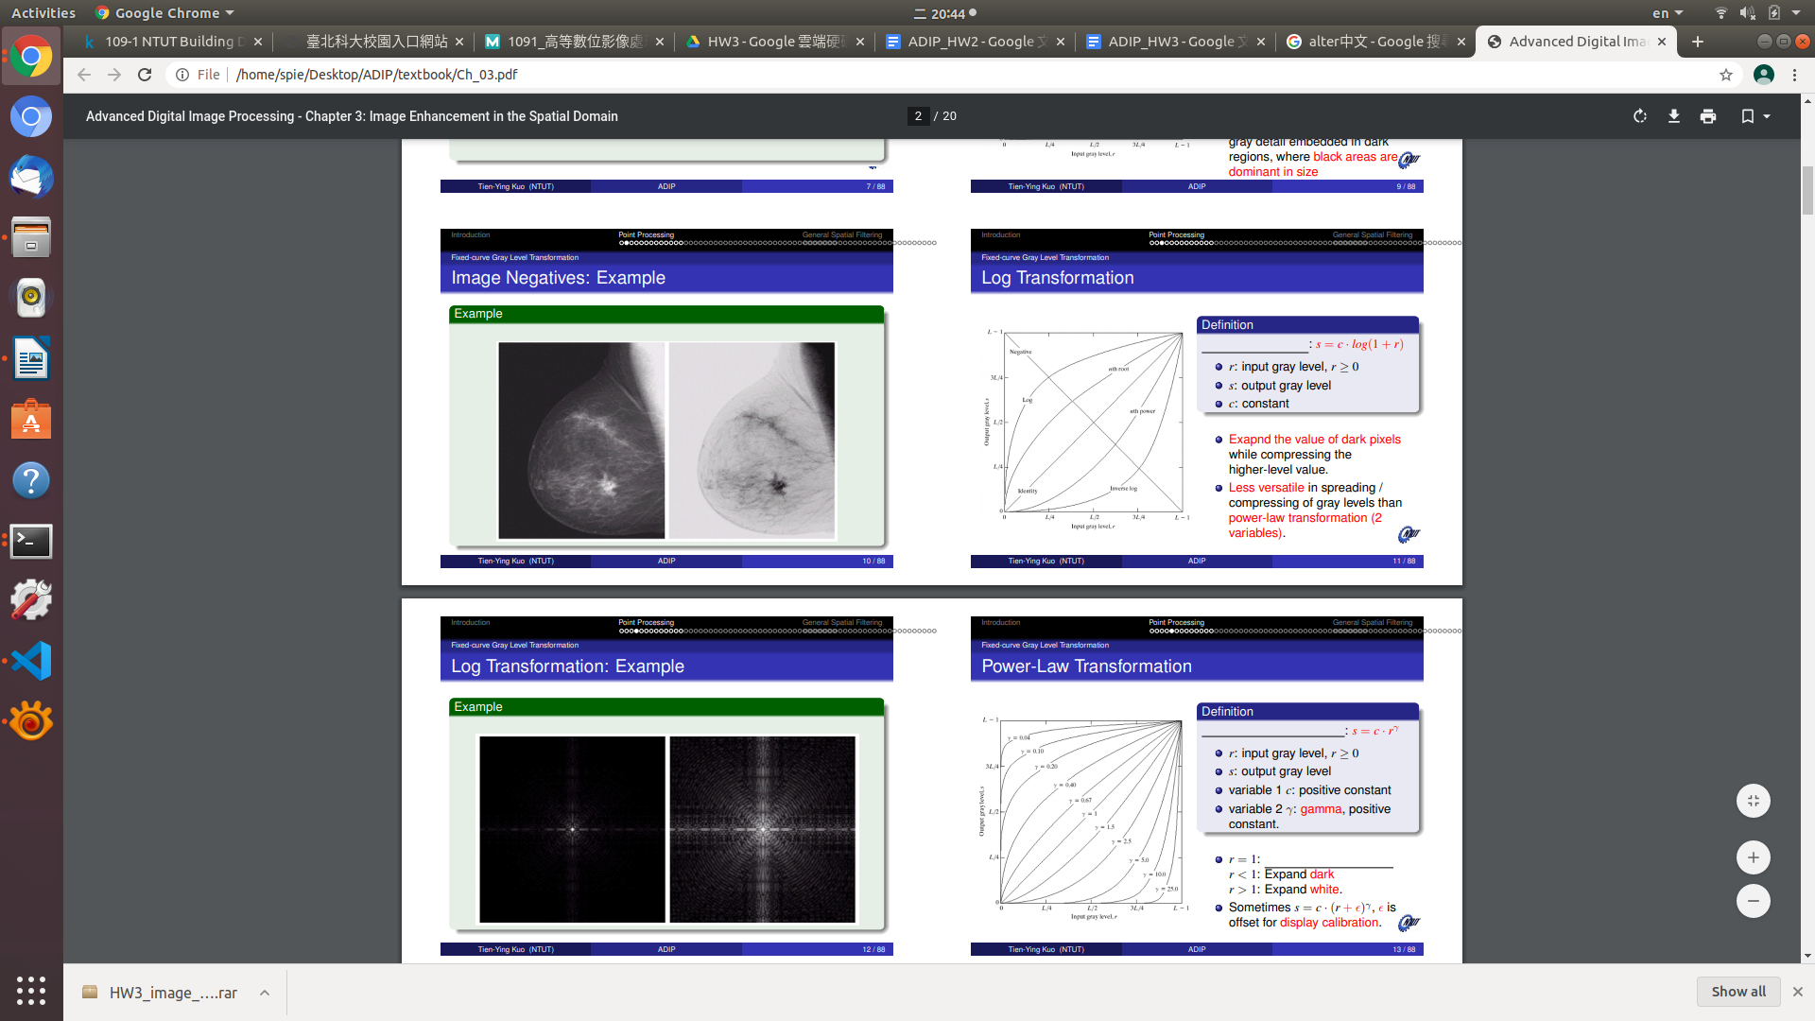

To not let the value burst over the range you need to normalize the value before log transformation, so the value will be between 0 to 1. When it multiplied a C it will be between 0 to C, if your C is 20 you can’t see anything.

When C=100 you can see the cameraman's contrast is better than cameraman_b512 because we inhibit the brightness.

1. Power-Law transformation(𝛾=0.2 and𝛾=10, Try different c to discuss the effects):

|  |  |  |
| --- | --- | --- |
|  | livingroom | cameraman |
| c=100  𝛾=0.2 |  |  |
| c=255  𝛾=0.2 |  |  |
| c=100  𝛾=10 |  |  |
| c=255  𝛾=10 |  |  |

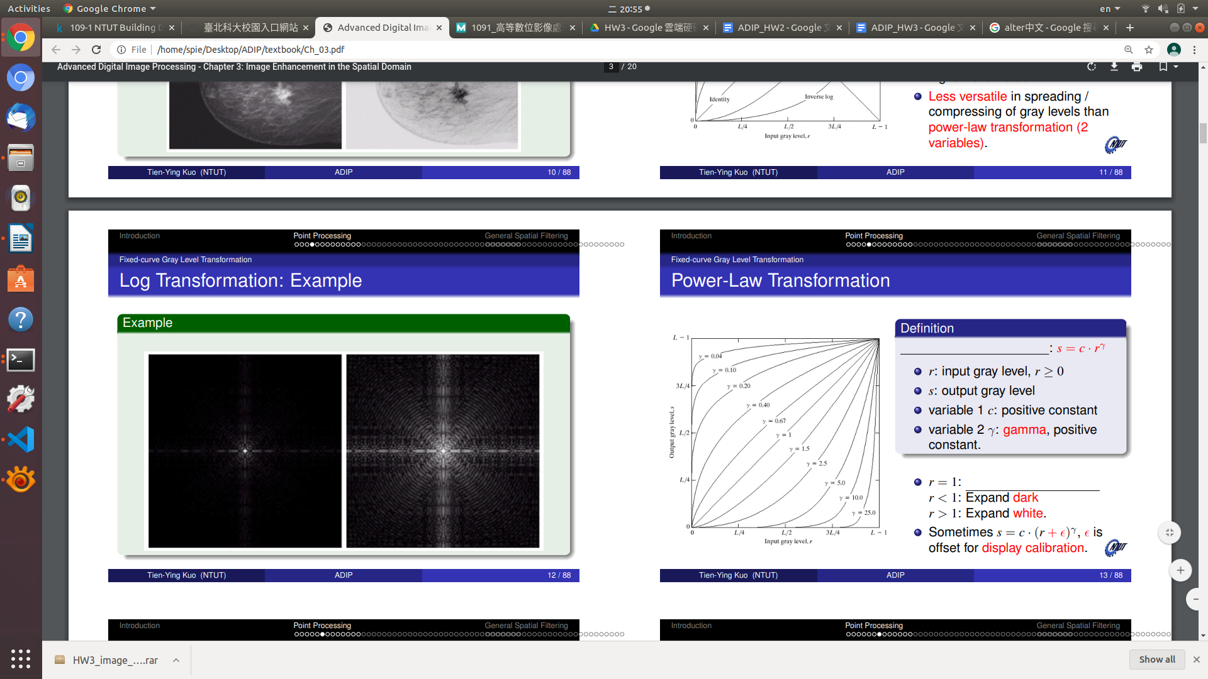

As you can see in power law transformation, when 𝛾=0.2 the transformation curve will improve the contrast in the dark and C is the limit of the output gray level. So we can see when 𝛾=0.2 ,livingroom’s contrast is better than livingroom_d and cameraman’s coat has good details but other place is over exposure.

When 𝛾=10, the transformation curve will improve the contrast in the bright. So the livingroom won’t show anything and the cameraman's background has a nice contrast but his coat is absolutely dark.

4.Histogram Equalization

1. Plot the histograms of the livingroom_d512.raw and cameraman_b512.raw. Discuss the difference among these histograms. You have to implement your own histogram function but you can use OpenCV to plot it.

|  |  |
| --- | --- |
| livingroom | cameraman |
|  |  |

livingroom: most value is at dark biome

cameraman: most value is at bright biome

1. Perform histogram equalization(implement your own function) on cameraman_b512.raw and livingroom_d512.raw. Plot their histogram and compare the histogram before and after histogram equalization. Discuss the outcome with (3)

|  |  |
| --- | --- |
| livingroom | cameraman |
|  |  |
|  |  |

As you can see, after the equalization both image’s contrast is better and value is more evenly distributed. You can see the details at the cameraman’s coat, background and livingroom background.