Advanced Digital Image Process

HW#4

作業#4

姓名：張耀中

學號：109368008

指導教授：高立人教授

### Development environment：

OS：unbuntu18.04

Editing tools：VScode

complilation tools：CMake

opencv version：3.2.0

1.Histogram processing

1. Use Histogram Matching to match the histograms of house512.raw to that of lena512.raw. Show the matched output of house512.raw. Also show the histogram of lena512.raw as well as the histograms of the house512.raw before and after histogram matching.

|  |  |
| --- | --- |
| origin_house | Histogram |
|  |  |
| House_match_lena | Histogram |
|  |  |
| origin_lena | Histogram |
|  |  |

Before histogram matching, house512.raw is very dark except the sky.

After histogram matching, image overall grey level is more similar to lena.

But a few points are too much so the histogram looks weird.

1. Use Local Histogram Equalization to enhance house512.raw. Try at least three different mask sizes to process it. Show and compare the input and output images. Also show and compare the histograms.

|  |  |
| --- | --- |
| kernel=3 | kernel=3 |
|  |  |
| kernel=5 | kernel=5 |
|  |  |
| kernel=7 | kernel=7 |
|  |  |

Local equalization with kernel =3,5,7 will have different resolution of gray level because the CDF level of the kernel is the quantity of kernel pixels. If the kernel is smaller, the resolution of gray level is less but the details will be clear. If the kernel is larger, the resolution of gray level is more but the details will be smooth then the small kernel.

2.Image Averaging

Try to use image averaging technique to average the frames selected by you in street.avi to extract the static background image, i.e., removing the moving cars. Try to find and compare the results with the difference in the number of frames(10,200,all). Show and discuss how the outcomes are affected by traffic flows in the scene.

|  |
| --- |
| 10frame_avr |
|  |
| 200frame_avr |
|  |
| allframe_avr |
|  |

As we can see, because the cars are always moving. For a long time we can treat it as noise. If we average images, the noise will disappear. So after averaging many images of the street, all the cars disappear. If the images doesn’t enough, we can see the afterimage of the car like 10frame_avr.

3.Edge Detection

Perform the following filters in walkbridge.raw.

1. Apply 3x3 Laplacian filter shown below with zero padding and replicated padding to extend images for filtering. Display the outputs and discuss their differences of these two filters. (filter1=nocorner,filter2=have corner)

|  |  |
| --- | --- |
| bridge_replicate_filter1 | bridge_zero_filter1 |
|  |  |
| bridge_replicate_filter2 | bridge_zero_filter2 |
|  |  |

If we use zero padding, we can see the boundary of the image obviously.

Using replicate padding, if the kernel is small it’s good enough but if the kernel is big the boundary of the image will be wierd.

Using filter1 with no corner, we can get more horizontal or vertical details.

But using filter2 with corners ,we can also get diagonal details.

1. Design 3x3 High-boost filters based on two filters shown in Fig1 by setting A =1,2,4. Use replicated padding to complete this problem. Display all result images, and discuss the differences between the results.

|  |  |  |
| --- | --- | --- |
|  | filter1 | filter2 |
| a=1 |  |  |
| a=2 |  |  |
| a=3 |  |  |

As we can see, filter2 will enhance details more than filter1.

But if A is too large the brightness of the image will be too high.

It probably should be larger when the image is too dark.

4.Gaussian filter

Experiment the following test in turtle512.raw with mirrored padding to extend images for filtering.

1. Apply 5x5 Gaussian filters with σ=0.8,1.3,2.0 to the given image. Display the results.

|  |  |
| --- | --- |
| origin | σ=0.8 |
|  |  |
| σ=1.3 | σ=2 |
|  |  |

In Gaussian filters, if σ is larger the image will blur more, if σ is smaller the image will blur less.

If we don't do normalization after Gaussian blur, the image will get darker, so we do a normalization after Gaussian blur to keep the intensity.

1. Difference of Gaussian (DoG) is a feature enhancement algorithm that involves the subtraction of one Gaussian blurred version of an original image (σ2) from another less blurred version of the original (σ1) with σ1<σ2

Study DoG yourself first Perform 5x5 DoGand discuss the result.

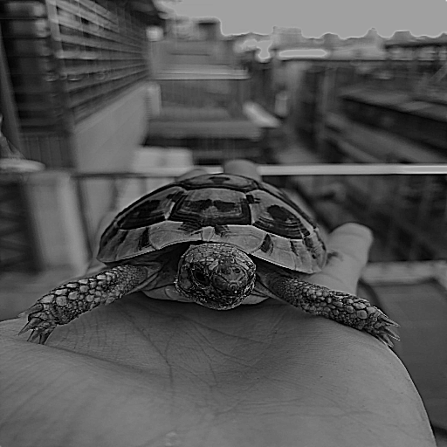

After doing DoG we got a sharpness image. We can see the result, the edge will be highlighted. But the average intensity will be darker.