# Generating a Technical Article

## Introduction

This document provides a comprehensive guide on how to use the ‘Document Generation’ feature within the Onvoke application to create a new Technical Article. The main screen is designed to be intuitive, allowing you to specify your documentation needs and provide the necessary context for generation.

The interface is divided into a main content area for document creation and a navigation sidebar on the left. The main area contains fields for describing the document, selecting its type, choosing sources, and initiating the generation process.

### Prerequisites

* You must have an active account and be logged into the Onvoke application.
* Navigate to the ‘Document Generation’ page from the main dashboard or navigation menu.

### Learning Outcomes

* Understand the layout of the Document Generation page.
* Learn how to select the correct document type.
* Identify the available options for providing source material.
* Successfully initiate the generation of a technical article.

## Key Features

* Select from multiple document templates including Technical Article, SOP, and RCA.
* Provide a detailed description of the desired document using natural language.
* Option to add source materials directly by capturing your screen.
* Ability to attach relevant files to serve as context for generation.
* A streamlined user interface for quick document creation.
* Centralized navigation to switch between ‘Chat’ and ‘Source Configuration’.

The Document Generation tool streamlines the creation of standardized technical documents. The process begins by clearly defining the document’s scope in the description field. This input is crucial as it guides the AI in structuring the content and tone of the article. After providing a description, you must select the appropriate document type, which tailors the output format and available input options.

## Procedure / Steps

**Step 1:** In the center of the ‘Document Generation’ screen, click the dropdown menu that is initially labeled ‘Technical Article’.

This is the first step in specifying the kind of document you want to create. Clicking this dropdown reveals a list of available document templates.

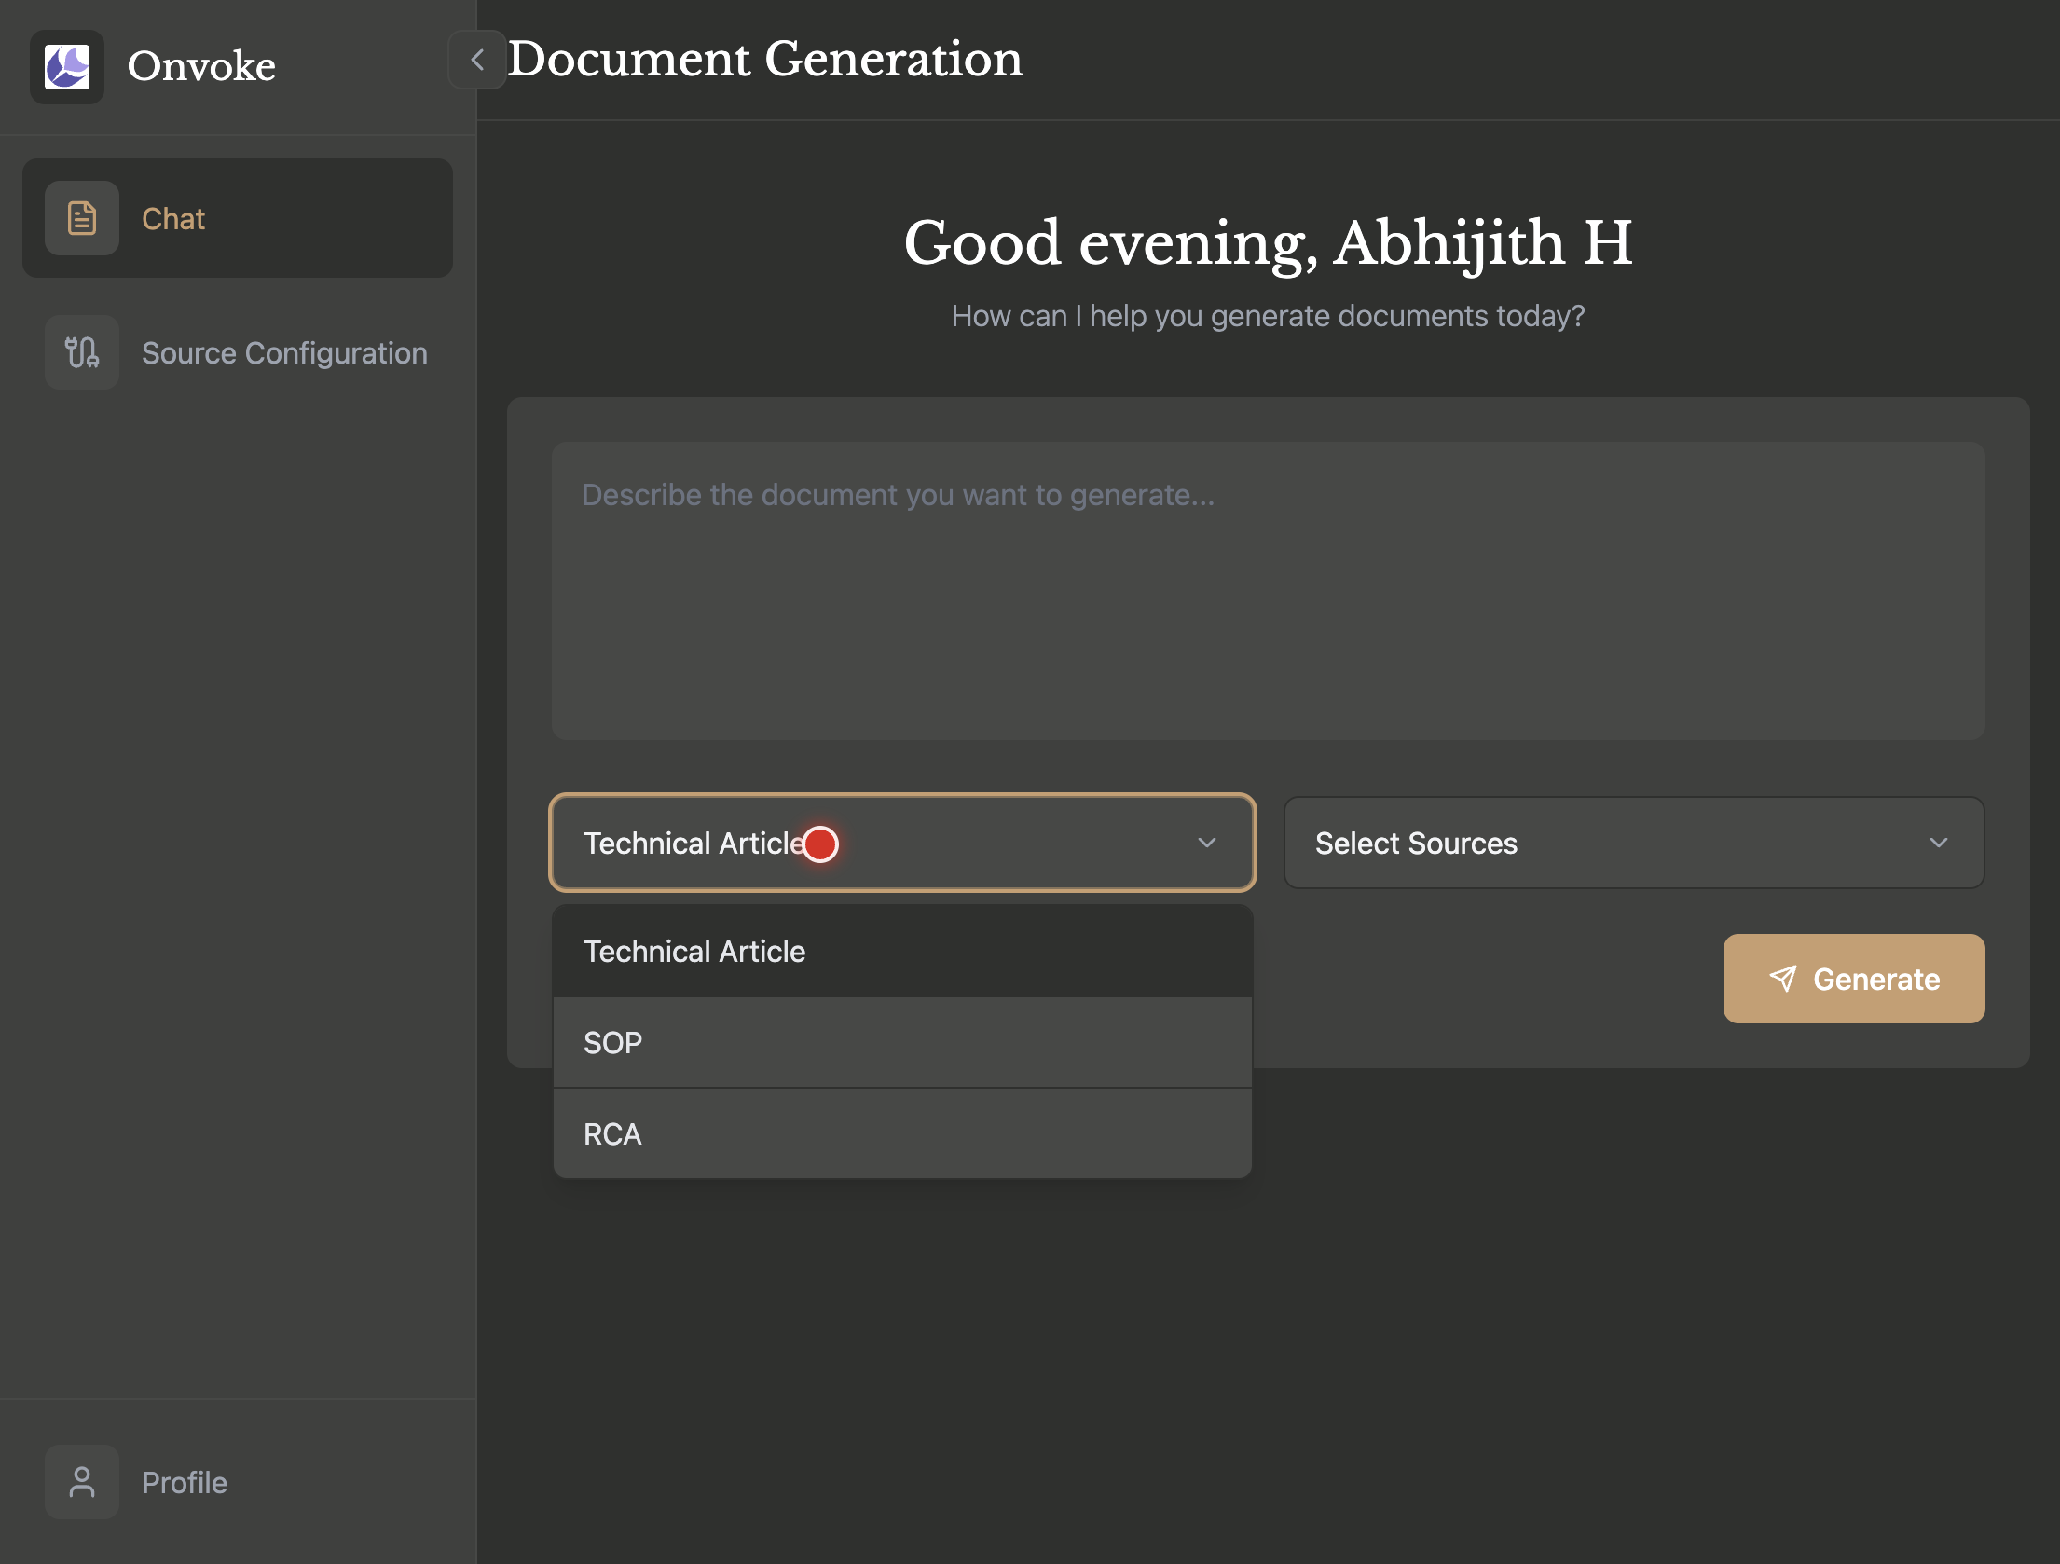

This is the first step in specifying the kind of document you want to create. Clicking this dropdown reveals a list of available document templates.

**Step 2:** Select ‘Technical Article’ from the list of options that appears.

From the list of options (‘Technical Article’, ‘SOP’, ‘RCA’), selecting ‘Technical Article’ confirms your choice. This action may update the UI to show additional input options relevant to this document type, such as ‘Capture Screen’ and ‘Attach’.

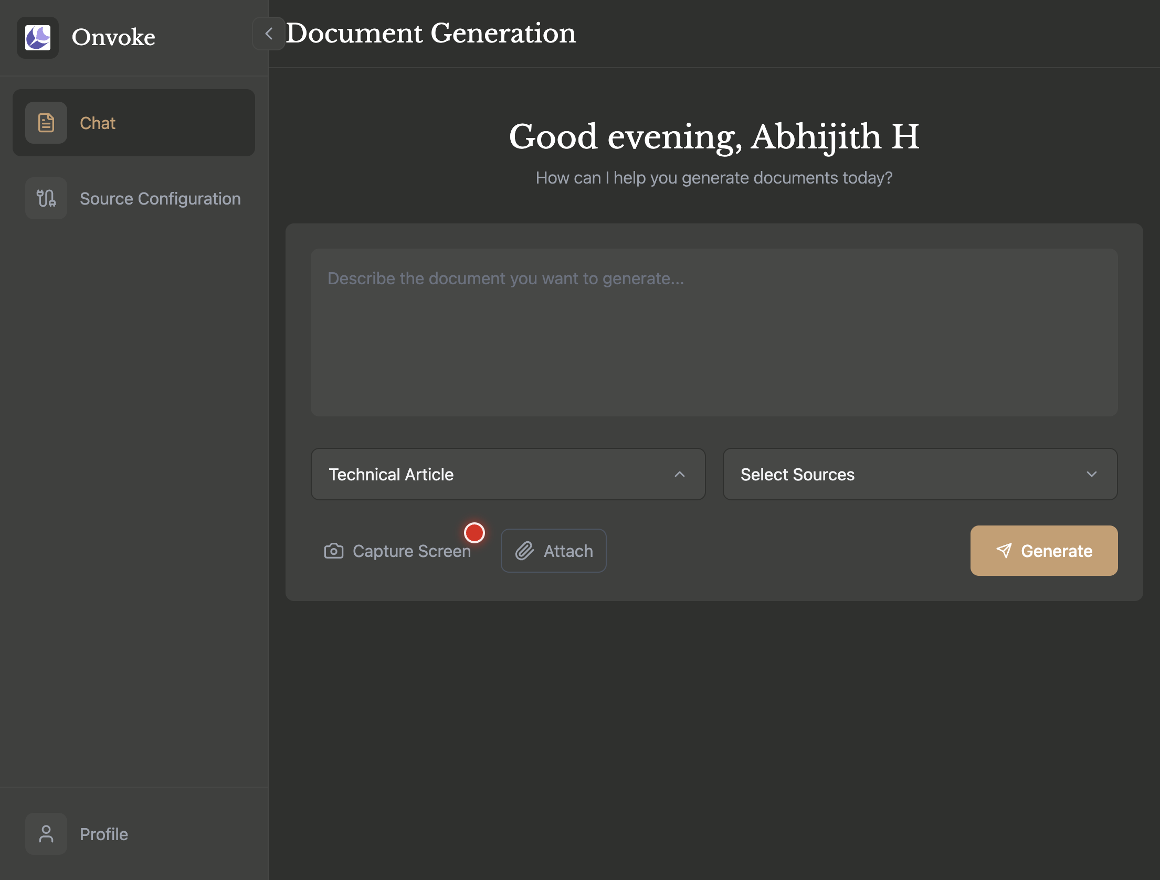

From the list of options ‘Technical Article’, ‘SOP’, ‘RCA’, selecting ‘Technical Article’ confirms your choice. This action may update the UI to show additional input options relevant to this document type, such as ‘Capture Screen’ and ‘Attach’.

**Step 3:** Click the ‘Select Sources’ dropdown menu to the right of the document type selector.

This step is for selecting pre-configured data sources to inform the document. Note that this feature is not yet active. A ‘Coming Soon!’ tooltip will appear, indicating it will be available in a future release.

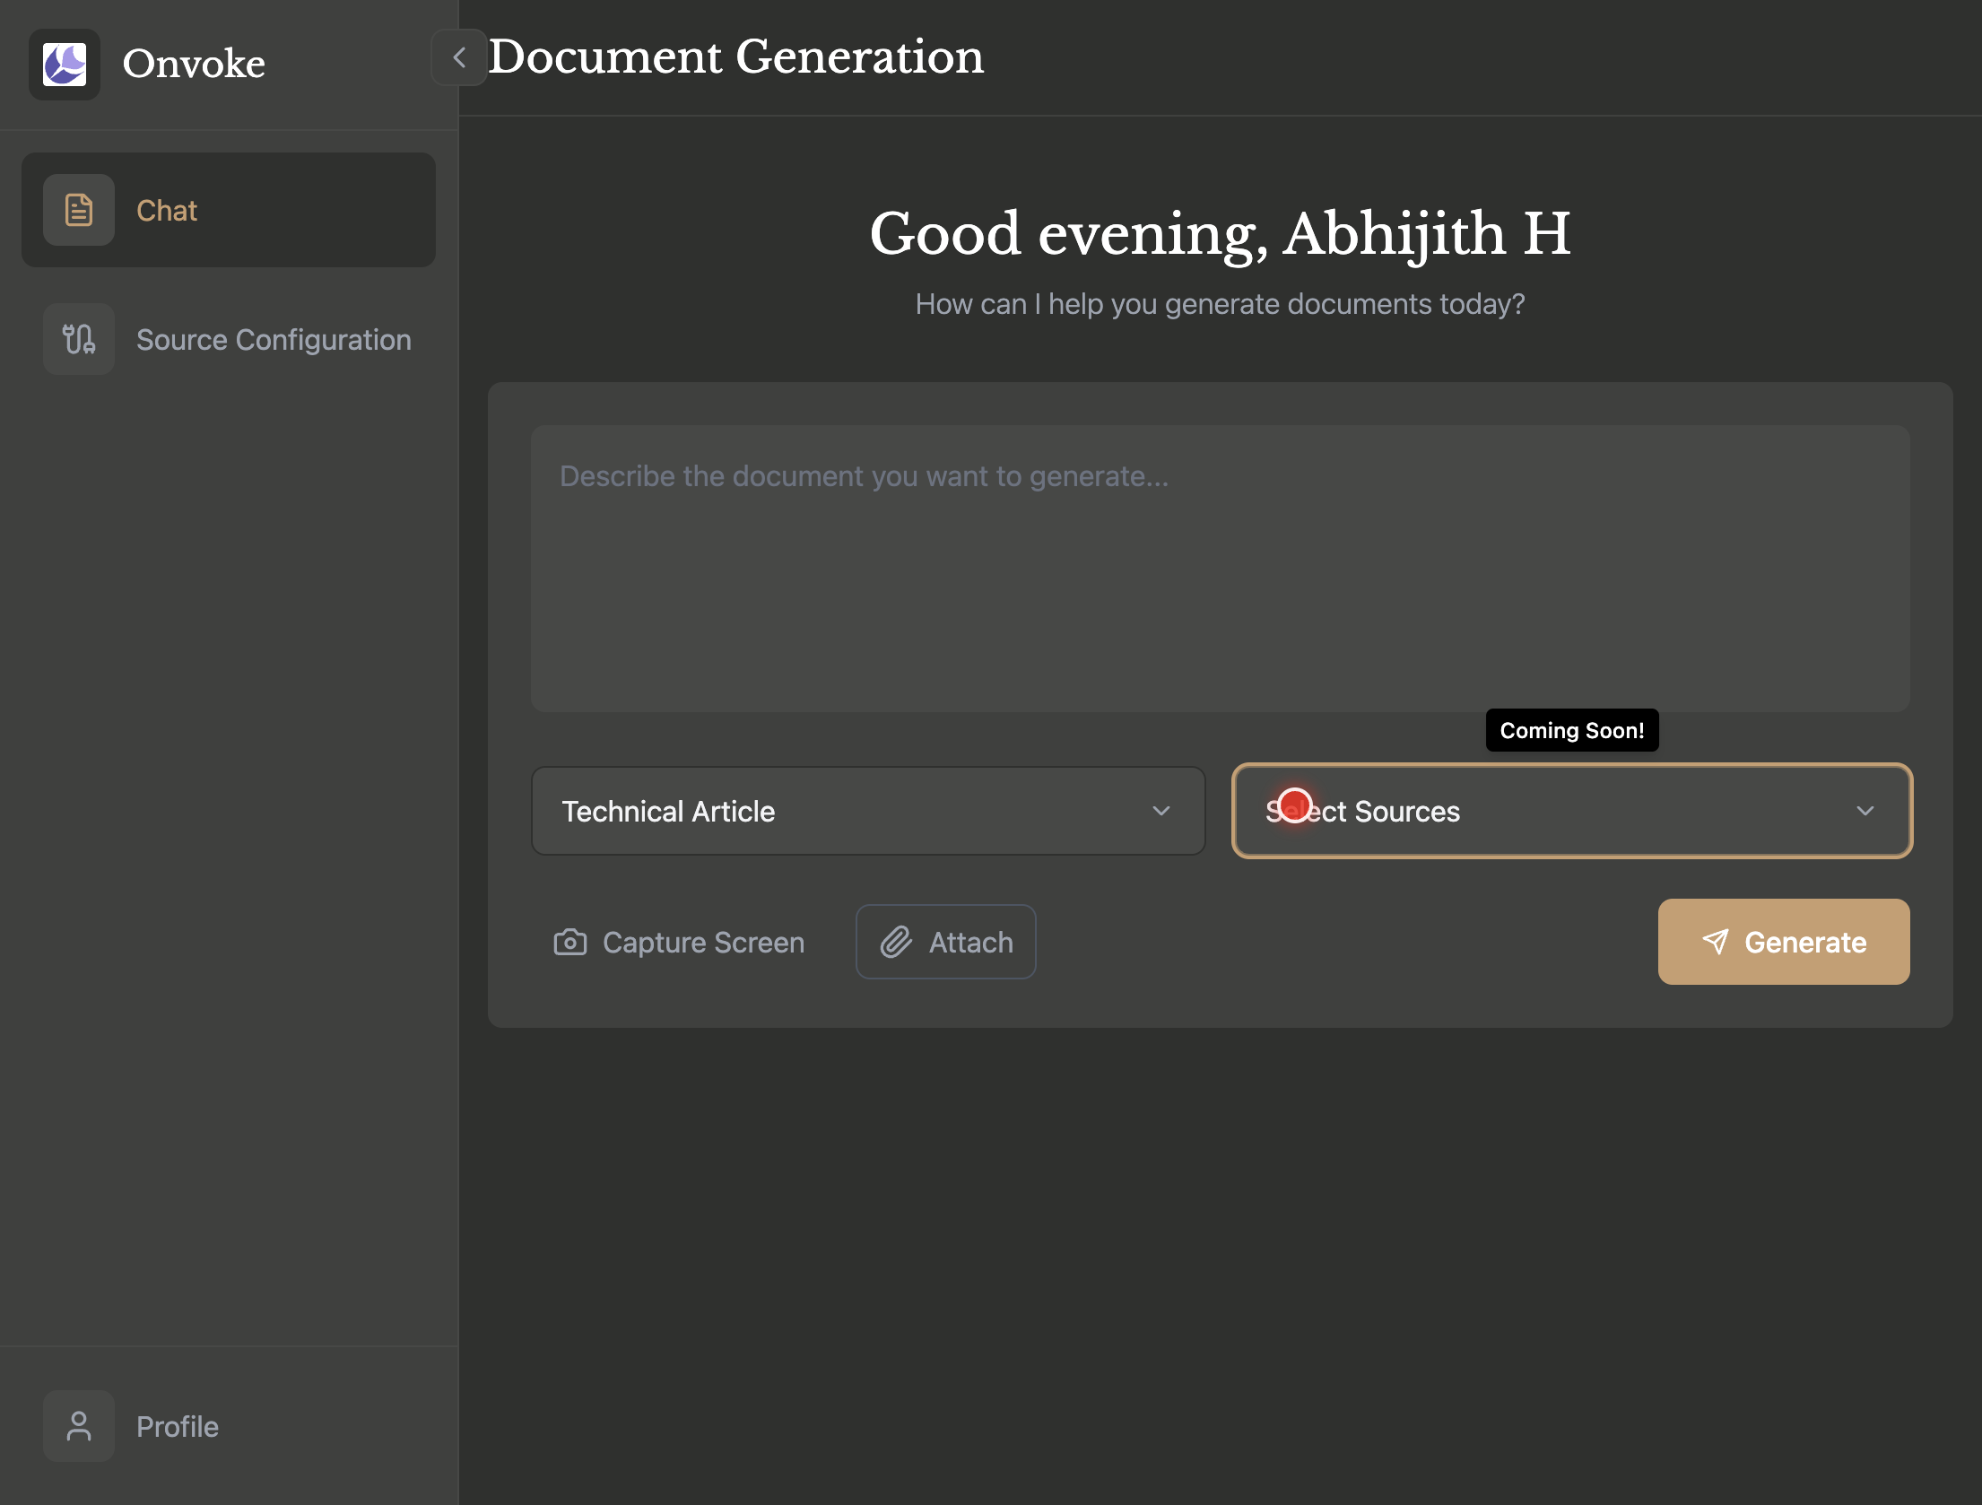

This step is for selecting pre-configured data sources to inform the document. Note that this feature is not yet active. A ‘Coming Soon!’ tooltip will appear, indicating it will be available in a future release.

**Step 4:** Enter a detailed description in the text area with the placeholder ‘Describe the document you want to generate…’.

Before generating, you must provide a prompt in the large text area. This description guides the AI on the subject matter, key sections, and overall goal of the article.

**Step 5:** Click the ‘Generate’ button, located at the bottom right of the input area.

Once you have entered a description, selected the document type, and added any attachments or screen captures, click this button to start the document creation process.



Once you have entered a description, selected the document type, and added any attachments or screen captures, click this button to start the document creation process.

## Frequently Asked Questions (FAQ)

**Q:** What types of documents can I generate? **A:** The platform supports several document types. As seen in the dropdown menu, you can select ‘Technical Article’, ‘SOP’ (Standard Operating Procedure), or ‘RCA’ (Root Cause Analysis).

**Q:** What is the purpose of the ‘Capture Screen’ and ‘Attach’ buttons? **A:** After you select a document type like ‘Technical Article’, the ‘Capture Screen’ and ‘Attach’ buttons appear. ‘Capture Screen’ allows you to take a new screenshot to include as a source, while ‘Attach’ allows you to upload existing files (e.g., logs, images, documents) from your computer.

**Q:** What happens when I click ‘Select Sources’? **A:** Currently, the ‘Select Sources’ feature is under development. When you click on it, a ‘Coming Soon!’ message appears. In the future, this will allow you to connect to various pre-configured data sources.

**Q:** What should I write in the description box? **A:** In the ‘Describe the document you want to generate…’ text area, you should provide a clear and detailed natural language prompt explaining the topic, purpose, intended audience, and key points you want the technical article to cover.

## Conclusion

You have now learned the fundamental steps to initiate the creation of a technical article using the Onvoke Document Generation tool. By following the process of selecting the document type, providing a detailed description, and attaching relevant source materials, you can efficiently generate comprehensive technical documentation.

### Next Steps

* Review the generated document for accuracy and completeness.
* Experiment with generating other document types such as SOP or RCA.
* Explore the ‘Source Configuration’ section to manage data sources for future use.