**Automate your pathway enrichment analysis with R**

Biodata club – 3/15/19

Pathway analysis

Different types of pathway analysis:

Dealing with lists

1.) Overrepresentation analysis:

2.) Functional class scoring: similar GSEA (but GSEA uses gene expression)

Dealing with networks

3.) Pathway topology:

enrichR runs overrepresentation analysis

Contingency tables:

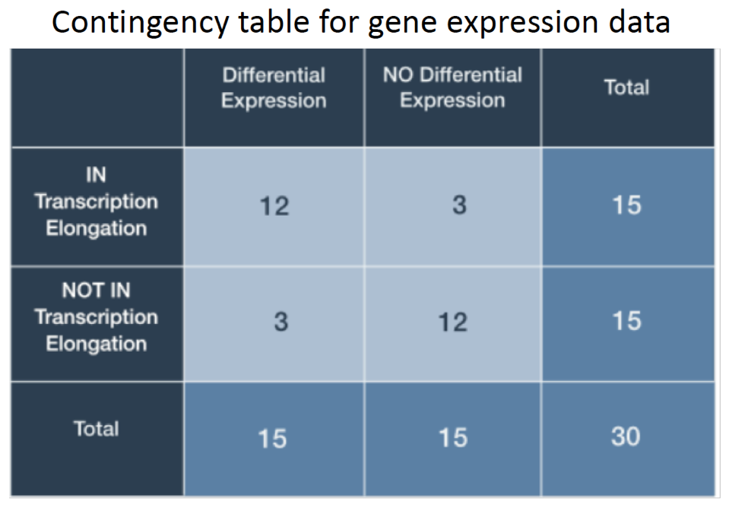

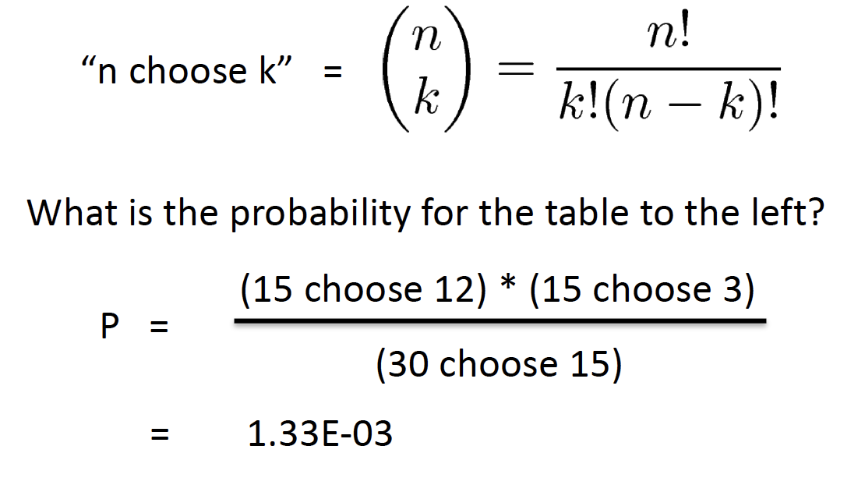

Fisher’s Exact Test amounts to summing the probability of observing our table of observed joint values in addition to those more extreme than our table, so

P-value = (R4, C1) + (R4, C2) + (R4, C3) + (R4, C4) = 0.0014

From this result, we claim that the probability of our observed data or that more extreme under the assumption that there is no association between expression and gene set membership is 0.0014.

Why enrichR?

tests your data against multiple databases