**Project**

## Description

The project requires you to create a 3D scene by yourself. You may decide the content of the scene you create, which could be a scene from real world, or a virtual scene created by your imagination. The purpose of this proposed project is for you to demonstrate your knowledge of computer graphics techniques taught in the lectures and labs. ***We note that you are required use C or C++ programming with OpenGL library to do the programming.*** In the project, we also give credits for your creative ideas being contributed in your project. Some example 3D scene are given for your reference as follows:

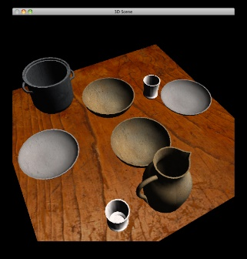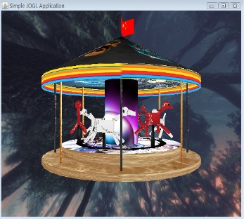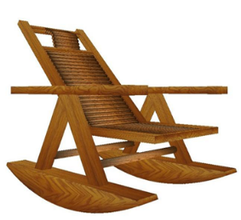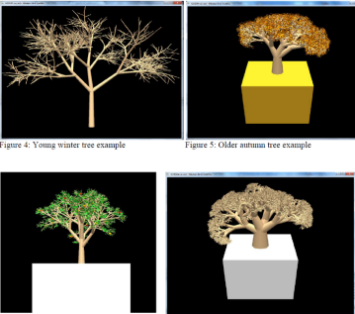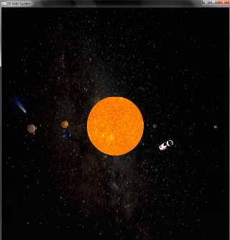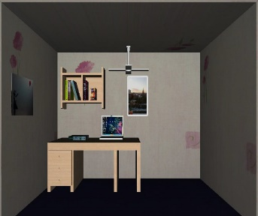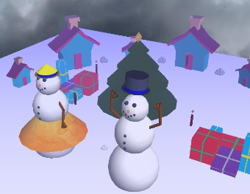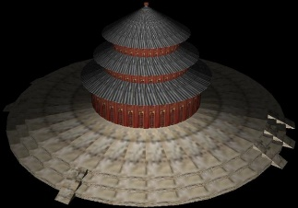

You are required to create a 3D scene with the following items:

* + Several 3D models, (*weightage: 20%*)
  + Transformation of models (scaling, translating, rotating), (*weightage: 15%*)
  + Different viewpoint to the scene environment, (*weightage: 5%*)
  + Animations for some objects in the scene, (*weightage: 15%*)
  + Texturing –you need to employ texture to make some models look more realistic, (*weightage: 15%*)
  + Lighting – you should apply lighting effect in your scene, (*weightage: 5%*)
  + Some your own interesting creative ideas. (*weightage: 25%*)

Here we remark that the marks you obtained for each item of the above depend on the ***quality*** of objects or requirements you produced in your project.

## Proposal

In the first one and a half weeks, you need to submit **2-page** draft proposal of what you want to do for creating the 3D scene (although you could deviate a bit when you are progressing in doing your project). We expect that ***each group create a different scene.***  **(3% marks)**

**Due date: 4:00pm, 13 November 2019, Wednesday**

## Interim Report

Then after a couple of weeks, you need to submit a **6-page** progress report telling us the progress of your program, what tasks are remained to be done. The purpose of this interim report is to remind you *NOT* to do the whole project until the very last minute. So please try to do *MORE* programming up to this stage.

**(7% marks)**

**Due date: 4:00pm, 20 November 2019, Wednesday**

## Full Program and Report

And then after another couple of weeks, you need to submit a zip file including: full report, and source code.

* + Full report: (**around 10 pages**)

Describing how to use your program, how you meet the requirements of the project, and your creative ideas contributed in creating the scene. Note that in your report, you *MUST* include a screenshot picture of your full scene you produced in your program.

**(15% marks)**

* + Source Code:

Apart from the requirements described in the Description section, some minor credits **(5%)** are given for accounting for the readability, good structure and good style of the source code you write.

**(65% marks)**

**Due date: 4:00pm, 12 December 2019, Thursday**