**Link to Demo:**

[**https://youtu.be/71yvavCa0MU**](https://youtu.be/71yvavCa0MU)

**Hardware:**

**BOM**

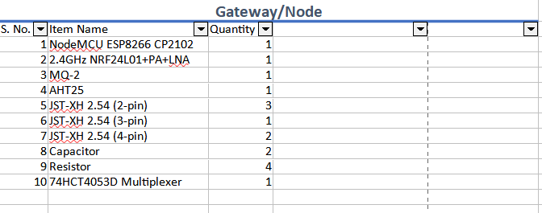

**Optional module we used for testing:**

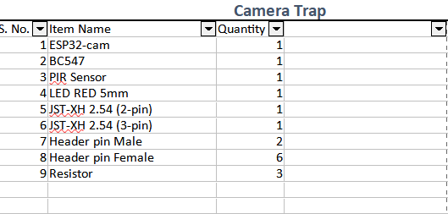

Schematic Node/Gateway :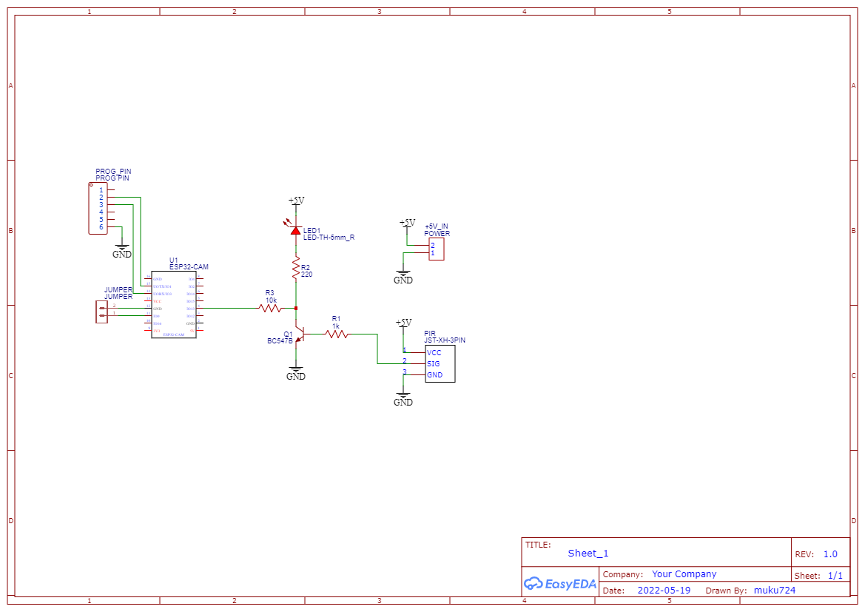Schematic, Camera Trap Module:

After making the connections, please upload the node and gateway firmware from the repository. And the camera trap module is optional, but the firmware for esp32cam is also available in the repository.

**Software:**

Link to explore the website: <https://wildeye-the-perfact-eye.herokuapp.com/>

We have choose the Web application software for our projects which Includes HTML,CSS,Javascript, jquery for ajax requests ,Flask(python), Firebase(storage,realtime database, firestore,cloud functions(triggers)) , google map api, axios and Twilio messaging api.

HTML is used here to design the template of the website and its styling is done by CSS.

Javascript provides dynamic features to our website like interacting with Google map API and it's also used to communicate with our Server Flask (which is programmed with python language) through Ajax requests to its multiple routes for submitting gateway information, nodes information, or user information and many more.

We have used flask as a server that deals with our backend Firebase and javascript at the same time. All the data manipulation in firebase is done by flask through multiple routes.

Flask routes are also used here to receive Post requests from hardware so it will be able to perform best in firebase.

Firebase real-time database used to store and update the information about Gateways, Nodes, and Users.

Firebase Storage is used here to store the images of wild animals after sorting on the cloud.

Firebase firestore is used here to store the URLs of uploaded images and also for easy sorting and filtering according to species in the explore section of our web application.

Firebase Function used Triggers so if any node fire_status value changes to 0 to 1 it will trigger and generate a post request using axios to the route of flask server so it will send the Message using Twilio messaging API.

Twilio API is used here to send the fire to detect messages to the people of that particular city where the gateway detects the fire. all the sorting is done in a flask in routes and in function.