**Case Study Royal Manufacturing**

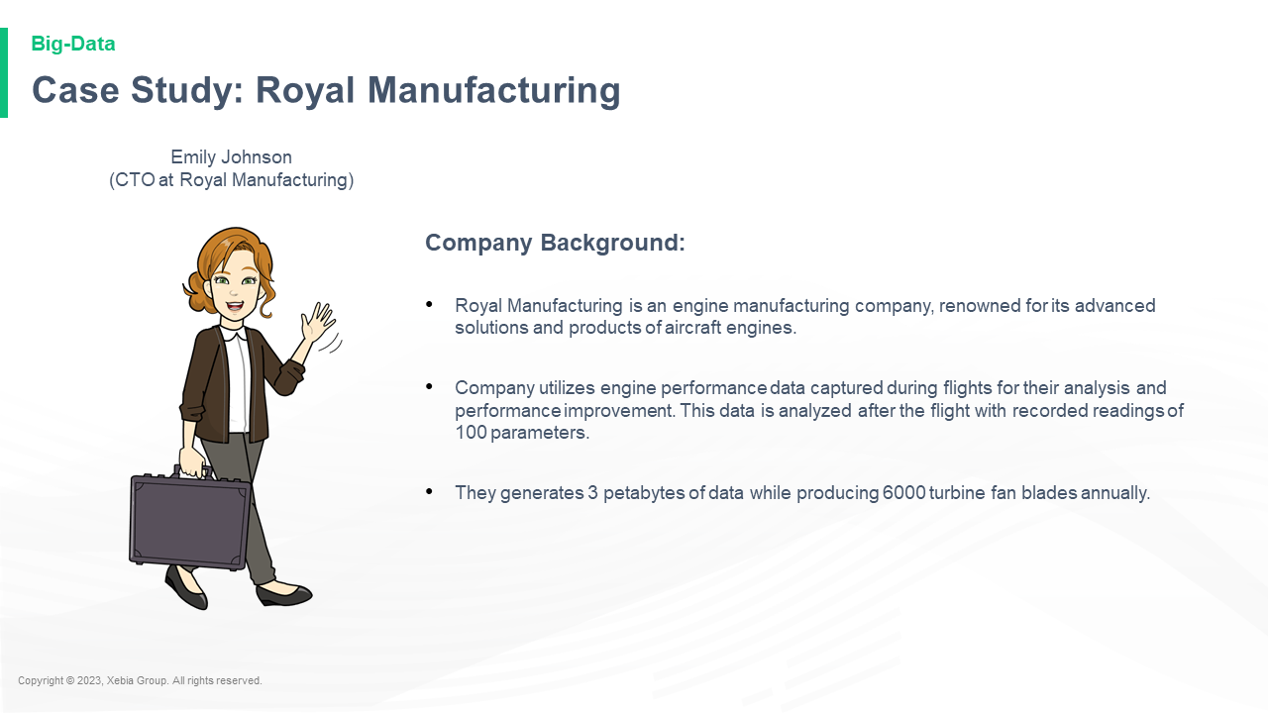

Company Background Royal Manufacturing is an engine manufacturing company renowned for its advanced solutions and products of aircraft engines Company utilizes engine performance data captured during flights for their analysis and performance improvement This data is analyzed after the flight with recorded readings of 100 parameters They generates 3 petabytes of data while producing 6000 turbine fan blades annually Emily Johnson CTO at Royal Manufacturing

**Case Study Royal Manufacturing**

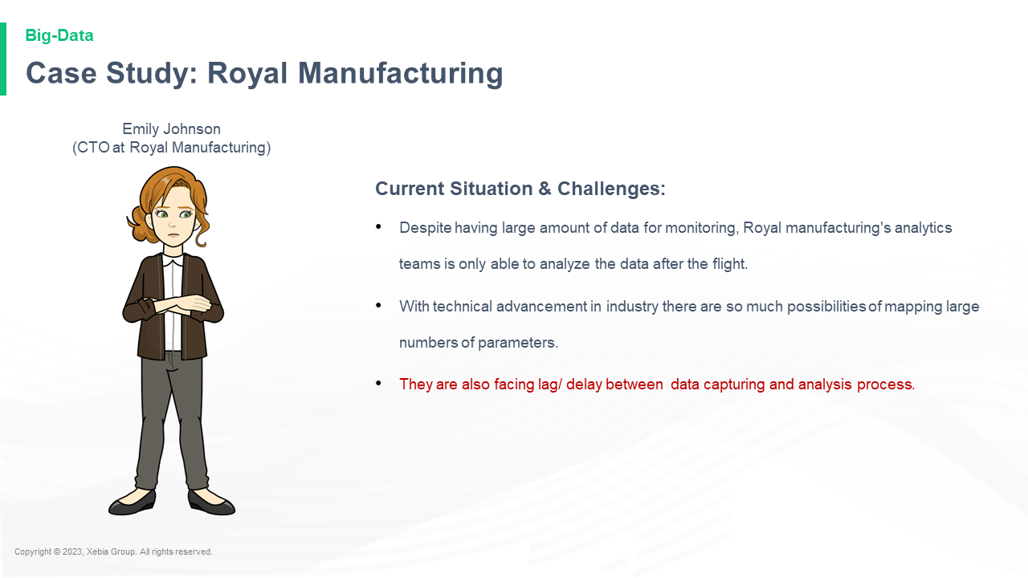

Current Situation Challenges Despite having large amount of data for monitoring Royal manufacturing s analytics teams is only able to analyze the data after the flight With technical advancement in industry there are so much possibilities of mapping large numbers of parameters They are also facing lag delay between data capturing and analysis process Emily Johnson CTO at Royal Manufacturing