**Investigation of a solution to the problem of population concentration using visualization**

Ryo Takamatsu(229x112x)

※Japanese version: <https://10matcho27.github.io/InfoVis2022/Final_Assignment/Final_Report_ja.pdf>

# **Introduction**

Since the end of World War II, urban areas, especially in the three major metropolitan areas, have experienced a continuous influx of population, while the population has been moving out of Hokkaido, Tohoku, and other regions. In each region, population concentration and depopulation are respective problems. Noise and environmental problems are occurring in densely populated areas, and marginal settlements are occurring in depopulated areas. This research paper examines ways to solve these problems by visualizing the correlation between the percentage of employment by industry and population density in each prefecture.

# **Method**

I prepared a map of Japan and a bar graph. The map of Japan is a white to black color map with each prefecture color-coded. The higher the population density, the darker the black color is, and the lower the population density, the closer to pure white the color is painted. It also displays a bar graph sorted by prefecture with the highest population density, with the color shading changing with the percentage of each industry employment in each prefecture. As with the map of Japan, it is drawn with varying shades of color according to proportions.

The shading of the Japan map is linearly varied, so it is difficult to differentiate between prefectures with extremely low/high population densities. For this reason, I have provided a slider for adjusting the range of the color map. Moving the slider to the left or right makes it easier to distinguish areas of extremely low/high population density. You can also move that map by dragging and zooming in and out with the mouse wheel. The population density of each prefecture is displayed in a tooltip by mouse-over. The color map of the bar graph changes as each industry button is pressed, and the percentage of the industry for that button is indicated by the shade of the bar graph.

# **Result・Discussion**

　The visualization results in Fig 1 show a negative correlation: the percentage of primary industry workers is lower in areas with high population density, and conversely higher in areas with low population density. On the other hand, as shown in Fig2, a positive correlation was found between population density and tertiary industry. Population density is extremely high in Tokyo, Osaka, Aichi, and surrounding areas, and extremely low in Tohoku and Hokkaido.

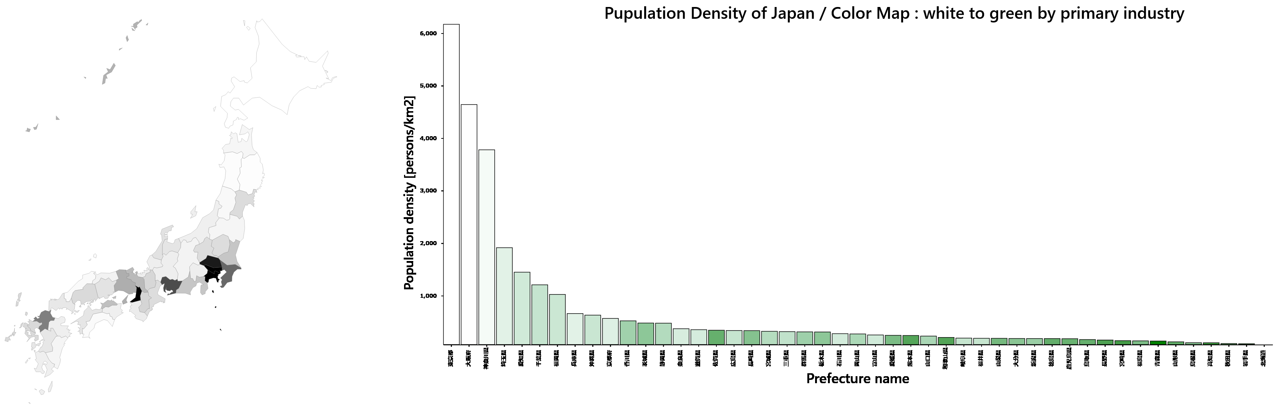

Fig 1. Correlation between primary industry and population density

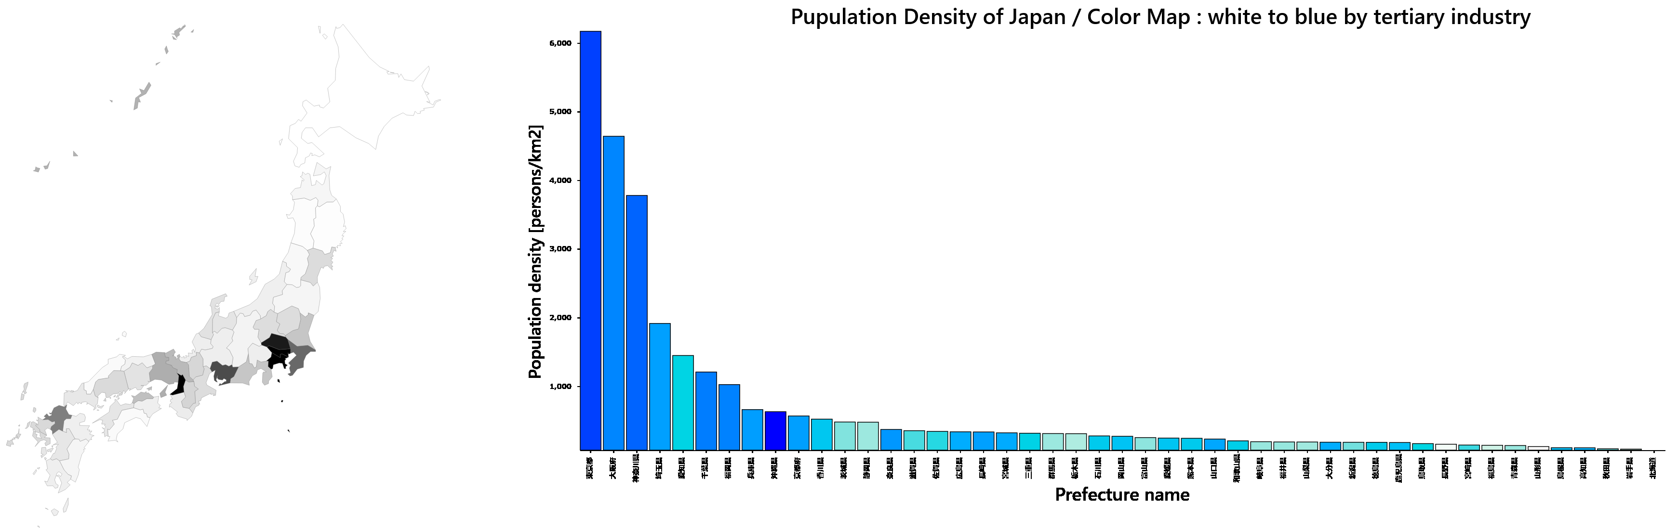 Fig 2. Correlation between tertiary industry and population density

# **Conclusion**

In my opinion, in order to prevent population concentration and depopulation, it is desirable to develop the tertiary industry, i.e., the service industry, such as tourism, utilizing the primary industry in the area. I believe that at first, by developing and revitalizing the area by local residents, the population concentrated in the three major metropolitan areas will return to the countryside.

# **Refference**

* d3-3d(<https://github.com/Niekes/d3-3d>)
* 国勢調査 平成27年国勢調査 就業状態等基本集計（労働力状態，就業者の産業･職業など）(<https://www.e-stat.go.jp/dbview?sid=0003175084>)
* Natural Earth (https://www.naturalearthdata.com/)