Nathaniel Smith

April 18, 2020

Foundations of Programming: Python (IT FDN 100 A Sp 20)

Assignment01

Writing a Python Script in Windows

# Introduction

The purpose of this paper is to describe my process for writing a Python script in Windows, saving the script, and running the script from the Windows command prompt.

# Download and Install Python

I first had to download and install python on my Windows 10 machine. I downloaded python 3.8.2 for Windows from <https://www.python.org/> (external site). I followed the installation instruction provided by Corey Schafer on YouTube (<https://www.youtube.com/watch?v=YYXdXT2l-Gg&vl=en>) (external site). Unfortunately, I did not take screenshots of the installation process as I did not see the usefulness of such until writing this paper. In Corey’s instructional video he made a mention to the PyCharm IDE from JetBrains which I also installed after installing Python. However, I have not used PyCharm yet, but it will be used for future assignments because it provides advanced editing features for writing and testing Python code.

# Launch IDLE and Open Text Editor

I used IDLE (Python’s Integrated Development and Learning Environment) to write the python script. I launched IDLE from the Windows start screen but it can also be launched by typing “IDLE” into Windows search, see Figure 1. In IDLE I launched the text editor by clicking “File” and selecting “New File” from IDLE’s toolbar. This opens a second window, the python text editor, where I wrote the Python script.

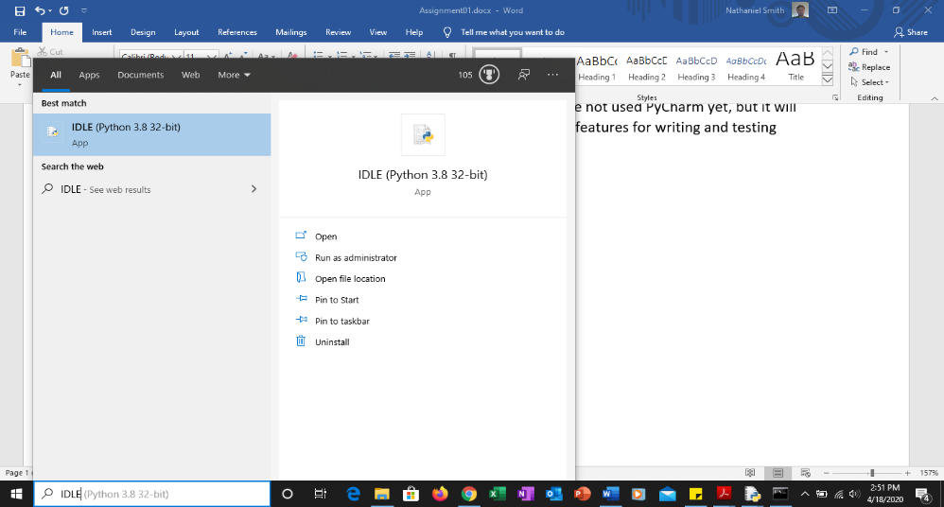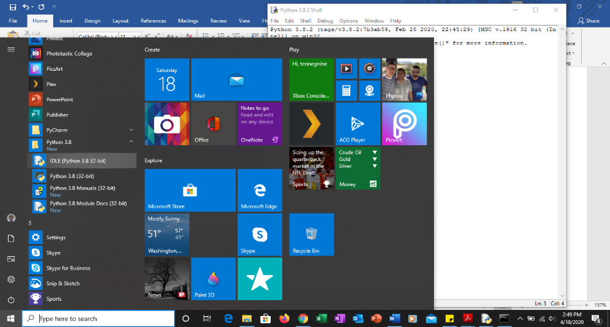

Figure 1. Launching IDLE

# Save Python Script

As I wrote the script, I tested the code by clicking “Run” and selecting “Run Module” from the toolbar of the text editor. The first time I ran the module I was prompted to save the file, but I could have saved the file beforehand by clicking “File” and selecting “Save” from the text editor’s toolbar. My final script, test.py, is shown in Figure 2 below.

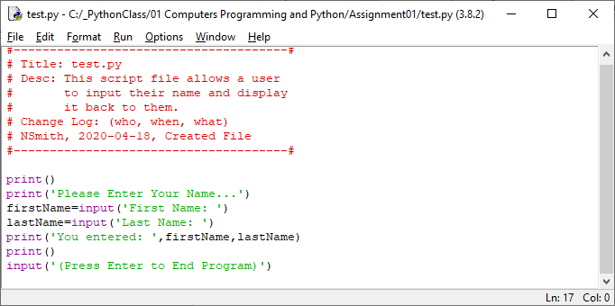

Figure 2. test.py Script Text

# Run test.py from Windows Command Prompt

I launched the command prompt by typing “cmd” into the Windows search. I copied the path to the test.py file and pasted the path into the command prompt and pressed enter. Because the file was saved with the extension .py, and the .py filetype is associated to Python in Window’s system settings, the file was ran by Python automatically just by typing the path for the file into the command prompt. My test.py Python script is shown running from the command prompt in Figure 3.

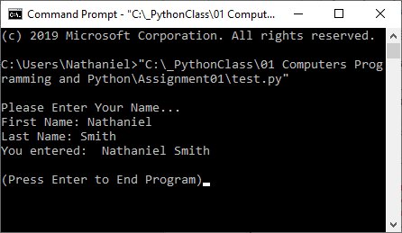

Figure 3. Running test.py in Windows Command Prompt

# Summary

I installed Python 3.8.2 on my Windows 10 machine and successfully wrote, saved, and tested a Python script from IDLE and then ran the script from the command prompt in Windows.