# 认识实习作业报告

**题目：** Mili Web Site

**成绩：**

**序号：** 120

**班级：** 软20004

**姓名：** 林一龙

**学号：** 20202241431

大连理工大学软件学院

2021年7月

**一 选题说明**

该网页仿制于乐队Project Mili的官网网站（<http://projectmili.com/>），网页分为主页，news, music , about & contact，导航的每一个主网页都完成了制作，没有使用该网站的原始网页（除站外跳转外，如bilibili网页）。

**二 功能说明**

* 1. 上方导航栏：通过css设置实现了导航栏在不同页面的字体颜色变化；通过javascript脚本和jquery 实现了鼠标移动到超链接上用动画渐变超链接样式。
  2. 主页：
     1. 主页通过jquery的插件和少量相关代码实现了视差滚动，使网页观看体验上升。
     2. 超链接同样实现了动画渐变。
  3. News页面：
     1. 页面底有文本框和提交按钮，但未设置功能
  4. 通过css和html总体上实现了和原网页相近的排版，字体，字号等，观感较好

**三 实现截图**

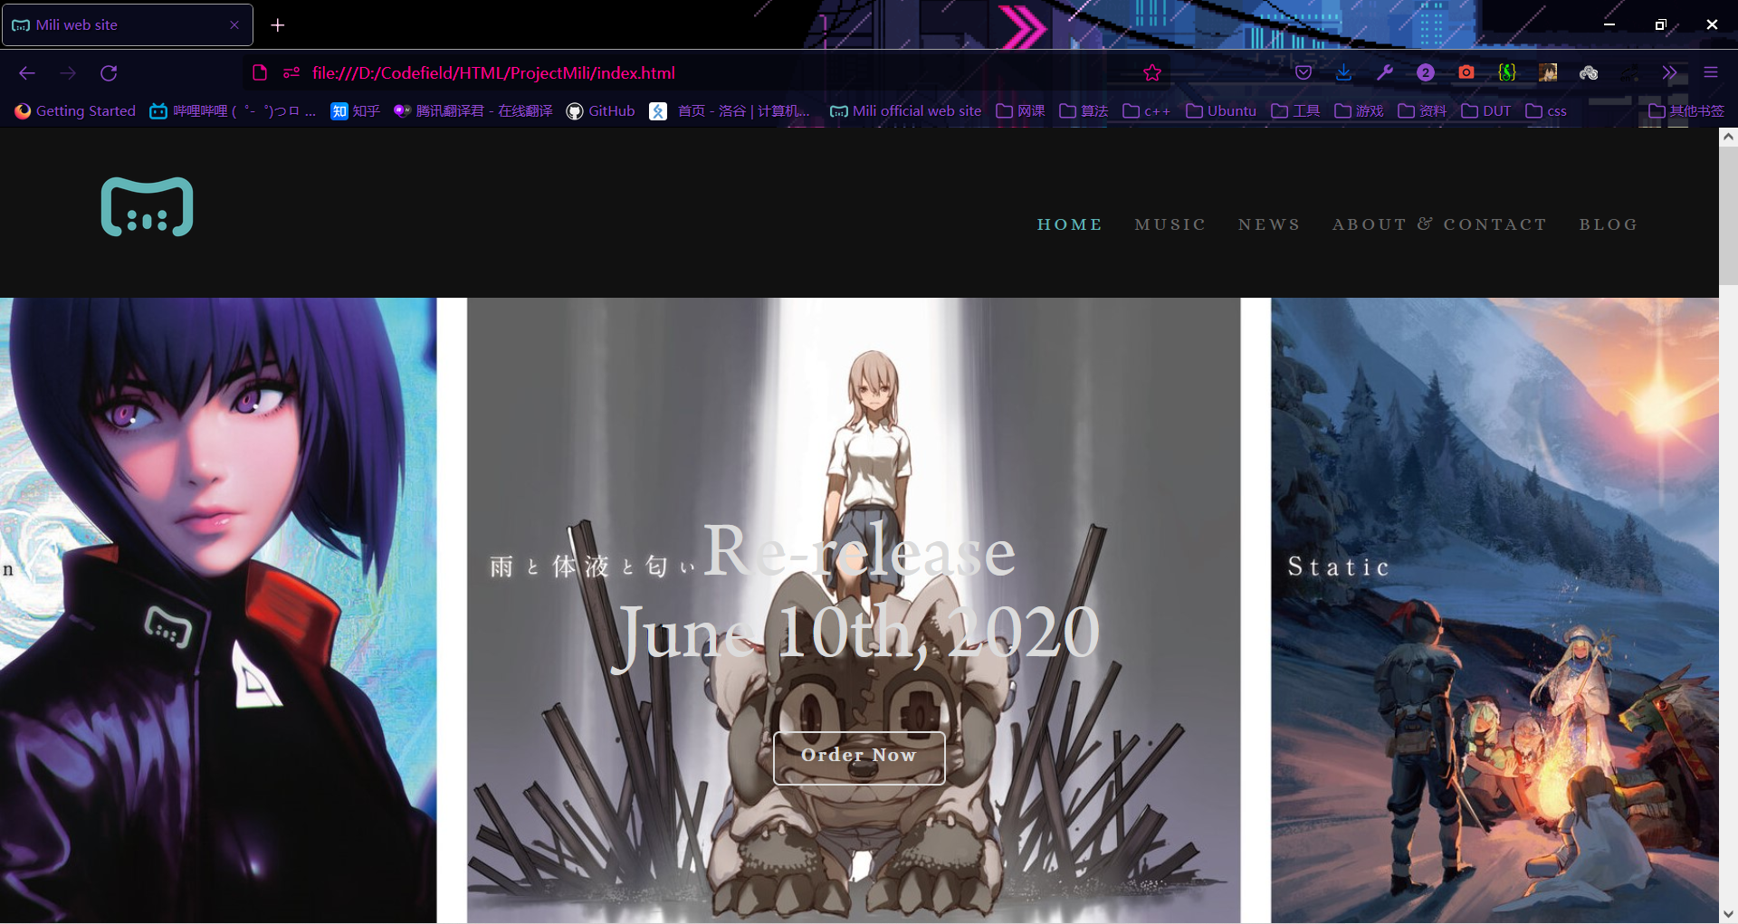

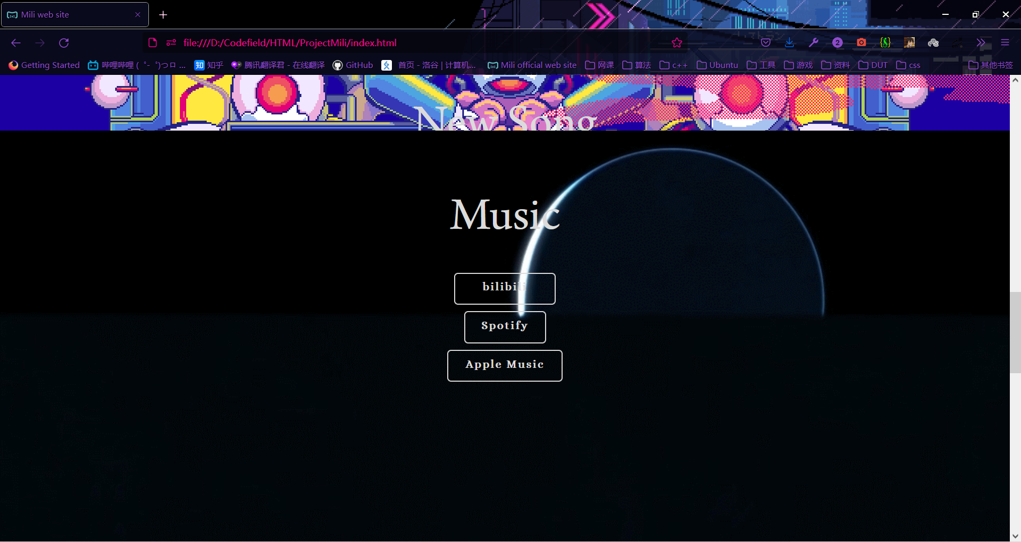 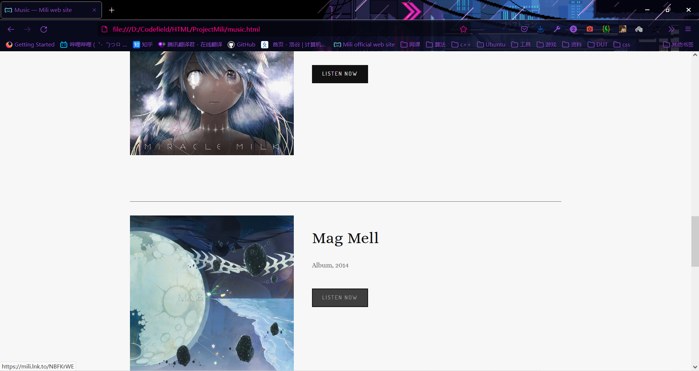

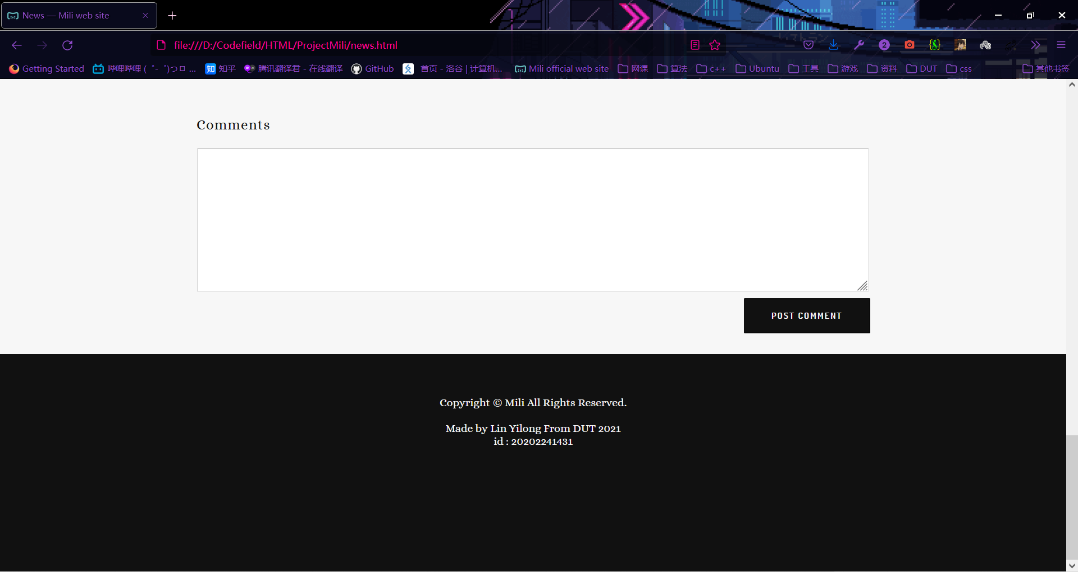

**四 程序源码**

**主页：**

<!DOCTYPE html>

<html lang="zh">

<head>

<title>Mili web site</title>

<link rel="stylesheet" type="text/css" href="./css/projectmili.css">

<link rel="shortcut icon" tyle="image/x-icon" href="./image/index.png">

<script type="text/javascript" src="./janpaepke-ScrollMagic-f1cccba/assets/js/lib/jquery.min.js"></script>

<script type="text/javascript" src="./janpaepke-ScrollMagic-f1cccba/assets/js/lib/gsap3/gsap.min.js"></script>

<script type="text/javascript" src="./janpaepke-ScrollMagic-f1cccba/scrollmagic/uncompressed/ScrollMagic.js"></script>

<script type="text/javascript" src="./janpaepke-ScrollMagic-f1cccba/scrollmagic/uncompressed/plugins/animation.gsap.js"></script>

<script type="text/javascript" src="js/jquery.animate-colors-min.js"></script>

<style>

body,p,pre{

     font-family:"Alice","Ryumin Regular"!important;

}

h1,h2,h3,h4,h5,h6{

    font-family:"Alice","Ryumin Regular"!important;

}

</style>

<meta charset="utf-8">

</head>

<body>

    <div>

             <nav ><img src="./image/Mili+logo_no+back_SQ.png" id="logo">

                <ul style="text-align: right;">

                    <li class="horizontalLi"><a href="index.html">HOME</a> </li>

                    <li class="horizontalLi"><a href="music.html" class="otherlink">MUSIC</a> </li>

                    <li class="horizontalLi"><a href="news.html" class="otherlink">NEWS</a> </li>

                    <li class="horizontalLi"><a href="aboutcontact.html " class="otherlink">ABOUT &amp; CONTACT</a> </li>

                    <li class="horizontalLi"><a href="https://lineblog.me/mili/" target="blank" class="otherlink">BLOG</a></li>

                </ul>

            </nav>

        <main>

                <div id="parallax1" class="parallaxParent" style="padding-top: 150px;">

                    <div style="background-image: url(./image/名称未設定+2.jpg)"class="indexback">

                        <div class="indexlarge">Re-release<br>

                            June 10th, 2020

                        </div>

                        <div class="indexsmall">

                            <a href="https://www.jvcmusic.co.jp/flyingdog/mili/tokuten/" target="blank">

                                Order Now</a>

                        </div>

                        </div>

                </div>

                <div id="parallax2" class="parallaxParent">

                    <div style="background-image: url(./image/thumbnail.png)"class="indexback">

                        <div class="indexlarge">New Song <br>"sustain++;" <br>Ghost In The Shell: <br>SAC_2045 Ending Theme

                        </div>

                        <div class="indexsmall">

                            <a href="https://www.bilibili.com/video/BV1Vk4y1z7Pb" target="blank">

                            bilibili

                            </a>

                        </div>

                    </div>

                </div>

                <div id="parallax3" class="parallaxParent">

                    <div style="background-image: url(./image/Gif3.gif);"class="indexback">

                        <div class="indexlarge">

                            Music

                        </div>

                        <div class="indexsmall">

                            <a href="https://space.bilibili.com/23340150/" target="blank"> bilibili</a><br>

                        </div>

                        <div class="indexsmall" style="margin-top: 10px; width: 120px;">

                            <a href="https://open.spotify.com/artist/0K05TDnN7xPwIHDOwD2YYs?si=V__Pl88ITNODSGGUJLHPLA" target="blank">Spotify</a>

                        </div>

                        <div class="indexsmall" style="margin-top: 10px; width: 170px;">

                            <a href="https://itunes.apple.com/jp/artist/mili/906934266" target="blnak"> Apple Music</a>

                        </div>

                    </div>

                </div>

                <div id="parallax4" class="parallaxParent" style="padding-top: 142px;">

                    <div style="background-image: url(./image/表1表4gentei1.jpg);"class="indexback" sty>

                        <div class="indexlarge" style="padding-top: 85px; font-size: 20px ; line-height: 1.6em;font-family: Alice">

                            Mili 3rd Album<br>

                        </div>

                        <div class="indexlarge" style="padding-top: 0;">

                            Millennium Mother<br>

                        </div>

                        <div class="indexlarge" style="padding-top: 0;font-size: 20px ; line-height: 1.6em;font-family: Alice">初回限定盤 SNCL-00016~00017 | ¥3,500+税<br>通常盤 SNCL-00018 | ¥3,000+税<br>2018/4/25 Wed Release<br><br><br><br>

                        </div>

                        <div class="indexlarge" style="padding-top: 0;font-size: 20px ; line-height: 1.6em;font-family: Alice">

 購入・予約<br> To Buy or Pre-order<br>購買／預購<br></div>

                        <div class="indexlarge" style="padding-top: 0;"> Special Site<br>

                        </div>

                        <div class="indexsmall">

                            <a href="https://twitter.com/share" target="blank">Twitter </a>

                        </div>

                    </div>

                </div>

                <script src="./js/scroll.js"></script>

                <script src="./js/href.js"></script>

        </main>

        <footer>Copyright &copy; Mili All Rights Reserved.<br><br>Made by Lin Yilong From DUT 2021<br>id : 20202241431

        </footer>

    </div>

</body>

</html>

**Music**

<!DOCTYPE html>

<html lang="zh">

<head>

<title>Music &mdash; Mili web site</title>

<link rel="stylesheet" type="text/css" href="./css/projectmili.css">

<link rel="shortcut icon" tyle="image/x-icon" href="./image/index.png">

<script src="./js/jquery-3.6.0.min.js"></script>

<script type="text/javascript" src="js/jquery.animate-colors-min.js"></script>

<style>

body,p,pre{

     font-family:"Alice","Ryumin Regular"!important;

}

h1,h2,h3,h4,h5,h6{

    font-family:"Alice","Ryumin Regular"!important;

}

</style>

<meta charset="utf-8">

</head>

<body>

    <div>

        <nav><img src="./image/Mili+logo_no+back_SQ.png" id="logo">

            <ul style="text-align: right;">

                <li class="horizontalLi"><a href="index.html" class="otherlink">HOME</a> </li>

                <li class="horizontalLi"><a href="music.html" >MUSIC</a> </li>

                <li class="horizontalLi"><a href="news.html" class="otherlink">NEWS</a> </li>

                <li class="horizontalLi"><a href="aboutcontact.html" class="otherlink">ABOUT &amp; CONTACT</a> </li>

                <li class="horizontalLi"><a href="https://lineblog.me/mili/" target="blank" class="otherlink">BLOG</a></li>

            </ul>

        </nav>

        <main class="othermain">

            <div class="mainSepeline">

            <h1>Albums</h1>

            </div>

            <div class="musicSepe">

                <img src="image/限定版_表1.jpg" class="leftimg">

                <h2>Millennium Mother</h2>

                <p>Album, 2018</p>

                <div class="musiclink">

                    <a href="https://mili.lnk.to/XXwbIWE" target="blank">LISTEN NOW</a>

                </div>

            </div>

            <div class="musicSepe">

                <img src="./image/Rightfully+(Miliスペシャルパッケージ)(CD+LiveDVD＆moer).jpg " class="leftimg">

                <h2>Rightfully</h2>

                <p>Single, 2018</p>

                <div class="musiclink">

                    <a href="https://mili.lnk.to/RLgk4WE" target="blank">LISTEN NOW</a>

                </div>

            </div>

            <div class="musicSepe">

                <img src="./image/hue.png" class="leftimg">

                <h2>Hue</h2>

                <p>EP, 2017</p>

                <div class="musiclink">

                    <a href="https://mili.lnk.to/1ywrPWE" target="blank">LISTEN NOW</a>

                </div>

            </div>

            <div class="musicSepe">

                <img src="./image/miracle milk.jpg" class="leftimg">

                <h2>Miracle Milk</h2>

                <p>Album, 2016</p>

                <div class="musiclink">

                    <a href="https://mili.lnk.to/jJKqCWE" target="blank">LISTEN NOW</a>

                </div>

            </div>

            <div class="musicSepe">

                <img src="./image/Mag+Mell.jpg" class="leftimg">

                <h2>Mag Mell</h2>

                <p>Album, 2014</p>

                <div class="musiclink">

                    <a href="https://mili.lnk.to/NBFKrWE" target="blank">LISTEN NOW</a>

                </div>

            </div>

            <div class="mainword"  style="padding-bottom: 50px;">

                <h3 style="padding-top: 30px;">Previous Works & Digital EPs</h3>

                <br>

                <img style="float:left" height="297" width="297" src="image/MuNiCa.jpg">

                <img height="297" width="297" src="image/Klavier.jpg">

                <img style="float:right" height="297" width="297" src="image/Holy+and+DarknessⅠ.png ">

                <br><br>

                <img style="float:left" height="214.5" width="214.5" src="image/Chocological_Jak.jpg">

                <img  height="214.5" width="214.5" src="image/YUBIKIRI-GENMAN_back.jpg">

                <img style="padding-left: 28px;" height="214.5" width="214.5" src="image/image-asset.jpeg">

                <img style="float:right" height="214.5" width="214.5" src="image/image-asset+(1).jpeg">

            </div>

            <script src="./js/href.js"></script>

        </main>

        <footer>Copyright &copy; Mili All Rights Reserved.<br><br>Made by Lin Yilong From DUT 2021<br>id : 20202241431

        </footer>

    </div>

</body>

</html>

**News**

<!DOCTYPE html>

<html lang="zh">

<head>

<title>News &mdash; Mili web site</title>

<link rel="stylesheet" type="text/css" href="./css/projectmili.css">

<link rel="shortcut icon" tyle="image/x-icon" href="./image/index.png">

<script src="./js/jquery-3.6.0.min.js"></script>

<script type="text/javascript" src="js/jquery.animate-colors-min.js"></script>

<style>

body,p,pre{

     font-family:"Alice","Ryumin Regular"!important;

}

h1,h2,h3,h4,h5,h6{

    font-family:"Alice","Ryumin Regular"!important;

}

</style>

<meta charset="utf-8">

</head>

<body>

    <div>

        <nav><img src="./image/Mili+logo_no+back_SQ.png" id="logo">

            <ul style="text-align: right;">

                <li class="horizontalLi"><a href="index.html" class="otherlink">HOME</a> </li>

                <li class="horizontalLi"><a href="music.html" class="otherlink">MUSIC</a> </li>

                <li class="horizontalLi"><a href="news.html">NEWS</a> </li>

                <li class="horizontalLi"><a href="aboutcontact.html" class="otherlink">ABOUT &amp; CONTACT</a> </li>

                <li class="horizontalLi"><a href="https://lineblog.me/mili/" target="blank" class="otherlink">BLOG</a></li>

            </ul>

        </nav>

        <main class="othermain">

            <div class="newsSepe">

                <div style="float: left;">

                <h1>An apology regarding the deletion of our video "Birthday Kid"</h1>

                <section>September 10, 2019</section>

                </div>

                <h3>「Birthday Kid」動画削除につきまして謝罪と対応</h3>

                <p>YouTube、bilibili動画に投稿されているMiliの楽曲「Birthday Kid」を 削除する流れとなりました。<br><br>理由としましては、Birthday Kidに描かれた表現と歌詞の内容が意図しない方向へと解釈され、 日本及び諸外国の一部のファンの皆様に不快感を与えている事から削除という形で対応させて頂く事となりました。 今作において気分を害された皆様、大変誠に申し訳御座いませんでした。 <br><br>また、「Birthday Kid」は製作段階より政治的な意味、主張を持たせる意図はなく、 歌詞に関して、『深い精神世界で幼少期の記憶を辿り、少しづつ前に進む事』が、意図となり、イラストに関しましては、

『歌詞とキャラクターの設定を受け、「辛さ」「苦しさ」を表現する為にこのような構図、デザインとした事』が、制作過程となります。<br><br>今後の対応として、「Birthday Kid」のイラストから政治的な意味合いを連想させない形で修正を施したものをYouTubeとbilibili動画に再度投稿予定となります。投稿時期は追って皆様にお知らせする形となります。<br><br>重ねて、皆様へご心配お掛けし大変申し訳ありませんでした。br><br>今後ともMiliの応援の方をよろしくお願い致します。</p>

<h3>An apology regarding the deletion of our video "Birthday Kid":</h3>

                    <p>We will be deleting the video titled "Mili - Birthday Kid" from YouTube and Bilibili.<br><br>The illustration and lyrics of Birthday Kid could be interpreted in ways that are not intended, which has caused distress among our fans. We would like to delete the video to prevent the unintentional interpretations from spreading further.<br><br>We are deeply sorry for causing any confusion or pain through the video.<br><br>We would like you to know that in the making of Birthday Kid, we have never intended to connect the song to any political movements, and that the resemblance to a certain political symbol is purely coincidental.<br><br>The lyrics are meant to illustrate someone "grieving over their unfortunate childhood and slowly reaching the decision to move on".<br><br>A comment from the illustrator said "after receiving the lyrics and the character settings, I designed the image composition this way to show the character's hardships and suffering".<br><br>We will be re-uploading the video for Birthday Kid on YouTube and Bilibili, after we redo the illustration so that it does not resemble political symbols. <br><br>We will announce again once the new video for Birthday Kid is ready.<br><br>Once again, we are deeply sorry for creating this situation. <br><br>Thank you for supporting Mili. </p>

            </div>

            <div>

                <h3 style="text-align: left; padding-left: 250px;">Comments</h3>

                <textarea id="comment"></textarea>

                <input type="submit" value="POST COMMENT" id="submit">

            </div>

            <script src="./js/mainhref.js"></script>

        </main>

        <footer>Copyright &copy; Mili All Rights Reserved.<br><br>Made by Lin Yilong From DUT 2021<br>id : 20202241431

        </footer>

    </div>

</body>

</html>

**About & Contact**

<!DOCTYPE html>

<html lang="zh">

<head>

<title>About &amp; Contact &mdash; Mili web site</title>

<link rel="stylesheet" type="text/css" href="./css/projectmili.css">

<link rel="shortcut icon" tyle="image/x-icon" href="./image/index.png">

<script src="./js/jquery-3.6.0.min.js"></script>

<script type="text/javascript" src="js/jquery.animate-colors-min.js"></script>

<style>

body,p,pre{

     font-family:"Alice","Ryumin Regular"!important;

}

h1,h2,h3,h4,h5,h6{

    font-family:"Alice","Ryumin Regular"!important;

}

</style>

<meta charset="utf-8">

</head>

<body>

    <div>

        <nav><img src="./image/Mili+logo_no+back_SQ.png" id="logo">

            <ul id="navul">

                <li class="horizontalLi"><a href="index.html" class="otherlink">HOME</a> </li>

                <li class="horizontalLi"><a href="music.html" class="otherlink">MUSIC</a> </li>

                <li class="horizontalLi"><a href="news.html" class="otherlink">NEWS</a> </li>

                <li class="horizontalLi"><a href="aboutcontact.html">ABOUT &amp; CONTACT</a> </li>

                <li class="horizontalLi"><a href="https://lineblog.me/mili/" target="blank" class="otherlink">BLOG</a></li>

            </ul>

        </nav>

        <main class="othermain">

            <div class="mainSepeline">

            <h3>Mili is an international indie band currently based in Japan.</h3>

            </div>

            <div class="mainSepeline">

            <h2>Members</h2>

            <p>

                <a href="https://twitter.com/momocashew" target="blank">Cassie Wei</a> - vocals, song writing<br>

                <a href="https://twitter.com/HAMOloid" target="blank">Yamato Kasai</a> - song writing, arrangements, guitar<br>

                <a href="https://twitter.com/going_man" target="blank">Yukihito Mitomo</a> - bass<br>

                <a href="https://twitter.com/shoto_0y" target="blank">Shoto Yoshida</a> - drums<br>

                <a href="https://twitter.com/pioooooon" target="blank">Ao Fujimori</a> - illustrations, animations<br>

            </p>

            </div>

            <div class="mainSepeline">

            <h2>Contact</h2>

            <h3>(work inquiries only)<br>

                <span style="font-weight: 100;">（仕事の問い合わせのみ）</span>

            </h3>

            <p id="email"><a href="mailto:contact@projectmili.com">contact@projectmili.com</a></p>

            <ul class="ulmain">

                <li class="horizontalLi" style="padding-right: 100px;">

                We would love to work with you, whether it be soundtracks <br>

                for movies,drama, anime, games,or commercials, or <br>

                artist collaborations.<br>

                Please don't hesitate to email us.<br>

                </li>

                <li class="horizontalLi">

                    私達は国際的なアーティスト達、会社と共に作品を作っています。<br>

                    そして、私達は世界中から楽曲制作の依頼を承る事が出来ます。<br>

                    映画、アニメ、ゲーム、CM、演劇、アーティストコラボ等…<br>

                    御連絡お待ちしております。

                </li>

            </ul>

            </div>

            <img src="./image/Mili_Official_PHOTO_20180209.jpg" width="960px" height="640px">

            <div class="mainSepeline">

                <h2>Releases</h2>

                <ul class="ulli">

                    <h3>Albums</h3>

                    <li>Millenium Mother (2018)</li>

                    <li>Miracle Milk (2016)</li>

                    <li>Mag Mell (2014)</li>

                    <h3>Mini Albums & EPs</h3>

                    <li>Hue (2017)</li>

                    <h3>Singles</h3>

                    <li>Rightfully (2018)</li>

                </ul>

            </div>

            <div class="mainSepeline">

                <h2>Concerts & Festivals</h2>

                <ul class="ulli">

                    <h3>2019</h3>

                    <li>Mili Tour 2019-2020 "AJIWAIIAJI TOUR" in Japan</li>

                    <li>Mili 1st Live 2019 "Mother Ship Gi6pon" in Japan</li>

                    <li>AFA(Anime Festival Asia) I LOVE ANISONG Matsuri Malaysia 2019</li>

                    <h3>2018</h3>

                    <li>Summer Sonic 2018 Tokyo in Japan</li>

                    <li>MUSIC CONFERENCE vol.2 in Japan</li>

                    <li>C3 AFA(Anime Festival Asia) Singapore 2018</li>

                    <li>Mili Live Tour 2018 "Mommy, Where's My Left Hand Again?" in Japan, Taiwan, & China</li>

                    <h3>2017</h3>

                    <li>Summer Sonic 2017 Tokyo in Japan</li>

                    <li>NO FEAR FESTIVAL 2017 in Taiwan</li>

                    <li>SINGING BOYS & GIRLS LIVE in Japan</li>

                    <li>Citail presents PREMIUM SECRET LIVE in Japan</li>

                    <li>Mili 5th Anniversary Live Tour "Mag Milk All Songs" in Japan & Taiwan</li>

                    <li>Mili Live Tour "15158775" in Japan</li>

                    <h3>2016</h3>

                    <li>Mili Live Tour "タンブラー？いいえ、これは哺乳瓶…デス!!!!" in Japan</li>

                    <h3>2015</h3>

                    <li>H△G×Mili at Shibuya Club QUATTRO in Japan</li>

                </ul>

            </div>

        </div>

        <script src="./js/mainhref.js"></script>

        </main>

        <footer>

            Copyright &copy; Mili All Rights Reserved.<br><br>

            Made by Lin Yilong From DUT 2021<br>

            id : 20202241431

        </footer>

    </div>

</body>

</html>

**Css**

@font-face {font-family: 'Alice';font-style: normal;font-weight: 400;

src: url(../fonts/Alice.woff2) format('woff2');}

@font-face {font-family: 'arno';font-style: normal;font-weight: 400;src: url(../fonts/arno-pro.woff2) format('woff2');}

@font-face {font-family: 'Ryumin Regular';font-style: normal;font-weight: 400;

src: url(../fonts/G-OTF-GRyuminPro-Regular.otf) format('opentype');}

@font-face {font-family: 'Ryumin Heavy';font-style: normal;font-weight: 400;src: url(../fonts/A-OTF-RyuminPr5-Heavy.otf) format('opentype');}

@font-face {font-family: 'Dosis';font-style: normal;font-weight: 400;src: url(../fonts/Dosis.woff2) format('woff2');}

body{max-width:none;margin: 0;}

a{text-decoration: none;color:#61B5B7;}

nav{background-color: #111111;height: 90px;padding-top: 60px;padding-right: 50px;letter-spacing: 3px;}

footer{padding-top: 60px;background-color: #111111;color:#F7F7F7;text-align:center;height: 250px;}

h1,h2,h3,h4,h5,h6{color: #111111;letter-spacing: 1px;}

h1,h2{padding-top: 30px;}

h1{font-size: 50px;line-height: 1em;font-weight: 400;}

h2{font-size: 35px;line-height: 1.1em;font-weight: 400;}

h3{font-size: 20px;line-height: 1.2em;font-weight: 400;}

p{font-size: 15px;line-height: 24px;}

.othermain{background-color: #F7F7F7;color: #696969;text-align: center;line-height: 220%;padding : 30px;}

.horizontalLi{display:inline-block;padding-right: 20px;}

.otherlink{color: #696969;}

.mainword, .mainSepeline, .musicSepe, .newsSepe{

    text-align: center;margin-left: auto;margin-right: auto;width: 65%;}

.mainSepeline, .musicSepe , .newsSepe{border-width: 37%;border-bottom: thin solid #696969;padding-bottom: 30px;margin-bottom: 30px;}

.musicSepe{text-align: left;padding-bottom: 260px;}

.musicSepe p, .musicSepe h2{padding-left: 400px;}

.newsSepe{border-top: thin solid #696969;padding-bottom:  50px;

border-bottom: none;margin-top: 50px;}

.newsSepe h1, .newsSepe p ,.newsSepe h3 ,.newsSepe section{

    text-align: left;}

.newsSepe h1{border-bottom: none;width: 200px;}

.newsSepe h3{margin-left: 400px;padding-top: 50px;}

.newsSepe p{margin-left: 400px;padding-bottom: 50px;border-bottom: thin solid #696969;}

.newsSepe a{padding-bottom: 200px;}

.ulmain, .ulli{font-size: 85%;text-align: left;list-style-type: none;}

.ulli li{list-style-type: disc;margin-left: 40px;}

.indexlarge{padding-top: 300px;text-align: center;font-size: 72px;line-height: 1em;color:#DBDBDB ; font-family: "arno";}

.indexsmall,.musiclink{width: 150px;height: 30px;margin-top: 50px;margin-left:auto;margin-right: auto;padding-top: 10px;padding-bottom: 5px;border-width: 2px;border-style: solid;border-color: #DBDBDB;border-radius: 5px;text-align: center;background-color:transparent;font-size: 17px;font-weight: 600;letter-spacing: 2px;color:#DBDBDB ; }

.indexsmall a{color: #DBDBDB ;display: block;}

.leftimg{width: 360px;height: 360px;float: left;}

.musiclink{width: 120px;height: 22px;margin-top: 40px;   margin-left: 400px;background-color: #111111;border-color: #111111;

border-radius: 0;line-height: normal;font-size: 12px;font-weight: 400;

font-family: 'Dosis';}

.musiclink a{color: #F7F7F7;}

#comment{width: 950px;height: 200px;border-color: thin solid #696969;

border-width: 1.5px;}

#submit{margin-left: 780px;top: 100px;background-color: #111111;border-color: #111111;color: #F7F7F7;width: 180px;height: 50px;border-radius: 1px;line-height: 12px;font-size: 12px;font-weight: 600;font-family: 'Dosis';letter-spacing: 2px;}

#logo{float:left;margin: -40px 0px 0px 80px;width: 100px;height: 100px;}

#indexlogo{float:left;margin: 10px 0px 0px 80px;width: 100px;height: 100px;}

#email{margin-bottom: 40px;}

#navul{text-align: right;}

.parallaxParent {height: 100vh;overflow: hidden;}

.parallaxParent > * {height: 200%;position: relative;top: -100%;}

.indexback{background-repeat: no-repeat;background-attachment: fixed;background-size: contain;}

**Javascript(jquery)**

$(document).ready(function(){

    $('.indexsmall').mouseenter(function(){

        $(*this*).animate({

            backgroundColor: '#DBDBDB'

        },"fast")

        $(*this*).children().animate({color:'#111111'},"fast")

    })

        $('.indexsmall').mouseleave(function(){

        $(*this*).animate({backgroundColor:'transparent'},"fast");

        $(*this*).children().animate({color:'#DBDBDB'},"fast");

    })

})

$(document).ready(function(){

    $('.musiclink').mouseenter(function(){

        $(*this*).animate({

            backgroundColor: '#3F3F3F#'

        },"fast")

        $(*this*).children().animate({color:'#AAAAAA'},"fast")

    })

        $('.musiclink').mouseleave(function(){

        $(*this*).animate({backgroundColor:'#111111'},"fast");

        $(*this*).children().animate({color:'#F7F7F7'},"fast");

    })

})

var precolor;

$(document).ready(function(){

    $('nav > ul > li > a').mouseenter(function(){

        precolor = $(*this*).css("color");

        $(*this*).animate({

            color: '#4C4C4C'

        },"fast")

    })

    $('nav > ul > li > a').mouseleave(function(){

        $(*this*).animate({color:precolor},"fast")

    })

})

var precolor;

$(document).ready(function(){

    $('a').mouseenter(function(){

        precolor = $(*this*).css("color");

        $(*this*).animate({

            color: '#4C4C4C'

        },"fast")

    })

    $('a').mouseleave(function(){

        $(*this*).animate({color:precolor},"fast")

    })

})

var controller = new ScrollMagic.Controller({globalSceneOptions: {triggerHook: "onEnter", duration: "200%"}});

                    new ScrollMagic.Scene({triggerElement: "#parallax1"})

                                    .setTween("#parallax1 > div", {y: "80%", ease: Linear.easeNone})

                                    .addTo(controller);

                    new ScrollMagic.Scene({triggerElement: "#parallax2"})

                                    .setTween("#parallax2 > div", {y: "80%", ease: Linear.easeNone})

                                    .addTo(controller);

                    new ScrollMagic.Scene({triggerElement: "#parallax3"})

                                    .setTween("#parallax3 > div", {y: "80%", ease: Linear.easeNone})

                                    .addTo(controller);

                    new ScrollMagic.Scene({triggerElement: "#parallax4"})

                                    .setTween("#parallax4 > div", {y: "80%", ease: Linear.easeNone})

                                    .addTo(controller);