10PEARLS
SHINE INTERNSHIP PROGRAM
SonarQube Code Quality
Analysis Report

Project: MERN Notes App
Prepared by: Ayesha Iqbal
Internship: 10Pearls Shine Internship — Cohort 9
Date: 4 September 2026
Static Code Analysis • Quality Gates • Security & Reliability

1. Introduction
This report documents the static code quality analysis performed on the Cohort 9 MERN Notes Application as part of the 10Pearls Shine Internship Program. Static code analysis is a critical practice in modern software development, enabling early detection of bugs, vulnerabilities, code smells, and maintainability issues before code reaches production.
SonarQube, an industry-standard code quality and security analysis platform, was used to scan both the frontend (React) and backend (Node.js / Express) codebases of the Notes App. The analysis covers key software quality dimensions including security, reliability, maintainability, test coverage, and code duplication, providing an objective, data-driven view of the project's overall code health.
2. Objective
The primary objective of this exercise was to evaluate the frontend and backend codebases of the MERN Notes App using SonarQube, in order to:
- Identify security vulnerabilities and hotspots within the application code.
- Assess the reliability of the codebase by detecting potential bugs.
- Measure maintainability through code smells and technical debt indicators.
- Evaluate code coverage achieved by existing automated tests.
- Detect duplicated code blocks that may affect long-term maintainability.
- Confirm whether the project satisfies SonarQube's default Quality Gate criteria.

3. SonarQube Setup
SonarQube was configured and run locally to analyze the project. The SonarQube server was accessed via the local dashboard at localhost:9000, where both the frontend and backend projects were registered and scanned independently using the SonarScanner CLI.
SonarQube Dashboard & Registered Projects
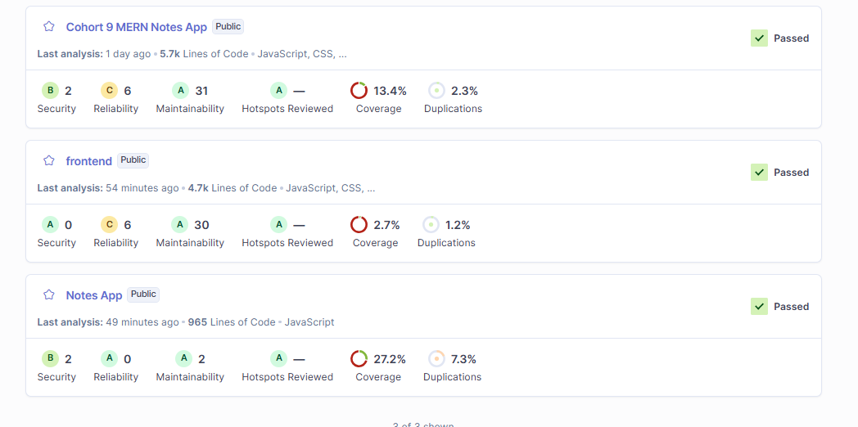

Note: For security reasons, the SonarQube authentication token used during the scan is not included anywhere in this report. The token used for this analysis has been revoked and regenerated after submission, in line with secure credential-handling practices.
4. Frontend Analysis
Frontend SonarQube Analysis — Project: frontend
The frontend React application was scanned to evaluate its code quality across all standard SonarQube dimensions. The scan completed successfully and the project satisfied the default Quality Gate.
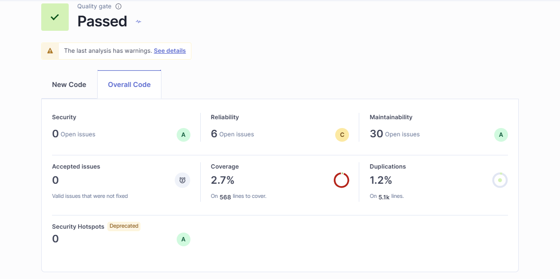

Summary of Results
Metric | Result
Quality Gate | Passed
Security | A
Reliability | C
Maintainability | A
Coverage | 2.7%
Duplications | 1.2%
Lines of Code | 4.7k

The frontend maintained a strong Security rating (A) and Maintainability rating (A), indicating clean, well-structured code with minimal vulnerabilities. The Reliability rating (C) suggests a small number of potential bugs that should be reviewed and addressed. Test coverage (2.7%) remains low and is recommended as a key area for improvement in future iterations.
5. Backend Analysis
Backend SonarQube Analysis — Project: notes-app
The backend Node.js / Express application was analyzed separately under the project key notes-app. The scan completed successfully and the backend also satisfied the default Quality Gate.
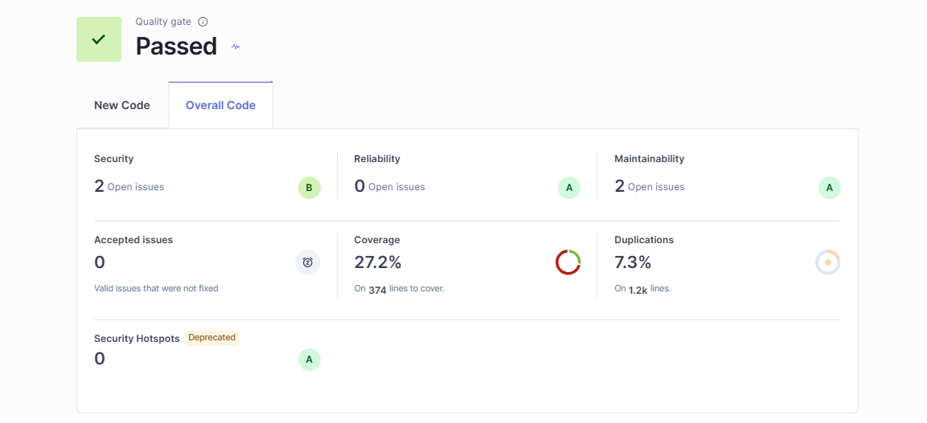

Summary of Results
Metric | Result
Quality Gate | Passed
Security | B
Reliability | A
Maintainability | A
Coverage | 27.2%
Lines of Code | 965

The backend achieved excellent Reliability and Maintainability ratings (A), along with a notably higher test coverage of 27.2% compared to the frontend. The Security rating (B) indicates a small number of security hotspots that warrant a closer manual review, though none were severe enough to fail the Quality Gate.
6. Scan Execution
Both scans were executed via the SonarScanner CLI from the project's terminal. Each scan completed with an ANALYSIS SUCCESSFUL confirmation, along with a direct link to the generated dashboard for the respective project.
Frontend Scan — Terminal Output
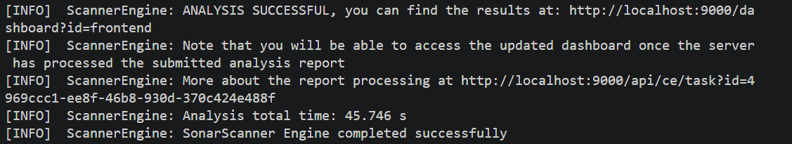

Backend Scan — Terminal Output
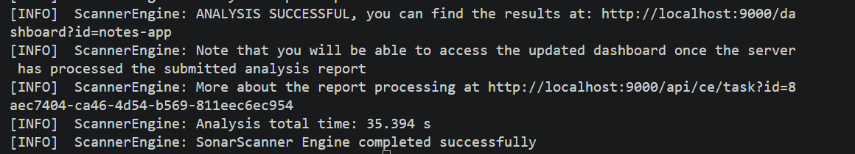

7. Results Summary
The table below presents a side-by-side comparison of the frontend and backend SonarQube results, offering a quick overview of the overall code health of the MERN Notes App.
Metric | Frontend | Backend
Quality Gate | Passed | Passed
Security | A | B
Reliability | C | A
Maintainability | A | A
Coverage | 2.7% | 27.2%
Duplications | 1.2% | —
Lines of Code | 4.7k | 965

Both codebases passed their respective Quality Gates, confirming that neither the frontend nor the backend contains blocking-level issues as defined by SonarQube's default rule set. The backend outperforms the frontend in reliability and test coverage, while the frontend holds a slight edge in security rating.
8. Conclusion
The SonarQube static code analysis of the Cohort 9 MERN Notes App was completed successfully for both the frontend and backend codebases. Both projects passed their Quality Gates, confirming an acceptable baseline of code quality, security, and maintainability.
The frontend demonstrated strong security and maintainability but would benefit from increased automated test coverage and minor reliability improvements. The backend showed excellent reliability and maintainability, along with comparatively higher test coverage, though a small number of security hotspots should be reviewed in future iterations.
Overall, this analysis validates that the MERN Notes App meets the foundational code quality standards expected during the 10Pearls Shine Internship Program, while also highlighting clear, actionable opportunities for continued improvement — particularly around expanding unit test coverage across both layers of the application.

Prepared by: Ayesha Iqbal
Program: 10Pearls Shine Internship — Cohort 9
Date: 4 September 2026

