Table of Contents

A Pluggable System for Modeling Asteroid-Impact Cascades

Design document — from abstractions to implementation
One sentence. This system turns a collection of independent environmental models into a single, reproducible pipeline that predicts the chain of effects following an asteroid impact — by giving every model and every data source one uniform contract and letting an engine discover and run whatever is needed to satisfy a request.
This document is written abstraction-first: each idea is introduced as a concept, then grounded in how it is implemented. Infrastructure concerns (which supercomputer, which job scheduler) are deliberately kept to the margins — they are a supporting capability, and we flag the genuinely hard part of them as a challenge rather than a feature.

Table of contents
- Motivation — why a cascade needs a system
- The core abstractions
  - 2.1 The Producer
  - 2.2 Variables and the Data Catalog
  - 2.3 Dependency resolution — the cascade
  - 2.4 Merge policies — combining outputs
- Layered architecture
- Worked example — WRF-SFIRE as model 1
- Extending — a second model plugs in
- The central challenge — “is it already in the system?”
- Supporting concerns
- Implementation map
- Glossary

1. Motivation
An asteroid airburst is not a single event with a single consequence. The thermal pulse ignites wildfires; the fires loft smoke and aerosols; the smoke degrades air quality over large regions; the burn scars change the land surface and drive later flooding. Each effect becomes the cause of the next.
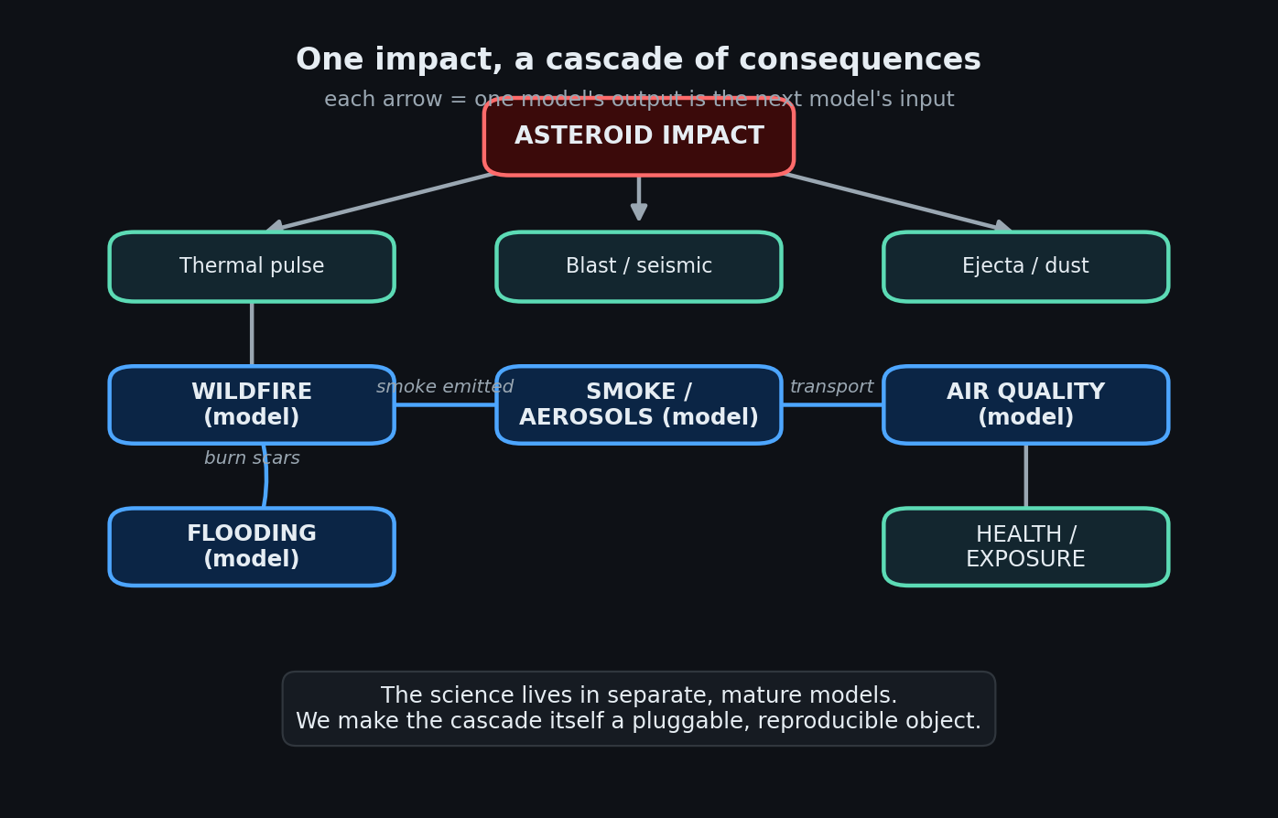
The cascade of consequences
The scientific community already has excellent, mature models for each link in this chain — fire-spread models, chemical-transport models, hydrology models. The problem is not the physics of any one link. The problem is the coupling:
- The models are written by different groups, in different languages, expecting different input formats, and designed to run on different machines.
- Wiring one model’s output into the next is done by hand, per study, with custom glue scripts. The result is fragile, hard to reproduce, and nearly impossible to extend to a new link in the chain.
Our goal is to make the cascade itself a first-class object: a system where a new model is added by declaring what it needs and what it produces, and the system figures out the rest — fetching data, running upstream models, and assembling the chain end-to-end, reproducibly.

2. The core abstractions
Everything in the system rests on three ideas. None of them mention fire, smoke, or any specific science — that generality is the point.

2.1 The Producer — the one idea
A producer is anything that can create a piece of data. It declares three things and nothing more:
Declaration | Meaning
produces | the variables it can make
requires | the variables it needs before it can run
run() | how to actually make them
That is the entire contract. The crucial design decision is that two very different things satisfy the same contract:
- a data driver — fetches bytes from the outside world (a reanalysis archive, a fuel map, a terrain model) and writes a variable; it usually requires nothing.
- a model — computes a variable from other variables (a fire model consumes fuel + wind + ignition and produces fire-arrival time).
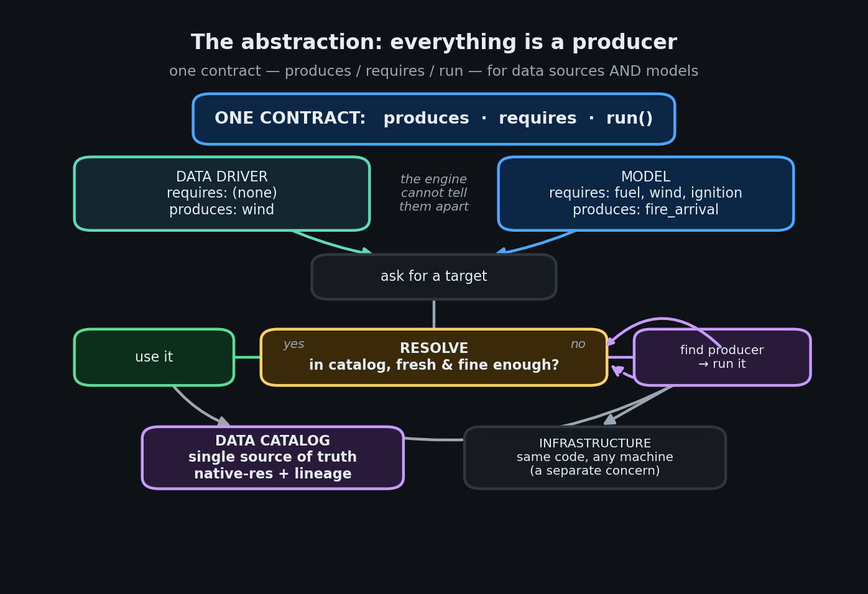
The producer abstraction and the resolver
Because both are “producers”, the rest of the system cannot tell them apart — and does not need to. This symmetry is what allows a model to transparently trigger another model: from the engine’s point of view, “run a download” and “run a 50,000-core simulation” are the same verb.
Implementation. The contract is the ProducerV2 base class (engine/contracts.py). Models use a thin specialization, ModelAdapter (engine/model_adapter.py), which adds a familiar three-step shape — stage inputs → run the binary → parse outputs. Data drivers use the Driver protocol and are wrapped automatically. A registry maps each variable name to the one producer that makes it.

2.2 Variables and the Data Catalog
Producers communicate only through named variables written into a shared data catalog. Nobody passes data to anybody directly; a producer writes fire_arrival into the catalog, and any later producer that needs fire_arrival reads it from the catalog.
The catalog is therefore the system’s single source of truth and its memory. Critically, every variable is stored with metadata that later decisions depend on:
- its native resolution (how fine the data actually is),
- its provenance / lineage (which producer made it, from which inputs, under which configuration),
- its time coverage (for time-varying fields).
Implementation. The catalog is the cube (cube/): array data in Zarr, an index and metadata in DuckDB. A producer never writes files in a model-specific format for another producer to read; it writes a variable. This is what makes the pieces composable.

2.3 Dependency resolution — the cascade
Given a target (the variable the user wants), the system must work out everything required to produce it, in the right order. It does this by walking the contracts backwards: the producer of the target declares what it requires; each of those is itself produced by some producer with its own requires; and so on, until the chain bottoms out at data drivers that require nothing.
The result is a dependency graph (a DAG) the engine executes in order. The key property: the user names only the end goal. If they ask for a downstream model’s output, every upstream model and data driver is discovered and run automatically.
Implementation. Two cooperating pieces: Pipeline.from_targets (engine/pipeline.py) builds the DAG by walking requires → produces; DataAdapter.resolve (engine/data_adapter.py) is the per-variable decision — is this already in the catalog, or must I run its producer? The same code path handles a data download and a nested simulation, because both are producers.

2.4 Merge policies
When the same variable can be written more than once — for example, a quantity accumulated over tiles, or a peak intensity seen across several runs — the producer declares how writes combine: keep the latest, keep the cell-wise minimum (e.g. earliest arrival time), keep the maximum (e.g. peak intensity), accumulate, or union. This keeps combination logic declarative and out of the models.
Implementation. MergePolicy on each output’s VarSpec (engine/contracts.py); the catalog applies it on write.

3. Layered architecture
The abstractions stack into four layers. The top three are completely generic; only the producers know any science.
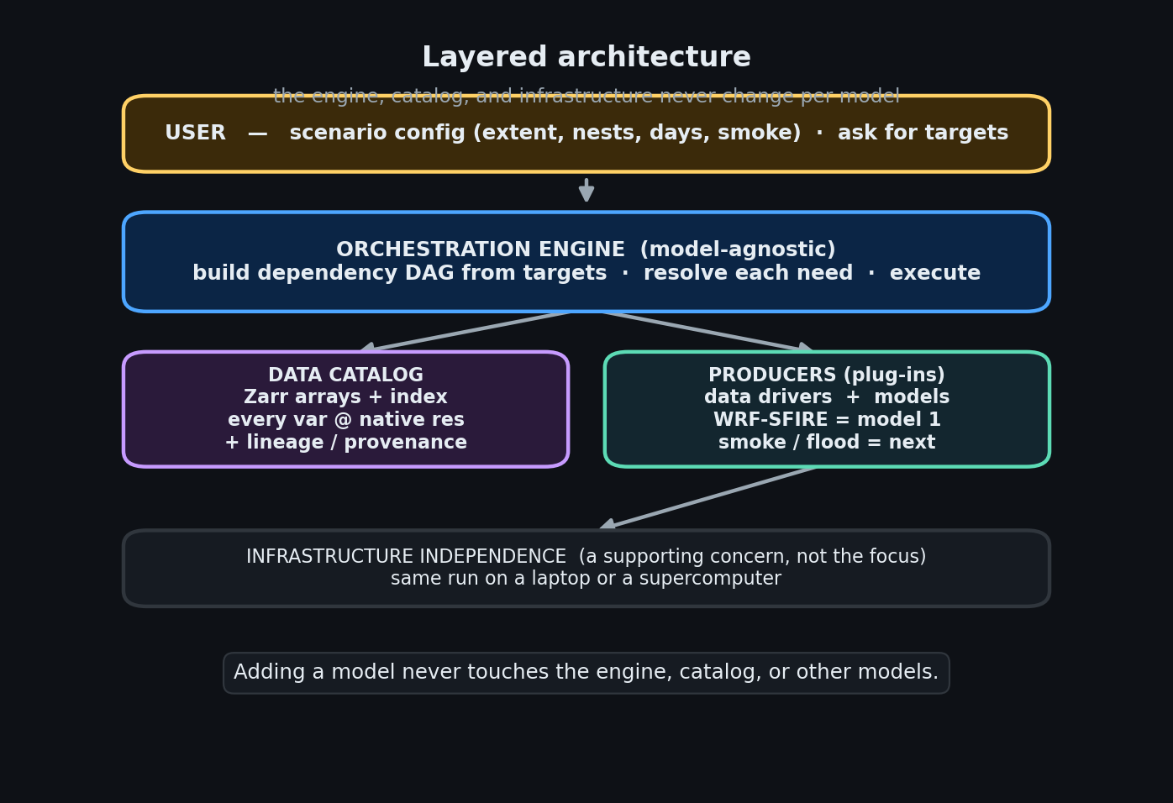
Layered architecture
- User layer — a scenario configuration (area, resolution, nesting, duration, which effects to include) and a request for one or more target variables.
- Engine layer — builds the DAG, resolves each need, executes. Model-agnostic; never edited to add a model.
- Producers + Data catalog — the pluggable science and the shared store they read and write.
- Infrastructure — runs the work on whatever machine is available. A supporting concern (see §7), not the focus.
The single most important property of this picture: adding a model never touches the engine, the catalog, or any other model. A model is a leaf you attach; the system already knows how to reach it.

4. Worked example — WRF-SFIRE as model 1
To make the abstractions concrete, here is the first real model wired into the system: WRF-SFIRE, a coupled fire-spread / atmosphere model. It is the wildfire link of the cascade.
As an abstraction, WRF-SFIRE is just a producer:
requires | ignition_t0, nfuel_cat (fuel), dem (terrain), wind
produces | arrival_s (fire arrival time), fire_area, and optional diagnostics (rate of spread, intensity, fuel consumed)
Each requirement is satisfied by a data driver: the ignition field comes from the impact’s thermal footprint, fuel from a land-cover dataset, terrain from a DEM, wind from a reanalysis archive.
As an implementation, the model follows the three-step shape every model uses:
- Stage — translate catalog variables into the files WRF expects: generate the namelist (grid, nesting, physics, optional smoke chemistry), and inject the ignition / fuel / terrain fields into the model’s input file. The asteroid scenario is expressed as a gridded pre-ignition field — the whole impact footprint is ignited — rather than a single match.
- Run — launch the solver. The launch command is supplied by the infrastructure layer, so the same model definition runs on any machine.
- Parse — read the model’s output and write the results back into the catalog as arrival_s, fire_area, etc., at their native resolution.
Implementation. models/wrf_sfire_adapter.py (the three hooks); models/wrf_config.py (turns a simple scenario — extent, nest resolutions, duration, smoke on/off — into the model’s nested configuration files). The user-facing knobs live in a single YAML (configs/wildfire_scenario.yaml).
The takeaway: nothing about WRF-SFIRE leaks into the engine. It is a producer with a fire-shaped requires/produces, plus three functions that know how to talk to the WRF binary.

5. Extending — a second model plugs in
Now the payoff. Suppose we add a smoke model (hypothetical here) that turns fire output into smoke concentration. As an abstraction it is, again, just a producer:
- requires: fire_arrival, burned_area (from WRF-SFIRE), wind
- produces: smoke_concentration
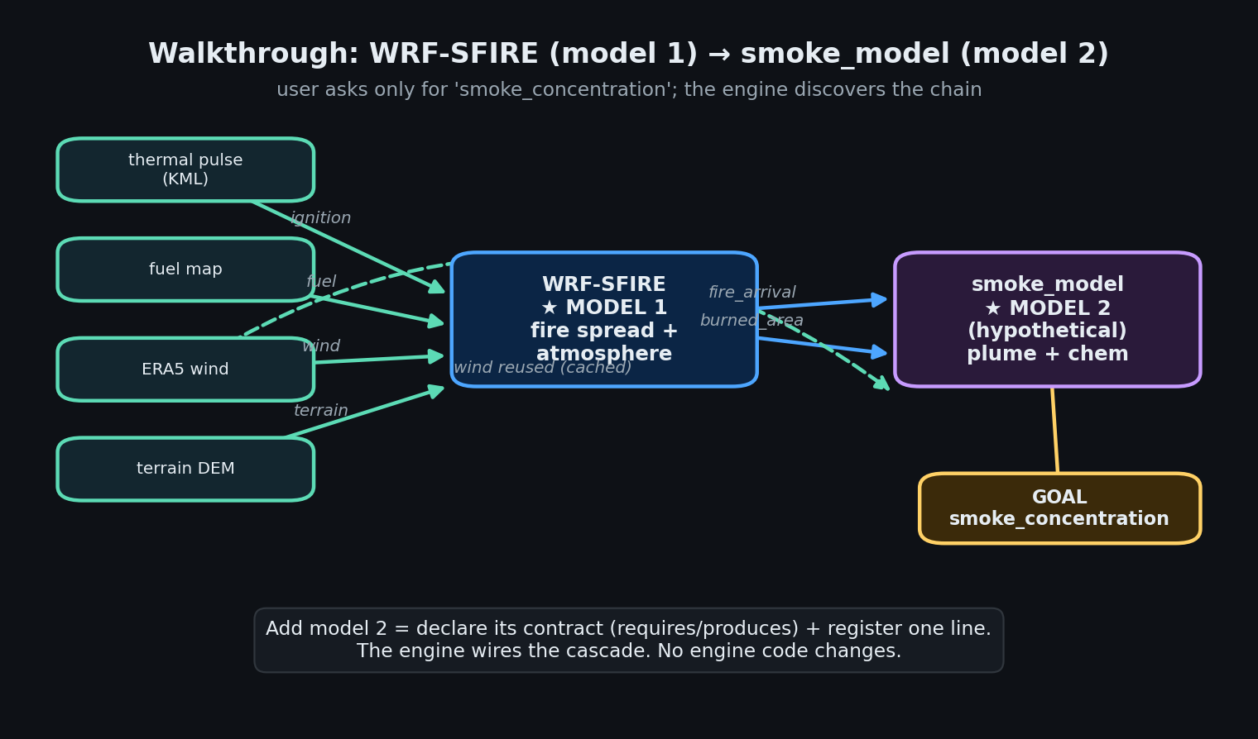
Walkthrough: model 1 feeds model 2
The user asks for smoke_concentration and nothing else. The engine:
- sees the smoke model needs fire_arrival;
- finds WRF-SFIRE produces it, so schedules WRF-SFIRE first;
- sees WRF-SFIRE needs ignition, fuel, terrain, wind, and schedules those data drivers;
- runs everything in dependency order;
- reuses the wind field — WRF-SFIRE already pulled it into the catalog, so the smoke model gets the cached copy instead of fetching it again.
The entire integration effort for the new model is:
1. declare its contract: requires = {fire_arrival, burned_area, wind}
produces = {smoke_concentration}
2. register it: catalog.add_model("smoke", ...) ← one line
No engine change. No catalog change. No change to WRF-SFIRE. This is the property that lets the cascade grow — flooding, air quality, exposure — each new model simply declaring which upstream variables it consumes.

6. The central challenge
The abstraction is easy to state. The hard, interesting research problem is making one specific decision trustworthy:
Before running an expensive model, decide whether what it needs is already in the system — reuse it — or must be recomputed.
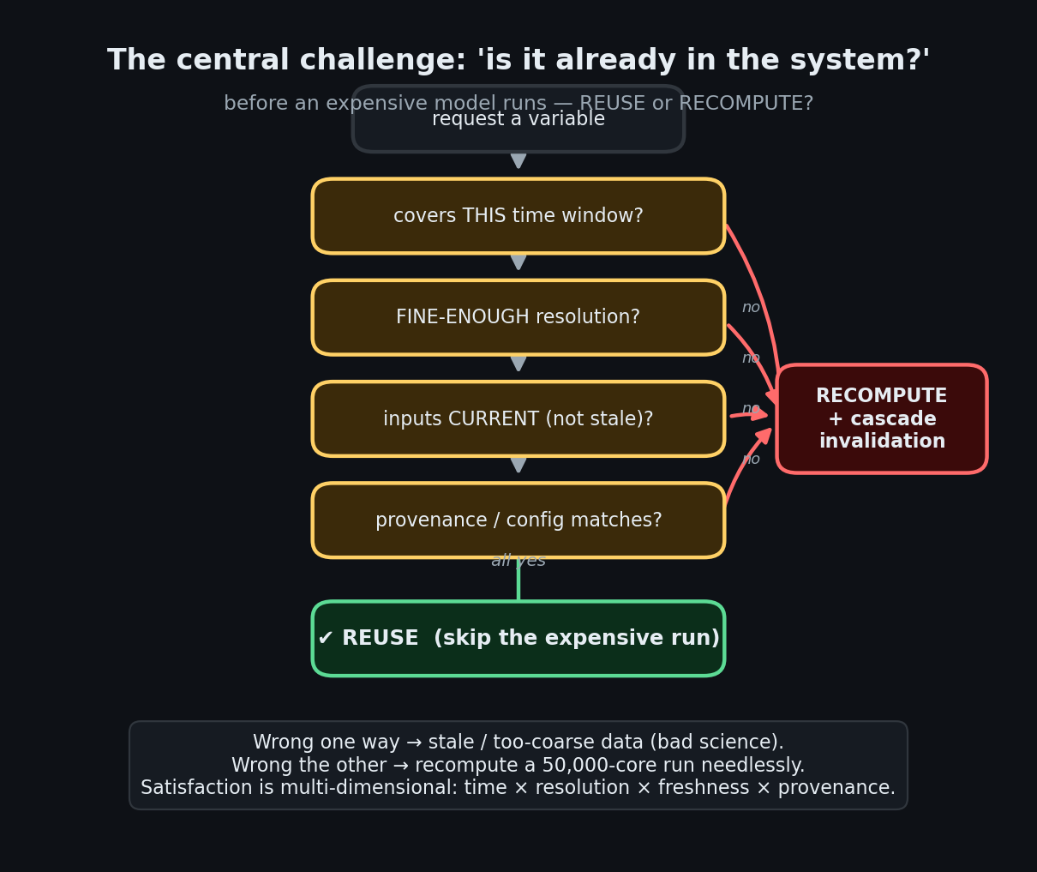
Reuse or recompute — the satisfaction decision
This is not the trivial “does the variable exist in the catalog?” A stored variable might be present but unusable for the current request. True satisfaction is multi-dimensional:
- Time coverage — does the stored field span the requested window?
- Resolution — is it fine enough? A 28 km wind field does not satisfy a consumer that declared it needs ≤ 1 km.
- Freshness — were its inputs since changed? If the ignition field was updated, yesterday’s fire result is stale.
- Provenance — was it produced under a configuration compatible with this request?
The cost of getting this wrong is asymmetric and large in both directions:
- Too lax → the system silently reuses stale or too-coarse data, and the science is quietly wrong.
- Too strict → the system needlessly recomputes a simulation that may cost tens of thousands of core-hours.
And the decision has a second half: when an upstream input does change, the system must invalidate exactly the affected downstream products — no more (or it wastes work), no less (or it serves stale results).
Our design stance keeps this as an abstraction rather than scattering it through the models:
- Producers declare requirements, not procedures — e.g. “I need this input at ≤ 100 m”, not “go fetch it like so”.
- The catalog records each variable’s native resolution and lineage.
- A single resolver makes the reuse-vs-recompute decision from that metadata.
Because the policy lives in one place, it can be made smarter over time (richer satisfaction tests, partial reuse across nested grids) without editing a single model. This is the part we are actively deepening.

7. Supporting concerns
These matter for a real deployment but are deliberately not the intellectual core of the design.
Reproducibility & lineage. Every catalog write records what produced it, from which inputs, under which configuration. Two identical runs are identical by construction, and any result can be traced to its sources. This is what makes the satisfaction decision in §6 possible at all.
Infrastructure independence — and its real challenge. Models never name a machine; the system detects the environment and supplies the right launch command, so the same run executes on a workstation or a supercomputer. The easy part is emitting the correct command. The hard part — and we call it out as a challenge, not a solved feature — is making expensive, long-running jobs first-class citizens of the DAG: submitting them to a batch queue, surviving the wait, resuming after a failure, and reconciling that asynchrony with the reuse/recompute logic of §6. Today this layer handles the mechanics; the orchestration of very large asynchronous jobs is future work.

8. Implementation map
For readers who want to go from concept to code. (Names are guides, not the point — the abstractions above are.)
Concept | Where
Producer contract | engine/contracts.py
Model plug-in shape (stage/run/parse) | engine/model_adapter.py
Build the dependency DAG from targets | engine/pipeline.py
Resolve a need — reuse vs run its producer | engine/data_adapter.py
Execute the DAG | engine/scheduler.py
Data catalog (store + index + lineage) | cube/
Plug-a-model registry | models/catalog.py
Model 1 — WRF-SFIRE | models/wrf_sfire_adapter.py
Scenario → configuration / namelists | models/wrf_config.py
Data drivers (ignition, fuel, terrain, wind) | drivers/
Simple user configuration | configs/wildfire_scenario.yaml
Infrastructure (a supporting concern) | hpc/

9. Glossary
- Producer — anything that creates a variable; declares produces / requires / run. Data drivers and models are both producers.
- Data driver — a producer that fetches external data.
- Model — a producer that computes a variable from other variables.
- Variable — a named piece of data in the catalog (e.g. wind, fire_arrival).
- Data catalog — the shared store all producers read and write; the single source of truth.
- Target — the variable the user asks for; it drives the whole DAG.
- Resolver — the component that decides, per variable, reuse vs recompute, and runs producers as needed.
- Satisfaction — whether a stored variable is actually usable for a request: time × resolution × freshness × provenance.
- Lineage / provenance — the record of what produced a variable, from which inputs, under which configuration.
- Cascade — the chain of models where each one’s output feeds the next.

