**Servlet**

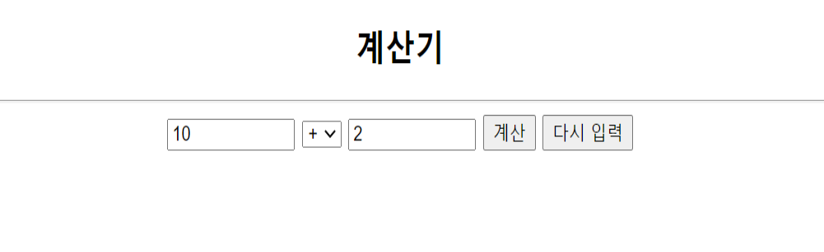



[CalcServlet.java]

|  |
| --- |
| **import** java.io.IOException;  **import** java.io.PrintWriter;    **import** javax.servlet.ServletException;  **import** javax.servlet.annotation.WebServlet;  **import** javax.servlet.http.HttpServlet;  **import** javax.servlet.http.HttpServletRequest;  **import** javax.servlet.http.HttpServletResponse;    @WebServlet("/calc")  **public** **class** CalcServlet **extends** HttpServlet {  **private** **static** **final** **long** ***serialVersionUID*** = 1L;      **protected** **void** doGet(HttpServletRequest request, HttpServletResponse response)  **throws** ServletException, IOException {  }      **protected** **void** doPost(HttpServletRequest request, HttpServletResponse response)  **throws** ServletException, IOException {  // **TODO** Auto-generated method stub  // doGet(request, response);  **int** num1, num2;  **int** result;  String op;        result = calc(num1, num2, op);        }    **public** **int** calc(**int** num1, **int** num2, String op) {  **int** result = 0;  **return** result;  }    } |

[calc_JSP.JSP]

|  |
| --- |
| <%@ page language=*"java"* contentType=*"text/html; charset=utf-8"*  pageEncoding=*"utf-8"*%>  <!DOCTYPE html PUBLIC "-//W3C//DTD HTML 4.01 Transitional//EN" "http://www.w3.org/TR/html4/loose.dtd">  <html>  <head>  <meta http-equiv=*"Content-Type"* content=*"text/html; charset=utf-8"*>  <title>Insert title here</title>  </head>  <body>  <h2 align=*"center"*>계산기</h2>  <HR>  <!-- 서블릿 버전 계산기 실행을 위해 계산 버튼 클릭시 서블릿 호출 -->  </body>  </html> |