**Web Application의 Servlet에서 JDBC를 활용하여 emp 테이블에 데이터 자장하기**

[결과]

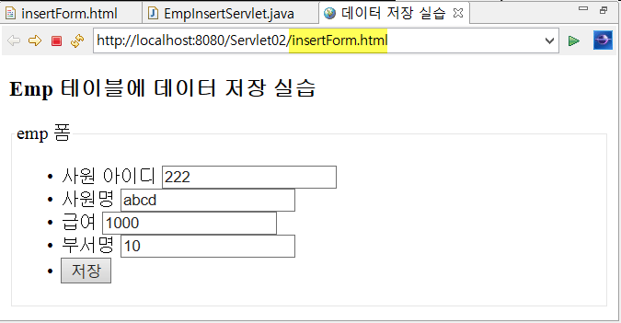

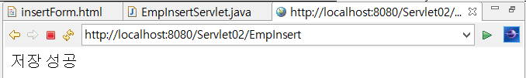

[저장확인하기]

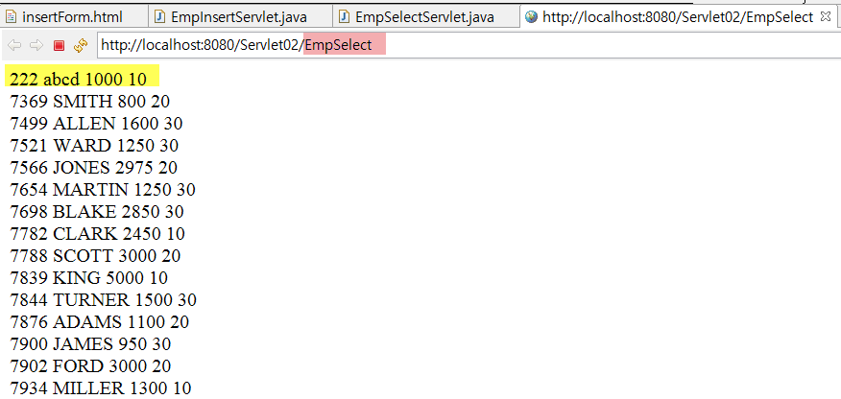

[insertForm.html]

|  |
| --- |
| <!DOCTYPE html>  <html>  <head>  <meta charset=*"utf-8"*>  <title>데이터 저장 실습</title>  </head>  <body>  <h3>Emp 테이블에 데이터 저장 실습</h3>  </body>  </html> |

[EmpInsertServlet.java]

|  |
| --- |
| **package** com.emp;  **import** java.io.IOException;  **import** java.io.PrintWriter;  **import** java.sql.Connection;  **import** java.sql.DriverManager;  **import** java.sql.SQLException;  **import** java.sql.Statement;  **import** javax.servlet.ServletException;  **import** javax.servlet.annotation.WebServlet;  **import** javax.servlet.http.HttpServlet;  **import** javax.servlet.http.HttpServletRequest;  **import** javax.servlet.http.HttpServletResponse;  @WebServlet("/EmpInsert")  **public** **class** EmpInsertServlet **extends** HttpServlet {  **private** **static** **final** **long** ***serialVersionUID*** = 1L;  **protected** **void** doGet(HttpServletRequest request, HttpServletResponse response) **throws** ServletException, IOException {    }  **protected** **void** doPost(HttpServletRequest request, HttpServletResponse response) **throws** ServletException, IOException {      }//end doPost  }//end class |

[EmpSelectServlet.java]

|  |
| --- |
| **package** com.emp;  **import** java.io.IOException;  **import** java.io.PrintWriter;  **import** java.sql.Connection;  **import** java.sql.DriverManager;  **import** java.sql.ResultSet;  **import** java.sql.SQLException;  **import** java.sql.Statement;  **import** javax.servlet.ServletException;  **import** javax.servlet.annotation.WebServlet;  **import** javax.servlet.http.HttpServlet;  **import** javax.servlet.http.HttpServletRequest;  **import** javax.servlet.http.HttpServletResponse;  @WebServlet("/EmpSelect")  **public** **class** EmpSelectServlet **extends** HttpServlet {  **private** **static** **final** **long** ***serialVersionUID*** = 1L;  **protected** **void** doGet(HttpServletRequest request, HttpServletResponse response) **throws** ServletException, IOException {    doPost(request, response);  }  **protected** **void** doPost(HttpServletRequest request, HttpServletResponse response) **throws** ServletException, IOException {      }//end doPost  }//end class |