CARAMBA NORTH
EXECUTIVE BRIEF
Confidential — prepared for a limited number of prospective counterparties under NDA
Caramba North is a 1,300-acre parcel sitting inside an already-forming power and data-center corridor. Two hyperscale-scale projects — 7.65 GW and 2 GW — sit on the same north-south line through the property, at 15.5 and 19.3 miles, backed by a transmission, water, and gas position that is already permitted, not proposed. The region’s own numbers do the selling: 32.7 GW of operating and queued power capacity within 60 miles, in a state where the interconnection backlog has grown large enough — 474 GW, about 90% data centers — to trigger a gubernatorial audit and a queue-processing pause. Caramba North is positioned to benefit from the same buildout without carrying the exposure of the marginal, unproven project in that queue: water and gas are already under contract-ready terms, not just an application.
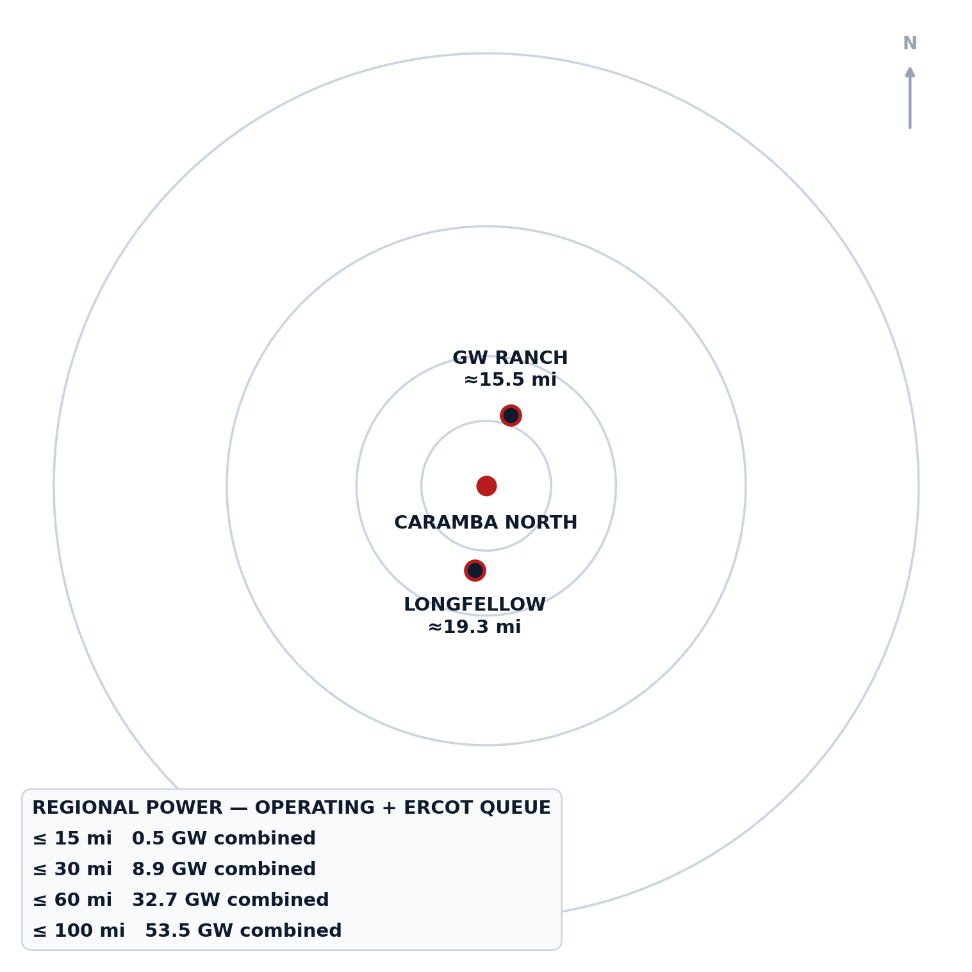
Operating + ERCOT-queued power capacity by radius from Caramba North, with GW Ranch and Longfellow plotted at true bearing and distance.
32.7 GW operating + queued within 60 miles of Caramba North

The Property
As-of-right industrial land inside the fastest-growing load pocket in ERCOT — not a rezoning story.
The tract totals 1,300 acres of maximum contiguous acreage on the north side of Interstate 10 in Pecos County, roughly five miles from Fort Stockton’s services and regional airport. The site carries no zoning ordinance, so industrial and energy use is available as of right — there is no rezoning process standing between acquisition and construction. It sits in ERCOT’s Far West weather zone, the system’s highest-growth large-load pocket.
1,300 contiguous acres, as-of-right industrial/energy use

The Transmission Position
Fifteen miles from the delivery point of all three approved 765 kV Permian import lines — the transmission decision is already made, upstream of this site.
The property sits 15 miles from AEP/CPS Energy’s Solstice Substation, the western terminus of all three PUCT-approved 765 kV Permian import paths (approved April 24, 2025, PUCT Docket No. 55718). Six local substations sit within 10 miles of the tract. ERCOT is separately tracking 141 substation and 133 line upgrades system-wide under its Transmission Planning Improvement Tool — a pipeline of planned upgrades, not yet built, offered here as corridor context rather than committed capacity.
15 mi to Solstice Substation — terminus of all three approved 765 kV Permian lines

The Regional Power Cluster
12 GW already queued in this county alone — before counting the two hyperscale campuses profiled on the next page.
Pecos County has 3,226 MW of generation operating today — 2,178 MW solar, 542 MW wind, 505 MW battery storage, and 1 MW gas — plus 12,039 MW queued across 39 ERCOT interconnection projects. The six adjacent counties (Reeves, Crane, Ward, Upton, Ector, Crockett) add 7,022 MW operating and 24,585 MW queued. Within 20 miles of the tract specifically, 13 queued projects total 3,973 MW, and the nearest operating storage asset, St. Gall Energy Storage I, sits 1.9 miles away.
12,039 MW queued in Pecos County alone (39 ERCOT projects)

Water & Gas
Two-thirds of the district’s industrial water rights are already permitted to this position — the water conversation is closed, not open.
47,418 acre-feet per year (42.3 MGD) is permitted on adjacent affiliated lands, drawn from the Edwards-Trinity (Plateau) aquifer, whose recharge held through the 1950s drought of record — roughly two-thirds of all Middle Pecos Groundwater Conservation District industrial water rights. On gas, the site sits 20 miles from the Waha hub, where an indicative supply quote is already in hand: 200,000 MMBtu/day on a 15-year term at Waha-index pricing, with a $15–25 million CIAC and a 9–15 month lead time. Waha has priced at a structural discount to Henry Hub, including negative prints in 2024–2025 as new pipelines rebalance Permian egress.
47,418 AF/yr permitted water · 200,000 MMBtu/day gas quote in hand

The Regional Data-Center Pipeline
GW Ranch sits almost due north and Longfellow almost due south of Caramba North — the property sits on the line between them, not off to one side.
Two hyperscale-scale anchors bracket the property on the same north-south corridor. Across both, 79.3% of combined announced capacity (GW Ranch) is under construction and 20.7% (Longfellow) is in planned/phase-1 status — the regional pipeline is majority-built, not majority-speculative.
GW Ranch (Amazon)
The largest air permit issued in the US this year sits fifteen miles up the same highway corridor — under construction, not announced.
GW Ranch is an 8,000-acre site in Pecos County, approximately 15.5 miles from Caramba North (edge-to-edge), disclosed as Amazon-owned in August 2026 (previously developed by Pacifico Energy Group, which remains the power-plant developer/operator). It holds a 7.65 GW TCEQ air permit for 35 gas turbines — issued January/February 2026 and the largest in the US — plus 1.8 GW of battery storage and up to 750 MW of solar, with three data-center buildings targeted for completion in December 2026 and an estimated $12 billion in total project investment. The 7.65 GW figure is a TCEQ generation air permit, not an ERCOT interconnection queue position; the project is off-grid initially.
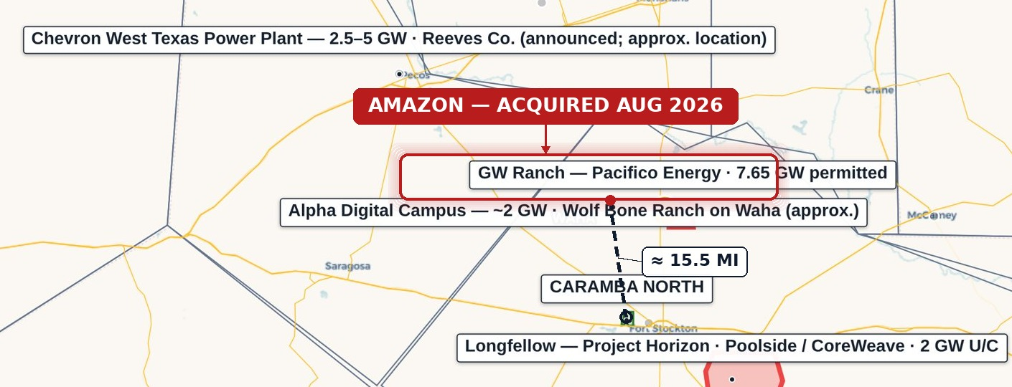
7.65 GW air permit — largest in the US · ≈15.5 mi from Caramba North
Longfellow
A second phased gas-generation campus twenty miles south — the corridor’s demand for on-site power isn’t one project deep.
Longfellow is a 568-acre site in Pecos County, approximately 19.3 miles from Caramba North (edge-to-edge); the site’s own public materials describe the location as more than 25 miles outside Fort Stockton. On-site natural-gas generation is planned using aero-derivative turbines with SCR and carbon-capture capability, cooled on a closed loop using permitted non-potable groundwater. Originally announced in October 2025 as a 2 GW, eight-phase campus, phase-1 site work is underway, with the on-site generation build planned in phases. No confirmed ERCOT queue position or TCEQ air-permit record has been found for this site as of August 2026.
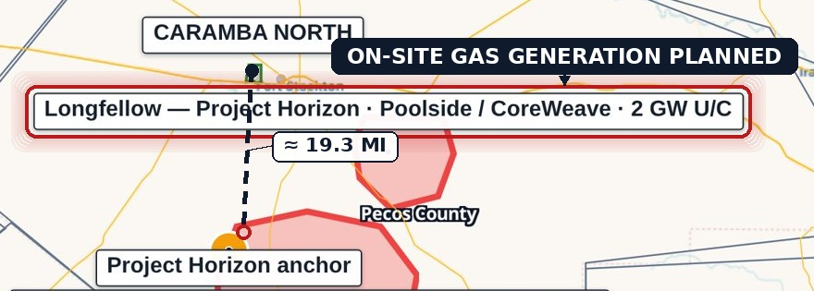
2 GW planned, 8 phases · ≈19.3 mi from Caramba North

Subsurface & Drilling Activity
Pecos County has the lowest new-drilling count of seven comparable Permian counties since 2020 — a 90%-below-peer-average level of activity, not merely quiet.
Pecos County has recorded 115 new-drill wellbore events since 2020, out of 1,140 total RRC events — 90% of recorded activity is workovers or reworks, not new drilling. Zero new-drill wells sit within 2 miles of the tract since 2020, zero within 5 miles, and only one within 10 miles (9.37 miles away); beyond 10 miles, the median distance to the remaining 114 wells is 19.9 miles. Against six comparable Permian counties — Reagan (668), Howard (990), Reeves (1,053), Loving (1,121), Midland (1,569), and Martin (1,685) — Pecos’s 115 new-drill count is the lowest of all seven, roughly 90% below the 1,181 peer average. Within 10 miles, 83% of non-plugged wellbores are marginal or end-of-life production, an even higher share than the 60–62% seen closer in.
115 new-drill wells since 2020 — lowest of 7 peer counties (vs. 1,181 average)

NOTICES
This is a confidential offering memorandum prepared for a limited number of prospective counterparties under NDA. It is not an offer to sell or a solicitation of securities. Information is preliminary and indicative, from sources believed reliable. Public data is drawn from the sources cited in the underlying diligence platform (ERCOT GIS Report/TPIT, PUCT, EIA-860, TCEQ, RRC, FracFocus, Middle Pecos GCD, HIFLD, USGS, BTS, Census TIGER); third-party transaction news is sourced to public reporting cited in the companion source register.
DISTANCE METHODOLOGY
Distances to GW Ranch and Longfellow are measured edge-to-edge — from the nearest point on the Caramba North tract boundary to each site’s disclosed location — rather than centroid-to-centroid, which is consistently longer because the Caramba North tract itself has spatial extent (GW Ranch: 15.5 mi vs. 17.3 mi centroid; Longfellow: 19.3 mi vs. 19.7 mi centroid). Longfellow’s own public site describes its location as more than 25 miles outside Fort Stockton, consistent with the longer figure; this distance should not be represented as shorter.

