CARAMBA NORTH  TECHNICAL SNAPSHOT | CONFIDENTIAL OFFERING MEMORANDUM  Pecos County, Texas | August 2026  Data-room reference — figures per §2.7 diligence platform

32.7 GW  OPERATING + QUEUED, 60 MI | 15.5 MI  TO GW RANCH (7.65 GW) | 19.3 MI  TO LONGFELLOW (2 GW) | 47,418 AF/YR  WATER PERMITTED, ADJACENT

1,300 contiguous acres on I-10 in Pecos County, positioned inside an already-forming power and data-center corridor: two hyperscale-scale projects (7.65 GW and 2 GW) sit on the same north–south line through the property at 15.5 and 19.3 miles, backed by transmission, water, and gas positions that are permitted or contract-ready, not proposed. The tables below carry the data-room figures; narrative framing is in the companion Executive Brief.
FIG 2.6 Power-Gravity Diagram  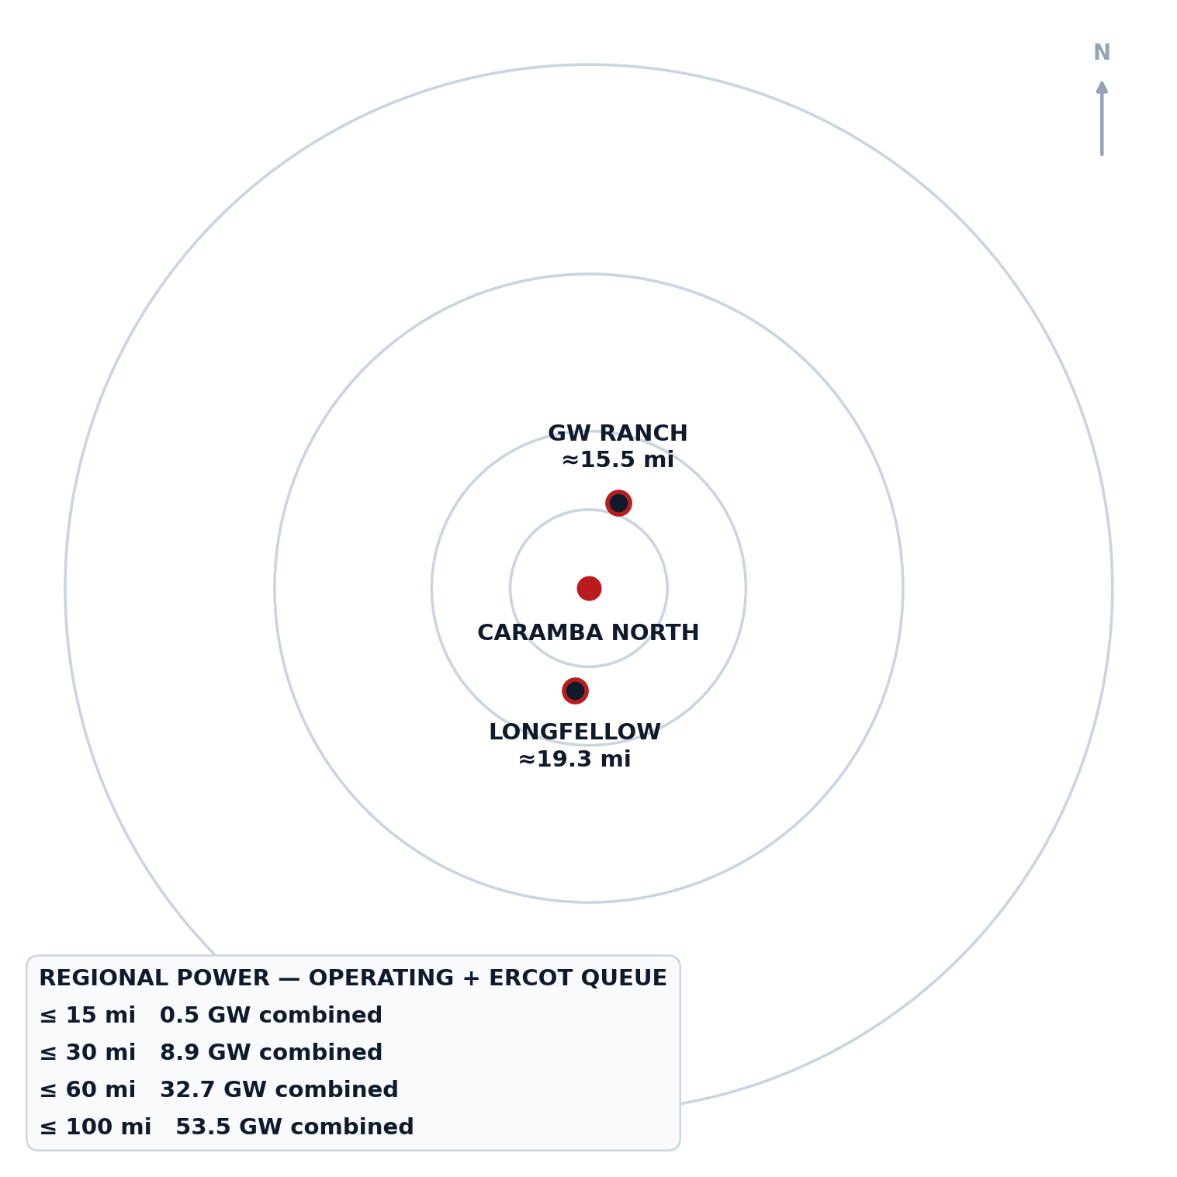  Concentric operating + ERCOT-queue capacity, Caramba North at center. GW Ranch ≈N (19°); Longfellow ≈S (188°). |  | SEC 2.1 The Property  As-of-right industrial land inside the fastest-growing load pocket in ERCOT — not a rezoning story.  PROPERTY FACT VALUE  Max contiguous acreage 1,300 ac  Location N side of I-10, Pecos Co.  Distance to Fort Stockton ≈ 5 mi  Zoning None — as-of-right  ERCOT weather zone Far West (highest-growth)

SEC 2.2 Transmission

Fifteen miles from the delivery point of all three approved 765 kV Permian import lines — the transmission decision is already made, upstream of this site.

TRANSMISSION FACT | VALUE
Distance to Solstice Substation (AEP/CPS Energy) | 15 mi
Role of Solstice | Western terminus, 3 PUCT-approved 765 kV Permian import paths
Approval | PUCT Docket No. 55718, approved Apr 24, 2025
Local substations within 10 mi | 6 (138/69 kV and 69 kV)
ERCOT-wide TPIT pipeline (planned, not built) | 141 substation + 133 line upgrades

SEC 2.3 Regional Power Cluster — Pecos County

12 GW already queued in this county alone — before counting the two hyperscale campuses profiled in §2.6.

CAPACITY | OPERATING | ERCOT QUEUE
Pecos County — Solar | 2,178 MW / 13 proj. | —
Pecos County — Wind | 542 MW / 5 proj. | —
Pecos County — BESS | 505 MW / 6 proj. | —
Pecos County — Gas | 1 MW / 1 proj. | —
Pecos County — TOTAL | 3,226 MW | 12,039 MW / 39 proj.
Adjacent 6 counties (Reeves, Crane, Ward, Upton, Ector, Crockett) | 7,022 MW | 24,585 MW
Within 20 mi of Caramba North specifically | — | 3,973 MW / 13 proj.
Nearest operating storage | St. Gall Energy Storage I — 1.9 mi, 103 MW BESS | —

SEC 2.6 Ring Analysis — Region-Wide Operating + Queued Capacity

32.7 GW sits within 60 miles of Caramba North — the property is inside the radius, not adjacent to it.

RADIUS | OPERATING + QUEUE
≤ 15 mi | 0.5 GW
≤ 30 mi | 8.9 GW
≤ 60 mi | 32.7 GW
≤ 100 mi | 53.5 GW
Region-wide EIA-860 operating + ERCOT-queue capacity within each radius of the Caramba North tract boundary — not county-bounded. See Fig. 2.6.

SEC 2.6 Project-Maturity Framing

STATUS | SHARE OF COMBINED ANCHOR MW
Under construction (GW Ranch) | 79.3%
Planned / phase-1 (Longfellow) | 20.7%
The regional pipeline anchored by the two profiled campuses (feature profiles below) is majority-built, not majority-speculative.

SEC 2.4 Water  Two-thirds of the district's industrial water rights are already permitted to this position — the water conversation is closed, not open.  WATER FACT VALUE  Permitted volume 47,418 AF/yr  Permitted volume 42.3 MGD  Share of Middle Pecos GCD industrial rights ≈ 2/3  Source aquifer Edwards-Trinity (Plateau)  Recharge record Held through 1950s drought of record |  | SEC 2.5 Natural Gas  A signable 15-year gas quote at Waha basis — the same structural discount now drawing behind-the-meter generation to this corridor.  GAS FACT VALUE  Distance to Waha hub 20 mi  Indicative supply quote 200,000 MMBtu/d  Term 15 yr, Waha-index  CIAC $15–25M  Lead time 9–15 mo

MACRO CONTEXT — ERCOT's large-load interconnection queue grew from 63 GW (end 2024) to ~474 GW of pending requests by Aug 2026 (~90% data-center-driven) — large enough that the Governor directed an audit of all ERCOT-queue data centers and paused the “Batch Zero” large-load review (public reporting, Aug 2026). The 32.7 GW within 60 mi of Caramba North sits inside that same queue.

SEC 2.6 Regional Data-Center / Power Pipeline — Feature Profiles

2.6.A GW Ranch (Amazon)

The largest air permit issued in the US this year sits fifteen miles up the same highway corridor — under construction, not announced.

GW RANCH FACT VALUE  Site size 8,000 ac, Pecos County  Distance to Caramba North (edge-to-edge) ≈ 15.5 mi  Ownership Amazon (disclosed Aug 2026)  Generation permit 7.65 GW TCEQ air permit (largest in US, issued Jan/Feb 2026)  Turbines 35 gas turbines  Storage / solar 1.8 GW battery; up to 750 MW solar  Data-center buildings 3 × 189,000 sf (Gensler); target Dec 2026  Estimated investment ≈ $12B total project  Status Under construction |  | 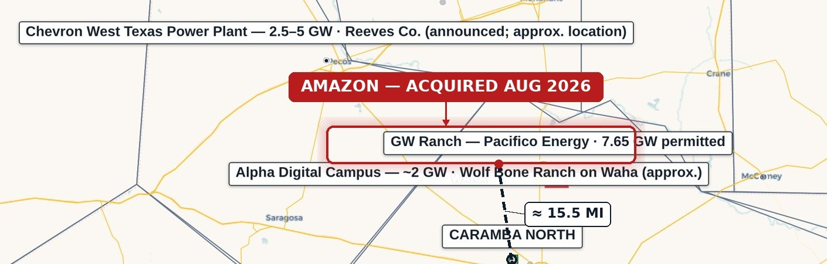  GW Ranch — ≈15.5 mi from Caramba North.  TCEQ air permit is a generation permit, not an ERCOT queue position; no disclosed ERCOT filing — site is off-grid initially.

2.6.B Longfellow

A second phased gas-generation campus twenty miles south — the corridor's demand for on-site power isn't one project deep.

LONGFELLOW FACT VALUE  Site size 568 ac, Pecos County  Distance to Caramba North (edge-to-edge) ≈ 19.3 mi  On-site generation plan Aero-derivative gas turbines, SCR + carbon-capture capable  Cooling Closed-loop, permitted non-potable groundwater  Original scope (Oct 2025 announcement) 2 GW, 8 phases (250 MW/phase)  Status Phase-1 site work underway; generation build planned in phases  ERCOT queue / TCEQ air permit on record None found as of Aug 2026 |  | 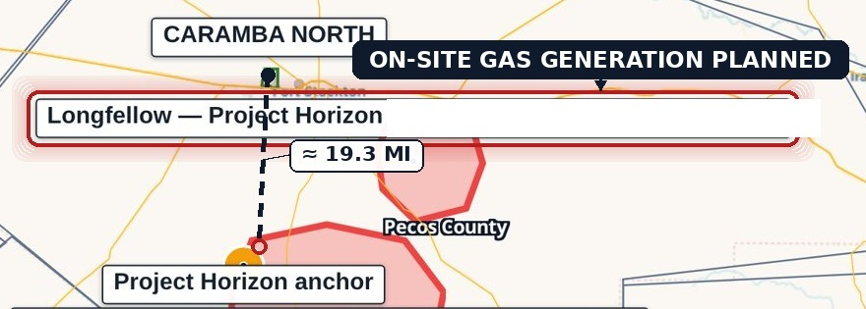  Longfellow — ≈19.3 mi from Caramba North.  Longfellow's own public materials describe the site as “more than 25 mi outside Fort Stockton” — consistent with the longer edge-to-edge figure.

SEC 2.8 Subsurface — New-Drill Activity, Pecos County

Pecos County has the lowest new-drilling count of seven comparable Permian counties since 2020 — a 90%-below-peer-average level of activity, not merely “quiet.”

SUBSURFACE FACT | VALUE
New-drill wellbore events since 2020, Pecos County | 115 of 1,140 total events (10%)
Share of Pecos events that are workovers/reworks | 90%
New-drill wells within 2 mi of tract, since 2020 | 0
New-drill wells within 5 mi of tract, since 2020 | 0
New-drill wells within 10 mi of tract, since 2020 | 1 (9.37 mi)
New-drill wells beyond 10 mi, since 2020 | 114 (median 19.9 mi, mean 20.9 mi)
Non-plugged wellbores that are marginal/EOL, ≤ 10 mi | 83% (vs. 60% ≤ 2 mi, 62% ≤ 5 mi)

SEC 2.8 Peer-County Comparison — New-Drill Count Since 2020

COUNTY | NEW-DRILL COUNT
Pecos (subject county) | 115
Reagan | 668
Howard | 990
Reeves | 1,053
Loving | 1,121
Midland | 1,569
Martin | 1,685
Peer average (6 counties, excl. Pecos) | 1,181

SEC 2.7 The Diligence Platform

Every figure in this document is independently re-derivable from a cited public source — this isn't a broker's summary.

PLATFORM FACT | VALUE
Source datasets | ERCOT GIS Report/TPIT, PUCT, EIA-860, TCEQ, RRC, FracFocus, Middle Pecos GCD, HIFLD, USGS, BTS, Census TIGER
Refresh cadence | RRC weekly; ERCOT queue/TPIT monthly; EIA/USGS/OSM annually
Build | Static, versioned; deployed bundle byte-verified on release; access logged
Access | lrp-tx-gis.netlify.app (credentials issued to deal team separately)

NOTICES
Confidential offering memorandum prepared for a limited number of prospective counterparties under NDA. Not an offer to sell or a solicitation of securities. Information is preliminary and indicative, from sources believed reliable. Public data is drawn from the sources listed under §2.7 above; third-party transaction news is sourced to public reporting cited in the companion source register.
Distance methodology: distances to GW Ranch and Longfellow are measured edge-to-edge, from the nearest point on the Caramba North tract boundary to each site's disclosed location, not centroid-to-centroid — consistently shorter given the tract's own spatial extent. GW Ranch: 15.5 mi (vs. 17.3 mi centroid). Longfellow: 19.3 mi (vs. 19.7 mi centroid); Longfellow's own public site states its location as more than 25 mi outside Fort Stockton, consistent with the longer figure — this distance should not be represented as shorter.

