STRICTLY CONFIDENTIAL · OFFERING MEMORANDUM · POST-NDA
CARAMBA NORTH
Up to 1,300 contiguous acres of powered land on the ERCOT 765 kV backbone
PECOS COUNTY, TEXAS · FAR WEST ERCOT · PERMIAN BASIN · I-10 CORRIDOR
1,300  CONTIGUOUS ACRES (UP TO) | 47,418  AF/YR PERMITTED WATER RIGHTS | 15 mi  TO 765 KV SOLSTICE SUBSTATION
20 mi  TO WAHA NATURAL GAS HUB | 12.0 GW  ERCOT QUEUE, PECOS CO. | 0  NEW-DRILL WELLS WITHIN 5 MI SINCE 2020
Prepared by Land Resource Partners · Interactive diligence platform: lrp-tx-gis.netlify.app
2026-08-20 · Data compendium for the buyer data room · Editable working draft

CONTENTS

Table of Contents
01 Executive Summary
02 The Property
03 Transmission — the 765 kV Grid Anchor & Planned Upgrades
04 Regional Power Cluster — Operating Fleet & ERCOT Queue, Named Projects
05 Water Rights at Institutional Scale
06 Waha-Basis Natural Gas
07 Regional Data Center Pipeline
08 The Diligence Platform
09 Subsurface & Drilling Activity — the Vibration Record
A.1 GIS Platform — Access & Navigation
A.2 Footnotes, References & Sources
A.3 Important Notices

01 · EXECUTIVE SUMMARY

A powered-land site at the intersection of transmission, water, gas, and proven hyperscale demand
Caramba North is an up-to-1,300-acre contiguous site on the north side of Interstate 10 in Pecos County, Texas — the Far West weather zone of ERCOT, the highest-growth large-load pocket in North America. The site combines a 765 kV transmission anchor 15 miles north, permitted groundwater at institutional scale on adjacent affiliated lands, Waha-basis natural gas 20 miles away, and a surrounding project pipeline of more than 25.5 GW of announced data-center and large-load capacity. Its subsurface record is unusually clean: no new-drill well lies within five miles, and no new-drill hydraulic-fracturing job has ever been filed within two miles.

Five pillars of the opportunity
# | PILLAR | SUBSTANCE
1 | Structural power cost | Waha-basis natural gas at a structural discount to Henry Hub, with recurring negative prints in 2024–2025 as Matterhorn, Blackcomb, Hugh Brinson, and GCX expansions rebalance basin egress.
2 | 765 kV transmission anchor | AEP Solstice Substation 15 miles north — the western terminus of the three PUCT-approved 765 kV Permian import paths under the Permian Basin Reliability Plan.
3 | Water rights at institutional scale | 47,418 AF/yr (~42.3 MGD) permitted on adjacent affiliated lands — nearly two-thirds of total Middle Pecos GCD rights — from the Edwards-Trinity (Plateau) aquifer, whose recharge record held through the 1950s drought of record.
4 | Demand already on the ground | 12,039 MW in the ERCOT queue in Pecos County across 39 projects; Pecos and adjacent counties host 9.7 GW of announced hyperscale and large-load capacity within 60 miles.
5 | As-of-right development | Unincorporated Pecos County has no zoning ordinance — no use districts, density limits, height restrictions, or setbacks. Industrial and energy uses are permitted as of right with no discretionary land-use review.

What this document is
This Memorandum is the post-NDA data compendium for the Caramba North data room. Each section opens with the conclusion the data supports, followed by the data itself — including named-project detail for the operating fleet and interconnection queue (Section 4) and the full drilling-activity study of the tract and its ten-mile radius (Section 9). Every figure derives from the public sources registered in Appendix A.2 or from counterparty-supplied indicative terms identified as such, and every mapped feature is independently verifiable on the companion GIS platform (Section 8, Appendix A.1). Map exhibits are captured directly from that platform.

02 · THE PROPERTY

Contiguous interstate-frontage acreage with rail, fiber, and municipal services within five miles
The Property comprises up to 1,300 contiguous acres on the north side of Interstate 10, approximately five miles west of Fort Stockton (tract centroid 30.9032° N, 102.9747° W). It carries direct interstate frontage, proximity to the Union Pacific Sunset Route rail line, and long-haul fiber along the I-10 corridor. Fort Stockton provides municipal services and a regional airport within approximately five miles. The Property is offered to accommodate a range of institutional counterparty structures — hyperscale data-center development, large-load industrial siting, or combined-cycle generation with co-located storage and renewables.

Site fundamentals
ATTRIBUTE | DETAIL
Size / configuration | Up to 1,300 contiguous acres, north side of I-10
Access | Direct interstate frontage; Union Pacific Sunset Route proximate; long-haul fiber along the I-10 corridor
Municipal services | Fort Stockton (~5 mi): municipal services, regional airport
Land-use regime | Unincorporated Pecos County — no zoning ordinance; industrial and energy uses as of right; no discretionary land-use review
Groundwater regulation | Middle Pecos Groundwater Conservation District (see Section 5)
ERCOT position | Far West weather zone — highest-growth large-load pocket in ERCOT
EXHIBIT 2.1 · PECOS COUNTY, TEXAS
The site: contiguous, interstate-front, five miles from Fort Stockton
Aerial view of the Caramba North tract (green boundary) on the north side of Interstate 10, with Fort Stockton and its municipal services to the east.
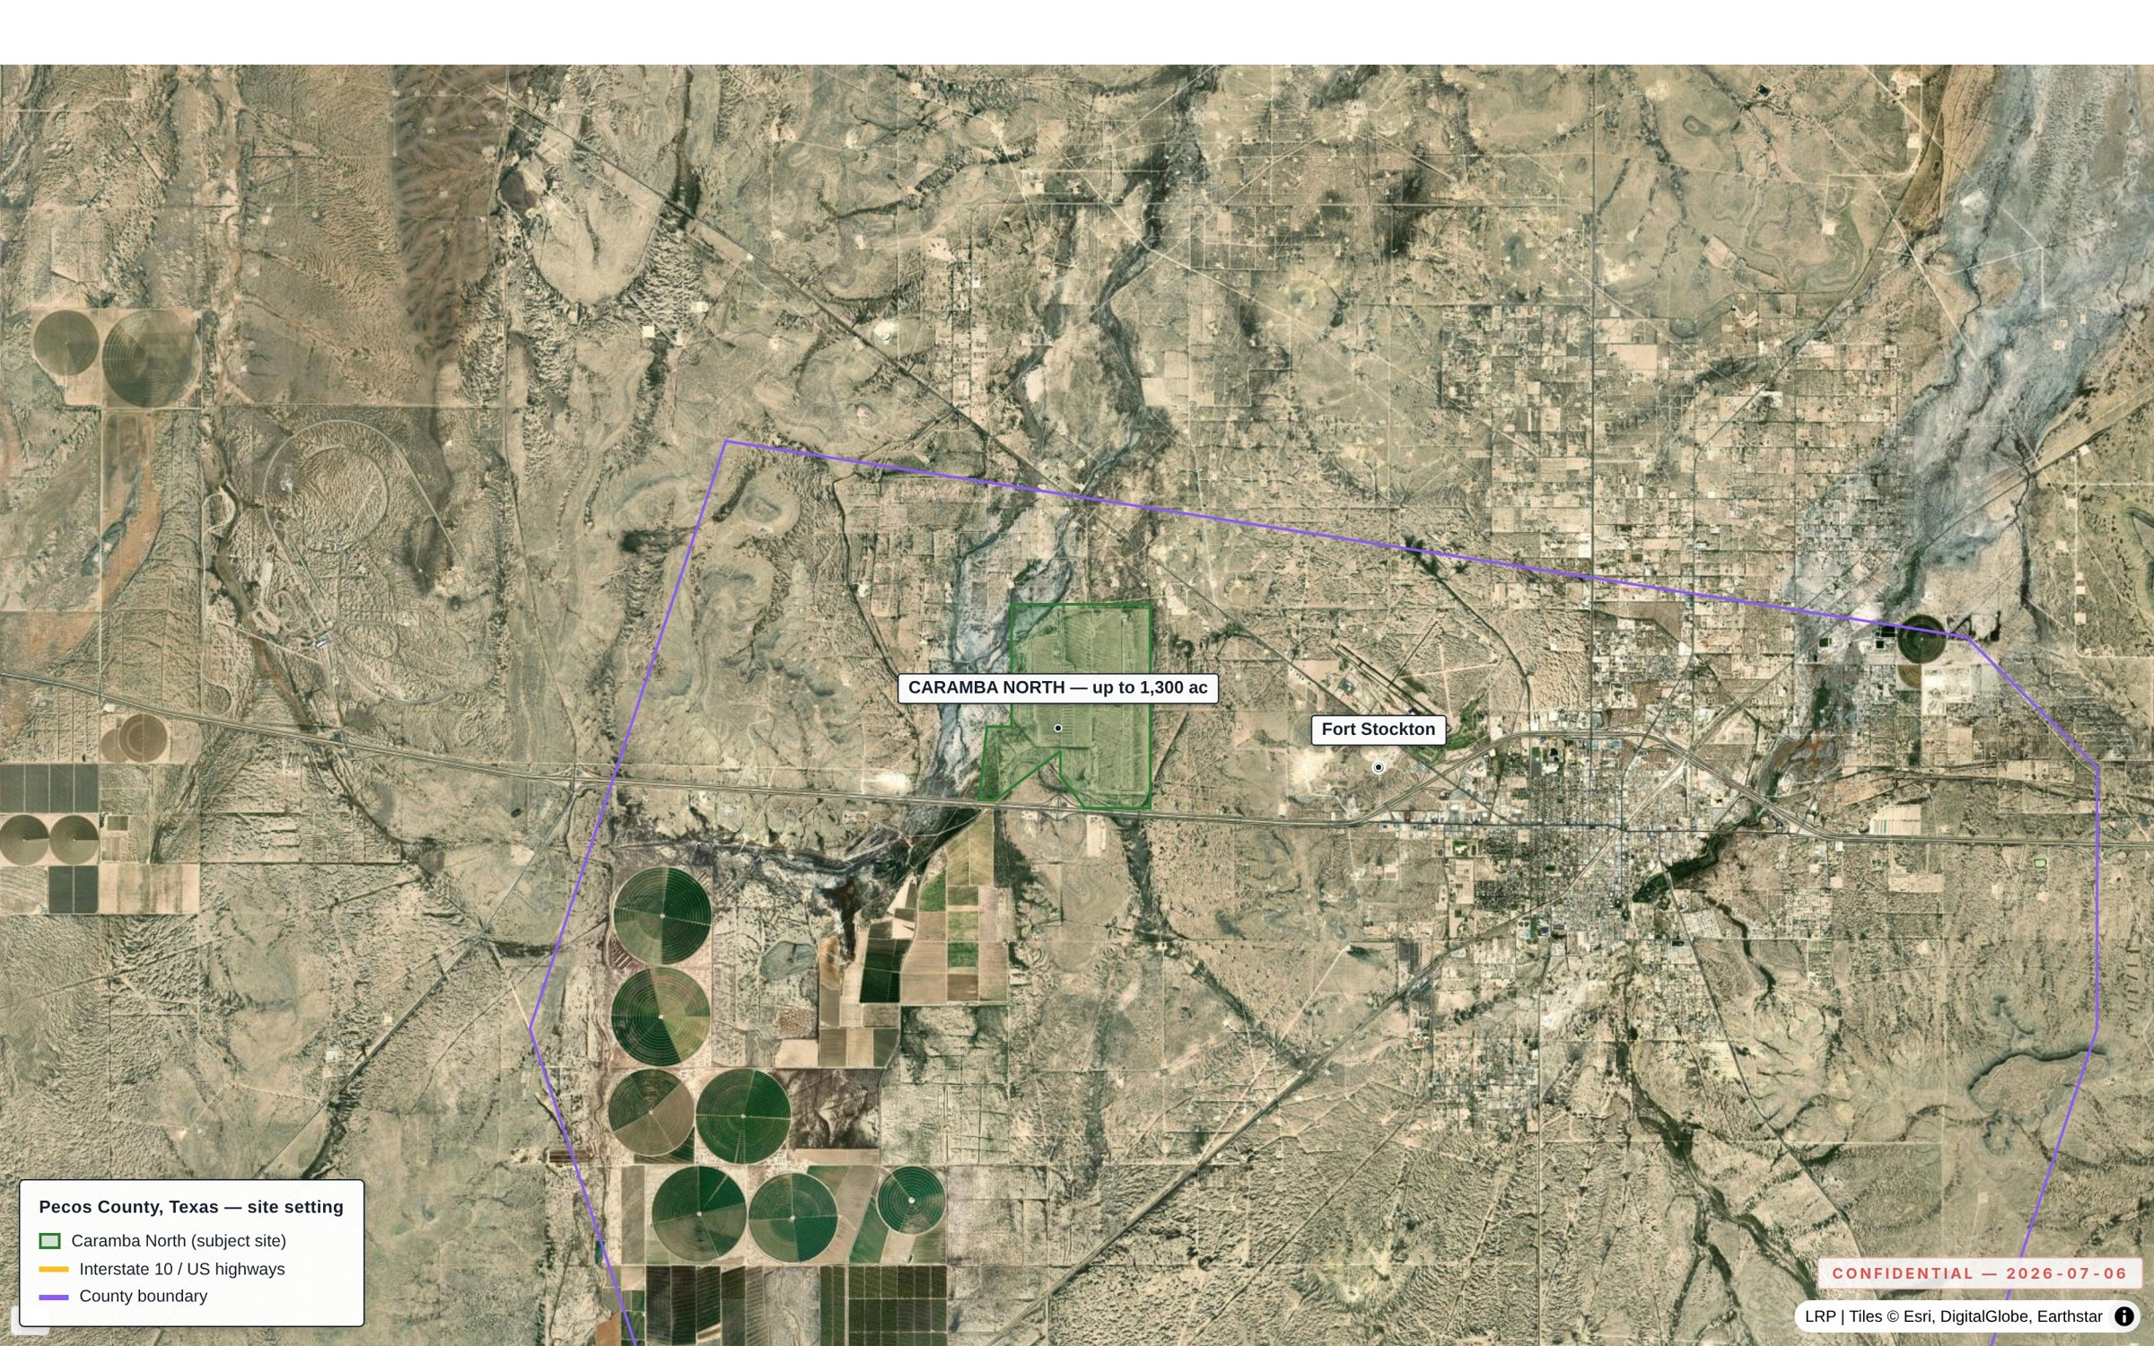
Takeaway — The tract is a single contiguous block with direct I-10 frontage and town services five miles away.

03 · TRANSMISSION

Fifteen miles from the western terminus of ERCOT's 765 kV import backbone — inside an active grid-upgrade corridor
AEP's Solstice Substation, 15 miles north of the Property, is the western terminus of the three PUCT-approved 765 kV Permian import paths — the largest transmission program in ERCOT history, approved April 24, 2025 under the Permian Basin Reliability Plan. Multiple 138 kV substations sit within seven miles of the site, and ERCOT's Transmission Project Information Tracking (TPIT) shows a dense program of planned line and substation upgrades across Pecos County and its neighbors. The Property is positioned to interconnect into a grid pocket that regulators have already committed to reinforcing at extra-high voltage.
ELEMENT | DETAIL
765 kV PUCT approval | Three import paths approved April 24, 2025 (Permian Basin Reliability Plan, Project No. 55718)
Solstice Substation | AEP / CPS Energy; western terminus of the three 765 kV paths; 15 mi north of the Property
Howard–Solstice line | ~300–370 miles to San Antonio; AEP / CPS Energy; CCN routing in progress (PUCT Docket 59366)
Local substations | Fort Stockton Plant (2 mi), Airport (3.3 mi), Fort Stockton (5.4 mi), 16th Street (6 mi)
Planned upgrades (TPIT) | 141 planned substation upgrades and 133 planned transmission projects tracked ERCOT-wide, refreshed monthly; the regional concentration is shown in Exhibit 3.1
Planning basis | ERCOT Permian Basin Reliability Plan Study (July 2024); PBRP approved September 2024
EXHIBIT 3.1 · CARAMBA NORTH CORRIDOR
Planned grid upgrades only (ERCOT TPIT) — the Solstice hub circled, the site beside it
Planned transmission upgrades and planned substation upgrades only — no existing infrastructure shown.
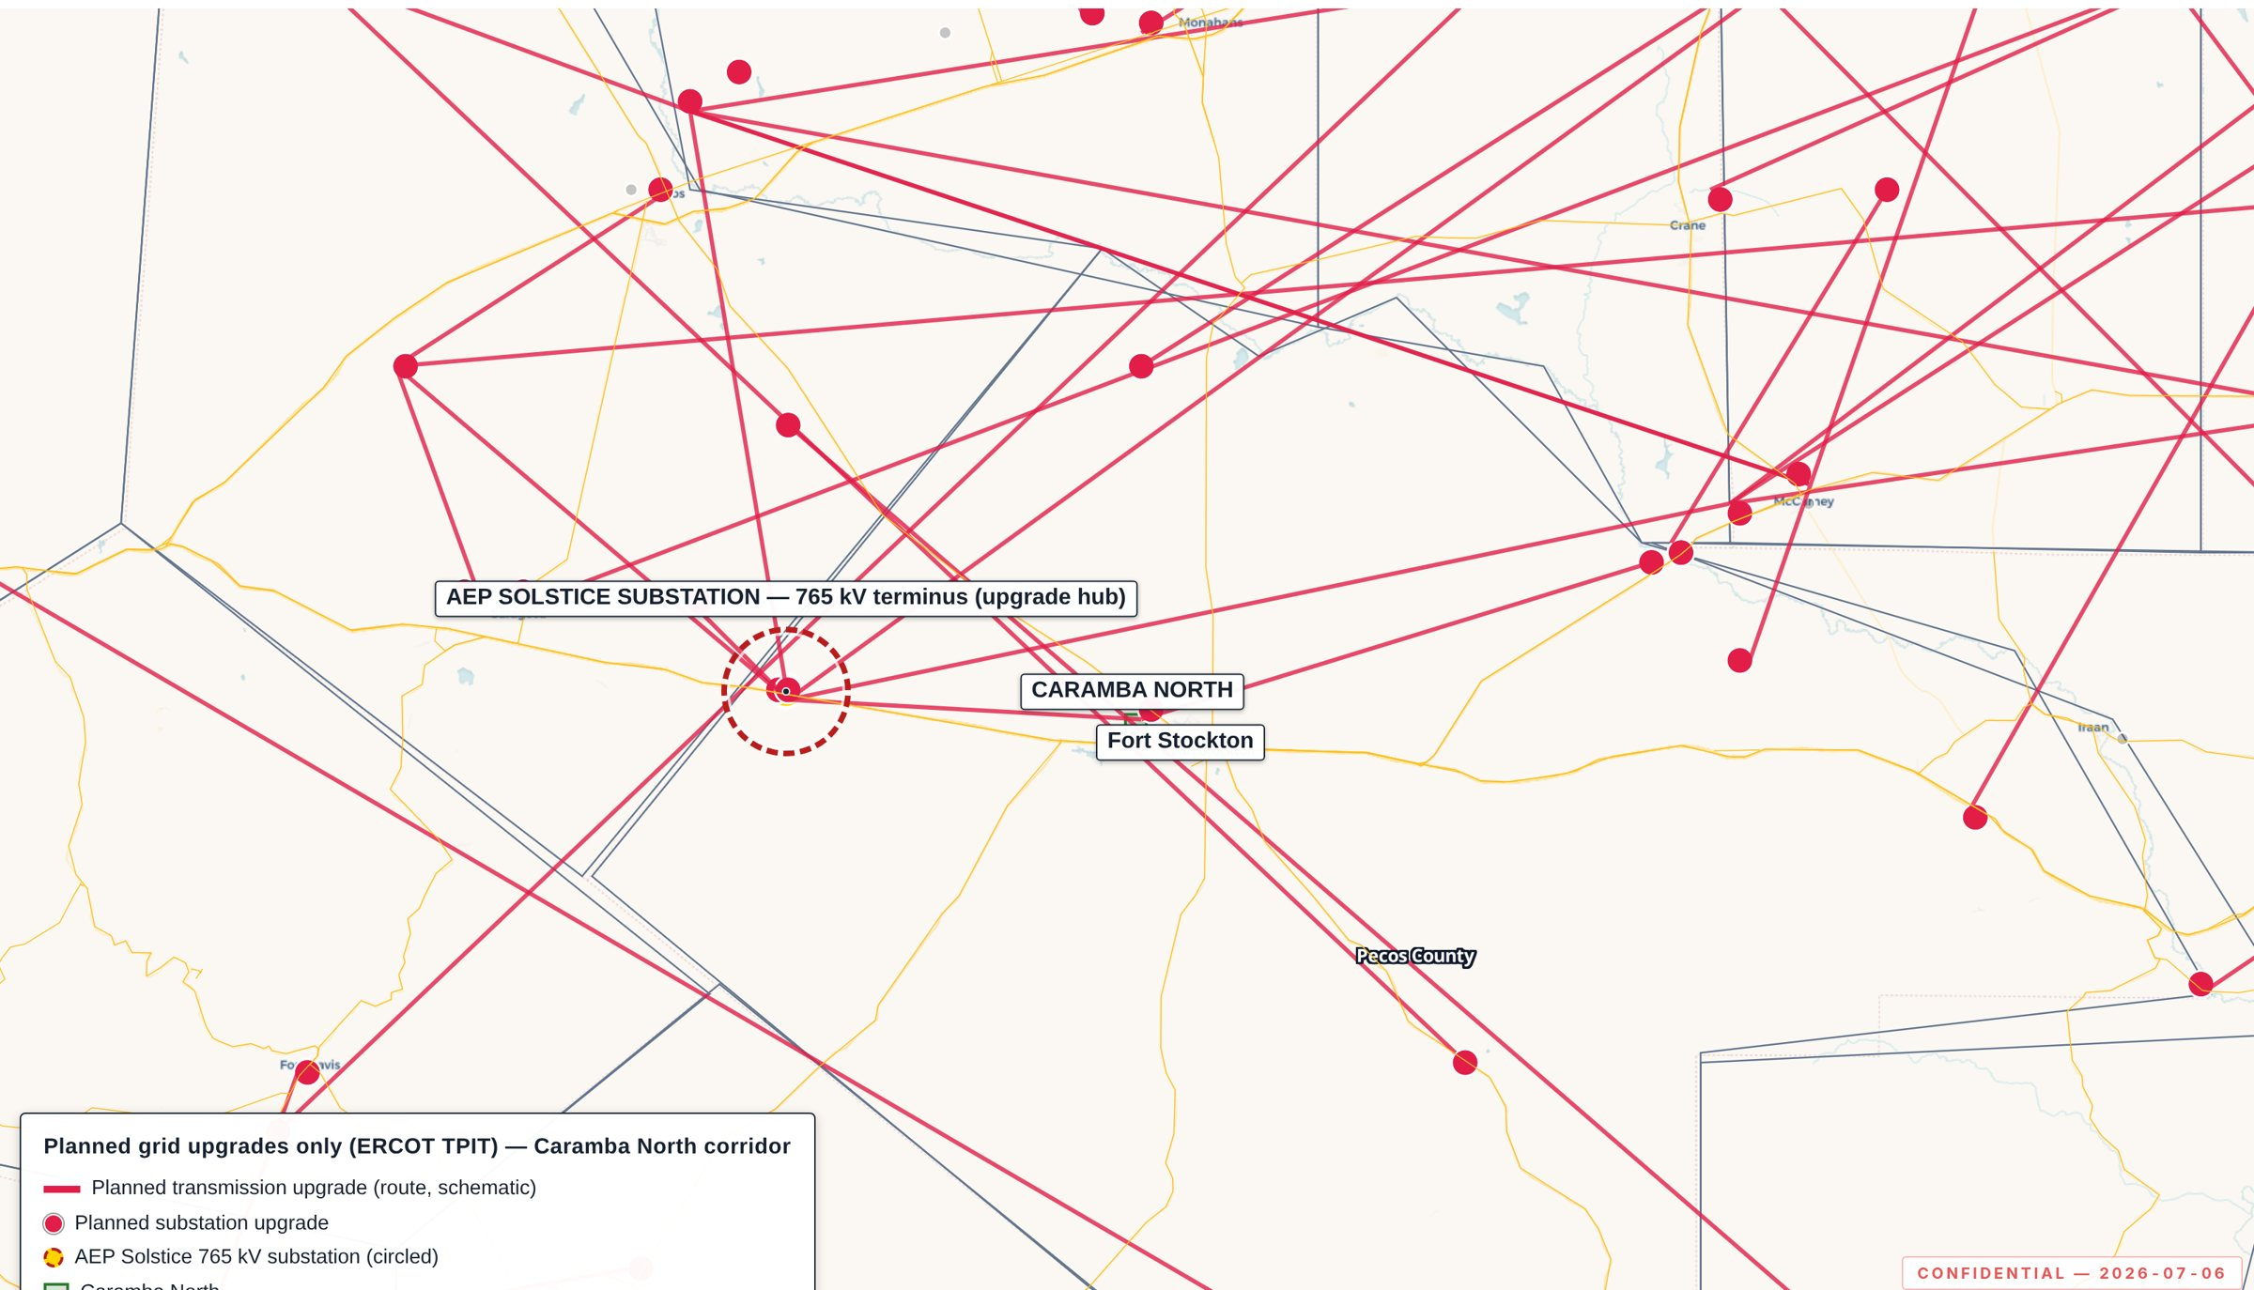
Takeaway — The planned-upgrade program radiates from the circled Solstice terminus on the site's doorstep.

04 · REGIONAL POWER CLUSTER

Embedded in the densest renewable generation cluster in ERCOT, with 12.0 GW queued in Pecos County
Pecos County is the number-one solar-producing county in Texas — 13 operating plants totalling 2.2 GW — and the ERCOT generator-interconnection queue in the county totals 12,039 MW across 39 projects. Operating storage is already on the ground at the site's doorstep. Named-project detail for the operating fleet and the queue follows in 4.2–4.5.

4.1 Operating fleet and queue, by county group
TECHNOLOGY | PECOS CO. — OPERATING | PECOS CO. — ERCOT QUEUE
Solar | 13 · 2.2 GW | 16 · 6.3 GW
Wind | 5 · 542 MW | 10 · 3.0 GW
BESS | 6 · 505 MW | 11 · 1.4 GW
Gas | 1 · 1 MW | 2 · 1.4 GW
Total | 3.2 GW | 12.0 GW
TECHNOLOGY | ADJACENT — OPERATING | ADJACENT — ERCOT QUEUE
Solar | 7 · 1.1 GW | 28 · 6.9 GW
Wind | 7 · 2.2 GW | 7 · 2.5 GW
BESS | 20 · 1.2 GW | 43 · 8.4 GW
Gas | 8 · 2.5 GW | 12 · 6.7 GW
Total | 7.0 GW | 24.6 GW
Adjacent counties: Reeves, Crane, Ward, Upton, Ector, Crockett. Operating fleet on an EIA-860 plant basis; queue on an ERCOT Generator Interconnection Status Report basis, one row per interconnection request, grouped by project name. Sources: ERCOT GIS Report; EIA-860; USGS/LBNL USWTDB.

Selected proximity markers
ASSET | DISTANCE | CAPACITY
St. Gall Energy Storage I (BESS) | 1.9 mi | 103 MW
Gomez (BESS) | 9.7 mi | 10 MW
Triple Butte I (BESS) | 11.3 mi | 8 MW

4.2 Operating fleet, Pecos County — 3.2 GW across 25 plants
Solar · 13 projects · 2.2 GW
PROJECT | MW
Greasewood II LLC | 306 MW
Taygete Energy Project LLC | 255 MW
Greasewood Solar | 255 MW
RE Maplewood | 250 MW
Taygete II Energy Project | 204 MW
Midway Solar - TX | 182 MW
RE Roserock | 160 MW
Buckthorn Westex | 154 MW
East Pecos Solar | 118 MW
Emerald Grove | 108 MW
Alamo 6 | 105 MW
Pearl Solar | 50 MW
+1 more
Wind · 5 projects · 542 MW
PROJECT | MW
Desert Sky | 168 MW
Sherbino II | 132 MW
NWP Indian Mesa Wind Farm | 82 MW
Woodward Mountain I | 82 MW
Woodward Mountain II | 78 MW
BESS · 6 projects · 505 MW
PROJECT | MW
Hydra | 200 MW
Pavo | 175 MW
St. Gall Energy Storage I | 103 MW
TX8 Worsham | 10 MW
Gomez | 10 MW
Triple Butte I | 8 MW
Gas · 1 project · 1 MW
No utility-scale gas capacity recorded
4.3 ERCOT queue, Pecos County — 12.0 GW queued, 3.7× the operating base
Solar · 16 projects · 6.3 GW
PROJECT | MW
Permian I Solar | 1,126 MW
Rio Vista Solar | 554 MW
Elk Ridge Solar | 503 MW
Titus Sienta Solar | 502 MW
MRR Solar | 500 MW
Star Of Texas Solar | 415 MW
Springfield Solar | 400 MW
Glass Mountain Solar 2 | 304 MW
Glass Mountain Solar 1 | 304 MW
Glass Mountain Solar Solstice | 304 MW
Wisdom Solar SLF | 299 MW
Selenite Springs Solar | 253 MW
+4 more
Wind · 10 projects · 3.0 GW
PROJECT | MW
Big Canyon Wind | 1,500 MW
Permian I Wind | 637 MW
Skyrider Wind | 370 MW
Laurel Wind Energy Center | 307 MW
Pecos Wind | 194 MW
Indian Mesa repower | 9 MW
Desert Sky repower | 7 MW
+3 more
BESS · 11 projects · 1.4 GW
PROJECT | MW
Mensa BESS | 307 MW
Grand Mesa BESS | 253 MW
Headcamp Energy Storage Plant | 153 MW
BRP Octans BESS | 130 MW
Longfellow BESS II | 106 MW
Rio Vista Storage | 103 MW
Gatsby Energy Storage | 103 MW
Wisdom BESS SLF | 103 MW
Sherbino II BESS SLF | 77 MW
Longfellow BESS I | 55 MW
+1 more
Gas · 2 projects · 1.4 GW
PROJECT | MW
Permian I Natural Gas | 1,247 MW
Comanche Creek generating station | 107 MW

4.4 Operating fleet, adjacent counties — 7.0 GW
Solar · 7 projects · 1.1 GW
PROJECT | MW
Roadrunner, LLC Hybrid | 463 MW
Upton County Solar | 150 MW
Oberon IA | 150 MW
Crane Solar Project | 150 MW
West of the Pecos Solar | 100 MW
Oberon IB | 30 MW
Oxy Renewable Energy - Goldsmith | 17 MW
Wind · 7 projects · 2.2 GW
PROJECT | MW
High Lonesome Wind Power, LLC Hybrid | 563 MW
White Mesa Wind | 501 MW
Ranchero Wind Farm LLC | 300 MW
King Mountain Wind Ranch 1 | 278 MW
Shamrock Wind | 224 MW
Notrees Windpower Hybrid | 188 MW
Appaloosa Run Wind | 172 MW
BESS · 20 projects · 1.2 GW
PROJECT | MW
Rodeo Ranch Energy Storage | 300 MW
Crossett Power Management LLC | 203 MW
Castle Gap Solar Hybrid | 190 MW
Revolution | 150 MW
Flower Valley II | 101 MW
Swoose II | 101 MW
Upton County BESS | 25 MW
Toyah Power Station | 10 MW
Odessa | 10 MW
TX7 Flat Top | 10 MW
Flower Valley I | 10 MW
Swoose I | 10 MW
+8 more
Gas · 8 projects · 2.5 GW
PROJECT | MW
Odessa-Ector Power Plant | 1,153 MW
Quail Run Energy Center | 550 MW
Permian Basin | 447 MW
Ector County Energy Center | 359 MW
Goldsmith | 9 MW
N. Mary Francis | 9 MW
Westover | 9 MW
+1 more
4.5 ERCOT queue, adjacent counties — 24.6 GW, skewed to storage and firm gas
Solar · 28 projects · 6.9 GW
PROJECT | MW
Shadow Ranch Solar | 808 MW
Tres Rios Ranch Solar | 508 MW
Gypsum Plains Solar | 503 MW
Western Flats Solar | 410 MW
Gridline Solar | 400 MW
Greyhound Solar | 335 MW
Cantaloupe Solar | 307 MW
Cattle Drive Solar | 307 MW
Badger Solar | 302 MW
Sisters Solar | 302 MW
Velociraptor Solar II | 252 MW
Velociraptor Solar I | 252 MW
+16 more
Wind · 7 projects · 2.5 GW
PROJECT | MW
Glass Mountain Wind 2 | 519 MW
Glass Mountain Wind 1 | 512 MW
Windecker | 420 MW
Vista Bluff Wind I "Alternate POI" | 290 MW
Vista Bluff Wind II "Alternate POI" | 290 MW
Big Sampson Wind | 265 MW
Giddings Wind | 240 MW
BESS · 43 projects · 8.4 GW
PROJECT | MW
Kilby1 Part 2 Tier1 BESS | 560 MW
Midnight Sun Energy Storage | 524 MW
Western Flats Storage | 411 MW
McCamey's Castle Battery | 410 MW
Larkspur Energy Storage | 307 MW
BRP Aras BESS | 304 MW
Tres Rios Ranch BESS | 290 MW
Velociraptor BESS II | 261 MW
Velociraptor BESS I | 261 MW
Van Zandt Energy Storage | 256 MW
Mesa View Storage | 251 MW
Bracero Pecan Storage | 238 MW
+31 more
Gas · 12 projects · 6.7 GW
PROJECT | MW
BasRanch (TEF - Due Diligence) | 1,350 MW
Wolf Bone North Energy Center | 1,204 MW
Kilby1 Part 4 Large Block Simple Cycle | 950 MW
West Royal Natural Gas (TEF-Due Diligence) | 888 MW
Vast Sands Power I (TEF -Due Diligence) | 440 MW
Vast Sands Power II (TEF-Due Diligence) | 440 MW
Exergy Energy West Texas Natural Gas Reciprocating Power I | 400 MW
Kilby1 Part 1 Small Block Simple Cycle | 371 MW
Tolivar Power Plant (TEF- Due Diligence) | 224 MW
Tolivar Power Plant Phase 2 | 224 MW
EMPower Odessa (TEF - Due Diligence) | 123 MW
Neptune Gas Generation Plant | 114 MW
EXHIBIT 4.1 · PECOS COUNTY AND NEIGHBORING COUNTIES
The operating fleet and the interconnection queue, on one map
Operating generation with the ERCOT generator-interconnection queue over the same footprint.
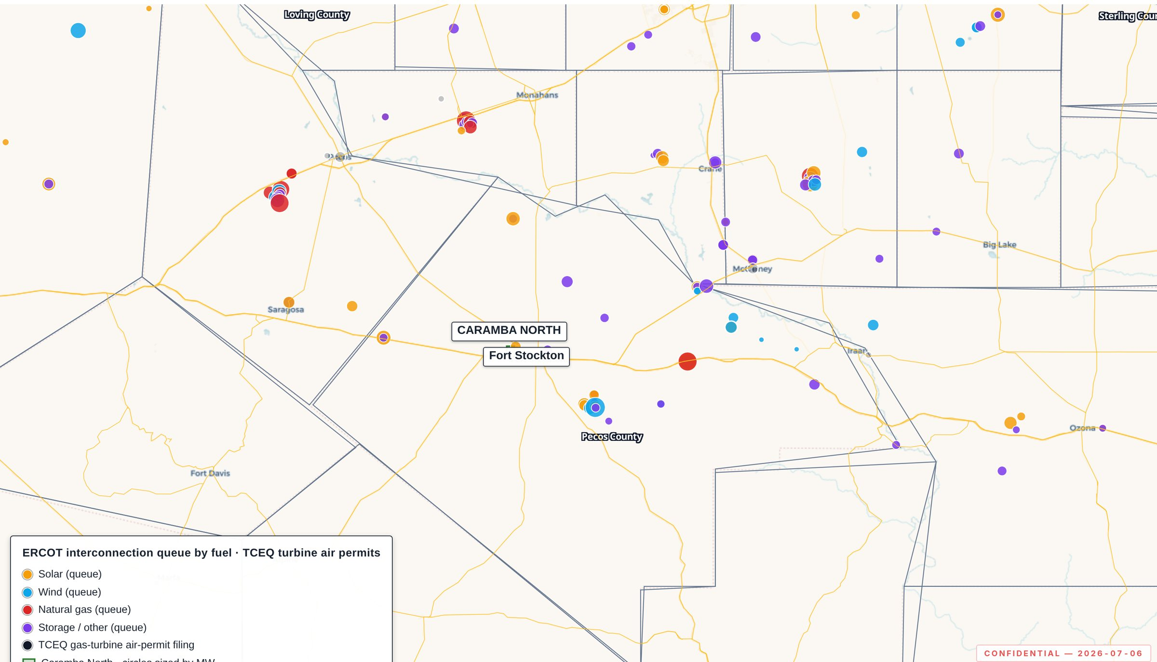
Takeaway — The site sits inside the densest operating renewable cluster in ERCOT.

05 · WATER

Permitted groundwater at a scale few competing sites can document
An affiliated party holds permits for 47,418 acre-feet per year (~42.3 million gallons per day) on adjacent lands — nearly two-thirds of the total permitted rights in the Middle Pecos Groundwater Conservation District. The source is the Edwards-Trinity (Plateau) aquifer, recharged from the mountains to the south, with an annual recharge record that held through the 1950s drought of record. The permit base is designated for industrial use and is sufficient for combined-cycle cooling and hyperscale data-center loads.
ELEMENT | DETAIL
Permitted volume | 47,418 AF/yr (~42.3 MGD) on adjacent affiliated lands — ≈ two-thirds of total district rights
Groundwater district | Middle Pecos GCD (MPGCD)
Aquifer source | Edwards-Trinity (Plateau); recharge from southern mountains
Drought resilience | Well-established annual recharge record; held through the 1950s drought of record
Permitted use profile | Industrial; sufficient for combined-cycle cooling and hyperscale data-center loads
06 · NATURAL GAS

Twenty miles from Waha, with an indicative long-term supply quote in hand
The Property sits approximately 20 miles from the Waha hub, the West Texas gas pricing and delivery point that has traded at a structural discount to Henry Hub — including recurring negative prints through 2024–2025 — as Matterhorn, Blackcomb, Hugh Brinson, and the GCX expansion rebalance basin takeaway. An indicative supply quote has been secured for 200,000 MMBtu per day on a 15-year term at Waha-index pricing, with contribution-in-aid-of-construction of $15–25 million and a build lead time of 9–15 months.
ELEMENT | DETAIL
Indicative supply quote | 200,000 MMBtu/day · 15-year term · Waha-index pricing (counterparty-supplied indicative terms)
CIAC / lead time | $15–25 million; 9–15 months from counterparty
Basis dynamic | Structural discount vs. Henry Hub; recurring negative prints 2024–2025
Takeaway expansion | Matterhorn in service; Blackcomb, Hugh Brinson, GCX expansion in the pipeline

07 · REGIONAL DATA CENTER PIPELINE

Announced hyperscale and large-load capacity inside 60 miles totals 9.7 GW
Pecos and Reeves counties are emerging as the Permian Basin's gigawatt-scale AI computing corridor. The announced campuses within 60 miles of the Property — sponsors including Pacifico Energy and Poolside/CoreWeave — target 9.7 GW between them, the nearest inside twenty miles. Each validates the same siting logic the Property offers: cheap Waha gas, big flat land, groundwater, and a reinforced grid.

Announced projects within 60 miles
PROJECT | SPONSOR | CAPACITY | COUNTY · DISTANCE | STATUS
GW Ranch | Pacifico Energy Group (San Juan Capistrano, CA) | 7.7 GW | Pecos · ~17.3 mi | Permitted
Project Horizon | Poolside (anchor tenant: CoreWeave) | 2.0 GW | Pecos · ~19.7 mi | Under Construction

Elsewhere in Texas — context, not catchment
The register also tracks 6 announced Texas campuses outside the regional catchment, totalling 15.9 GW. They are listed for market context and are not included in the 9.7 GW figure above.
PROJECT | SPONSOR | CAPACITY | COUNTY · DISTANCE | STATUS
Project Matador (Advanced Energy and Intelligence Campus) | Fermi America (Nasdaq: FRMI; Rick Perry, Toby Neugebauer co-founders); Texas Tech University System partner | 11.0 GW | Carson · ~314.9 mi | Permitted
Stargate Frontier Campus | Vantage (developer); Oracle (operator); OpenAI (tenant); Voltagrid (energy partner) | 1.4 GW | Shackelford · ~230.9 mi | Under Construction
Stargate Abilene (Project Ludicrous, Lancium Clean Campus) | Crusoe (developer); Oracle (operator); OpenAI (tenant); on Lancium Clean Campus | 1.2 GW | Taylor · ~221 mi | Operational
Stargate Milam County (SoftBank/SB Energy) | SB Energy (SoftBank Group); OpenAI | 1.2 GW | Milam · ~355.7 mi | Under Construction
Microsoft–Crusoe Abilene Campus (adjacent to Stargate) | Crusoe (developer); Microsoft (lessee, up to 900 MW) | 900 MW | Taylor · ~221.5 mi | Under Construction
Meta Temple Data Center | Meta Platforms (developer Polmer LLC); JE Dunn (general contractor) | 198 MW | Bell · ~330 mi | Operational
Anchor register compiled from corporate announcements, TCEQ air permits, ERCOT queue entries, and county tax-abatement filings; last compiled 2026-04-25. Distances are straight-line from the tract centroid. Coordinates marked approximate in the register are anchored to the nearest public reference where sponsors have not disclosed a location. The register covers announced or under-construction Texas campuses at or above roughly 100 MW; it is not a complete census of regional load.
EXHIBIT 7.1 · PECOS AND REEVES COUNTIES
The announced data-center and large-load projects surrounding the site
Campus land positions plus labeled callouts for announced projects.
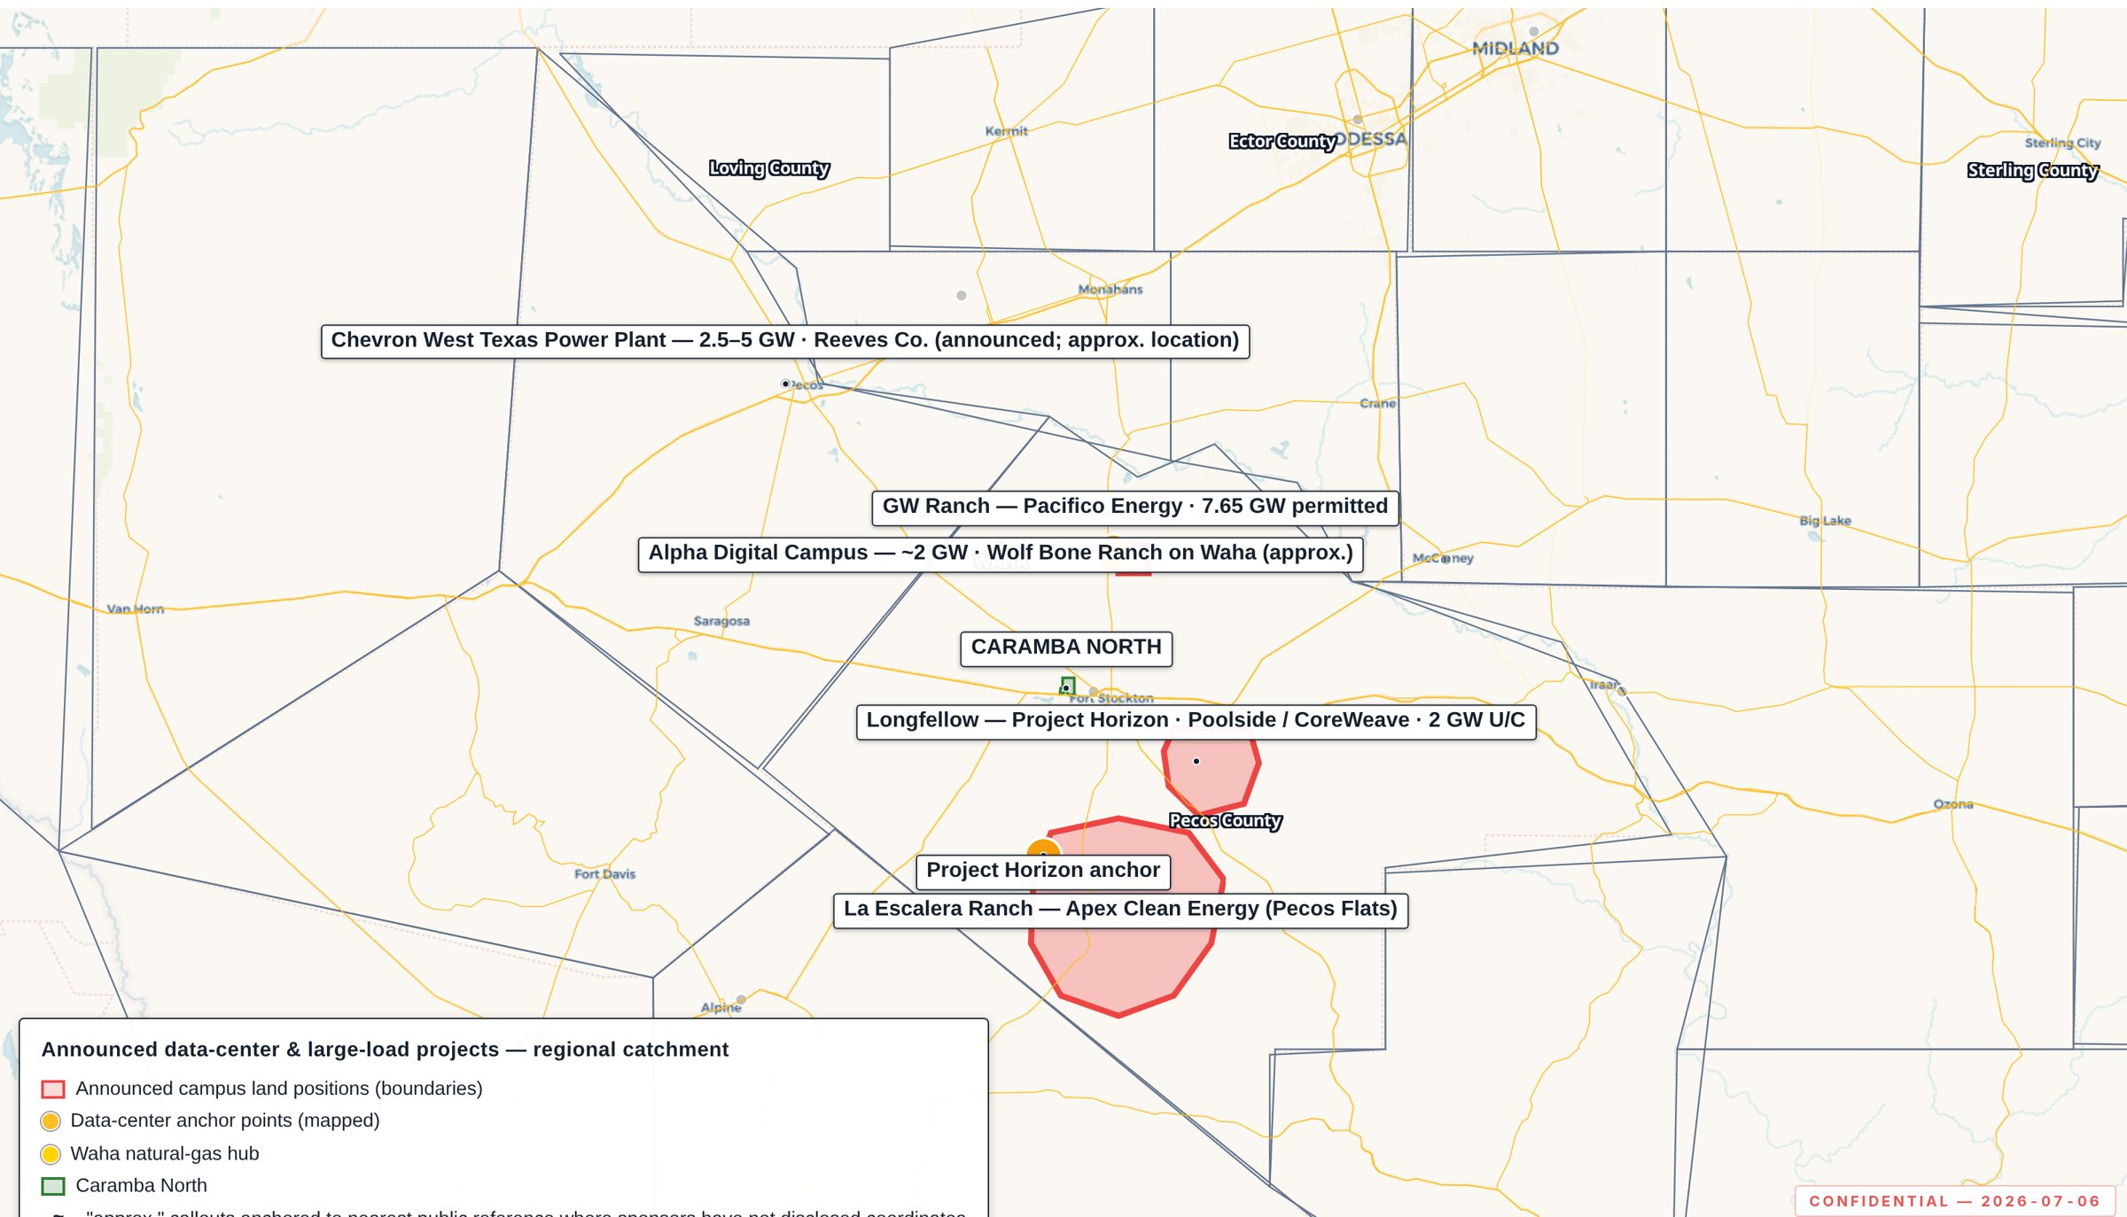
Takeaway — Gigawatt-scale sponsors have taken positions on every side of the site.

08 · THE DILIGENCE PLATFORM

Every figure in this Memorandum is independently verifiable, feature by feature
The data behind this Memorandum lives on a password-protected interactive GIS platform carrying the Property boundary, the regional generation fleet and ERCOT queue, transmission and planned upgrades, midstream networks, the announced campus land positions, permits and tax abatements, and the complete wellbore record used in Section 9. Layers refresh on weekly-to-monthly cadences from the primary sources registered in Appendix A.2, every feature carries its source citation in its popup, and map states can be shared as URLs that reproduce exact views, layers, and filters. The map exhibits in this Memorandum were captured directly from the platform. Access credentials and a navigation guide are provided in Appendix A.1.
PROPERTY OF THE PLATFORM | WHY IT MATTERS FOR DILIGENCE
Source-cited features | Every point, line, and boundary traces to a cited public dataset; per-feature citations in popups. Nothing is hand-placed except labeled reference toponyms; the single approximated boundary (the groundwater management zone) is disclosed as such.
Refresh discipline | RRC wells/permits and abatements weekly; ERCOT queue and TPIT monthly; EIA/USGS/OSM annually on release.
Analytical tooling | Field-level filters (wells by county/depth/spud year; queue by fuel/capacity/status), pre-built analytical views with exportable statistics, a time scrubber animating the drilling record by year, and measure/share/print tools.
Reproducibility | Static, versioned build; the deployed bundle is byte-verified against the build on every release. Access is logged.

09 · SUBSURFACE & DRILLING ACTIVITY

No new drilling is occurring at or near the site — and the public record proves it three independent ways
This section reproduces the drilling-activity study of the tract and its ten-mile radius, prepared as vibration-context due diligence for data-center development. Counting only genuine new wells — wellbore records with recompletion re-stamps excluded — no new-drill well lies within five miles of the tract, only 1 sit within ten miles across 2020–present, and the public hydraulic-fracturing disclosure record shows no new-drill frack within two miles, ever. The wellbore record, the production record, and the fracturing disclosure record each independently support the same conclusion.
0  NEW-DRILL WELLS WITHIN 2 MI SINCE 2020 | 0  NEW-DRILL WELLS WITHIN 5 MI SINCE 2020 | 1  NEW-DRILL WELLS WITHIN 10 MI — NEAREST 9.37 MI
0  NEW-DRILL FRACKS WITHIN 2 MI, EVER | 2002  MOST RECENT SHALLOW SPUD WITHIN 2 MI | 10%  SHARE OF 2020+ PECOS WELLBORE EVENTS THAT ARE NEW DRILLING

9.1 On the tract itself: legacy completions, no modern shallow drilling
The wellbores recorded inside the tract boundary are decades-old completions. The table below is the complete record.
DEPTH (FT) | SPUD YEAR | STATUS | OIL / GAS
2,873 | 1960 | Plugged & abandoned | Gas
3,067 | 1991 | Plugged & abandoned | Oil
3,109 | 1957 | Plugged & abandoned | Oil
3,186 | 1987 | Plugged & abandoned | Oil
3,250 | 2008 | Not plugged | Oil
22,545 | 1978 | Plugged & abandoned | Gas

9.2 Pecos "drilling activity" is ~90% rework of existing wells, not new drilling
The Railroad Commission of Texas maintains a master wellbore database (dbf900) in which every drilling, completion, and workover event is logged against a unique API well number. Tracing every Pecos wellbore with any recorded activity since 2020: of 1,140 wellbore-record events, only ≈ 10% (115) are genuine new drilling. The remaining ≈ 90% (1,025) are recompletion or workover events on existing wellbores. A workover rig on an existing bore is not the drilling-and-fracturing activity associated with ground vibration, and the program is not near the site.

9.3 Proximity: drilling near the tract ended over two decades ago
Within one mile — 3 wellbores of any depth; none shallow (< 3,000 ft). Within two miles — of 46 wellbores, the 10 shallow wells were spudded 1960–2002; most are plugged and abandoned. The nearest non-plugged shallow wells were spudded 1970 (1.28 mi) and 1988 (1.97 mi) — decades-old completions, not active drilling.

9.4 New drilling since 2020, by distance and depth
Counting only genuine new wells drilled in Pecos since 2020 (recompletion re-stamps excluded), the activity is deep and remote. The 114 new wells beyond ten miles sit at a median distance of ≈ 19.9 miles (max 60.4), and the great majority are deep — the modern Permian unconventional program.
RADIUS | NEW-DRILL WELLS, SPUDDED ≥ 2020
≤ 2 mi | 0
≤ 5 mi | 0
≤ 10 mi | 1 (nearest ≈ 9.37 mi)
> 10 mi | 114 (median 19.9 mi, max 60.4 mi)
County-wide total | 115
DEPTH BAND (WELLS > 10 MI) | WELLS | SHARE
< 3,000 ft (shallow) | 6 | 5%
5,000 – 9,999 ft | 60 | 53%
≥ 10,000 ft | 48 | 42%
Classification note — 3 wellbore(s) within ten miles carry a completion year exactly one year before a 2020-or-later spud year (6.94 mi, spud 2026, completion 2025, 9,484 ft; 6.95 mi, spud 2026, completion 2025, 9,464 ft; 9.23 mi, spud 2020, completion 2019, 6,984 ft). The locked recompletion filter excludes them from the new-drill counts above. They are disclosed here because a reader comparing against an earlier vintage of this study will see them counted as new drills.

9.5 County-wide, Pecos has a fraction of the new drilling of its peers
On the same genuine-new-drill basis, Pecos — at ≈ 4,700 square miles — has dramatically less new drilling than comparable Permian counties. Its 115 new wells since 2020 are a small fraction of the comparable-county average (≈ 1,181). Genuine new shallow drilling is negligible in every county.
COUNTY | NEW-DRILL WELLS SINCE 2020 (SHALLOW)
Pecos (site county) | 115 (6 shallow)
Reagan | 668 (9 shallow)
Howard | 990 (1 shallow)
Reeves | 1,053 (32 shallow)
Loving | 1,121 (25 shallow)
Midland | 1,569 (15 shallow)
Martin | 1,685 (20 shallow)
New-drill wells spudded since 2020 (shallow < 3,000 ft in parentheses). RRC dbf900, genuine-new-drill basis. Howard and Loving lie outside the six-county sale-area set and are included only to broaden the comparison.

9.6 Production near the site is decades-old completions — 83% marginal or end-of-life
Every well was additionally cross-referenced against the Railroad Commission's production records, joined by API number. A well is treated as "marginal or end-of-life" when its trailing-average output is at or below 125 Mcf/day of gas and at or below 25 bbl/day of oil — a strict marginal-well threshold.
Of the 298 non-plugged wellbores within ten miles of the tract, 247 (≈ 83%) are marginal or end-of-life. These are not new drilling: they are decades-old completions that have depleted over 30–60 years of production. The vintage distribution makes the point.
RADIUS | NON-PLUGGED WELLBORES | MARGINAL / EOL | SHARE
≤ 2 mi | 5 | 3 | 60%
≤ 5 mi | 89 | 55 | 62%
≤ 10 mi | 298 | 247 | 83%
SPUD DECADE | NON-PLUGGED WELLBORES ≤ 10 MI
1950s | 5
1960s | 33
1970s | 57
1980s | 122
1990s | 20
2000s | 42
2010s | 18
2020s | 1
Spud-decade distribution of the non-plugged wellbores within ten miles.

9.7 The public fracking record independently confirms the wellbore record
The Texas FracFocus disclosure database is the public record of every hydraulic-fracturing job filed in Texas since 2011. Every Pecos County disclosure (950 in total) was cross-referenced against the RRC wellbore record by API number to exclude re-fracs on existing wells; the figures below are confirmed new-drill fracks only — a frack performed at the original completion of a newly drilled wellbore.
DISTANCE BAND FROM TRACT | NEW-DRILL FRACKS (2011–PRESENT) | MOST RECENT
0 – 2 mi | 0 | — none, ever
2 – 5 mi | 9 | 2015
5 – 10 mi | 19 | 2025
10 – 20 mi | 452 | 2026
No new-drill hydraulic-fracturing job has ever been performed within two miles of the tract. The broader Permian program does exist — 480 new-drill fracks within twenty miles since 2011, dominated by the deep-horizontal unconventional players (Diamondback E&P LLC 196, XTO Energy/ExxonMobil 56, Gordy Oil Company 45) — but it is concentrated outside the ten-mile buffer, almost entirely at unconventional depths.
BOTTOM LINE — SECTION 9
Whether the question is framed as shallow drilling, hydraulic fracturing, or new drilling of any kind, three independent public records point the same way: it is not happening at or near this site.
Wellbore record (RRC dbf900) · production record (RRC, API-matched) · fracturing disclosures (FracFocus, API-cross-referenced). Method detail and thresholds are stated in-line above; sources in Appendix A.2.

APPENDIX A.1

GIS Platform — Access & Navigation
ACCESS | DETAIL
URL | https://lrp-tx-gis.netlify.app
Login | Business email + access password (issued to the deal team separately)
Notes | No installation; desktop Chrome/Edge/Safari recommended. Sessions persist per browser. Access is logged; credentials are for the deal team only.

Layout
Left sidebar — layer groups with individual on/off toggles and live feature counts. High-density layers activate as you zoom in. Top bar — Measure (distance/area), Reset (default view), Share (copies a URL capturing your exact view, layers, and filters — the standard way to circulate a specific exhibit), Print (landscape print/PDF). Basemaps — Esri World Imagery (default), Carto Light (best for dense layer work). Popups — click any feature for its attributes with source and as-of date.

Analysis tools
Filters — wells by county/depth/spud year; the ERCOT queue by fuel/capacity/status; permits by operator. Views — pre-built analytical views of the drilling record with exportable summary statistics. Time scrubber — animates the well record by year.

Exhibit provenance
EXHIBIT | TITLE | CAPTURED
Exhibit 2.1 | The site: contiguous, interstate-front, five miles from Fort Stockton | 2026-07-06
Exhibit 3.1 | Planned grid upgrades only (ERCOT TPIT) — the Solstice hub circled, the site beside it | 2026-07-06
Exhibit 4.1 | The operating fleet and the interconnection queue, on one map | 2026-07-06
Exhibit 7.1 | The announced data-center and large-load projects surrounding the site | 2026-07-06

APPENDIX A.2

Footnotes, References & Sources

Numbered footnotes
# | REFERENCE
1 | PUCT Order approving three 765 kV import paths, April 24, 2025 — Permian Basin Reliability Plan, Project No. 55718. interchange.puc.texas.gov (No. 55718)
2 | AEP Texas / CPS Energy, Howard–Solstice Transmission Line Project; PUCT Docket 59366. interchange.puc.texas.gov (No. 59366)
3 | ERCOT Permian Basin Reliability Plan Study, July 2024; PBRP approved September 2024. ercot.com/gridinfo/planning
4 | ERCOT Long-Term Load Forecast. ercot.com/gridinfo/load/forecast
5 | Apex Clean Energy disclosures, Pecos Flats project area. apexcleanenergy.com
6 | EIA Form 860; USGS/LBNL U.S. Wind Turbine Database; project-level GIS analysis. eia.gov/electricity/data/eia860
7 | ERCOT GIS Report of projects in the Generator Interconnection Queue. ercot.com/gridinfo/resource
8 | TCEQ Air Permit filings; sponsor press releases, 2025–2026. tceq.texas.gov/permitting/air
9 | ERCOT Generator Interconnection Queue entries, Longfellow cluster, Pecos County.
10 | Middle Pecos Groundwater Conservation District — permit registry and district rules. middlepecosgcd.org
11 | Railroad Commission of Texas, dbf900 Full Wellbore ASCII master file (weekly release), genuine-new-drill basis: every event tagged to a unique API number; recompletion/workover re-stamps excluded. rrc.texas.gov
12 | RRC production records joined by API number. Marginal threshold: ≤ 125 Mcf/d gas AND ≤ 25 bbl/d oil, trailing average. webapps.rrc.texas.gov/PDQ
13 | FracFocus Chemical Disclosure Registry, Texas disclosures 2011–present, API-cross-referenced against the RRC wellbore record to isolate new-drill fracks. fracfocus.org

General source register (GIS platform layers)
DOMAIN | SOURCE | CADENCE | LINK
County / highway reference | U.S. Census TIGER/Line 2023 | Static | census.gov
Rail | BTS North American Rail Network | Static | geodata.bts.gov
Plants, batteries, solar | EIA-860 annual + generator detail | Annual | eia.gov
Wind turbines | USGS/LBNL U.S. Wind Turbine Database | Annual | eerscmap.usgs.gov/uswtdb
Transmission; NG/crude/NGL pipelines; processing | EIA U.S. Energy Atlas (HIFLD) | Annual | atlas.eia.gov
Substations | OpenStreetMap | Annual | openstreetmap.org
Interconnection queue | ERCOT GIS Report | Monthly | ercot.com/gridinfo/resource
Planned grid upgrades | ERCOT TPIT | Monthly | ercot.com/gridinfo/transmission
Wellbore & permit record | RRC public datasets (dbf900, W-1) | Weekly | rrc.texas.gov
Large-diameter pipelines | RRC digital pipeline data | Annual | rrc.texas.gov/pipeline-safety
Air permits | TCEQ air permitting records | Annual | tceq.texas.gov/permitting/air
Tax abatements (Ch. 381/312) | County commissioners-court records (compiled) | Weekly | County clerk agendas
Groundwater district | Middle Pecos GCD (zone boundary approximate, disclosed) | On publication | middlepecosgcd.org
Distances stated in this Memorandum are straight-line from the tract centroid unless labeled otherwise. Map exhibits were captured from the companion GIS platform on the dates shown in Appendix A.1. Every figure in Sections 3, 4, 7 and 9 is derived programmatically from the layer data at build time; the indicative gas terms in Section 6 and the permitted water volume in Section 5 are counterparty-supplied and identified as such. Compiled 2026-08-20.

APPENDIX A.3

Important Notices
This Confidential Offering Memorandum (the "Memorandum") has been prepared solely for the use of a limited number of prospective counterparties, under executed non-disclosure agreement, in connection with the potential acquisition of, or investment in, the Caramba North property (the "Property"). The Memorandum contains proprietary data of Harvest Energy, LLC and is delivered on a strictly confidential basis. By accepting this Memorandum, the recipient agrees that it will not be reproduced or distributed, in whole or in part, to any other person, and that the information contained herein will be used solely for the purpose of evaluating the potential transaction described.
This Memorandum does not constitute an offer to sell or a solicitation of an offer to buy any security or interest. Any such offer or solicitation will be made only by means of definitive transaction documents and in compliance with applicable law. The information contained in this Memorandum is preliminary and indicative, has been compiled from sources believed to be reliable, and is subject to revision, correction, completion, and update without notice. No representation or warranty, express or implied, is made as to the accuracy or completeness of any information set forth herein.
Public data referenced in this Memorandum is drawn from ERCOT, the Public Utility Commission of Texas, the U.S. Energy Information Administration, the Texas Commission on Environmental Quality, the Railroad Commission of Texas, the FracFocus Chemical Disclosure Registry, the Middle Pecos Groundwater Conservation District, HIFLD, USGS, BTS, and U.S. Census TIGER, supplemented by project-level GIS analysis and counterparty-supplied indicative terms. Distances stated are straight-line from property boundary or centroid, as labeled. Forward-looking statements are subject to risks, uncertainties, and assumptions.
Recipients should conduct their own independent investigation and analysis of the Property, the transaction, and the matters referred to in this Memorandum, including consultation with their own legal, tax, accounting, engineering, and other professional advisors. Any and all liability for representations or warranties, express or implied, contained in, or for omissions from, this Memorandum or any other written or oral communications transmitted to a prospective counterparty in the course of its evaluation of the transaction is expressly disclaimed.

