DELHI PUBLIC SCHOOL – BOPAL, AHMEDABAD
SESSION : 2020 – 21
STUDY MATERIAL : BIOLOGY
CHAPTER 6 :LIFE PROCESSES
CYCLE 1
- Parameters which indicate that something is living: a) Nutrition, b) Respire, c) Show internal growth, d) respond to stimuli, e) show visible/non-visible movement, f) circulation of nutrients and excretion of waste, g) Reproduce, h) have a definite life span.
- Life Processes: The functions which happen inside an organism to keep it alive.Eg: Nutrition, Respiration etc.
- Nutrition: The process of intake of nutrients from an external source and it’s utilization by an organism is called nutrition.Nutrients can be obtained from various sources.The nutrients can be organic or inorganic in nature.
- Modes of nutrition:
- Autotrophic Mode of nutrition.
- Heterotrophic Mode of nutrition.
AUTOTROPHIC MODE OF NUTRITION:
- This is the type of nutrition where the organism prepares it’s food from basic matter available . And the source of energy can be solar or chemical reactions.

- Plants convert solar energy into chemical energy by the process of photosynthesis.
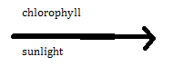
- Photosynthesis: The preparation of complex organic food by using simple substances like water and carbon dioxide in presence of sunlight and chlorophyll.

6CO₂ + 12 H₂O C₆H₁₂O₆ + 6 O₂ + 6 H₂O

- The process of photosynthesis happens in three steps:
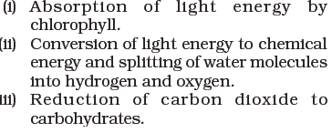
- Site of Photosynthesis: The process occurs in the Chloroplast Where steps (i) and (ii) happen in the thylakoid region and the step (iii) occurs in the Stroma.
- Raw materials required:
- Carbon dioxide : obtained from air through stomata.
- Water: obtained from soil through roots.
- Light and chlorophyll are also essential for the process. ( Acitvity 6.2, 6.3 )
- STOMATA: The structure of stomata is essential for:
- Exchange of gasses
- Transpiration
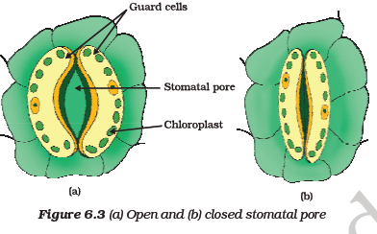

- FACTORS AFFECTING THE RATE OF PHOTOSYNTHESIS:
- EFFECT OF LIGHT:- Maximum photosynthesis occurs in the wavelength of red and blue light.
- EFFECT OF WATER:- If the amount of water decreases the rate of photosynthesis decreases.
- EFFECT OF TEMPERATURE:- As the temperature is increased initially the rate of photosynthesis increases, but at high temperature the rate decreases.

- Process of Photosynthesis:
- In the first step, Light energy is absorbed and conversion of light energy into chemical energy begins. Light induced breakdown of water molecule takes place resulting in the formation of H ions, electrons and O₂ .
- At the end of light dependent phase ( Light Phase) ATP molecules, NADP molecules and O₂ are produced of which oxygen is released as a by product.
- The third step is the reduction of carbon dioxide to glucose by utilizing the products of light phase. This process of conversion is called Calvin cycle.This step is independent of presence of light hence it is called Dark Phase.
It is not necessary that all the 3 step should occur in succession , like in some desert plants which cannot afford to keep their stomata open in the day time, the carbon dioxide is absorbed at night converted into an intermediate and stored in the stroma, the products of light phase are produced in the day time and they then act upon the intermediate to complete the calvin cycle.
- 12 NADPH, 18 ATP are used to produce one glucose molecule.

HETEROTROPHIC MODE OF NUTRITION:
The mode of nutrition in which the organism depends on other organism to procure its food is called heterotrophic mode of nutrition. It is further of three basic types:
- Saprophytic mode of nutrition: Organism obtains its food from dead and decaying matter.
- Parasitic mode of nutrition: Organism obtains its food from living host.
- Holozoic mode of nutrition: Organism takes in complex food and by 5 specific process internalize the nutrients into cellular matter. This can be further bifurcated as Herbivores, Carnivores and Omnivores.

