**Fire and Ice Summary Class 10 English**

**Summary of Fire and Ice**

This article is about the Fire and Ice summary. Its poet is Robert Frost. He presents two opposite views about the end of humanity and the world. He discusses these two possibilities which will be the reason for the end of the world. One such possibility is the world ending in flames of fire. It is so, because when he ponders over the burning flames of desires of people. These will definitely hurl the world into another nuclear war, and hence it will burn up the entire world in flames. The second possibility for the end of the world is due to the ice.

The poet has a strong feeling that people have so much hatred in their hearts against each other that it will be sufficient to freeze the entire planet towards death. So, the fire due to evil desires and ice of wicked hatred are the two opposite opinions enough to destroy the world.

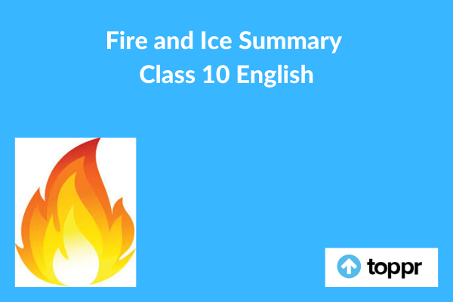

**Fire and Ice Summary in English**

The poet is very much sure of the destruction of humanity on someday. He is talking about the two different beliefs regarding the end of this world. These are on the basis of the sayings of the people. The poet says that he is in favour of those people who say this world will end in fire. This is because he has seen the effect and result of uncontrolled and unending desires over the life of human beings. He finds that human evil desires are similar to the fire in its nature. So this fire may become a big reason to destroy humankind and this world too.

On the other hand, the second belief in this regard says that ice is also sufficient for destroying this world. Here the poet compares the nature of ice with hatred feelings of humans with the other humans. As ice can make the body numb with its prolonged contact, similarly hatred can also give the numbness to our mind and thoughts. And hence it can make us insensitive and cruel. Such cruelty towards humanity will be more responsible for the destruction of the world compared to the desire.

The speaker brings us all into the middle of the argument between two different categories of the people. One who thinks that the world will come to a fiery end and other people who think the world will freeze resulting to the end. Poet is possibly talking about the literal end of the world. But he is also talking about the power that human beings have to destroy each other.

The poet experiences the romantic desire that he has taught the passion for emotions like love and lust. These will probably have the power to turn the earth into a big fireball. But he has also experienced the other extreme side. This is about colder emotions like hate which have great destructive power. It is a common fact that love gets all the publicity, whereas hate is the silent killer. It may not have the same effect as the fireball ending, but it will do the trick.

**Conclusion of Fire and Ice**

The poem is revolving around the theme that human emotions are destructive, and has two possible forms.